NGS Variant calling and Annotation analysis

After performing variant calling and stringent filtering, high-confidence variants from chromosome 5 and chromosome 7 were obtained across all three samples. These variants were further analyzed to assess their distribution and functional consequences.

Chromosome 5

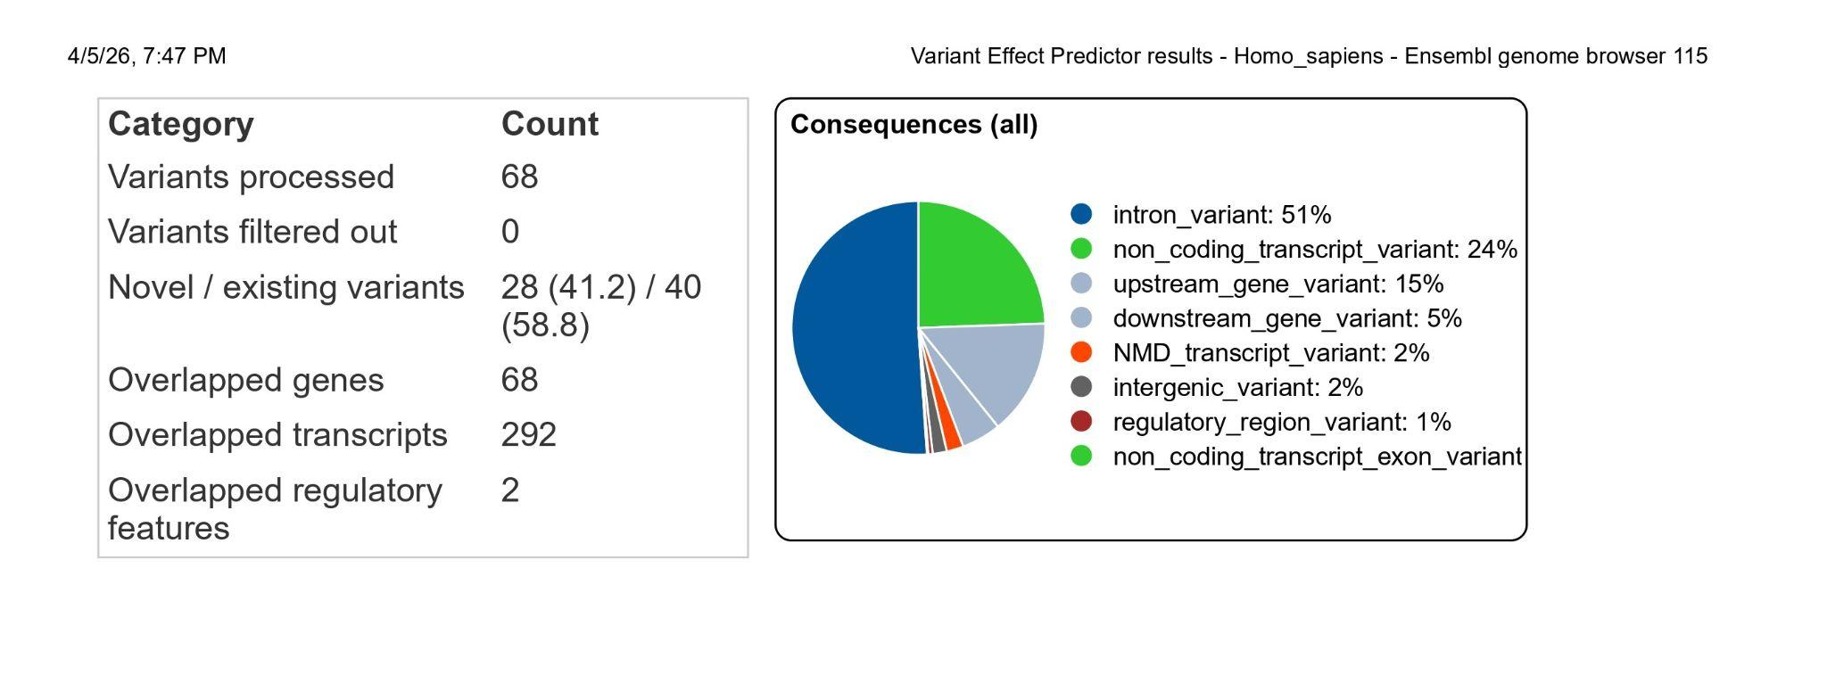Following stringent filtering, chromosome 5 displayed the highest variant count (~68 variants). A large proportion of these variants were located in non-coding regions, including intronic and intergenic regions. Functional annotation revealed that most variants were categorized as modifier impact, indicating minimal predicted influence on protein structure or function.

Chromosome 7

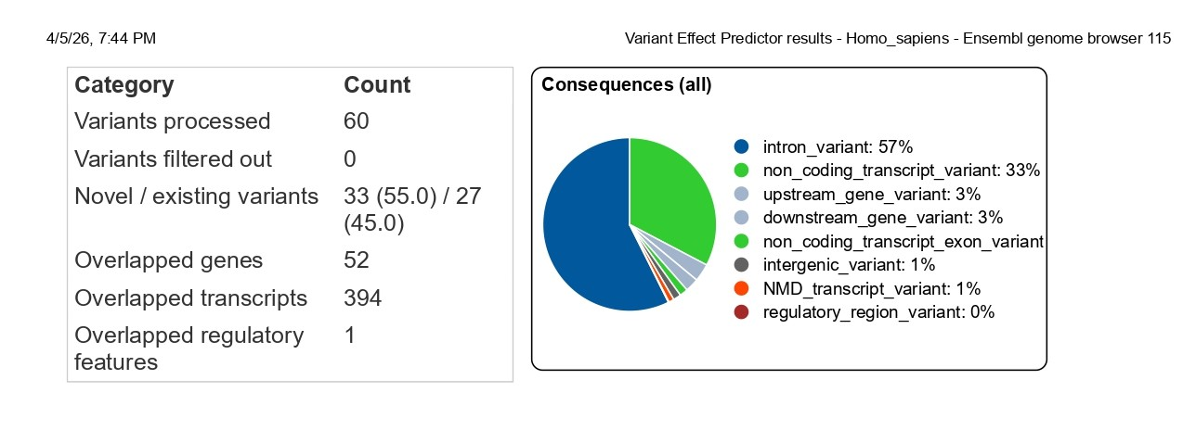

Chromosome 7 demonstrated a relatively lower number of variants count (~60) in comparison to chromosome 5. Similar to the observations in chromosome 5, the majority of variants were located in non-coding regions and were classified as modifier impact, indicating limited functional consequences.

Conclusion

Comparative analysis of chromosome 5 and chromosome 7 revealed that chromosome 5 has a higher number of variants than chromosome 7. Functional annotation indicated that the majority of variants were located in non-coding regions, including intronic, intergenic, upstream, and downstream regions. Consequently, all identified variants were classified under the MODIFIER impact category, suggesting minimal direct effect on protein structure but potential roles in gene regulation.
The absence of coding variants such as missense or nonsense mutations may be attributed to stringent filtering criteria and analysis restricted to selected chromosomal regions.

Visualization of variants using IGV

Visualization using IGV confirmed the presence of selected variants. The alignment data showed consistent read support at variant positions, along with adequate read depth and high base quality scores (Phred score), supporting the reliability of variant calls.

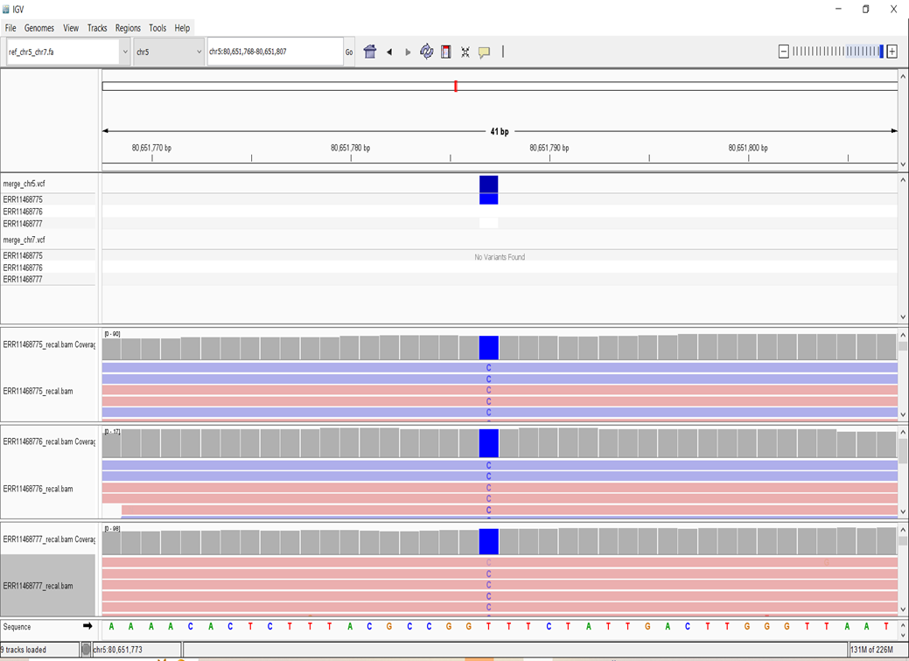
Chr5

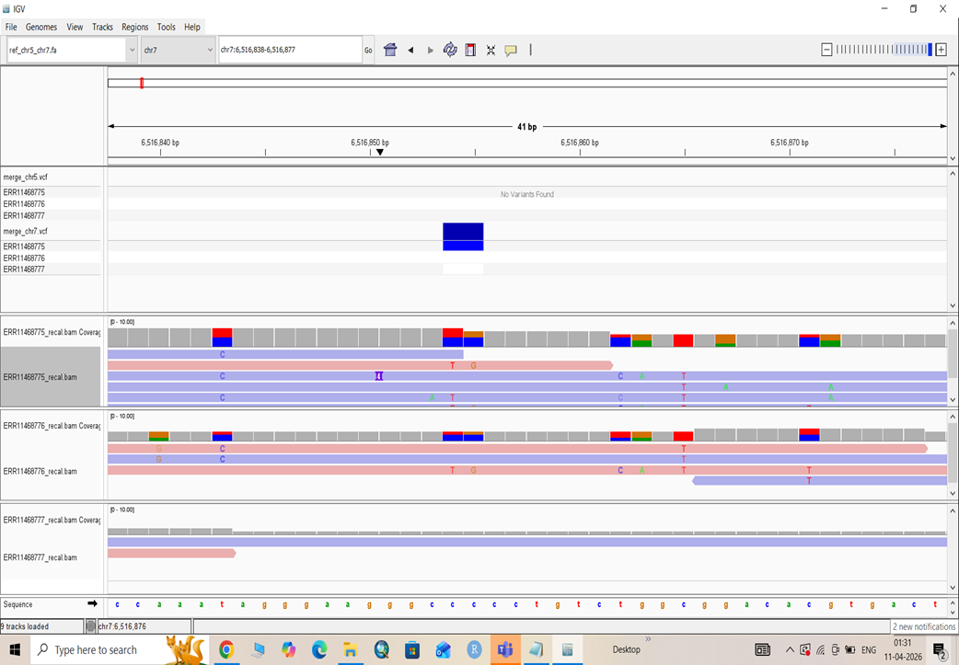
Chr 7

