PRACTICAL – 1
Problem Definition: Initiate the semester-long StudentHub portal by identifying the problemscope, user roles, key modules, navigation flow, and minimum 10 pages.Create a sitemap, low-fidelity wireframe, project folder structure, README file, and GitHub repository.

Code/Script/Task:
- SiteMap:

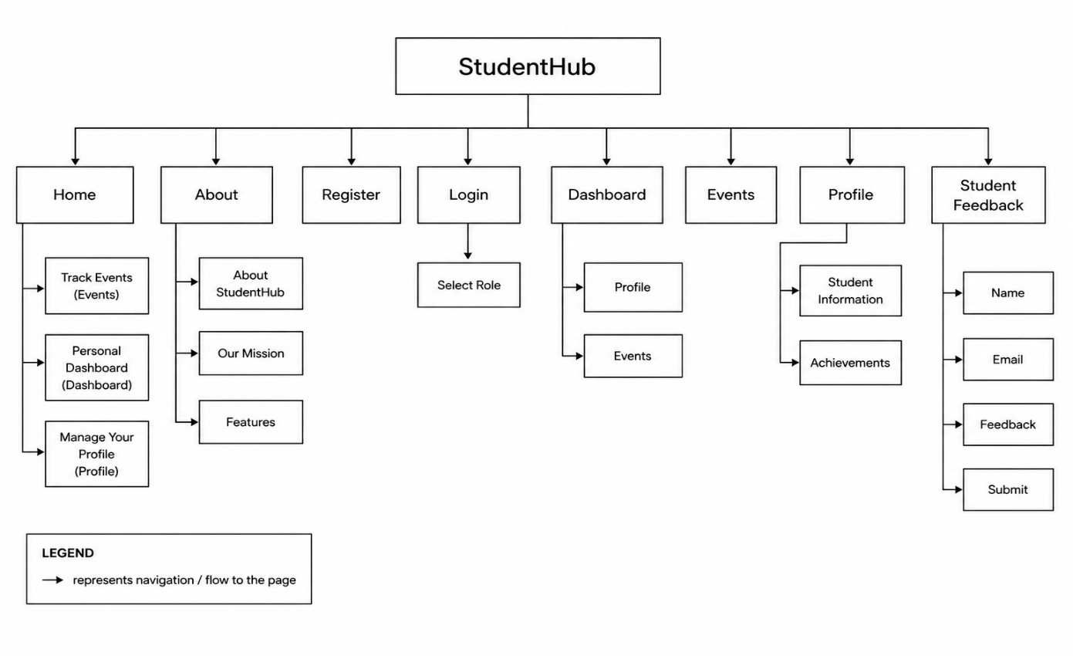

- Wireframe :
- Home Page:
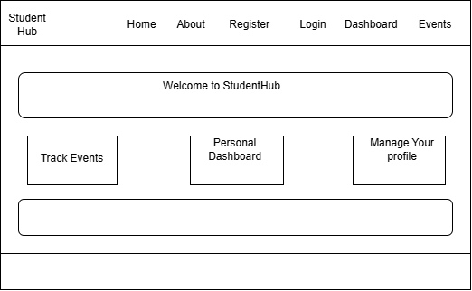

Login_page:

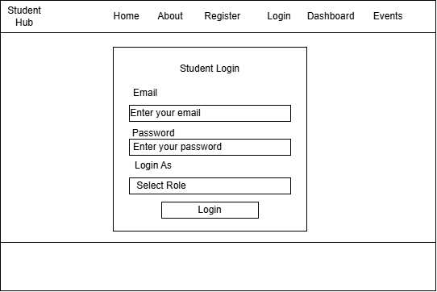

About_us_page:

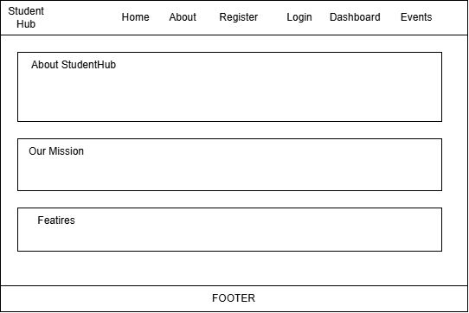

Feedback_page:

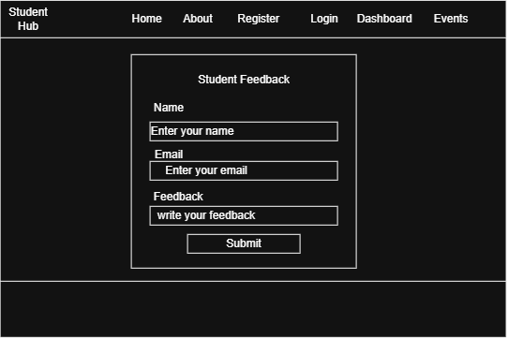

Profile Page:
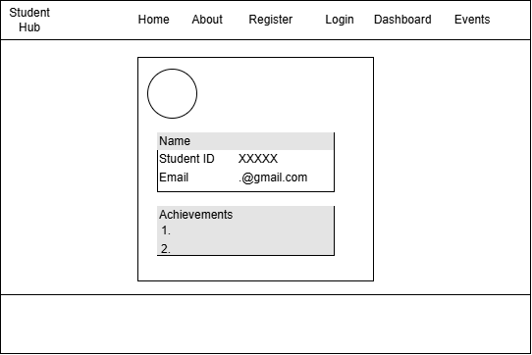

Question & Answer:

- What is URL and parts of URL?
- A URL (Uniform Resource Locator) is the unique address used to find and access resources like web pages or files on the internet. Its key parts include the scheme/protocol, domain name, and path.

- How does HTML file processed in web browser?
- A web browser processes an HTML file through a sequence called the Critical Rendering Path (CRP), which converts code into visual pixels on your screen.

- How will page navigation flow managed among all HTML pages?
- Page navigation flow is managed through HTML hyperlinks, shared navigation menus, and a consistent file structure

- How will GitHub commits be maintained after each practical?
- GitHub commits will be maintained using a structured commit convention, regular pushing, and separate branches for each practical.

Conclusion / Learning Outcome:

The Student Hub portal project successfully established the foundation for a semester-long web application by defining the project scope, identifying user roles, designing key modules, planning the navigation flow, and creating a minimum of 10 interconnected pages. The sitemap, low-fidelity wireframes, project folder structure, README file, and GitHub repository provide a well-organized base for future development. This initial phase ensures that the project is scalable, user-friend

Learning Outcomes
- Understood the process of planning and initiating a web development project.
- Identified user requirements and defined different user roles (Student, Faculty, and Admin).
- Designed a clear sitemap and navigation structure for improved usability.

Created low-fidelity wireframes to visualize the application's layout before development.

