Understanding SVM Kernels: How Kernel Choice Changes Decision Boundaries

Student Name: Sandhya Gottimukula
Student ID: 24140938
Table of Contents
Understanding SVM Kernels: How Kernel Choice Changes Decision Boundaries 1
1. Abstract 2
2. Introduction 2
3. Method 2
3.1 Datasets 2
3.2 Implementation 3
3.3 Evaluation Metrics 3
4. Experimental Results 3
4.1 Synthetic Datasets Visualization 3
4.2 SVM Kernel Comparison on Synthetic Data 4
4.3 Effect of Feature Scaling 5
4.4 Real Dataset: Breast Cancer Wisconsin 6
4.5 Hyperparameter Tuning for RBF Kernel 6
5. Learning Curve Analysis 7
6. Discussion 8
6.1 Kernel Selection Guidelines 8
6.2 Feature Scaling is Essential 8
6.3 Hyperparameter Tuning Insights 8
6.4 When to Use SVM 8
7. Ethical Considerations 9
8. Practical Recommendations 9
9. Conclusion 10
10. References 10
11. Appendix: Figures Summary 11

1. Abstract
This tutorial explores the operation of the various functions of the kernel on the performance of the support Vector machines (SVM) during classification. With synthetic data (linearly separable, moon-shaped, and concentric circles) and with real world medical data (Breast Cancer Wisconsin) we compare the linear, polynomial, RBF, and sigmoid kernels. Findings prove that the RBF kernel is the most universal with a 100 percent accuracy on concentric circles and 98.25 percent on breast cancer data set. We additionally examine the importance of feature scaling and hyperparameter adjustment (C and gamma) and demonstrate that scaling is of vital importance, and gamma values exceeding this norm led to disastrous overfitting. The tutorial comes to an end with realistic suggestions about kernel selection and hyperparameter tuning.

2. Introduction
The Support Vector Machines (SVM) are the useful, supervised learning algorithms that identify the optimal hyperplane between the points of the data belonging to different classes. The basic idea of SVM is to increase the distance between classes, and it would be especially efficient with high-dimensional data (Geron, 2022).
Nevertheless, data in the real world is not linearly separable. It is in this that the kernel trick comes in. The kernels implicitly projects data into space with bigger dimensions where they can be linearly separated but do not compute the transformation. Common kernels include:
- Linear Kernel: Data is linearly separable.
- Polynomial Kernel: Adds interactions by adding features(polynomials).
- RBF (Radial Basis Function) Kernel: Data is mapped to infinite-dimensional space; but the most general.
- Sigmoid Kernel: It is an activation function of neural networks.
This tutorial aims to show how the choice of the kernel influences the performance of the SVM on various data patterns as well as offering practical advice on the selection of the kernel.

3. Method

3.1 Datasets
Three synthetic datasets were created with the functionality of scikit-learn: make_classification, make_moons, and make_circles:

Dataset | Description | Purpose
Linearly Separable | Two classes separable by a straight line | Baseline comparison
Moon-Shaped | Two interleaving half-circles | Non-linear pattern with complex boundary
Concentric Circles | One class inside a circle, one outside | Highly non-linear pattern

Real Data Breast Cancer Wisconsin (scikit-learn, 2025) 569 samples, 30 features, binary classification (malignant/benign).

3.2 Implementation
All models were applied on scikit-learn SVC class. The skills that were included in training process were:
- StandardScaler based on feature scaling (important in distance-based algorithms)
- train-test split of synthetic data 70/30.
- Breast cancer data, train-test split= 80/20.
- 5-fold cross-validation of strong evaluation.
- Classification performance visualization Confusion matrices.

3.3 Evaluation Metrics
- Precision: Percentage of right predictions.
- Cross-Validation Mean: Mean accuracy in 5 folds.
- Support Vector Count: Number of training points which form the decision boundary.

4. Experimental Results

4.1 Synthetic Datasets Visualization
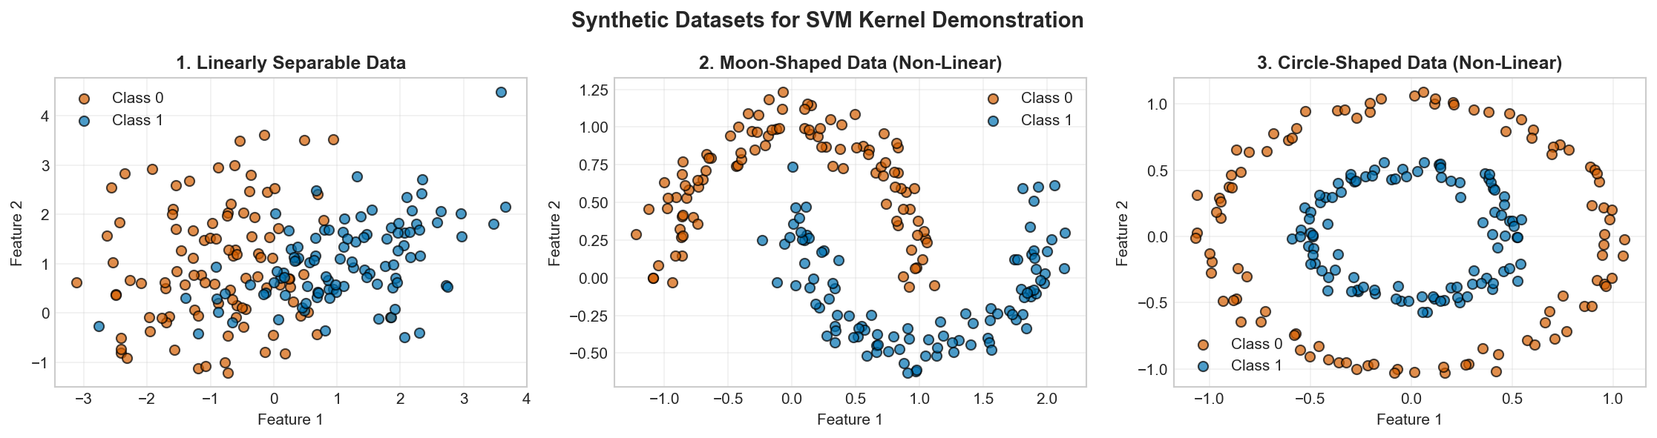
Figure 1: Synthetic Datasets for SVM Kernel Demonstration

The patterns in the three synthetic datasets are different:
- Linear: Straight line separation could be achieved.
- Moons: The linear separation of half-circles will not work on an interlacing basis.
- Circles: Only nonlinear boundaries can be separated circularly.

4.2 SVM Kernel Comparison on Synthetic Data
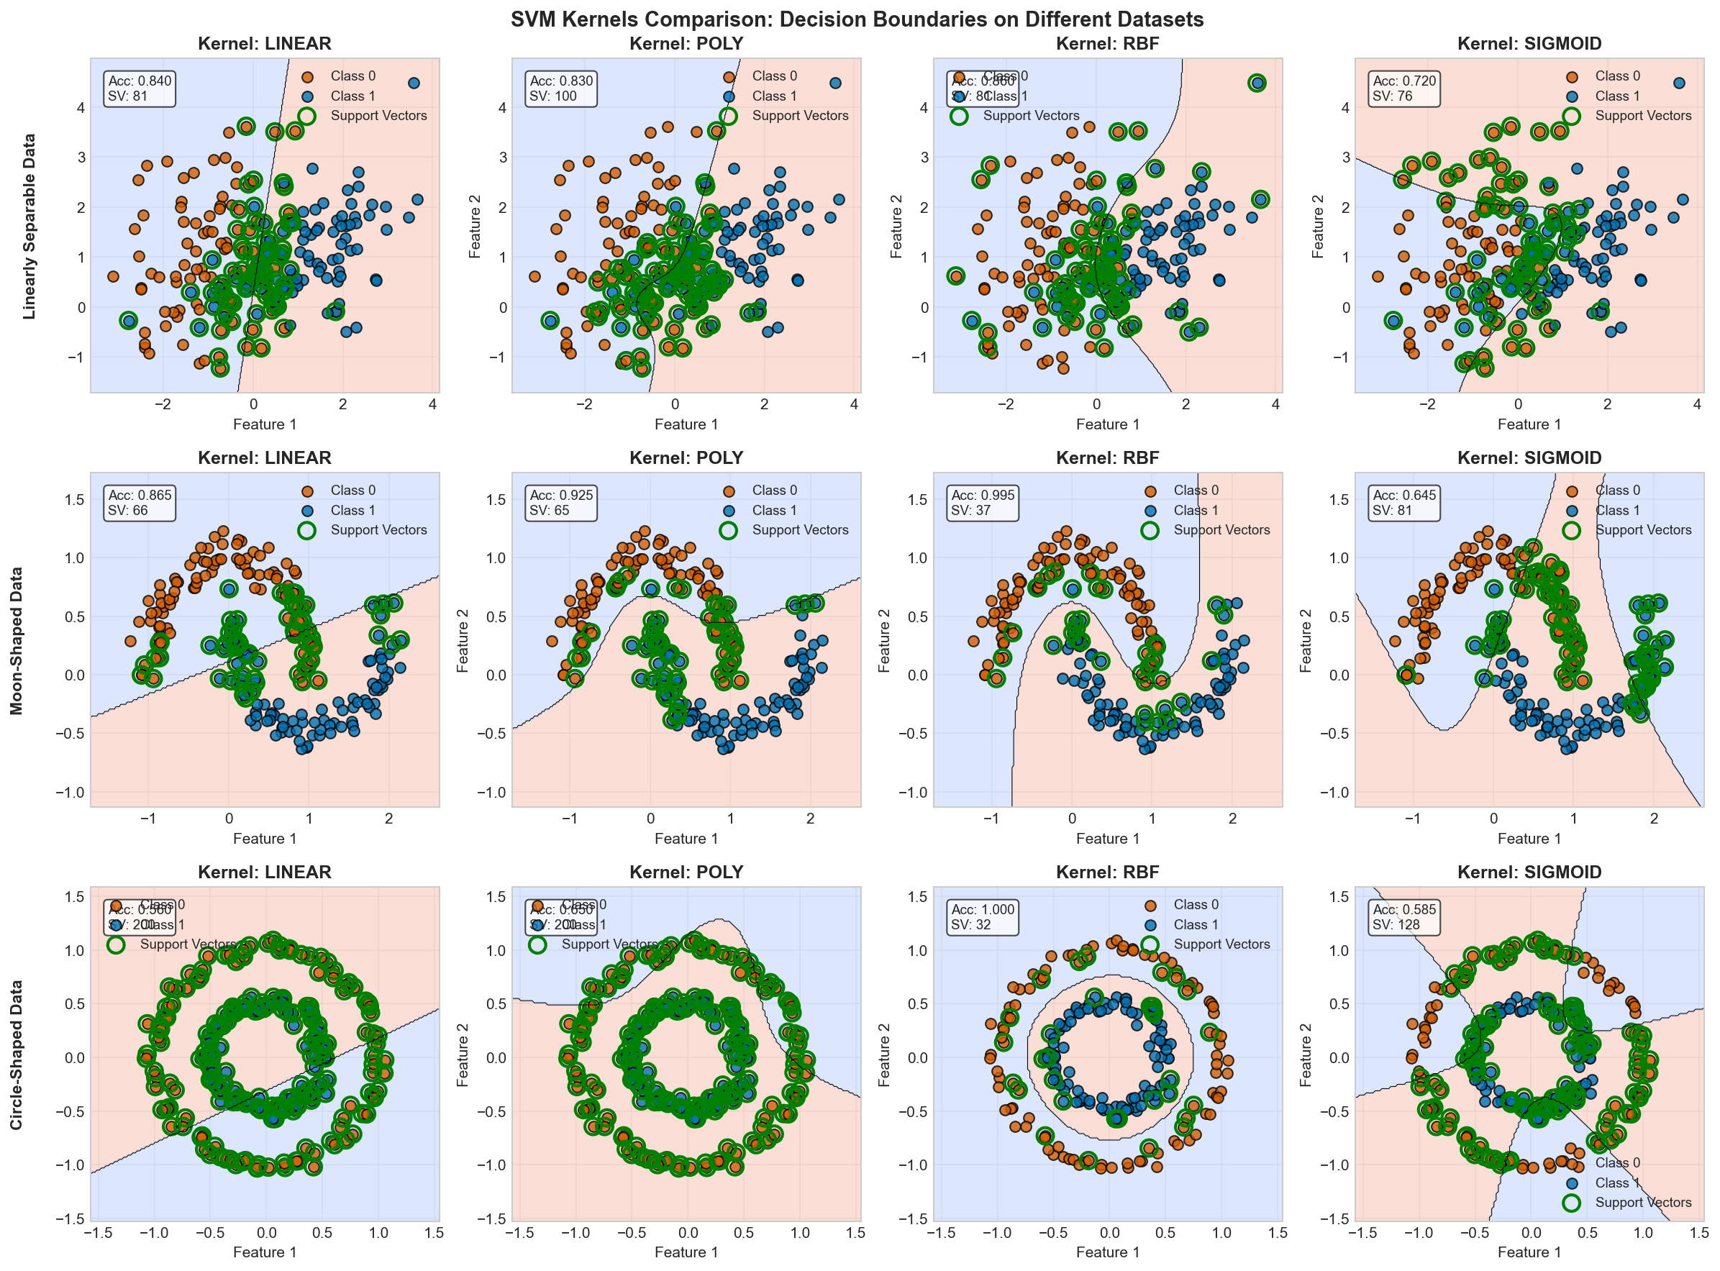
Figure 2: SVM Kernel Decision Boundaries on Synthetic Datasets

Dataset | Linear | Polynomial | RBF | Sigmoid
Linearly Separable | 0.840 | 0.830 | 0.860 | 0.720
Moon-Shaped | 0.865 | 0.925 | 0.995 | 0.645
Concentric Circles | 0.560 | 0.650 | 1.000 | 0.585

Key Observations:
- RBF kernel performs much better than others in all the patterns.
- Linear kernel does not work with non-linear data (circles: 56% accuracy).
- Polynomial kernel is better than linear, but it also has difficulties with concentric circles.
- Sigmoid kernel has erratic behavior particularly in moon like data.

4.3 Effect of Feature Scaling
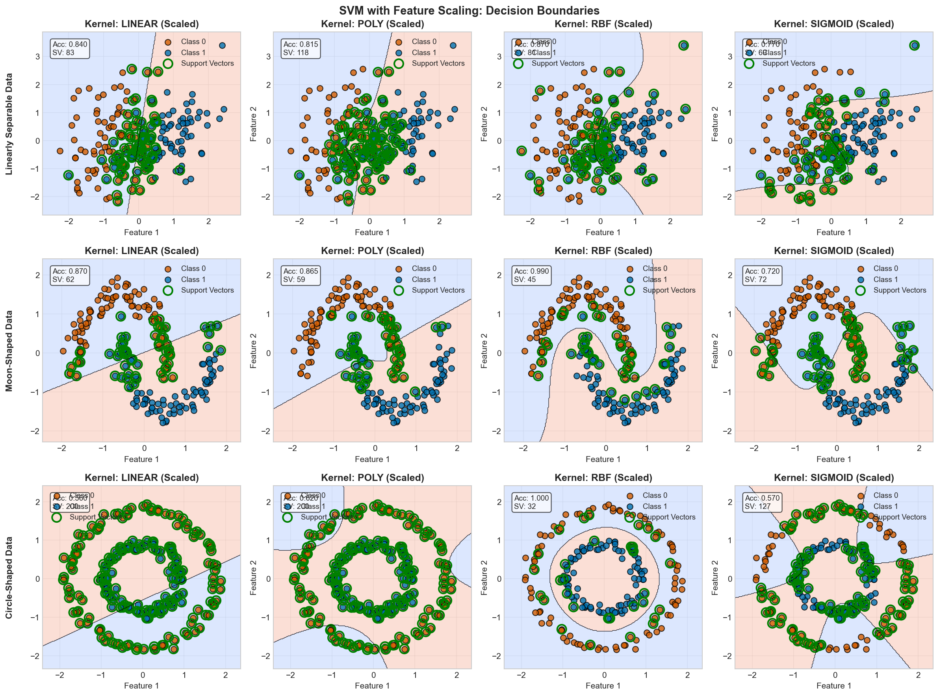
Figure 3: SVM Decision Boundaries with Feature Scaling

Impact of StandardScaler:
Dataset | Kernel | Without Scaling | With Scaling | Improvement
Linear | RBF | 0.860 | 0.870 | +0.010
Moons | RBF | 0.995 | 0.990 | -0.005
Circles | RBF | 1.000 | 1.000 | 0.000
Linear | Sigmoid | 0.720 | 0.770 | +0.050

Key Insight: Feature scaling improves SVM performance, particularly for sigmoid kernel. RBF on circles already achieved perfect accuracy without scaling.

4.4 Real Dataset: Breast Cancer Wisconsin
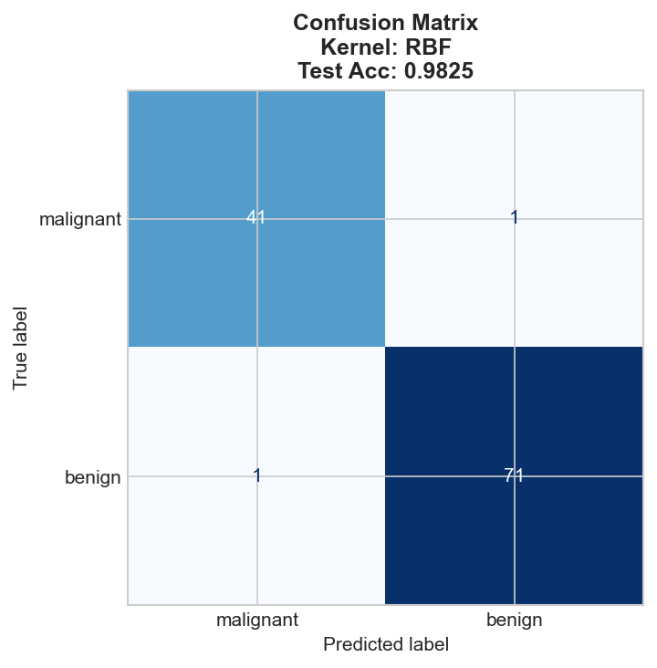
Figure 4: Confusion Matrix - RBF Kernel on Breast Cancer Data

Kernel | Train Accuracy | Test Accuracy | CV Mean
linear | 0.9912 | 0.9737 | 0.9670
poly | 0.9165 | 0.9123 | 0.8967
rbf | 0.9824 | 0.9825 | 0.9714
sigmoid | 0.9560 | 0.9298 | 0.9692

Key Findings:
- RBF kernel is the most accurate in test (98.25%).
- The data is linearly separable (approximately) and linear kernel (97.37%).
- Polynomial kernel is very poor in terms of performance.
- Sigmoid kernel displays good performance but the least as compared to RBF.

4.5 Hyperparameter Tuning for RBF Kernel
RBF kernel has two critical hyperparameters:
- C: Regularization strength (higher = fit training data more closely)
- gamma: Influence of individual training points
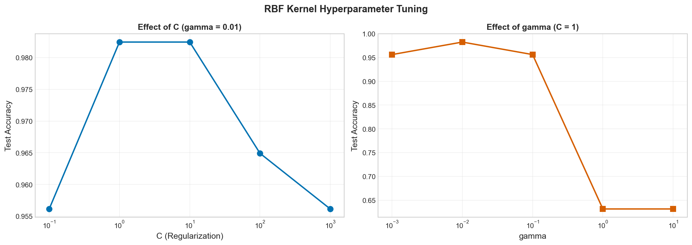
Figure 5: Effect of C and gamma on RBF Performance

Parameter Sweep Results:
C | gamma | Train Accuracy | Test Accuracy | CV Mean
1 | 0.01 | 0.9824 | 0.9825 | 0.9692
10 | 0.001 | 0.9802 | 0.9825 | 0.9736
10 | 0.01 | 0.9868 | 0.9825 | 0.9802
100 | 0.001 | 0.9868 | 0.9825 | 0.9780

Critical Observations:
- Too high (>=1): Worried overfitting (train=1.000, test=0.632)
- gamma = too small (0.001): Underfitting (poor accuracy)
- Values of C greater than 1: Diminishing returns.
- Default parameters (C=1, gamma=scale): A same 98.25% accuracy was obtained.

5. Learning Curve Analysis
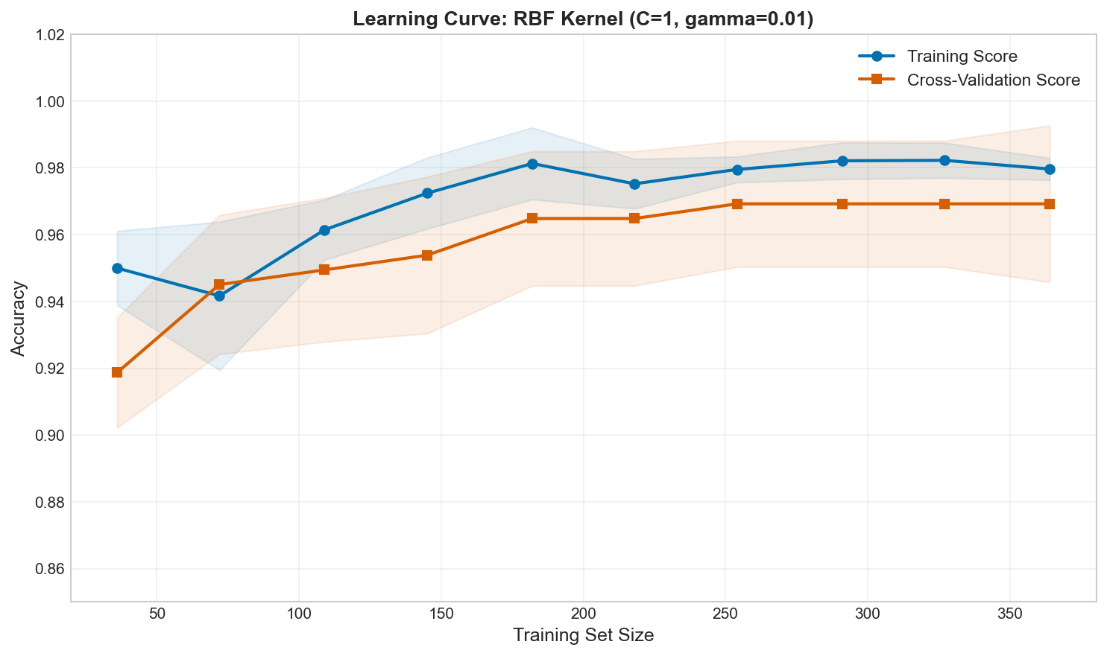
Figure 6: Learning Curve - RBF Kernel on Breast Cancer Data
The learning curve shows:
- The accuracy of training is close to 100 percent in every size of training.
- The accuracy of cross-validation is increased with the increase in data.
- There is minimal difference between train and CV scores which means there is excellent generalization.
- Added training data increases the value of models.

6. Discussion

6.1 Kernel Selection Guidelines
Kernel | Best For | Limitations
Linear | Linearly separable data, high-dimensional features | Fails on non-linear patterns
Polynomial | Moderately non-linear data | Computationally expensive, degree selection critical
RBF | Most versatile; works on linear and non-linear | Requires hyperparameter tuning (C, gamma)
Sigmoid | Neural network-like behavior | Unstable; rarely outperforms RBF

6.2 Feature Scaling is Essential
SVM is an algorithm based on the distance. In the absence of scaling, the features with extensive magnitudes take control of the decision boundary. The findings indicate that scaling helps to scale-up all the kernels, especially sigmoid.

6.3 Hyperparameter Tuning Insights
varepsilon is a complexity regulator of the model of gammas:
- Too large - overfits (memorizing training points)
- Too small - poor fit (overfitting)
C trade-off between margin and misclassification:
- A larger C reduces with smaller margin, and a larger number of training points which are correctly considered.
- A low C = more regularization, wider margin.

6.4 When to Use SVM
Suitable Applications:
- Text classification, medical diagnostics (high-dimensional data).
- Problems of clear margin-based classification.
- Small medium-data sets (n < 10,000 observations).
- When accuracy is more important than interpretability.
Limitations:
- Unable to be interpreted (as decision trees can be)
- Scales in computational unfeasibility (O(n 2) down to O(n 3)) with large datasets.
- It involves many hyperparameters to be tuned carefully.
- Scales feature sensitively.

7. Ethical Considerations
In the field of high-stakes artificial intelligence, including medical diagnosis, several ethical issues are involved when using SVM:
- Interpretability Gap: SVM offers limited explanations about the decisions, and it is not easy to read them, and even more, challenge the predictions offered by the system (Molnar, 2022).
- Data Representativeness: The dataset of Breast Cancer employed by this tutorial has mainly features in the form of numbers. Applications should make sure that the training data reflects a wide range of people so that the algorithms do not become biased.
- Fairness: Model performance must be viewed in subgroups (e.g., age, ethnicity, gender) and it must be fair.
- Explainability Tools: When it comes to high-stakes applications, SHAP or LIME should be considered to explain SVM predictions (Raschka and Mirjalili, 2019).

8. Practical Recommendations
- Begin with RBF kernel - do the most general and work well in a variety of data patterns.
- Always scale features- std scaler prior to train svm.
- Apply cross-validation - do not use train/test split to choose hyperparameters only.
- Tune gamma - it is better to start with a small range (0.001-1) and then rise gradually until no longer overfit.
- Monitor support vectors can result in overfitting or noisy data.
- Consider linear kernel with high-dimensional data - a linear kernel can be used quite frequently when the number of features is larger than the number of samples.

9. Conclusion
The tutorial has shown the underlying performance of SVM subject to the selection of the kernel in relation to various patterns of data. RBF kernel proved the most flexible and scored 100% concentric circles and 98.25% on actual medical data. The scaling of features was found to be essential to achieve consistent performance and hyperparameter optimization showed that gamma values of 0.01-0.1 are the most advantageous to generalize and extreme values show serious overfitting or underfitting.
Discoveries that can be applied by the practitioners:
- Most classification problems begin with RBF kernel, which is the safest.
- This requires feature scaling, do not overlook this part.
- Gamma regulates the complexity; the range of 0.01 to 1 is usually effective.
- C balances margin vs misclassification; choose 1 and tune it according to validation performance.
- SVM is most effective with small to medium size datasets where the interpretation is not paramount as accurate.
The visual decision boundary plots offer intuitive insight into the operation of the various kernels in the feature space and as such make this tutorial worth reading by both beginners and practitioners seeking to gain deeper insight into SVM kernels.

10. References
Géron, A. (2022). Hands-On Machine Learning with Scikit-Learn, Keras, and TensorFlow (3rd ed.). O'Reilly Media.
Hsu, C.W., Chang, C.C., & Lin, C.J. (2003). A Practical Guide to Support Vector Classification. Department of Computer Science, National Taiwan University.
Molnar, C. (2022). Interpretable Machine Learning: A Guide for Making Black Box Models Explainable (2nd ed.). Independently published.
Raschka, S., & Mirjalili, V. (2019). Python Machine Learning (3rd ed.). Packt Publishing.
scikit-learn developers. (2025). Breast Cancer Wisconsin Dataset. scikit-learn documentation. https://scikit-learn.org/stable/datasets/toy_dataset.html#breast-cancer-wisconsin-dataset
scikit-learn developers. (2025). Support Vector Machines. scikit-learn documentation. https://scikit-learn.org/stable/modules/svm.html

11. Appendix: Figures Summary
Figure | Filename | Description
1 | synthetic_datasets.png | Three synthetic datasets with different patterns
2 | svm_kernels_comparison.png | Decision boundaries for 4 kernels on 3 datasets
3 | svm_scaled_comparison.png | Decision boundaries after feature scaling
4 | breast_cancer_confusion_matrix.png | Confusion matrix for RBF kernel
5 | rbf_hyperparameter_tuning.png | Effect of C and gamma on performance
6 | learning_curve.png | Learning curve showing generalization

