**College of Science and Technology**

**Royal University Of Bhutan**

CSF101

ASSIGNMENT 1

Name: Tshering Yangchen Bedha

Student No: 02240136

Department: Electronics and Communications Engineering

PART A

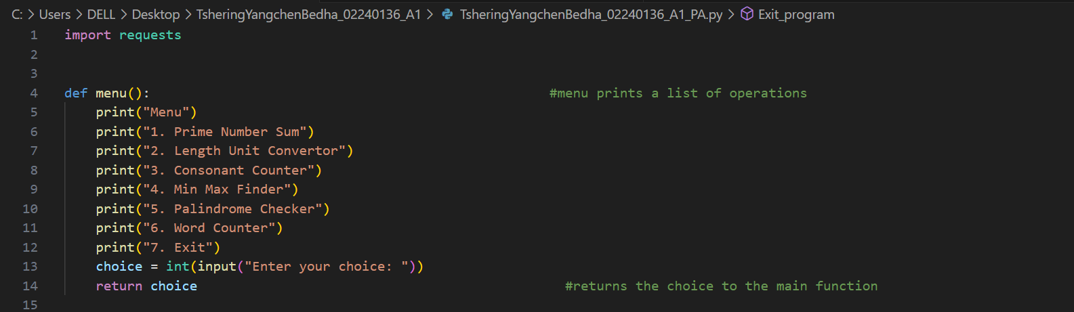

Prime Number Sum Calculator.

Length unit convertor.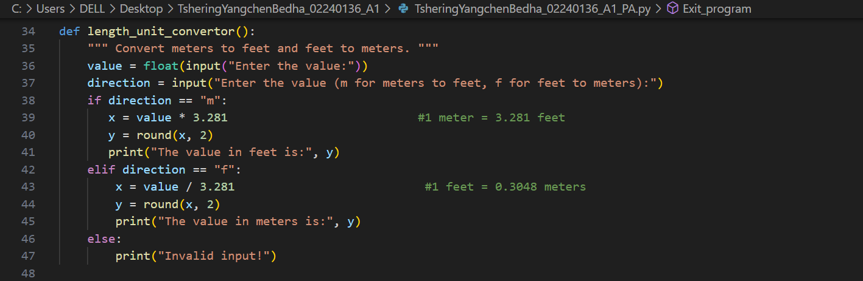

Constant Counter.

Min Max Finder.

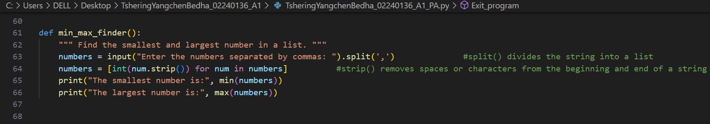

Palindrome Checker.

Word Counter

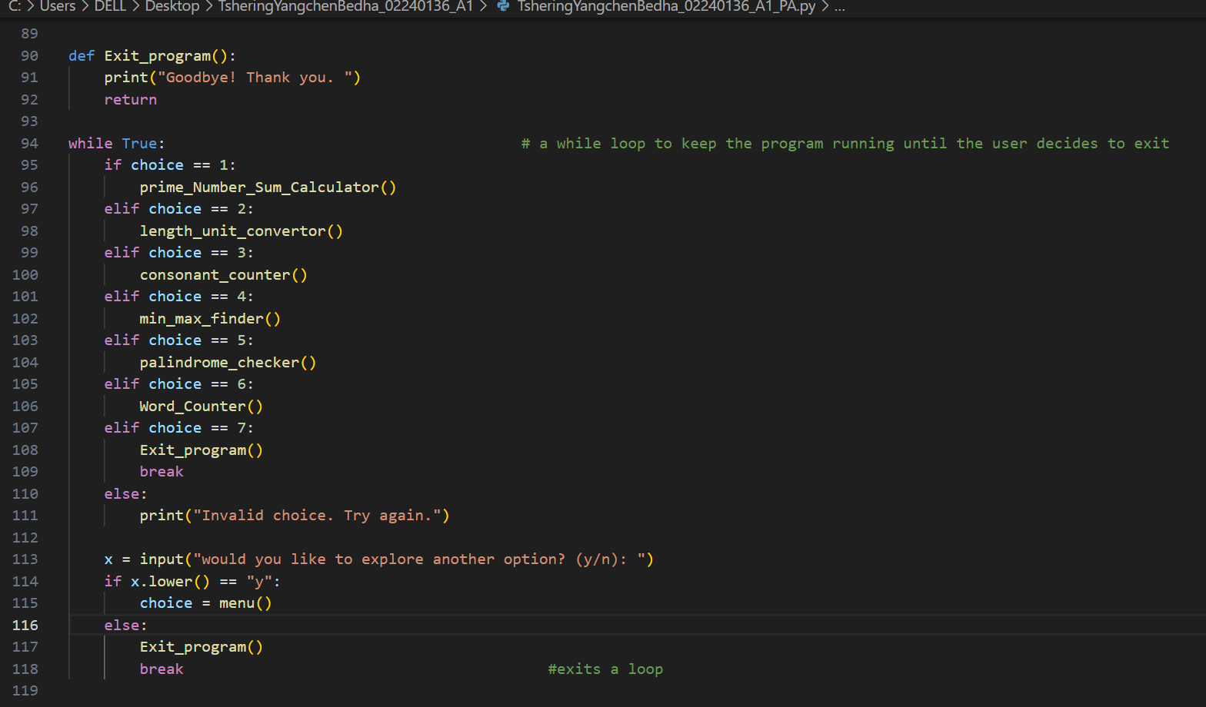

RESULTS:

PART B

Guess the number game

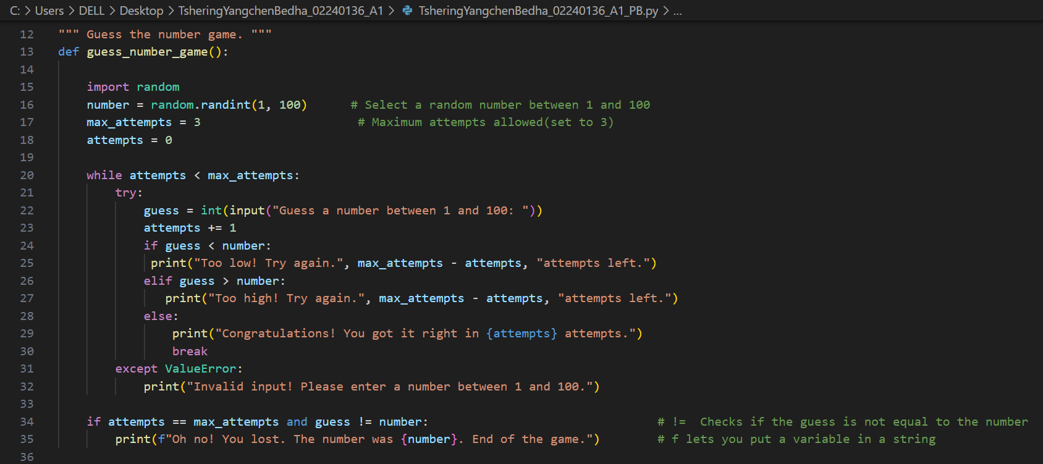

Rock Paper Scissors Game.

Result.

