|  |
| --- |
| Easy CST - Apps on Google Play  Programming Methodology (CSF 101)  Department of Instrumentation and Control Engineering  Assignment 1  Tshering Choden (02240274)  <https://github.com/02240274/TsheringChoden_02240274_A1> |

Part A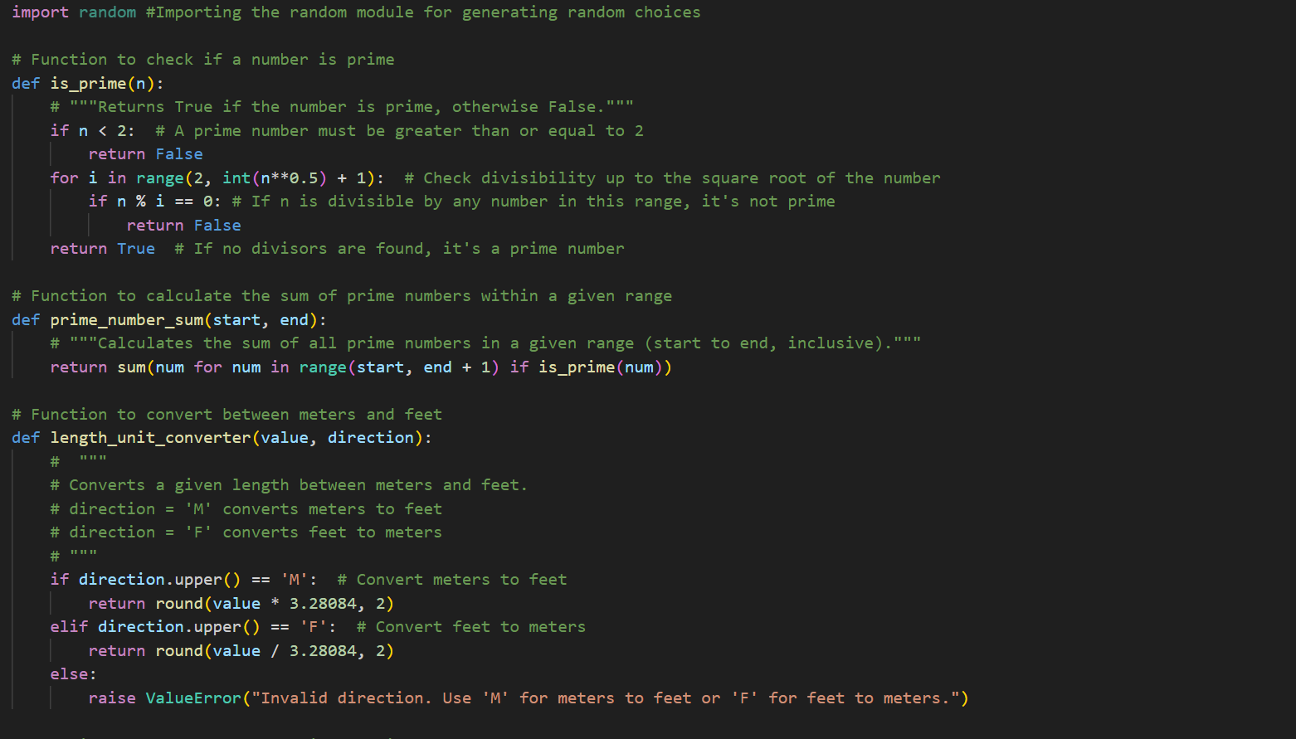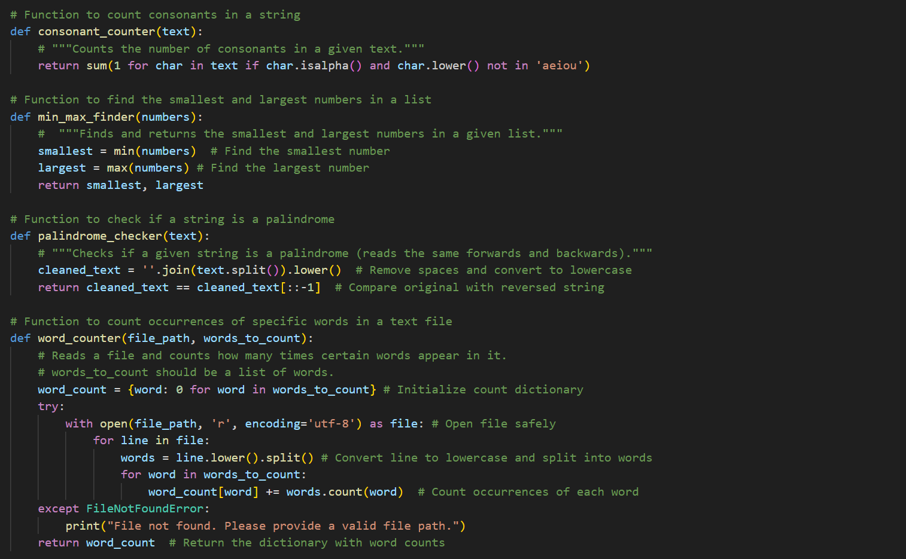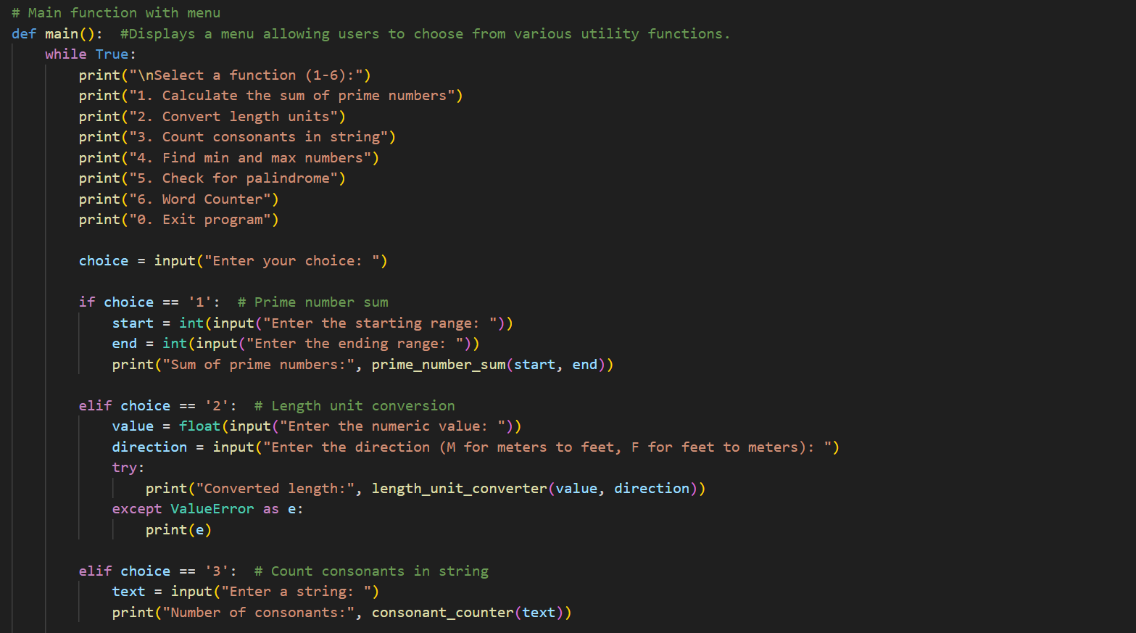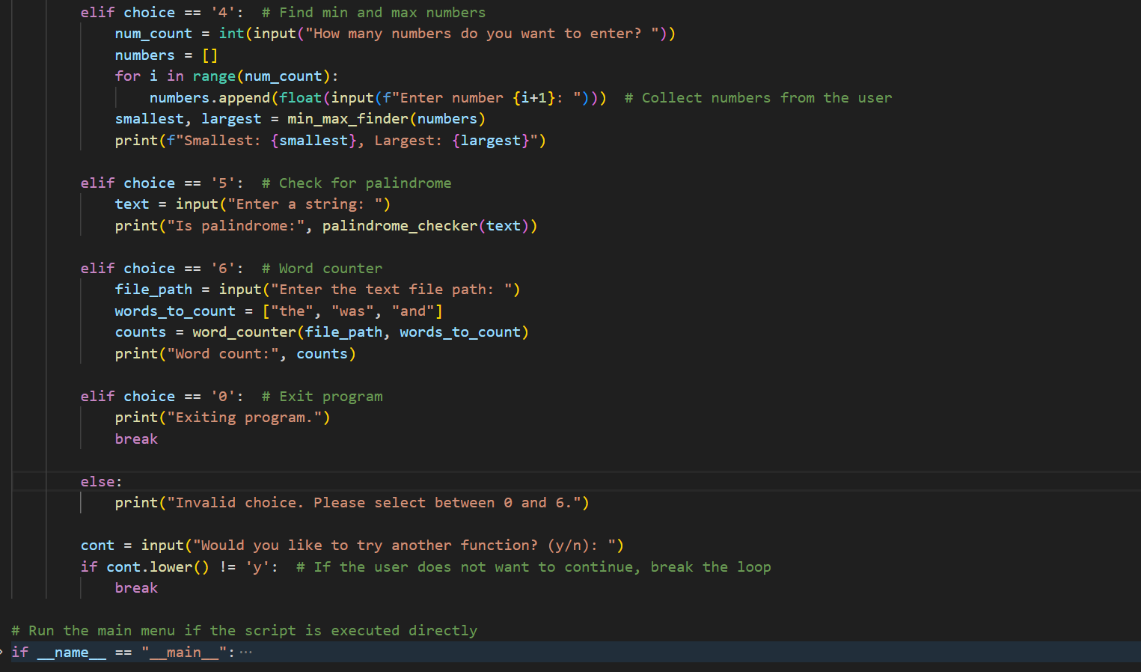

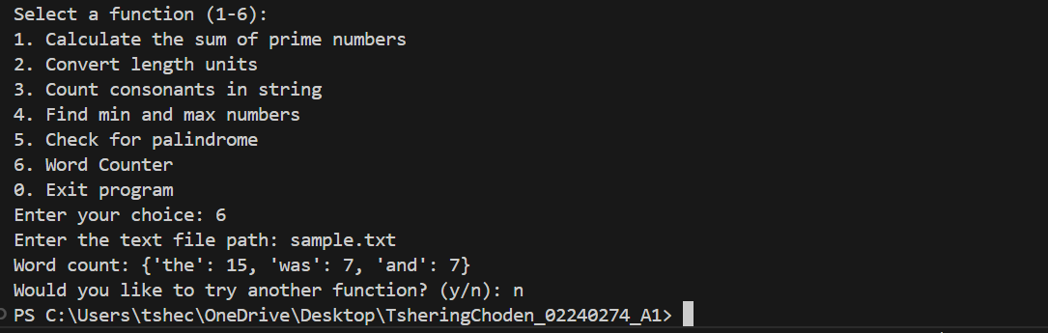

Part B



