Forecasting Singapore Monthly Live Births with SARIMA
Seasonal ARIMA analysis of monthly data, January 1960 to March 2025, with an R workflow
Report detail | Information
Team | PG-S2-51
Dataset | SARIMA_dataset.csv: 15 monthly live-birth series, 783 months (Jan 1960 - Mar 2025)
Main series | Total live births; also four ethnic groups and male / female births
Selected model | SARIMA(2,1,1)(0,1,1)[12] on the log scale, fitted to 2000-2025 data
Evaluation | Rolling-origin cross-validation (2010-2022) for selection; 24-month hold-out (Apr 2023 - Mar 2025) scored once
Software | R 4.6.1; packages forecast 9.0.2, tseries 0.10-63, ggplot2 4.0.3, patchwork 1.3.2
Date | September 2026

Main result
Monthly births have a strong, stable seasonal cycle: a September-November peak about 7% above the yearly level and a January-July trough 2-3% below it. A seasonal ARIMA model SARIMA(2,1,1)(0,1,1)[12] captured this cycle and beat every benchmark. On the 24-month hold-out it reached RMSE 98.8 births per month (MAPE 2.61%), against 150.8 for ETS, 186.9 for seasonal naive and 218.7 for a non-seasonal ARIMA. The model forecasts 31,304 births for 2025 and 30,525 for 2026, but it tends to forecast too high (about 47 births per month on the hold-out), so these figures should be read as upper-side estimates.

Contents
1 Executive Summary 3
2 Data and Study Design 3
2.1 The dataset 3
2.2 Study design 4
3 Exploratory Analysis 5
3.1 Level and trend 5
3.2 Seasonality 5
3.3 Decomposition 6
4 Stationarity and Model Identification 7
4.1 Transformation 7
4.2 Differencing 7
4.3 ACF and PACF 8
5 Model Selection 9
5.1 Candidate models 9
5.2 Cross-validation results 9
5.3 Horizon profile and information criteria 11
6 The Selected Model 11
6.1 Specification and coefficients 11
6.2 Residual diagnostics 12
7 Hold-out Test (April 2023 - March 2025) 12
8 Forecast: April 2025 to March 2027 14
9 SARIMA-based Analysis by Segment 15
9.1 Seasonal features 16
9.2 Hold-out accuracy by segment 17
9.3 Bottom-up versus direct forecasting 18
9.4 Segment forecasts and composition 18
9.5 Dragon-year effects 19
10 Discussion 20
10.1 What the analysis shows 20
10.2 Strengths 20
10.3 Limitations 20
10.4 Recommendations 21
11 Conclusion 21
References 21
Appendix A. Complete Cross-validation Results 23
Appendix B. Segment Models 24
Appendix C. Reproducing the Analysis 24
Appendix D. SARIMA Notation 25
(If page numbers look out of date in Word, right-click the contents list and choose Update Field.)

1 Executive Summary
This report applies the Box-Jenkins seasonal ARIMA (SARIMA) method to Singapore's monthly live-birth counts. It complements the earlier annual ARIMA report, which ignored within-year seasonality by design. The monthly file carries the seasonal information that annual data cannot, and it reconciles exactly with the annual totals (Section 2). The analysis has two parts: a full SARIMA study of total births, and a SARIMA-based analysis of ethnic groups, sex and Year-of-the-Dragon effects.
- Data. 783 complete months, no missing or zero values. Monthly totals sum to the annual file's totals for every complete year from 1960 to 2024.
- Seasonality. Births per day peak in September-November (index 1.073 in the peak month) and are lowest in Feb (index 0.965). Raw counts swing by 21% between the highest and lowest month, but only 11% once the number of days in each month is removed. The seasonal amplitude has weakened since 1980-1999.
- Model. A log transformation with one seasonal and one regular difference gives a stationary series. Of 23 SARIMA-family candidates (structure x training window), only 4 passed a residual-autocorrelation check, all trained on data from 2000. The best of those, SARIMA(2,1,1)(0,1,1)[12], was selected.
- Accuracy. Cross-validated RMSE is 139.8 births per month, 17% below ETS, 38% below seasonal naive and 38% below a non-seasonal ARIMA. On the untouched hold-out the reductions are 35%, 47% and 55%.
- Forecast. Total births are projected at 31,304 for 2025 (95% interval 29,450-33,168) and 30,525 for 2026 (26,044-35,507). The annual file records 29,864 for 2025, inside the 95% interval but below the 80% interval, which matches the model's upward bias on the hold-out.
- Segments. No single method wins for every ethnic group or sex. Bottom-up and direct forecasts of the total are within about 5% of each other, so disaggregation adds detail but not accuracy.
- Dragon years. Dragon years carry an estimated birth uplift of up to about 8% (significant in 1976, 1988 and 2000 for total births), concentrated in the Chinese group. The effect does not show a clear decline over time.
Table 1. Headline results
Item | Result
Selected model | SARIMA(2,1,1)(0,1,1)[12], log scale, training window from 2000
Cross-validated RMSE / MAPE (2010-2022) | 139.8 births / 3.36%
Hold-out RMSE / MAPE (Apr 2023 - Mar 2025) | 98.8 births / 2.61%
Hold-out benchmarks (RMSE) | ETS 150.8; seasonal naive 186.9; non-seasonal ARIMA 218.7
Ljung-Box p-values (lags 12 / 24 / 36) | 0.099 / 0.276 / 0.500
2025 births (Jan-Mar actual + forecast) | 31,304 (95%: 29,450 to 33,168)
2026 births | 30,525 (95%: 26,044 to 35,507)

2 Data and Study Design

2.1 The dataset
SARIMA_dataset.csv stores 15 monthly series in wide format, with one column per month (newest first). The rows are total live births, the four ethnic groups (Malays, Chinese, Indians, Other ethnic groups), and the same five rows again for male and for female births. The script reorders the columns chronologically and builds a monthly time series with frequency 12.
Table 2. Data-quality checks on SARIMA_dataset.csv
Check | Result
Observations (months) | 783
First month | 1960-01-01
Last month | 2025-03-01
Missing values | 0
Zero counts | 0
Gaps in monthly sequence | 0
Months where Total != sum of 4 ethnic groups | 40
Largest |Total - sum of ethnic groups| (births) | 2
Months where Total != Male + Female | 76
Largest |Total - (Male + Female)| (births) | 3
Months where Male != sum of male ethnic rows | 0
Months where Female != sum of female ethnic rows | 0

The series are complete and consistent. The total differs from the sum of the four ethnic groups by at most 2 births in 40 of 783 months, and from male plus female by at most 3 births in 76 months; the male and female rows equal the sum of their own ethnic rows exactly. These gaps are negligible and are treated as rounding or unclassified records. Cross-check with the annual file: the monthly totals add up to the annual total exactly for every complete year, 1960 to 2024 (Section 8 shows 2019-2025).

2.2 Study design
A single train/test split can flatter a model that is chosen after looking at the test set. The design below separates model selection from final testing:
- Selection: rolling-origin cross-validation. Thirteen forecast origins (March 2010 to March 2022, one per year). At each origin every model is refitted on the data available then and forecasts the next 12 months. This gives 156 out-of-sample forecasts per model.
- Adequacy screen. A candidate is eligible only if its training residuals pass a Ljung-Box test at lag 24 (p >= 0.01).
- Final test: 24-month hold-out. April 2023 to March 2025, scored once, after selection. It covers the Dragon year 2024 and the recent decline in births.
- Benchmarks. Seasonal naive (repeat last year), ETS on the log scale, and a non-seasonal ARIMA. A SARIMA model is worth using only if it beats these.
- Metrics. RMSE and MAE in births per month, MAPE, and empirical coverage of the 80% and 95% prediction intervals. All are computed on the original scale.

3 Exploratory Analysis

3.1 Level and trend
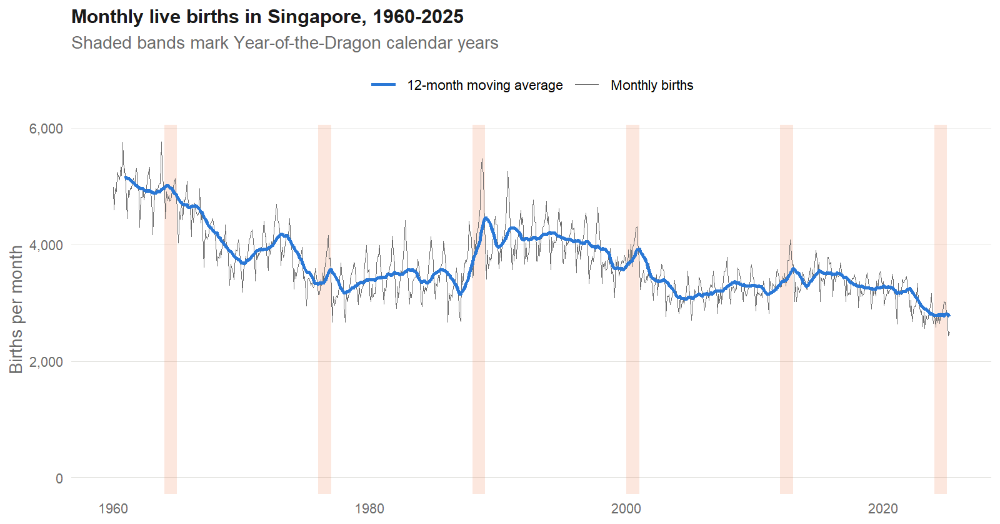
Figure 1. Monthly live births, 1960-2025, with a 12-month moving average. Shaded bands mark Dragon calendar years.
Births fell from about 4,111 per month in 1960-1979 to 3,810 in 1980-1999 and 3,267 in 2000-2025. Variability fell as well (standard deviation 673, 481 and 301). Short spikes appear in several Dragon years (most clearly 1988, 2000 and 2012) and there is a clear downward step after 2022. The highest complete year is 1960 (61,775 births) and the lowest recent year is 2023 (33,541).
Table 3. Monthly births by era
Era | Months | Mean per month | Min | Max | Std. dev.
1960-1979 | 240 | 4,111 | 2,670 | 5,761 | 673
1980-1999 | 240 | 3,810 | 2,668 | 5,478 | 481
2000-2025 | 303 | 3,267 | 2,437 | 4,308 | 301

3.2 Seasonality
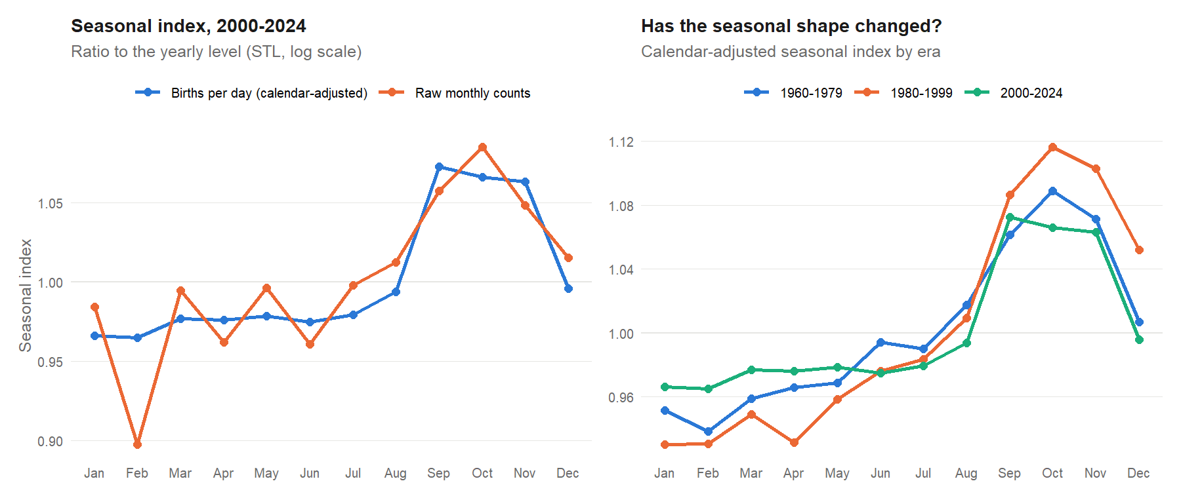
Figure 2. Seasonal index (left) and its stability across eras (right). The calendar-adjusted series removes the number of days in each month.
The raw index shows a deep February trough (0.898) and a peak in October (1.085), a 21% swing. About half of that swing is calendar arithmetic: February has 28 or 29 days. Measured per day, the pattern is a flat level from January to July (index 0.965-0.980), a rise in August and a plateau from September to November (1.063-1.073), then a drop in December. After removing the calendar effect the swing is 11%. The regression in Section 9.5 confirms the calendar effect: the estimated elasticity of births to days in the month is 1.03, very close to the theoretical value of 1.
The shape has been stable but the amplitude has not. The peak was highest in 1980-1999 (October index 1.117), lower in 1960-1979 (1.089) and lowest in 2000-2024 (September 1.073). A stable seasonal shape with a moderately changing amplitude suits a multiplicative (log-scale) SARIMA model.
Table 4. Seasonal index by month (STL, log scale)
Month | Raw counts | Per day | 1960-79 | 1980-99 | 2000-24
Jan | 0.985 | 0.966 | 0.952 | 0.930 | 0.966
Feb | 0.898 | 0.965 | 0.938 | 0.931 | 0.965
Mar | 0.995 | 0.977 | 0.959 | 0.949 | 0.977
Apr | 0.962 | 0.976 | 0.966 | 0.931 | 0.976
May | 0.997 | 0.978 | 0.969 | 0.958 | 0.978
Jun | 0.961 | 0.975 | 0.994 | 0.976 | 0.975
Jul | 0.998 | 0.980 | 0.990 | 0.983 | 0.980
Aug | 1.012 | 0.994 | 1.018 | 1.010 | 0.994
Sep | 1.058 | 1.073 | 1.061 | 1.086 | 1.073
Oct | 1.085 | 1.066 | 1.089 | 1.117 | 1.066
Nov | 1.048 | 1.063 | 1.071 | 1.103 | 1.063
Dec | 1.015 | 0.996 | 1.007 | 1.052 | 0.996

3.3 Decomposition
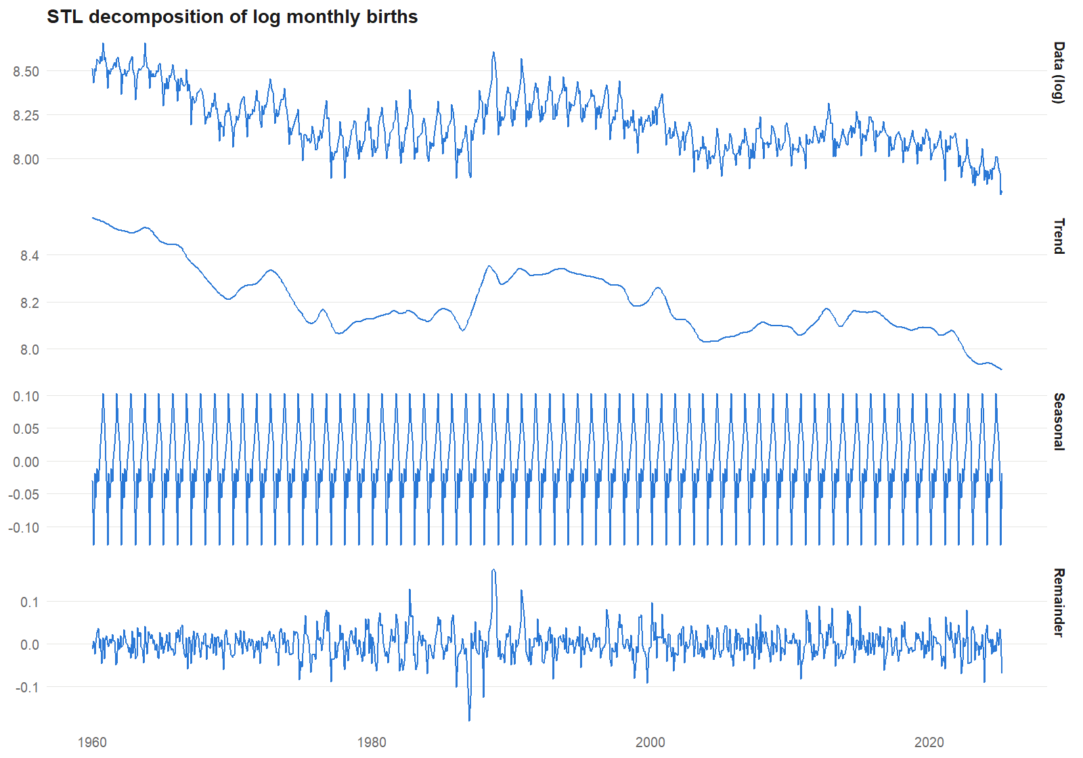
Figure 3. STL decomposition of log births into trend, seasonal and remainder components.
An STL decomposition of the log series gives a seasonal strength of 0.75 and a trend strength of 0.94 (1 means the component explains all variation that remains after the other components are removed). Both are high, so a model must handle a strong trend and a strong seasonal cycle together.

4 Stationarity and Model Identification

4.1 Transformation
A log transformation is the usual choice for count series whose seasonal swing scales with the level: it keeps forecasts positive and turns a change in level into a percentage. Cross-validation shows the transformation makes little difference to accuracy (SARIMA(0,1,1)(0,1,1) on the raw scale: RMSE 139.3; on the log scale: 138.2), so the log scale is used for its interpretability and positive forecasts, not for a large accuracy gain.

4.2 Differencing
Table 5. Unit-root and stationarity tests on log births
Series | KPSS stat. | KPSS p | ADF stat. | ADF p
log births (level) | 5.143 | <0.01 | -2.32 | 0.44
seasonal difference (D=1) | 0.133 | >0.10 | -8.202 | <0.01
first difference (d=1) | 0.015 | >0.10 | -20.001 | <0.01
d=1 and D=1 | 0.009 | >0.10 | -9.364 | <0.01
Notes: KPSS null = level stationarity. ADF (tseries::adf.test) includes a constant and a linear trend and uses 9 lags. Reported p-values are truncated at 0.01 and 0.10.
The level series is non-stationary: KPSS rejects stationarity and ADF cannot reject a unit root. After a seasonal difference (lag 12) both tests point to a stationary series. The evidence on the differencing orders is not perfectly clean, so the choice was tested rather than assumed:
- The seasonal-difference tests disagree: the seasonal-strength test (nsdiffs, test = "seas") recommends D = 1, while the OCSB test recommends D = 0. D = 1 is used because the seasonal pattern is strong and stable, and because the models with D = 1 forecast well.
- After D = 1 the KPSS test does not call for a further difference. A regular difference (d = 1) was still retained because the two d = 0 candidates with drift forecast worse in cross-validation (RMSE 142.5 and 157.1) and on the hold-out (137.8 and 201.7), and they over-forecast by 105 to 176 births per month because they revert to a fixed level while births kept falling.
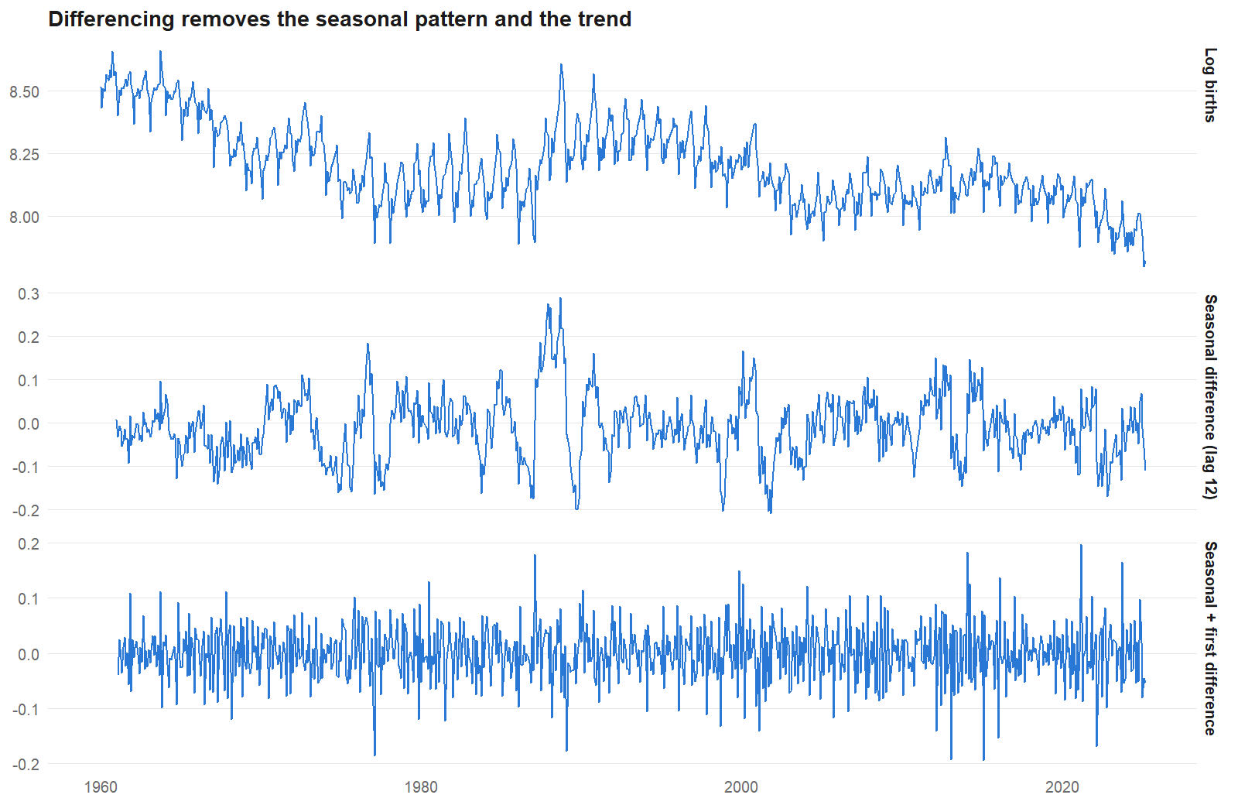
Figure 4. Log births, the seasonally differenced series and the seasonally plus regularly differenced series.

4.3 ACF and PACF
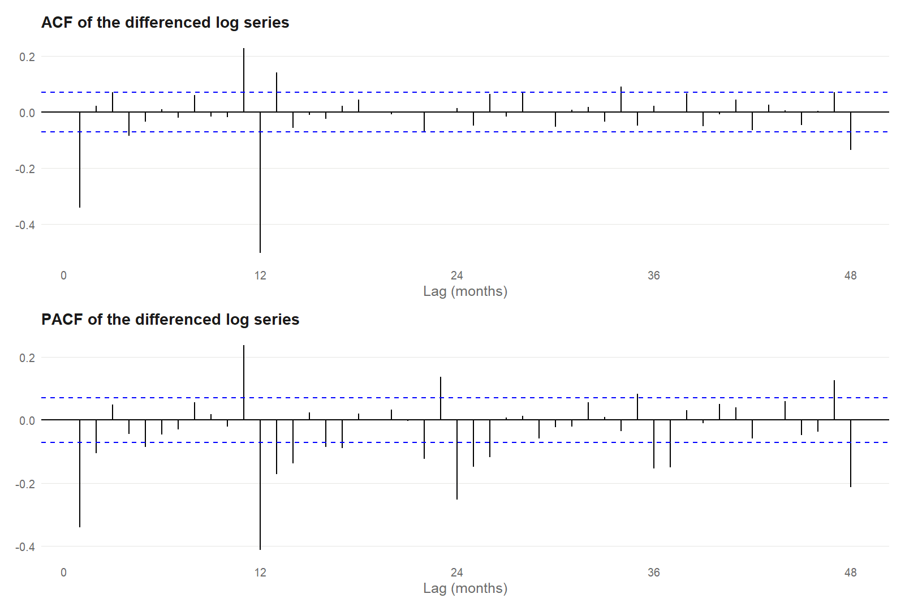
Figure 5. ACF and PACF of the log series after one seasonal and one regular difference.
The ACF has large negative spikes at lag 1 (about -0.34) and lag 12 (about -0.50), with smaller positive spikes at lags 11 and 13, and is close to zero afterwards. The PACF decays with spikes at lags 12, 24, 36 and 48. This is the signature of a multiplicative moving-average structure, MA(1) x seasonal MA(1), which is the well-known "airline" model SARIMA(0,1,1)(0,1,1)12. It is the natural starting point; the candidate search in Section 5 then tests extensions of it.

5 Model Selection

5.1 Candidate models
Sixteen models were compared over the full history (training window from 1960): seven SARIMA structures on the log scale around the airline model, two d = 0 alternatives with drift, the airline model on the raw scale, two regression-with-SARIMA-errors variants (log days in the month, and days plus Dragon-year dummies), auto.arima, and three benchmarks (seasonal naive, ETS and a non-seasonal ARIMA). The most accurate non-benchmark structures, plus the airline model and its calendar-adjusted version, were then re-run with training windows starting in 1980 and 2000, because the early decades (falling births, different policy regime) may not describe the present.

5.2 Cross-validation results
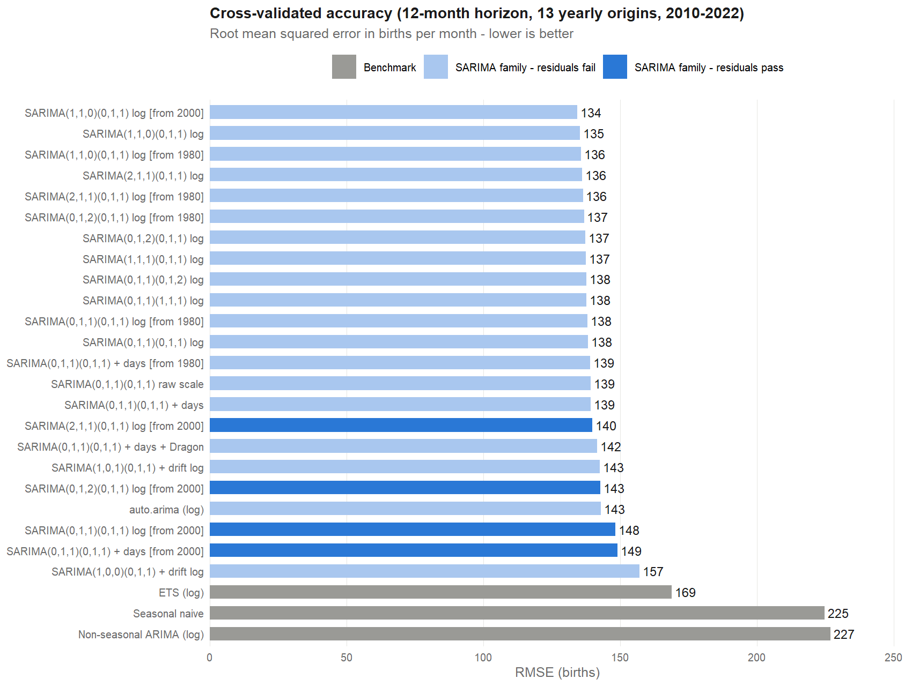
Figure 6. Cross-validated RMSE of all candidates. Light-blue bars fail the residual adequacy screen.
Table 6. Cross-validated accuracy of selected candidates (12-month horizon, 13 origins)
Model | Start | RMSE | MAE | MAPE | LB(24) p | Screen | 95% cov.
SARIMA(1,1,0)(0,1,1) log | 2000 | 134.3 | 107.0 | 3.28% | 0.0010 | fail | 99%
SARIMA(2,1,1)(0,1,1) log | 2000 | 139.8 | 109.2 | 3.36% | 0.1420 | pass | 98%
SARIMA(0,1,2)(0,1,1) log | 2000 | 142.8 | 112.8 | 3.47% | 0.0948 | pass | 98%
SARIMA(0,1,1)(0,1,1) log | 2000 | 148.3 | 117.2 | 3.59% | 0.1270 | pass | 97%
SARIMA(0,1,1)(0,1,1) log | 1960 | 138.2 | 111.5 | 3.42% | 0.0015 | fail | 99%
SARIMA(0,1,1)(0,1,1) + days | 2000 | 149.0 | 117.8 | 3.60% | 0.1170 | pass | 96%
SARIMA(0,1,1)(0,1,1) + days + Dragon | 1960 | 141.6 | 112.1 | 3.43% | 0.0098 | fail | 99%
SARIMA(1,0,1)(0,1,1) + drift log | 1960 | 142.5 | 110.9 | 3.37% | 0.0070 | fail | 99%
auto.arima (log) | 1960 | 143.0 | 113.9 | 3.50% | 0.0018 | fail | 99%
ETS (log) | 1960 | 168.9 | 133.4 | 4.09% | - | - | 98%
Seasonal naive | 1960 | 224.8 | 177.3 | 5.40% | - | - | 100%
Non-seasonal ARIMA (log) | 1960 | 227.0 | 182.9 | 5.66% | - | - | 99%
Selected model in bold. LB(24) p is the Ljung-Box p-value at lag 24 for training residuals; screen = pass if p >= 0.01. Benchmarks have no residual screen. The full table is in Appendix A.
What the results show:
- Seasonal models win clearly. Every SARIMA candidate that keeps d = 1 has a cross-validated RMSE between 134 and 149, against 169 for ETS, 225 for seasonal naive and 227 for a non-seasonal ARIMA. Ignoring seasonality raises the error by about 62%.
- The differences among SARIMA structures are small. The leading candidates lie within about 4% of each other (134 to 140). The ranking among them should not be over-interpreted.
- The accuracy-only winner is not adequate. SARIMA(1,1,0)(0,1,1) from 2000 has the lowest RMSE (134.3), but its residuals are clearly autocorrelated (LB(24) p = 0.0010). Its AR(1) term cannot reproduce the moving-average pattern seen in Figure 5.
- A shorter training window is needed for adequate residuals. All 4 candidates that pass the screen use data from 2000. Models trained on the full 1960-2023 history all show residual autocorrelation, consistent with the structural changes visible in Figure 1.
- Selected: SARIMA(2,1,1)(0,1,1) log from 2000. It has the lowest RMSE (139.8) among the models whose residuals pass the screen.
Note on the selection rule
The residual screen was added after a first run in which the accuracy-only winner failed its residual check. The change was motivated by that residual diagnostic, not by the hold-out result, but the hold-out scores had already been seen by then. The hold-out test in Section 7 should therefore be read as a strong but not perfectly independent check. The unscreened ranking is reported in full so the reader can judge.

5.3 Horizon profile and information criteria
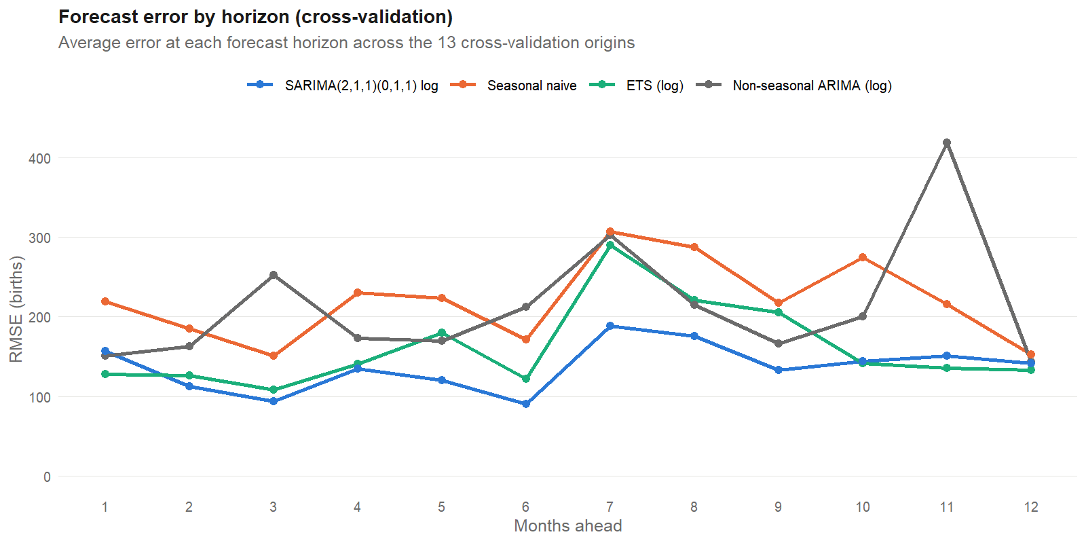
Figure 7. Cross-validated RMSE by forecast horizon for the selected model and the benchmarks.
The selected SARIMA has the lowest error at horizons 2 to 9. ETS is slightly better at horizon 1 and at horizons 10 to 12, and the non-seasonal ARIMA is erratic. Every model's error peaks at horizon 7: because the origins are in March, horizon 7 is October, the highest-volume month. AICc values (Appendix A) are reported only to compare models with the same differencing orders and the same transformation and window: models with different d, D, transformation or training window are fitted to different data, so their AICc values are not comparable.

6 The Selected Model

6.1 Specification and coefficients
The model is SARIMA(2,1,1)(0,1,1)[12] for the natural logarithm of monthly births, fitted to 303 months (January 2000 to March 2025). In backshift notation, with B the lag operator and y the log of births:
(1 - φ1·B - φ2·B²)(1 - B)(1 - B¹²) y(t) = (1 + θ1·B)(1 + Θ1·B¹²) ε(t)
where the autoregressive part has two terms, one regular and one seasonal difference are applied, and the moving-average part has one regular and one seasonal term. The R output labels the terms ar1, ar2, ma1 and sma1. In R's convention the AR terms enter as (1 - φ1B - φ2B²), and the estimates below are φ1 and φ2.
Table 7. Estimated coefficients, SARIMA(2,1,1)(0,1,1)[12]
Term | Estimate | Std. error | z | p-value
ar1 | -0.6510 | 0.2018 | -3.23 | 0.0013
ar2 | -0.3356 | 0.0928 | -3.62 | 0.0003
ma1 | 0.1309 | 0.2136 | 0.61 | 0.5400
sma1 | -0.9059 | 0.0409 | -22.13 | <0.0001

- Seasonal MA (sma1 = -0.906). This is the dominant coefficient. A value near -1 means the seasonal pattern changes very slowly from year to year: most of the seasonal shape is carried forward almost unchanged. It is invertible (|Θ1| < 1) but close to the boundary, which is also a hint that the seasonal pattern may be nearly deterministic (see Section 10).
- AR terms (φ1 = -0.651, φ2 = -0.336). Both are significant. The AR polynomial has complex roots with modulus about 1.7, so the model is stationary in its differenced form, and the negative values produce a damped oscillating adjustment after a shock.
- Regular MA (θ1 = 0.131). Not significant (p = 0.54). The model is slightly over-parameterised; a SARIMA(2,1,0)(0,1,1) was not in the candidate set and is worth testing.
- Innovation standard deviation. 0.0358 on the log scale, so a one-step error is typically about 3.6%.

6.2 Residual diagnostics
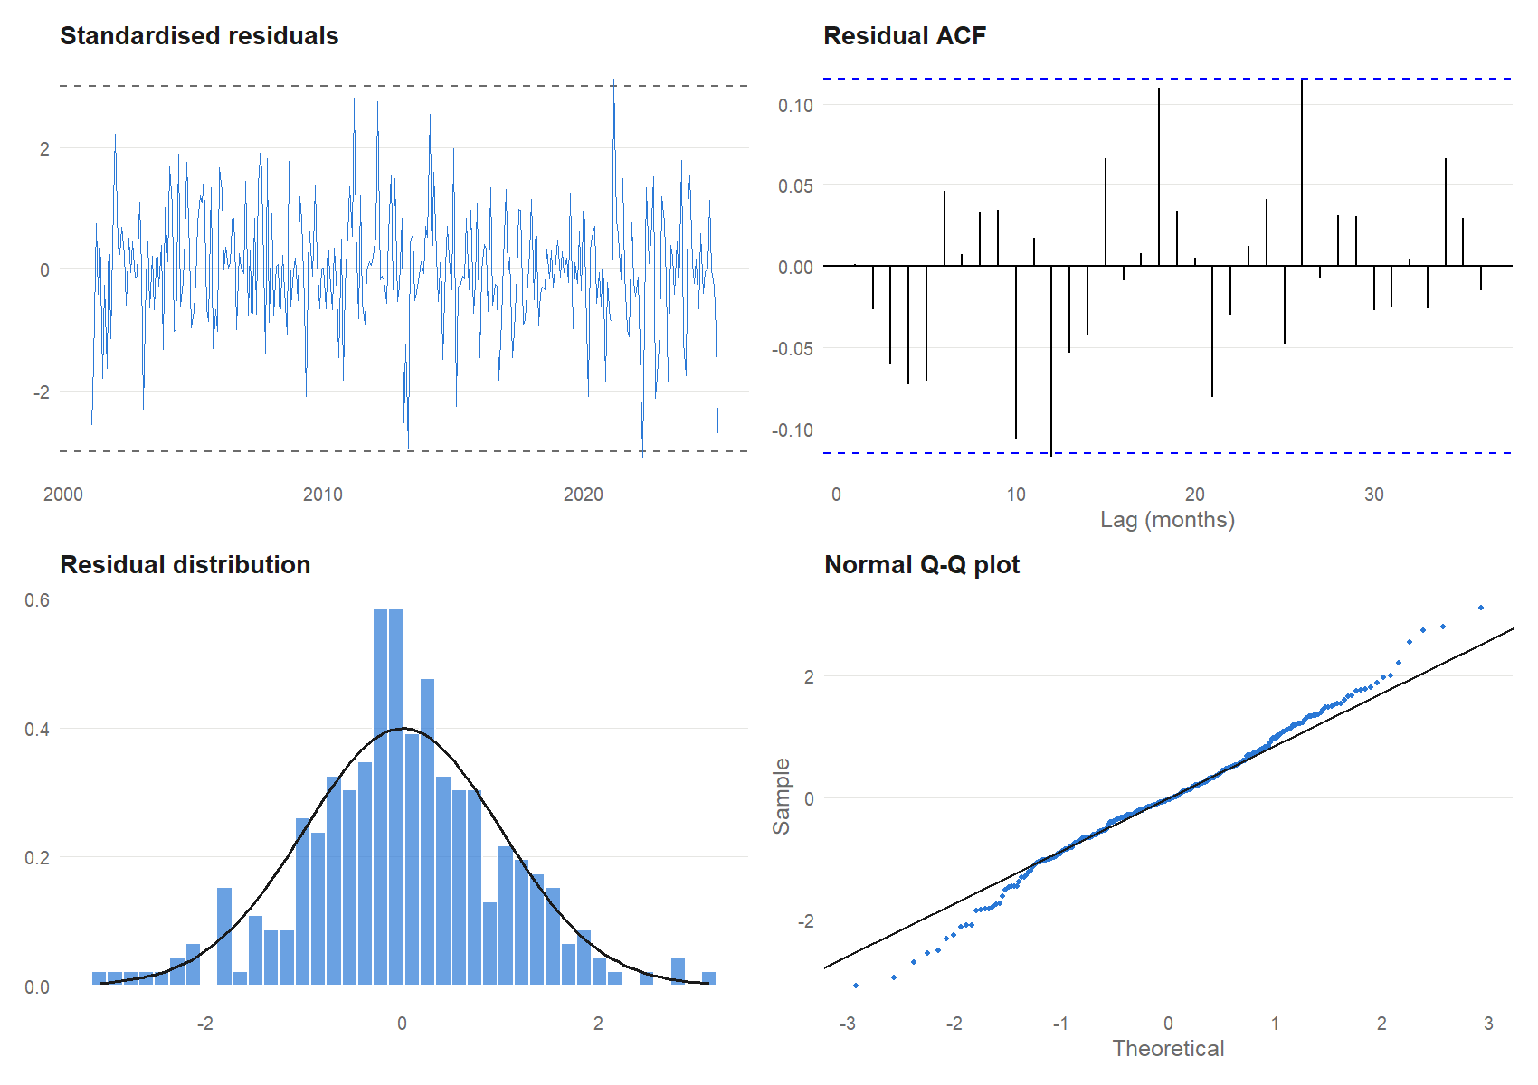
Figure 8. Residual diagnostics for the selected model: standardised residuals, ACF, histogram and normal Q-Q plot.
Table 8. Residual tests (start-up residuals removed)
Test | Statistic | df | p-value
Ljung-Box, lag 12 | 13.39 | 8 | 0.0992
Ljung-Box, lag 24 | 23.27 | 20 | 0.2760
Ljung-Box, lag 36 | 31.34 | 32 | 0.5000
Shapiro-Wilk (normality) | 0.9906 | - | 0.0605
Jarque-Bera (normality) | 5.45 | 2 | 0.0655
Ljung-Box on squared residuals, lag 12 | 19.15 | 12 | 0.0849

The model is adequate. The Ljung-Box test shows no remaining autocorrelation at lags 12, 24 and 36 (p = 0.10, 0.28 and 0.50), and 1 of 36 residual autocorrelations lies just outside the 95% limits, about what chance produces. The squared residuals show no volatility clustering (p = 0.08). Normality is borderline (Shapiro-Wilk p = 0.060, Jarque-Bera p = 0.066): the Q-Q plot shows slightly heavy tails. Two months exceed 3 standard deviations: 2021-03 (3329 births, z = 3.12) and 2022-04 (2683 births, z = -3.08). Neither is extreme, and no outlier correction was applied.

7 Hold-out Test (April 2023 - March 2025)
Each model was fitted to data up to March 2023 and asked to forecast the following 24 months, with no refitting. These months were not used to select the model.
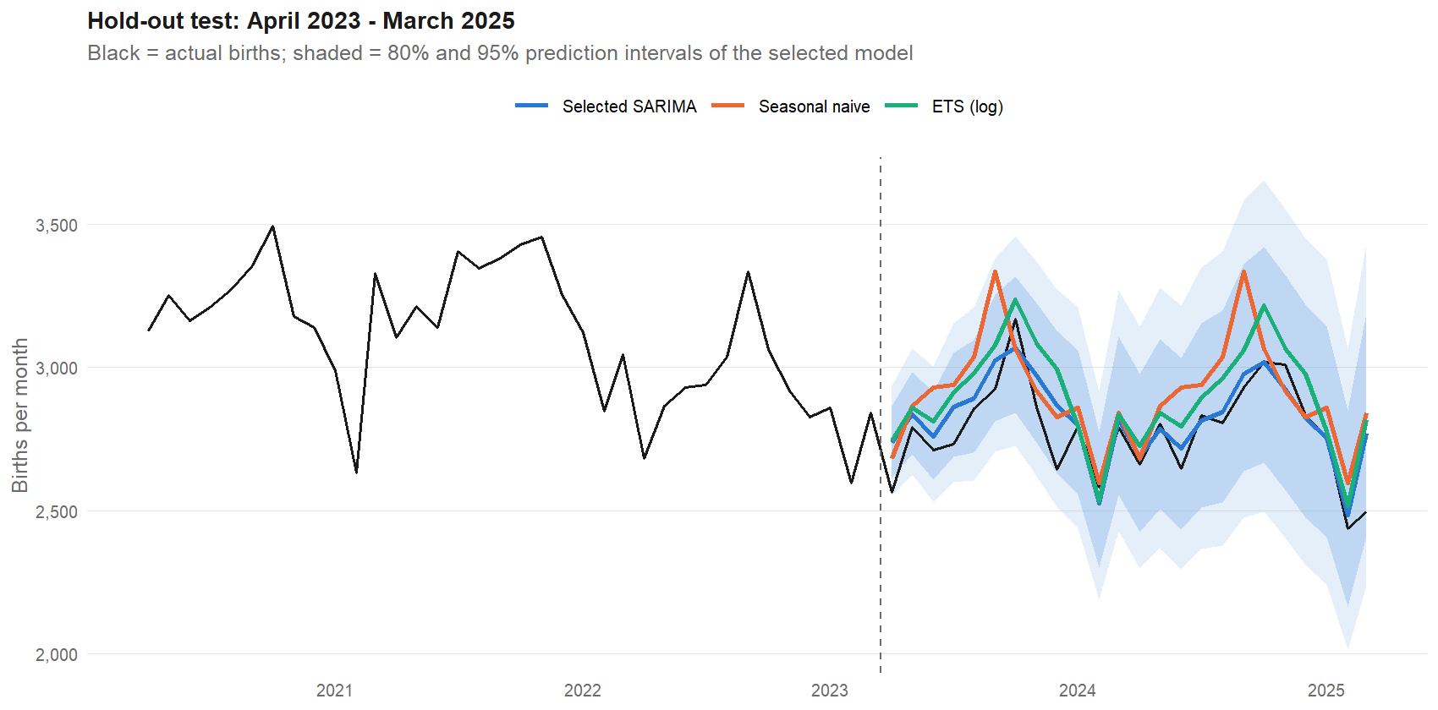
Figure 9. Hold-out forecasts against actual births. The shaded area is the selected model's 80% and 95% prediction interval.
Table 9. Hold-out accuracy (24 months)
Model | Start | RMSE | MAE | MAPE | Mean error | 80% cov. | 95% cov.
SARIMA(2,1,1)(0,1,1) log | 2000 | 98.8 | 70.6 | 2.61% | -46.5 | 96% | 100%
SARIMA(0,1,1)(0,1,1) log | 2000 | 94.3 | 67.5 | 2.49% | -37.5 | 92% | 100%
SARIMA(0,1,1)(0,1,1) log | 1960 | 91.7 | 68.7 | 2.50% | -16.5 | 96% | 100%
SARIMA(1,1,0)(0,1,1) log | 2000 | 95.4 | 68.2 | 2.52% | -38.6 | 96% | 100%
SARIMA(1,0,1)(0,1,1) + drift log | 1960 | 137.8 | 111.7 | 4.11% | -104.9 | 88% | 100%
auto.arima (log) | 1960 | 166.0 | 141.1 | 5.19% | -137.4 | 88% | 100%
ETS (log) | 1960 | 150.8 | 123.3 | 4.50% | -119.3 | 92% | 100%
Seasonal naive | 1960 | 186.9 | 147.2 | 5.34% | -130.2 | 96% | 100%
Non-seasonal ARIMA (log) | 1960 | 218.7 | 183.0 | 6.82% | -146.2 | 83% | 100%
Mean error = actual minus forecast; negative values mean the model forecast too high. Selected model in bold. The full 26-model hold-out table is in the output folder (t08_test_accuracy.csv).
The selected model reaches RMSE 98.8 and MAPE 2.61%. That is 35% lower RMSE than ETS, 47% lower than seasonal naive and 55% lower than a non-seasonal ARIMA. Four points need to be stated plainly.
- Other SARIMA variants scored slightly better. Several structures reached RMSE 91-95 on the hold-out. The selected model is about 8% above the best of them. With only 24 months this gap is within sampling noise, and selection was made on cross-validation, but it shows that among well-specified SARIMA models the exact choice matters little.
- Forecasts are too high on average. The mean error is -46.5 births per month (about 1.7% of a typical month). Errors were larger in the first year (MAPE 3.20%, mean error -62) than in the second (MAPE 2.02%, mean error -31). All benchmark models over-forecast more.
- Prediction intervals are conservative. 96% of months fell inside the 80% interval and 100% inside the 95% interval. In cross-validation the selected model's coverage was 90% and 98%. The intervals are wider than needed, which is safe but less informative.
- Models without a regular difference fail. SARIMA with d = 0 and drift, and auto.arima (which chose d = 0), have RMSE 138-202 and over-forecast by 105-176 births per month.

8 Forecast: April 2025 to March 2027
The selected model was refitted on all data through March 2025 and used to forecast the next 24 months. Figure 10 shows the monthly path.
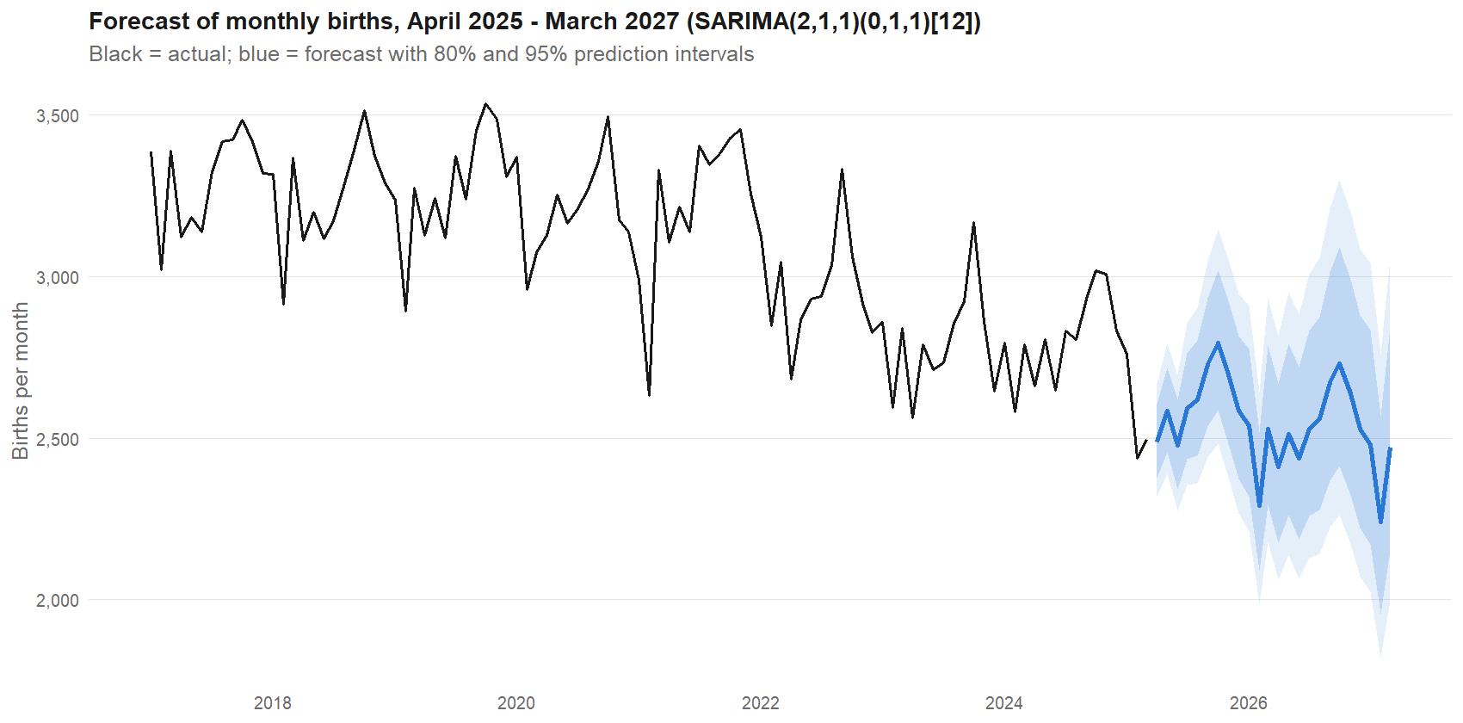
Figure 10. Monthly forecast with 80% and 95% prediction intervals, April 2025 to March 2027.
Table 10. Monthly forecasts of total live births
Month | Forecast | 80% interval | 95% interval | Month | Forecast | 80% interval | 95% interval
2025-04 | 2,488 | 2,377-2,605 | 2,319-2,669 | 2026-04 | 2,410 | 2,178-2,668 | 2,064-2,815
2025-05 | 2,583 | 2,455-2,718 | 2,390-2,792 | 2026-05 | 2,513 | 2,261-2,792 | 2,139-2,952
2025-06 | 2,477 | 2,343-2,618 | 2,275-2,696 | 2026-06 | 2,439 | 2,187-2,720 | 2,064-2,882
2025-07 | 2,593 | 2,434-2,762 | 2,354-2,856 | 2026-07 | 2,529 | 2,259-2,832 | 2,128-3,006
2025-08 | 2,618 | 2,446-2,802 | 2,360-2,904 | 2026-08 | 2,559 | 2,278-2,875 | 2,142-3,058
2025-09 | 2,728 | 2,537-2,933 | 2,442-3,048 | 2026-09 | 2,671 | 2,370-3,012 | 2,224-3,209
2025-10 | 2,794 | 2,586-3,019 | 2,482-3,145 | 2026-10 | 2,731 | 2,414-3,089 | 2,262-3,297
2025-11 | 2,695 | 2,484-2,924 | 2,379-3,053 | 2026-11 | 2,636 | 2,323-2,992 | 2,172-3,199
2025-12 | 2,585 | 2,373-2,816 | 2,268-2,947 | 2026-12 | 2,529 | 2,221-2,879 | 2,074-3,084
2026-01 | 2,538 | 2,320-2,775 | 2,213-2,910 | 2027-01 | 2,481 | 2,173-2,834 | 2,025-3,041
2026-02 | 2,292 | 2,088-2,516 | 1,988-2,644 | 2027-02 | 2,242 | 1,957-2,568 | 1,821-2,760
2026-03 | 2,528 | 2,295-2,785 | 2,180-2,932 | 2027-03 | 2,473 | 2,152-2,841 | 2,000-3,058

Annual totals come from 3,000 simulated future paths, so the intervals account for the correlation between months.
Table 11. Annual births implied by the model
Year | Basis | Mean | 80% interval | 95% interval
2025 | Jan-Mar actual + Apr-Dec forecast | 31,304 | 30,070 - 32,570 | 29,450 - 33,168
2026 | 12 forecast months | 30,525 | 27,534 - 33,607 | 26,044 - 35,507

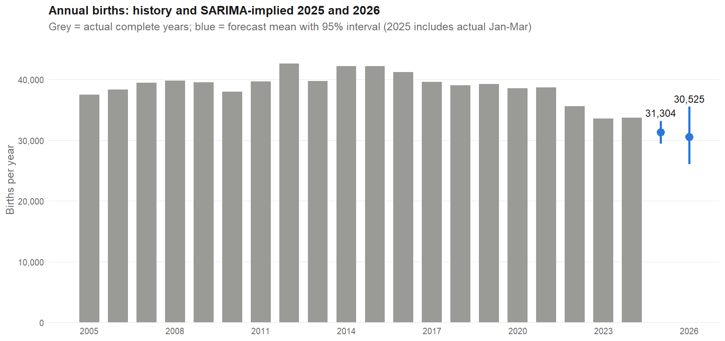
Figure 11. Annual births: complete years 2005-2024 and the SARIMA-implied totals for 2025 and 2026.
Reading the forecast. January-March 2025 was 7,693 births, 5.8% below the same quarter of 2024 (8,164). The model expects the remaining nine months to bring 2025 to 31,304. The annual file in the same folder records 29,864 for 2025, which would need April-December to fall 13.2% year on year. That figure lies inside the 95% interval (29,450-33,168) but below the 80% interval (30,070-32,570), and it is consistent with the model's tendency to over-forecast. Users who need a single number should treat the model's mean as an upper-side estimate and consider the lower half of the interval.
Cross-check with the annual data. The monthly file adds up to the annual file exactly for every complete year:
Table 12. Monthly sums against the annual file
Year | Sum of monthly | Months | Annual file | Difference
2019 | 39,279 | 12 | 39,279 | 0
2020 | 38,590 | 12 | 38,590 | 0
2021 | 38,672 | 12 | 38,672 | 0
2022 | 35,605 | 12 | 35,605 | 0
2023 | 33,541 | 12 | 33,541 | 0
2024 | 33,703 | 12 | 33,703 | 0
2025 | 7,693 | 3 | 29,864 | -22,171
The 2025 row is incomplete in the monthly file (three months), so the annual figure for 2025 comes from another source and cannot be verified within the SARIMA dataset.

9 SARIMA-based Analysis by Segment
The same workflow was applied to the four ethnic groups and to male and female births. Each series is modelled with the same structure and training window as the total (SARIMA(2,1,1)(0,1,1)[12], from 2000), so that segments are comparable and can be added up. auto.arima, ETS and seasonal naive are shown as comparisons. Accuracy is measured on the same 24-month hold-out.

9.1 Seasonal features
Table 13. Seasonal features by segment (2000-2024, calendar-adjusted)
Segment | Seasonal strength | Trend strength | Peak month | Trough month | Peak-to-trough | Mean/month, 2024
Total | 0.665 | 0.861 | Sep | Feb | 11.1% | 2,809
Malays | 0.345 | 0.835 | Sep | Feb | 12.1% | 575
Chinese | 0.606 | 0.892 | Sep | Jun | 12.5% | 1,660
Indians | 0.332 | 0.756 | Nov | Feb | 12.3% | 311
Others | 0.255 | 0.937 | Sep | Jan | 12.0% | 263
Male | 0.616 | 0.834 | Sep | Feb | 11.4% | 1,455
Female | 0.589 | 0.82 | Sep | Jan | 10.7% | 1,354

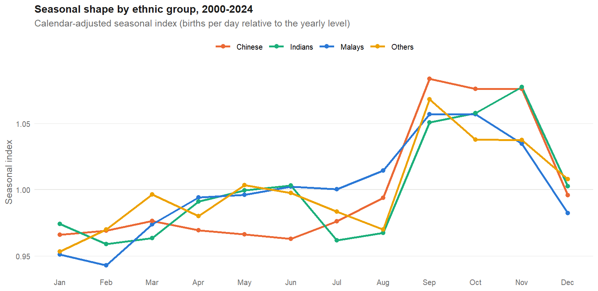
Figure 12. Calendar-adjusted seasonal index of the four ethnic groups, 2000-2024.
All groups peak in September-November and share a similar peak-to-trough range of about 11-12.5%. The strength of the seasonal signal differs sharply: it is 0.606 for the Chinese group and 0.616 and 0.589 for male and female births, but only 0.345, 0.332 and 0.255 for Malays, Indians and Others. In the smaller series the same seasonal swing is hidden by random month-to-month variation, so the seasonal pattern is harder to estimate. Indians peak later (November) than the other groups.

9.2 Hold-out accuracy by segment
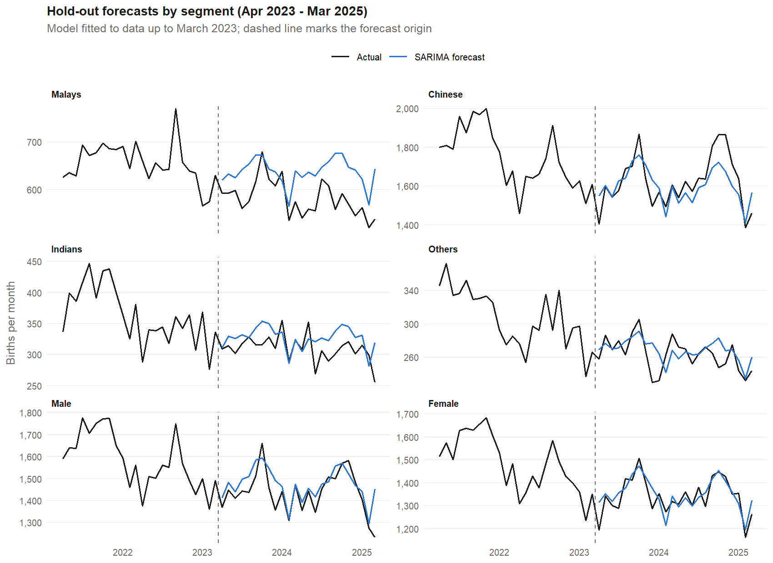
Figure 13. Hold-out forecasts by segment using the same SARIMA structure as the total.
Table 14. Hold-out accuracy by segment and method (24 months)
Segment | Method | RMSE | MAPE | Mean error | 95% cov.
Malays | Auto SARIMA (log) | 53.4 | 8.35% | -40.4 | 100%
Malays | ETS (log) | 63.3 | 9.84% | -54.2 | 92%
Malays | Same SARIMA as total (log) | 65.0 | 10.16% | -55.5 | 83%
Malays | Seasonal naive | 81.3 | 11.76% | -59.4 | 92%
Chinese | ETS (log) | 74.7 | 3.60% | -14.9 | 96%
Chinese | Auto SARIMA (log) | 84.2 | 4.11% | -34.4 | 96%
Chinese | Same SARIMA as total (log) | 85.3 | 4.21% | 20.4 | 96%
Chinese | Seasonal naive | 103.6 | 5.18% | -24.8 | 100%
Indians | Auto SARIMA (log) | 23.7 | 6.46% | -12.9 | 96%
Indians | Same SARIMA as total (log) | 27.4 | 7.53% | -16.7 | 92%
Indians | ETS (log) | 34.3 | 9.54% | -25.8 | 92%
Indians | Seasonal naive | 36.2 | 10.14% | -21.9 | 100%
Others | Same SARIMA as total (log) | 17.4 | 5.27% | -4.8 | 96%
Others | ETS (log) | 18.3 | 5.57% | 7.7 | 100%
Others | Auto SARIMA (log) | 18.5 | 5.96% | 1.0 | 100%
Others | Seasonal naive | 40.1 | 12.51% | -24.1 | 100%
Male | Same SARIMA as total (log) | 68.2 | 3.56% | -36.0 | 100%
Male | ETS (log) | 86.5 | 4.93% | -65.6 | 96%
Male | Seasonal naive | 114.5 | 6.40% | -70.6 | 100%
Male | Auto SARIMA (log) | 124.9 | 7.72% | -107.5 | 92%
Female | Same SARIMA as total (log) | 45.4 | 2.75% | -9.5 | 96%
Female | ETS (log) | 52.9 | 3.16% | -31.2 | 96%
Female | Auto SARIMA (log) | 65.1 | 4.06% | -34.3 | 100%
Female | Seasonal naive | 86.4 | 4.88% | -59.7 | 100%
Best method by MAPE in bold. Mean error = actual minus forecast.
No single method wins everywhere: Malays: Auto SARIMA (log); Chinese: ETS (log); Indians: Auto SARIMA (log); Others: Same SARIMA as total (log); Male: Same SARIMA as total (log); Female: Same SARIMA as total (log). The same-structure SARIMA is best for the Others, Male and Female series, ETS is best for the Chinese group, and auto.arima is best for Malays and Indians. In the three smallest and least seasonal series (Malays, Indians, Others) auto.arima chose models without seasonal differencing (D = 0) and with seasonal MA terms; for Malays and Indians these did better than seasonal differencing, consistent with a seasonal pattern that is small and stable rather than evolving. The same-structure model is over-parameterised for some segments (for example, both AR terms are close to zero for Indians and the first is close to zero for Malays; see Appendix B), which costs a little accuracy.

9.3 Bottom-up versus direct forecasting
Table 15. Forecasting the total: direct versus summing the segment forecasts (hold-out)
Approach | RMSE | MAPE | Mean error
Direct: selected SARIMA on the total | 98.8 | 2.61% | -46.5
Bottom-up: sum of 4 ethnic-group SARIMAs (same structure) | 104.1 | 2.79% | -56.7
Bottom-up: Male + Female SARIMAs (same structure) | 97.2 | 2.55% | -45.4
Bottom-up: sum of 4 ethnic-group auto.arima models | 130.4 | 3.88% | -86.7
Average of direct and ethnic bottom-up (same structure) | 101.3 | 2.68% | -51.6

Summing the ethnic-group models gives RMSE 104.1 and summing male and female gives 97.2, against 98.8 for the direct model. All three are within about 5% of each other, so bottom-up forecasting does not improve the total, although it provides the breakdown. Summing four auto.arima models is clearly worse (130.4), because the individually selected models have different orders and different biases that add up.

9.4 Segment forecasts and composition
Table 16. Forecast births by segment for 2026 compared with 2024
Segment | Apr-Dec 2025 | 2026 | Actual 2024 | 2026 vs 2024
Malays | 5,063 | 6,601 | 6,896 | -4.3%
Chinese | 13,652 | 17,583 | 19,926 | -11.8%
Indians | 2,637 | 3,402 | 3,728 | -8.7%
Others | 2,252 | 2,886 | 3,153 | -8.5%
Male | 12,122 | 15,635 | 17,458 | -10.4%
Female | 11,809 | 15,322 | 16,243 | -5.7%

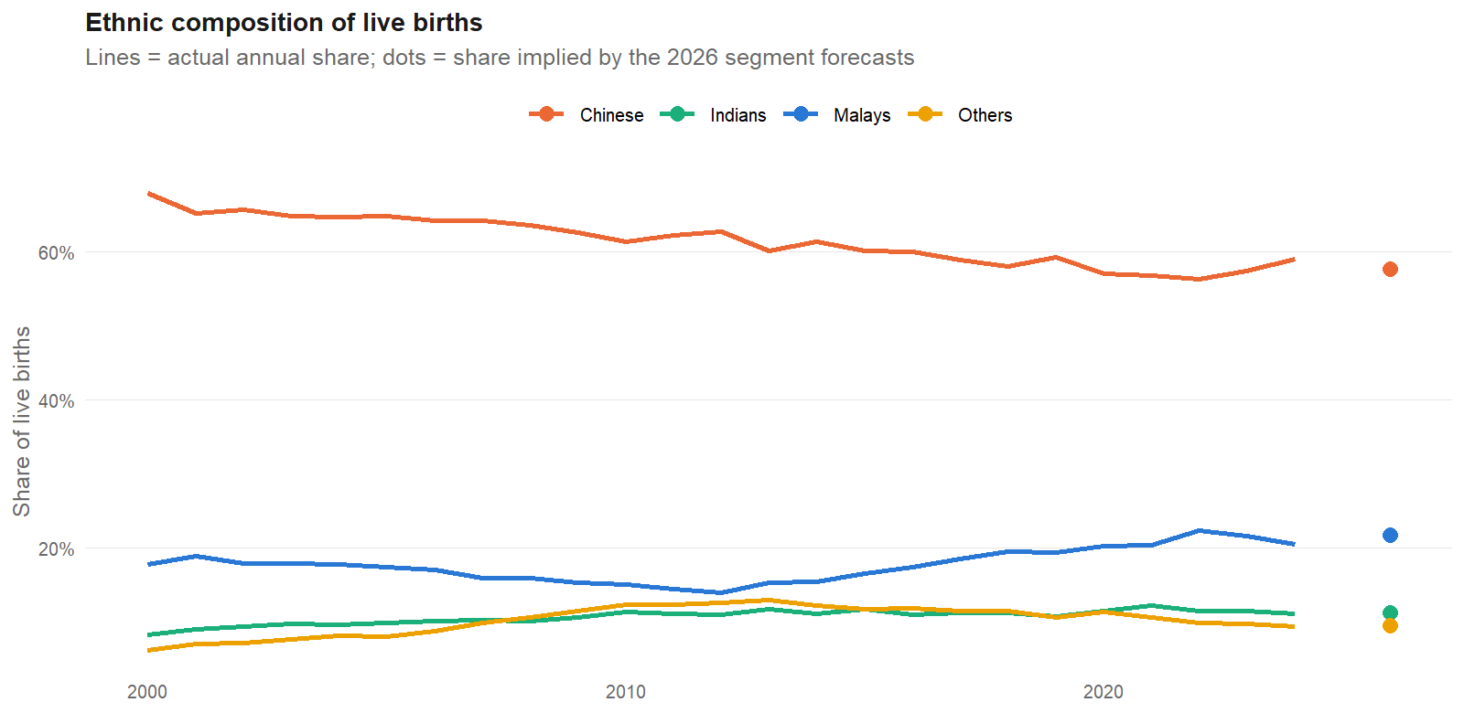
Figure 14. Ethnic composition of live births: actual annual shares and the shares implied by the 2026 forecasts.
The four ethnic-group forecasts add up to 30,472 births for 2026, within 0.2% of the direct forecast of 30,525, so the two views are coherent. The Chinese share is projected to be about 57.7% (59.1% in 2024) and the Malay share about 21.7% (20.5% in 2024); the Indian and Other shares change little.
Sex ratio: a warning about forecast noise. Historically the ratio of male to female births is stable at 1.06-1.08 (1.072 in the 2020s). The male and female models forecast 1.0204 for 2026 (male -10.4% and female -5.7% against 2024). A ratio that far from the historical range is not a demographic signal; it reflects the separate estimation noise of two models. Sex-specific forecasts should therefore not be interpreted individually; the total is more reliable.

9.5 Dragon-year effects
Births in Chinese-zodiac Dragon years (1964, 1976, 1988, 2000, 2012, 2024) are widely believed to rise. This was tested with a regression with SARIMA errors: SARIMA(0,1,1)(0,1,1)12 on log births, plus log days in the month and one dummy for each Dragon calendar year. Each dummy estimates that year's difference from the level the stochastic trend would give.
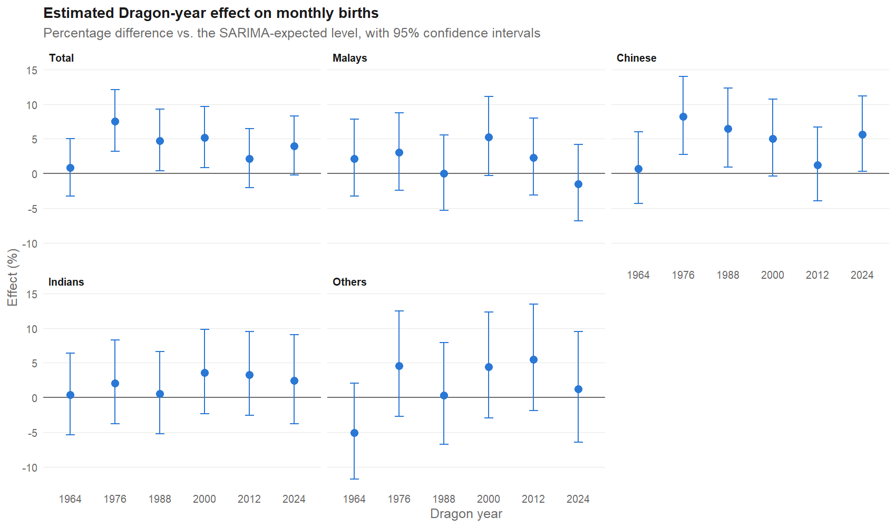
Figure 15. Estimated Dragon-year effect on monthly births, with 95% confidence intervals.
Table 17. Dragon-year effect (% difference; * = p < 0.05)
Group | 1964 | 1976 | 1988 | 2000 | 2012 | 2024
Total | +0.8 | +7.5* | +4.7* | +5.2* | +2.1 | +3.9
Malays | +2.2 | +3.0 | 0.0 | +5.3 | +2.3 | -1.5
Chinese | +0.7 | +8.2* | +6.5* | +5.0 | +1.2 | +5.6*
Indians | +0.4 | +2.1 | +0.6 | +3.6 | +3.3 | +2.5
Others | -5.1 | +4.6 | +0.3 | +4.4 | +5.5 | +1.2

For total births the estimated uplift is between 0.8% and 7.5%, significant in 1976 (+7.5%), 1988 (+4.7%) and 2000 (+5.1%). The effect is concentrated in the Chinese group (1976 +8.2%, 1988 +6.5%, 2024 +5.6%, all significant); no other group has a significant year. There is no clear decline over time: the 2024 estimate for total births (+3.9%, 95% interval -0.3% to +8.3%) is in line with 1988 and 2000, while 1964 and 2012 are close to zero.
These estimates need careful reading. There are only six events, and 6 of 30 individual tests are significant at 5%, so a single group-year estimate is unreliable. The effect is measured relative to a stochastic trend that partly absorbs a rise in births (for example, the surge into 1988), so the estimates are conservative. The Dragon lunar year runs from late January or February to the next January, not January to December, so a calendar-year dummy is an approximation. In forecasting, adding Dragon dummies lowered the AICc but did not improve out-of-sample accuracy (cross-validated RMSE 141.6 against 138.2 for the airline model), and none of the forecast period falls in a Dragon year (the next is 2036), so the dummies are not needed for the forecasts in Section 8.

10 Discussion

10.1 What the analysis shows
- Monthly data reveal a strong, regular seasonal cycle that annual models cannot see. Capturing it reduces forecast error by roughly 35-55% relative to ETS, seasonal naive and non-seasonal ARIMA benchmarks.
- The log transformation and both differences are needed. Models that omit the regular difference forecast poorly and are biased upward.
- Residual checks matter as much as accuracy. The model with the lowest cross-validated error failed the Ljung-Box test; the selected model is slightly less accurate in cross-validation but passes it.
- Half of the apparent February dip is calendar arithmetic, and the regression elasticity for days in the month is about 1.03.

10.2 Strengths
- Selection uses out-of-sample cross-validation with 156 forecasts per model, and a separate hold-out that was not used for selection.
- The residual adequacy screen prevents choosing a model that fits well on average but leaves structure in the errors.
- Every model is compared with sensible benchmarks, and the reproducible R script writes every figure and table in this report.

10.3 Limitations
- Small accuracy differences. Among the SARIMA variants, differences of a few percent are within noise; the specific structure chosen is not uniquely best.
- Upward bias. The hold-out mean error and the 2025 comparison both indicate that births have been falling faster than the model expects. Forecasts should be read as upper-side.
- Over-parameterisation. The regular MA term is not significant, and the seasonal MA coefficient near -1 hints at over-differencing of the seasonal component (the OCSB test recommended D = 0).
- Training-window choice. Only models trained from 2000 passed the residual screen. This reflects genuine structural change but also means the model uses about 25 years, not the full 65.
- Conservative intervals. Empirical coverage of the 80% and 95% intervals is 90-96% and 98-100%; intervals are safe but wider than necessary.
- No explanatory variables. The model uses births history, the days in the month and Dragon years only. It does not include marriages, migration, women of childbearing age, policy or the economy, so it describes patterns rather than causes.
- Segment models. A common structure across segments is convenient but not optimal; small series are noisy and their sex- and group-specific forecasts should not be over-interpreted.
- Selection-rule timing. The residual screen was added after a first run (see Section 5).

10.4 Recommendations
- Refit each month or quarter as new data arrive, and re-check the Ljung-Box test at lags 12, 24 and 36.
- Test SARIMA(2,1,0)(0,1,1), a seasonal-dummy or Fourier-term model with D = 0, and a level shift or intervention term for 2022 onward.
- Consider a bias adjustment or a shorter window (for example from 2010) if births continue to fall faster than the model expects.
- Add explanatory variables (SARIMAX) such as the number of women aged 20-39, marriages and policy indicators, and test whether they lower error.
- For sex and ethnic-group series, prefer the direct total forecast for planning and use segment forecasts only for approximate composition.
- Compare with a state-space (structural) model or TBATS, which handle changing seasonality naturally.

11 Conclusion
Monthly Singapore births follow a strong, stable seasonal cycle with a September-November peak, around a trend that has fallen sharply since 2022. A seasonal ARIMA model, SARIMA(2,1,1)(0,1,1)[12] on the log scale and fitted to data from 2000, captured both. It passed residual checks, reduced hold-out RMSE by 35-55% relative to standard benchmarks (RMSE 98.8, MAPE 2.61%), and gives total births of about 31,304 for 2025 and 30,525 for 2026. The model tends to forecast too high, so these numbers are best treated as upper-side estimates.
The segment analysis shows that ethnic-group and sex series share the same seasonal timing but differ in signal strength; that no single model is best for every segment; and that summing segment forecasts does not beat forecasting the total directly. Dragon years raise births by up to about 8%, mainly in the Chinese group, but the effect is estimated with wide uncertainty. Future work should update the model as data arrive, test intervention and explanatory-variable models, and compare with structural time-series methods.

References
Box, G. E. P., Jenkins, G. M., Reinsel, G. C., and Ljung, G. M. (2015). Time Series Analysis: Forecasting and Control (5th ed.). Wiley.
Cleveland, R. B., Cleveland, W. S., McRae, J. E., and Terpenning, I. (1990). STL: A seasonal-trend decomposition procedure based on loess. Journal of Official Statistics, 6(1), 3-73.
Hyndman, R. J., and Athanasopoulos, G. (2021). Forecasting: Principles and Practice (3rd ed.). OTexts.
Hyndman, R. J., and Khandakar, Y. (2008). Automatic time series forecasting: the forecast package for R. Journal of Statistical Software, 27(3), 1-22.
Kwiatkowski, D., Phillips, P. C. B., Schmidt, P., and Shin, Y. (1992). Testing the null hypothesis of stationarity against the alternative of a unit root. Journal of Econometrics, 54, 159-178.
Ljung, G. M., and Box, G. E. P. (1978). On a measure of lack of fit in time series models. Biometrika, 65(2), 297-303.
Osborn, D. R., Chui, A. P. L., Smith, J. P., and Birchenhall, C. R. (1988). Seasonality and the order of integration for consumption. Oxford Bulletin of Economics and Statistics, 50(4), 361-377.
Project dataset. SARIMA_dataset.csv: Singapore monthly live births by ethnic group and sex, January 1960 to March 2025.

Appendix A. Complete Cross-validation Results
All candidates, sorted by cross-validated RMSE. MASE is scaled by each model's own training window and is therefore not comparable across different start years, so it is omitted here.
Table 18. Cross-validation results for all candidates
Model | Start | RMSE | MAE | MAPE | 80% cov. | 95% cov. | LB(24) p | Screen
SARIMA(1,1,0)(0,1,1) log | 2000 | 134.3 | 107.0 | 3.28% | 96% | 99% | 0.0010 | fail
SARIMA(1,1,0)(0,1,1) log | 1960 | 135.3 | 109.9 | 3.36% | 96% | 99% | 0.0001 | fail
SARIMA(1,1,0)(0,1,1) log | 1980 | 135.7 | 110.2 | 3.37% | 97% | 99% | 0.0002 | fail
SARIMA(2,1,1)(0,1,1) log | 1960 | 136.1 | 109.7 | 3.37% | 95% | 99% | 0.0032 | fail
SARIMA(2,1,1)(0,1,1) log | 1980 | 136.4 | 110.1 | 3.38% | 97% | 99% | 0.0039 | fail
SARIMA(0,1,2)(0,1,1) log | 1980 | 136.8 | 110.8 | 3.39% | 97% | 99% | 0.0008 | fail
SARIMA(0,1,2)(0,1,1) log | 1960 | 137.3 | 110.9 | 3.40% | 96% | 99% | 0.0010 | fail
SARIMA(1,1,1)(0,1,1) log | 1960 | 137.4 | 111.0 | 3.40% | 95% | 99% | 0.0010 | fail
SARIMA(0,1,1)(0,1,2) log | 1960 | 137.7 | 111.5 | 3.42% | 95% | 99% | 0.0006 | fail
SARIMA(0,1,1)(1,1,1) log | 1960 | 137.8 | 111.5 | 3.42% | 95% | 99% | 0.0006 | fail
SARIMA(0,1,1)(0,1,1) log | 1980 | 138.1 | 111.5 | 3.42% | 96% | 99% | 0.0013 | fail
SARIMA(0,1,1)(0,1,1) log | 1960 | 138.2 | 111.5 | 3.42% | 95% | 99% | 0.0015 | fail
SARIMA(0,1,1)(0,1,1) + days | 1980 | 139.1 | 112.0 | 3.43% | 94% | 99% | 0.0012 | fail
SARIMA(0,1,1)(0,1,1) raw scale | 1960 | 139.3 | 112.3 | 3.44% | 97% | 99% | 0.0092 | fail
SARIMA(0,1,1)(0,1,1) + days | 1960 | 139.3 | 112.1 | 3.43% | 94% | 99% | 0.0031 | fail
SARIMA(2,1,1)(0,1,1) log | 2000 | 139.8 | 109.2 | 3.36% | 90% | 98% | 0.1420 | pass
SARIMA(0,1,1)(0,1,1) + days + Dragon | 1960 | 141.6 | 112.1 | 3.43% | 90% | 99% | 0.0098 | fail
SARIMA(1,0,1)(0,1,1) + drift log | 1960 | 142.5 | 110.9 | 3.37% | 91% | 99% | 0.0070 | fail
SARIMA(0,1,2)(0,1,1) log | 2000 | 142.8 | 112.8 | 3.47% | 89% | 98% | 0.0948 | pass
auto.arima (log) | 1960 | 143.0 | 113.9 | 3.50% | 91% | 99% | 0.0018 | fail
SARIMA(0,1,1)(0,1,1) log | 2000 | 148.3 | 117.2 | 3.59% | 86% | 97% | 0.1270 | pass
SARIMA(0,1,1)(0,1,1) + days | 2000 | 149.0 | 117.8 | 3.60% | 85% | 96% | 0.1170 | pass
SARIMA(1,0,0)(0,1,1) + drift log | 1960 | 157.1 | 121.4 | 3.66% | 92% | 99% | 0.0000 | fail
ETS (log) | 1960 | 168.9 | 133.4 | 4.09% | 91% | 98% | - | -
Seasonal naive | 1960 | 224.8 | 177.3 | 5.40% | 88% | 100% | - | -
Non-seasonal ARIMA (log) | 1960 | 227.0 | 182.9 | 5.66% | 94% | 99% | - | -

Table 19. Training-period fit statistics (fitted through March 2023)
Model | Start | Fitted order | AICc | Log-lik. | LB(12) p | LB(24) p
SARIMA(0,1,1)(0,1,1) log | 1960 | SARIMA(0,1,1)(0,1,1)[12] | -2,806.3 | 1,406.2 | 0.0004 | 0.0015
SARIMA(1,1,1)(0,1,1) log | 1960 | SARIMA(1,1,1)(0,1,1)[12] | -2,804.4 | 1,406.2 | 0.0002 | 0.0010
SARIMA(0,1,2)(0,1,1) log | 1960 | SARIMA(0,1,2)(0,1,1)[12] | -2,804.4 | 1,406.2 | 0.0002 | 0.0010
SARIMA(1,1,0)(0,1,1) log | 1960 | SARIMA(1,1,0)(0,1,1)[12] | -2,797.0 | 1,401.5 | 0.0000 | 0.0001
SARIMA(2,1,1)(0,1,1) log | 1960 | SARIMA(2,1,1)(0,1,1)[12] | -2,807.1 | 1,408.6 | 0.0007 | 0.0032
SARIMA(0,1,1)(1,1,1) log | 1960 | SARIMA(0,1,1)(1,1,1)[12] | -2,807.5 | 1,407.8 | 0.0002 | 0.0006
SARIMA(0,1,1)(0,1,2) log | 1960 | SARIMA(0,1,1)(0,1,2)[12] | -2,808.1 | 1,408.1 | 0.0002 | 0.0006
SARIMA(1,0,0)(0,1,1) + drift log | 1960 | SARIMA(1,0,0)(0,1,1)[12] | -2,750.5 | 1,379.3 | 0.0000 | 0.0000
SARIMA(1,0,1)(0,1,1) + drift log | 1960 | SARIMA(1,0,1)(0,1,1)[12] | -2,818.9 | 1,414.5 | 0.0006 | 0.0070
SARIMA(0,1,1)(0,1,1) raw scale | 1960 | SARIMA(0,1,1)(0,1,1)[12] | 9,469.7 | -4,731.8 | 0.0049 | 0.0092
SARIMA(0,1,1)(0,1,1) + days | 1960 | SARIMA(0,1,1)(0,1,1)[12] | -2,830.4 | 1,419.2 | 0.0019 | 0.0031
SARIMA(0,1,1)(0,1,1) + days + Dragon | 1960 | SARIMA(0,1,1)(0,1,1)[12] | -2,843.3 | 1,427.7 | 0.0007 | 0.0098
auto.arima (log) | 1960 | SARIMA(1,0,1)(1,1,1)[12] | -2,819.1 | 1,414.6 | 0.0003 | 0.0018
SARIMA(0,1,1)(0,1,1) log | 1980 | SARIMA(0,1,1)(0,1,1)[12] | -1,853.4 | 929.7 | 0.0012 | 0.0013
SARIMA(0,1,1)(0,1,1) log | 2000 | SARIMA(0,1,1)(0,1,1)[12] | -991.1 | 498.6 | 0.0534 | 0.1270
SARIMA(0,1,2)(0,1,1) log | 1980 | SARIMA(0,1,2)(0,1,1)[12] | -1,851.5 | 929.8 | 0.0007 | 0.0008
SARIMA(0,1,2)(0,1,1) log | 2000 | SARIMA(0,1,2)(0,1,1)[12] | -989.4 | 498.8 | 0.0382 | 0.0948
SARIMA(1,1,0)(0,1,1) log | 1980 | SARIMA(1,1,0)(0,1,1)[12] | -1,847.7 | 926.9 | 0.0001 | 0.0002
SARIMA(1,1,0)(0,1,1) log | 2000 | SARIMA(1,1,0)(0,1,1)[12] | -975.0 | 490.6 | 0.0001 | 0.0010
SARIMA(2,1,1)(0,1,1) log | 1980 | SARIMA(2,1,1)(0,1,1)[12] | -1,854.2 | 932.2 | 0.0039 | 0.0039
SARIMA(2,1,1)(0,1,1) log | 2000 | SARIMA(2,1,1)(0,1,1)[12] | -992.2 | 501.2 | 0.0849 | 0.1420
SARIMA(0,1,1)(0,1,1) + days | 1980 | SARIMA(0,1,1)(0,1,1)[12] | -1,864.7 | 936.4 | 0.0025 | 0.0012
SARIMA(0,1,1)(0,1,1) + days | 2000 | SARIMA(0,1,1)(0,1,1)[12] | -995.9 | 502.0 | 0.0798 | 0.1170
AICc is comparable only among models with the same differencing, transformation and training window. The raw-scale model's AICc is on a different scale and is not comparable with log-scale models.

Appendix B. Segment Models
Table 20. Same-structure SARIMA coefficients (standard errors in brackets) and auto.arima choices
Segment | Coefficients | auto.arima choice
Malays | ar1 = -0.008 (0.079); ar2 = -0.131 (0.070); ma1 = -0.729 (0.059); sma1 = -0.861 (0.053) | SARIMA(0,1,2)(0,0,2)[12]
Chinese | ar1 = -0.578 (0.276); ar2 = -0.248 (0.122); ma1 = 0.078 (0.285); sma1 = -0.936 (0.050) | SARIMA(1,0,1)(1,1,2)[12]
Indians | ar1 = -0.015 (0.083); ar2 = -0.035 (0.075); ma1 = -0.761 (0.060); sma1 = -0.838 (0.042) | SARIMA(1,1,3)(0,0,2)[12]
Others | ar1 = -0.018 (0.096); ar2 = -0.142 (0.077); ma1 = -0.649 (0.084); sma1 = -0.885 (0.042) | SARIMA(0,1,2)(0,0,2)[12]
Male | ar1 = -0.181 (0.263); ar2 = -0.131 (0.149); ma1 = -0.407 (0.269); sma1 = -0.916 (0.046) | SARIMA(3,0,0)(1,1,1)[12]
Female | ar1 = -0.138 (0.318); ar2 = -0.014 (0.197); ma1 = -0.508 (0.313); sma1 = -0.971 (0.109) | SARIMA(1,0,0)(1,1,0)[12]

Appendix C. Reproducing the Analysis
All results in this report come from one R script. To reproduce them:
- Open the folder "SARIMA report" (which sits next to the "dataset" folder) and run: Rscript SARIMA_analysis.R. The script installs any missing packages (forecast, tseries, ggplot2, patchwork, scales) into the user library and takes about 7-12 minutes.
- It writes 15 figures (output/figures/*.png), 25 tables (output/tables/*.csv), a console log and the R session information.
- The Word report is then rebuilt from these files with: python build_report.py (Python with python-docx). No number in the text is typed by hand.
- Random elements: the annual-total simulation uses set.seed(20260921).
Table 21. Files in the SARIMA report folder
File | Purpose
SARIMA_analysis.R | Complete R code: data preparation, exploration, tests, cross-validation, hold-out, final model, forecasts, segment analysis, Dragon-year regression
output/figures/fig01 ... fig15 | All figures used in this report
output/tables/t01 ... t25, key_numbers.csv | All tables and the key numbers quoted in the text
build_report.py, report_helpers.py | Builds this Word document from the R outputs
update_toc_pages.py, render_check.sh | Optional: refresh the contents-list page numbers from a rendered PDF (needs LibreOffice)
SARIMA_Report.docx | This report

Appendix D. SARIMA Notation
Symbol | Meaning
SARIMA(p,d,q)(P,D,Q)s | Seasonal ARIMA. (p,d,q) are the regular autoregressive, differencing and moving-average orders; (P,D,Q) the same at the seasonal lag; s = 12 for monthly data.
d = 1 | One regular difference: the model works with the month-to-month change.
D = 1 | One seasonal difference: the model works with the change from the same month a year earlier.
AR / MA | Autoregressive terms use past values; moving-average terms use past forecast errors.
Log scale | Models the natural logarithm of births, so effects are proportional (percentages).
Ljung-Box test | Tests whether residual autocorrelations up to a chosen lag are jointly zero. A small p-value means structure remains.
RMSE, MAE, MAPE | Root mean squared error, mean absolute error and mean absolute percentage error of forecasts.
Cross-validation (rolling origin) | Repeatedly refit a model on the data available at successive dates and forecast ahead, to measure out-of-sample accuracy.

