COMPUTER NETWORKS

Lab#11: Setup your own Web server

Lab Learning Objectives:

After completing this session, students would be able to:

* Understand and setup webservers.

Expected Deliverables:

In this lab, you will collect the following snapshots:

* Configuration Results

Lab Hardware and Software Required:

* Desktop Computer
* Packet Tracer Software

Introduction to Webserver

The World Wide Web (WWW) uses this client/server model to allow millions of users to access Web sites all over the world. A Web server is a specific type of server that knows how to communicate with clients using the HyperText Transfer Protocol (HTTP). A protocol is just a standard set of rules that allow a client and server to communicate. For a client and server to communicate, they must speak the same protocol. HTTP allows clients to request documents and servers to respond with those documents. The main goal of any Web server is to provide documents to clients. The purpose of a Web browser is to retrieve and display information from a Web server by using HTTP. A browser allows any user to access a server easily. Without even knowing what a Web server is, a user can easily obtain information from one just by entering a URL.

To summarize, a Web server is a server that is responsible for accepting HTTP requests from

web clients and serving them HTTP responses, usually in the form of webpages containing static (text, images etc) and dynamic (scripts) content.

References:

* <https://ptgmedia.pearsoncmg.com/images/0130225347/samplechapter/0130225347.pdf>
* <https://sites.duke.edu/workblog/files/2014/12/www.dedoimedo.com-apache-web-server-lm.pdf>

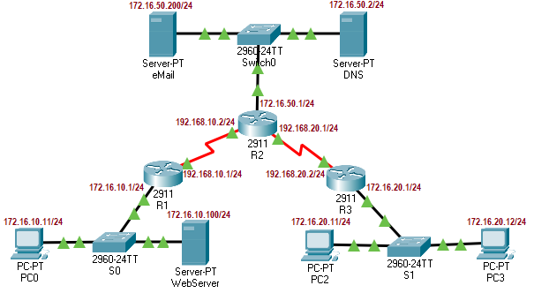

Figure 1: Overall network topology for this lab.

Prerequisite:

Please setup the network nodes with associated IPs as shown in figure#1. You need to configure routes (static/dynamic) in all the routers. Do not forget to assign respective gateway IPs and DNS IP 172.16.50.2 to every PC and server.

Create a Webserver

Procedure:

(Webserver Settings)

1. Go to Services>HTTP tab of WebServer
2. Turn the HTTP services On.
3. Edit index.html file with your name/cms-id information.

(DNS server Settings)

1. Go to Services>DNS tab of DNS server
2. Turn the DNS services On.
3. Add a domain name www.<yourname>.com and webserver IP address 172.16.10.100.
4. Click Add

You may now use browser of any PC and if Error! Hyperlink reference not valid. page is loaded with the same information that you gave at webserver.

Please paste the screenshot of the loaded page in the following box.

|  |
| --- |
|  |