Dispatching on SR-Dash

1. Click on “Case Creation”

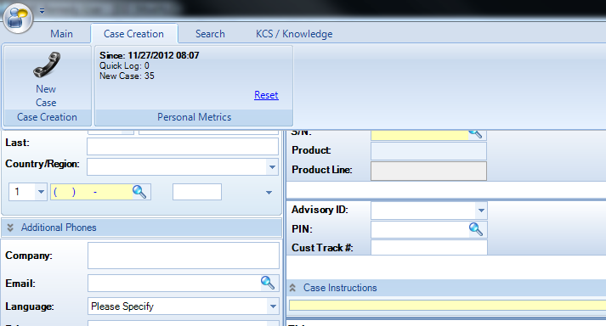

1. Put in Serial Number in **S/N:** field or SAID # in **Contract:** field and click on search icon
   1. If Entitlement is expired, use generic SAID for US and Canada sites; otherwise, T&M required for all international sites.
2. Fill out dispatch template with the following information & put in **Notes:** field
   1. Servername – brief description of problem
   2. Problem Description
   3. Remedy ticket #
   4. Node Name
   5. Serial Number
   6. Model
   7. Parts & Quantity recommended
   8. Site contact information (Site type, Site #, Address, City, State, Zip Code, & Phone)
3. Click on Contact Information Side on left side of the screen
   1. The **Title:** field will auto fill when you click on the contact information side
4. Fill in the following information on Contact Informatino:
   1. First Name = HP
   2. Last Name = Stab Team
   3. Phone Number = 800-472-0350
   4. Company = Site Type & Site #
   5. Email = [wmstab@hp.com](mailto:wmstab@hp.com)
   6. Address Line1 = Site Street Address
   7. Address Zip/Postal Code = Site Zip code
      1. After zip code is entered, City & State should auto populate, if not, fill in as needed
      2. See below for example of how contact information should look like

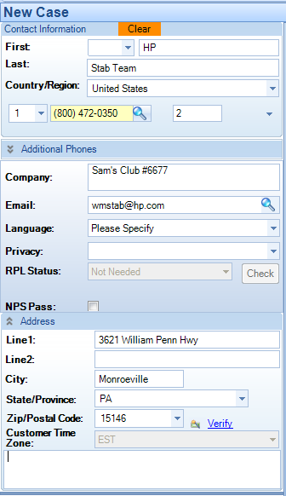

1. Click on Create Case button when all fields are populated like image below

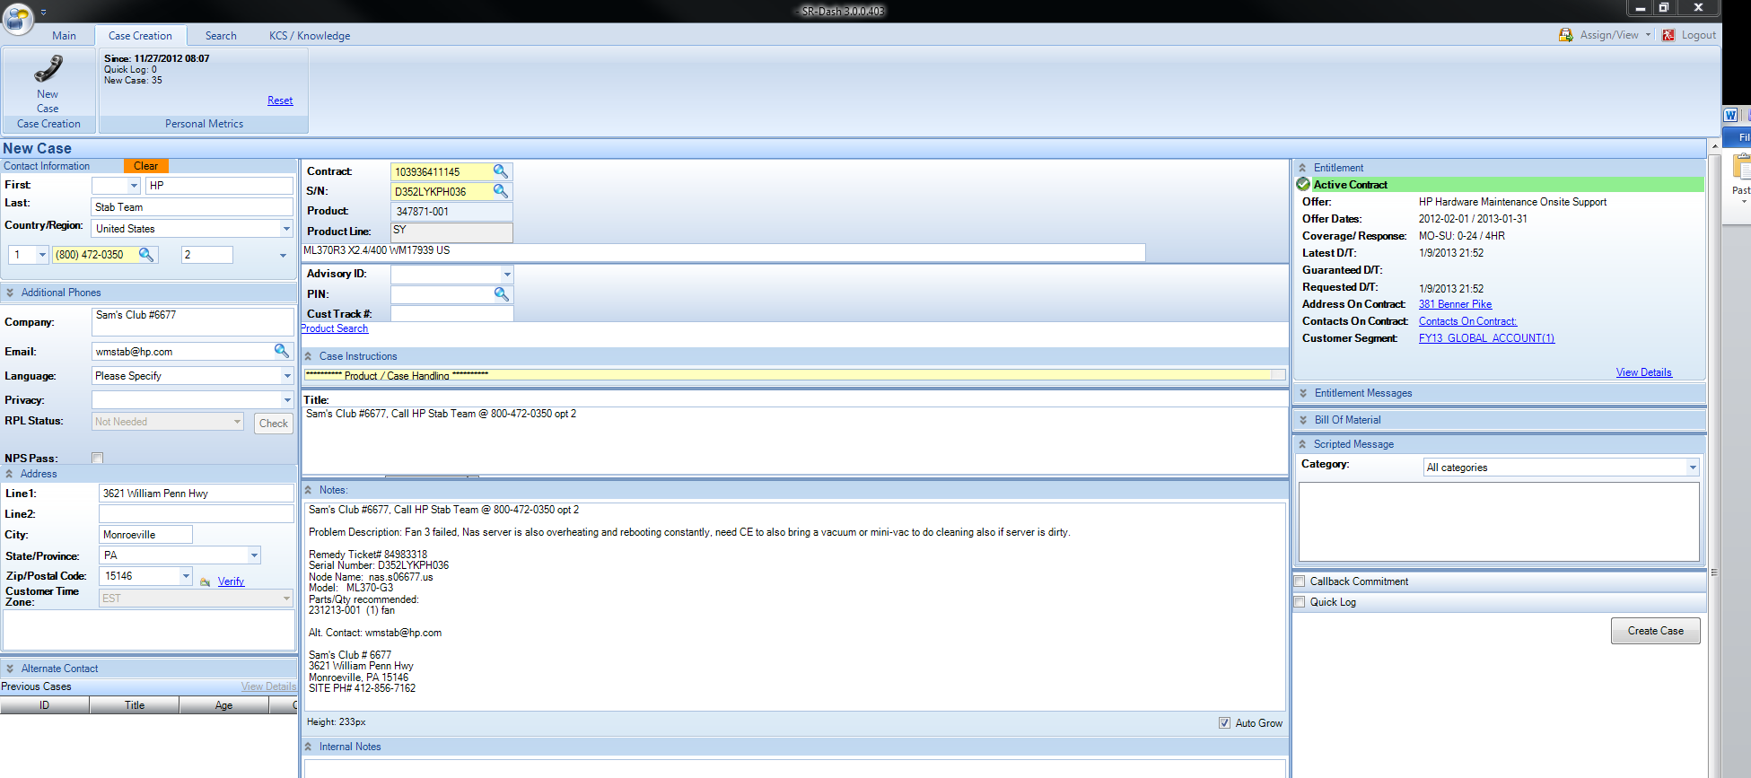

1. Double click on SR # at top to copy and then past SR # in the remedy & HPC ticket
2. Click on Edit Case and change the following if serial # entitled and click on save:
   1. Status = Active
   2. RPL Status = Passed

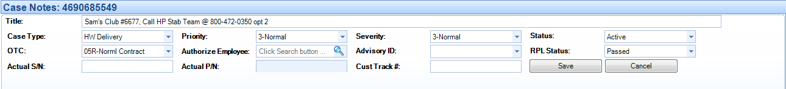

***\*\* If using generic SAID, fill in Actual S/N: field also and leave RPL Status as “Not Needed” \*\****

1. Click on On-site icon if CE and parts required



1. Change the following 2 fields in Service Delivery Tab:
   1. CSR Refused Reason: = CSR Not Allowed
   2. Business Center: = US TS

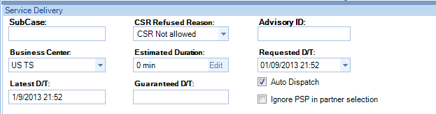

1. Click on Dropdown for Skill Category and select accordingly:
   1. BCS servers = WFM – Server – 1K/3K/9K & Superdome
   2. Nas, vhst, vsrv, or dds servers = WFM – Server – Intel
   3. D2D = WFM – Storage – Disk
   4. Evalue Kiosk = WFM – Desktops
   5. HP Blade Chassis or Servers = WFM – BladeSystems
2. Click on Skill Name and select accordingly
   1. BCS servers = 9000 and Integrity – mid-range servers (Legacy and SX1000)
   2. Nas, vhst, vsrv, or dds servers = varies based on model of server
   3. D2D = D2D, StoreOnce Backup System – HP StorageWorks
   4. Evalue Kiosk = Compaq Evo Desktop
   5. HP Blade Chassis or Servers = varies based on model of server
3. Click on Save button on bottom when all 4 fields in step 10-12 is done.

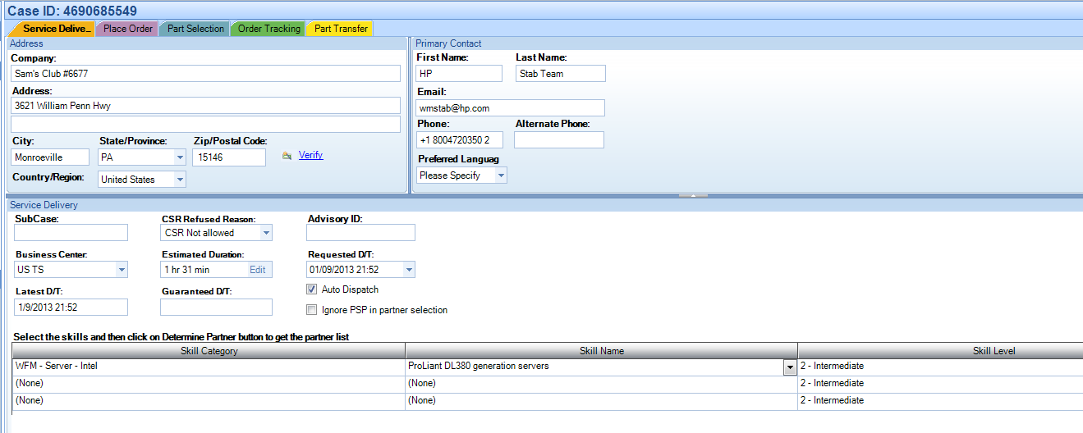

1. If part is required, click on Place Order tab
2. Fill in part #, quantity, and part description, click on Add Part

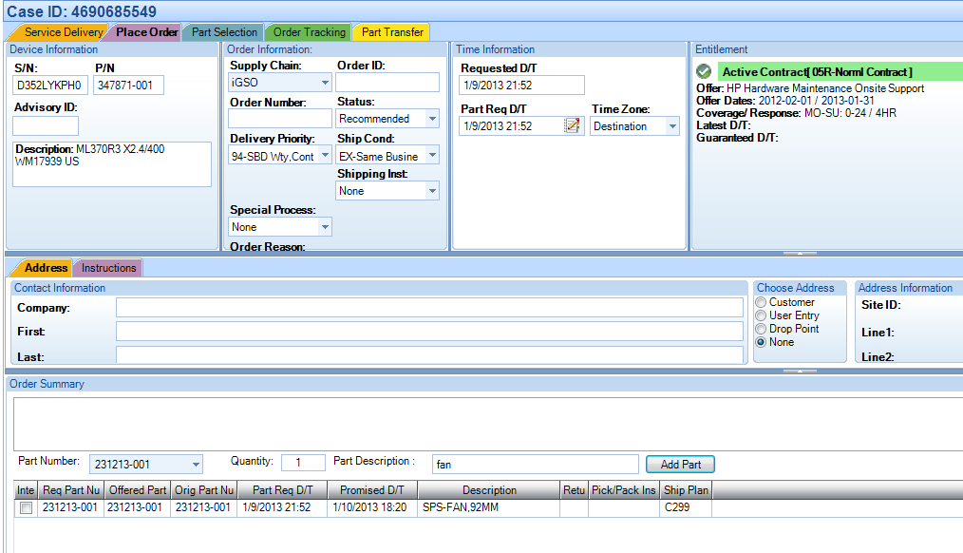

1. Click Save and then click on Service Delivery Tab
2. Ensure button is selected for “Dispatch to HPCE” and then click on Send



1. Click on Done at the top 

Updated 4/15/13