

**SCANNER and MONITOR**

**RETROFIT GUIDE**

**eValues RTS**

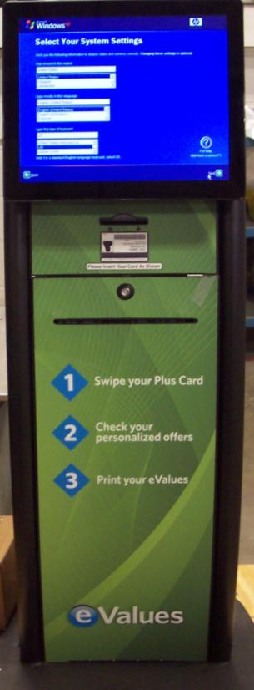

**Record Serial Number Here:________________**

**Date of Purchase: _______________ _**

**DOC Control**

**Revision History for MAN-00650**

Revision Date Description of change

0 12-23-2011 ORIGINAL Release

1 01-10-2012 Added New Illustrations and step details

2 6-12-2012 Added new explanations

3 6-25-2012 Added Steps and illustrations to replace Monitor

**Approvals Date**

Operations **___________________________ ________**

Technical Consultant  **___________________________ ________**

**Notices:**

**Product Safety**

**CAUTION**: The Socket Outlet Shall Be Installed Near The Equipment And Shall Be Easily Accessible.

This product is equipped with a 3-wire power cord and plug for the user’s safety. Use this power cord in conjunction with a properly grounded electrical outlet to avoid electrical shock.

Prior to performing the retrofitting operation, the following checks should be made to validate the kiosk is operating when originally installed;

1. Ensure that the kiosk is plugged into a properly grounded outlet.

2. Ensure that the Power Tap is on and does not show a fault inside the kiosk.

*This product meets Meridian safety standards.*

**Note:** For any safety-related incident that occurs related to this machine, the field personnel involved must immediately follow regular Safety Incident Reporting.

When applicable:

**WARNING:** This KIOSK must be used only on flat, level surfaces. Uneven or slanted surfaces could cause the kiosk to tip over.

Prior to working inside or using the kiosk, it must be

affixed to the floor to reduce the tipping hazard.

**

**Preface**

# Who Should Use This Manual?

The original user manual is intended for those responsible for the installation and service of the kiosk and should be used as reference. It contains information on:

* unpacking and inspections
* site preparation
* installation and set-up instructions
* operating procedures
* testing and servicing the components
* maintenance instructions

**This document is to be used only for the retrofit of the Symbol Scanner MS 3207 1000R scanner mounting bracket and to replace the original 17-inch monitor with a new 19-inch.**

**Introduction**

In order to get started with your kiosk you should first familiarize yourself with the original manual. **All technicians must read through each step thoroughly before you begin retrofitting this kiosk.**

If any problems arises at any point from the initial unpacking of the kiosk through installation and checkout, go through the basic inspections and troubleshooting procedures detailed this manual. If you are unable to correct the problem or have questions about your kiosk please contact your representatives at Meridian Kiosks.

**Contact Information**

Meridian

124 S. Pine Street

Aberdeen, NC 28315

910-944-1751

[www.meridiankiosks.com](http://www.meridiankiosks.com)

**Sales: 866-4-KIOSKS , 866-454-6767**

**Technical Support: 910-944-1751**

TABLE OF CONTENTS

PAGE NO.

Document Control…… ……………………………………………………… ii

Notices ……………………………………………………………………….. iii

Preface ………………………………………………………………………… iv

Introduction ………………….…………………………………………...…… iv

Table of Contents and Figures ……………………………………………….. v

Tools Needed and Parts List…………………………………………………. vi

SECTION 1 – Power down the Kiosk …………………………….………… 1

SECTION 2 – Remove the Symbol Scanner …..……………………………. 2

SECTION 3 – Install the Symbol Scanner …………………………………… 3

SECTION 4 – Power up and Test ………………………….………..…..…… 5

List of Figures

FIGURE 1 – 110V AC 60 HZ POWER CORD…………………………….. 1

FIGURE 2 – REAR COVER REMOVAL ………………………………….. 1

FIGURE 3 – EXISTING SYMBOL SCANNER BRACKET ………………. 2

FIGURE 4 – NEW SYNBOL SCANNER INSTALLATION ……………… 3

FIGURE 5 – REAR COVER REPLACEMENT ……………………………. 4

FIGURE 6 – SCANNER CHECKOUT ……………………………………… 5

**Tools Needed**

Below is a list of tools you might need in order to keep you kiosk maintained and running well for several years:

1. 7/16” nut driver or socket

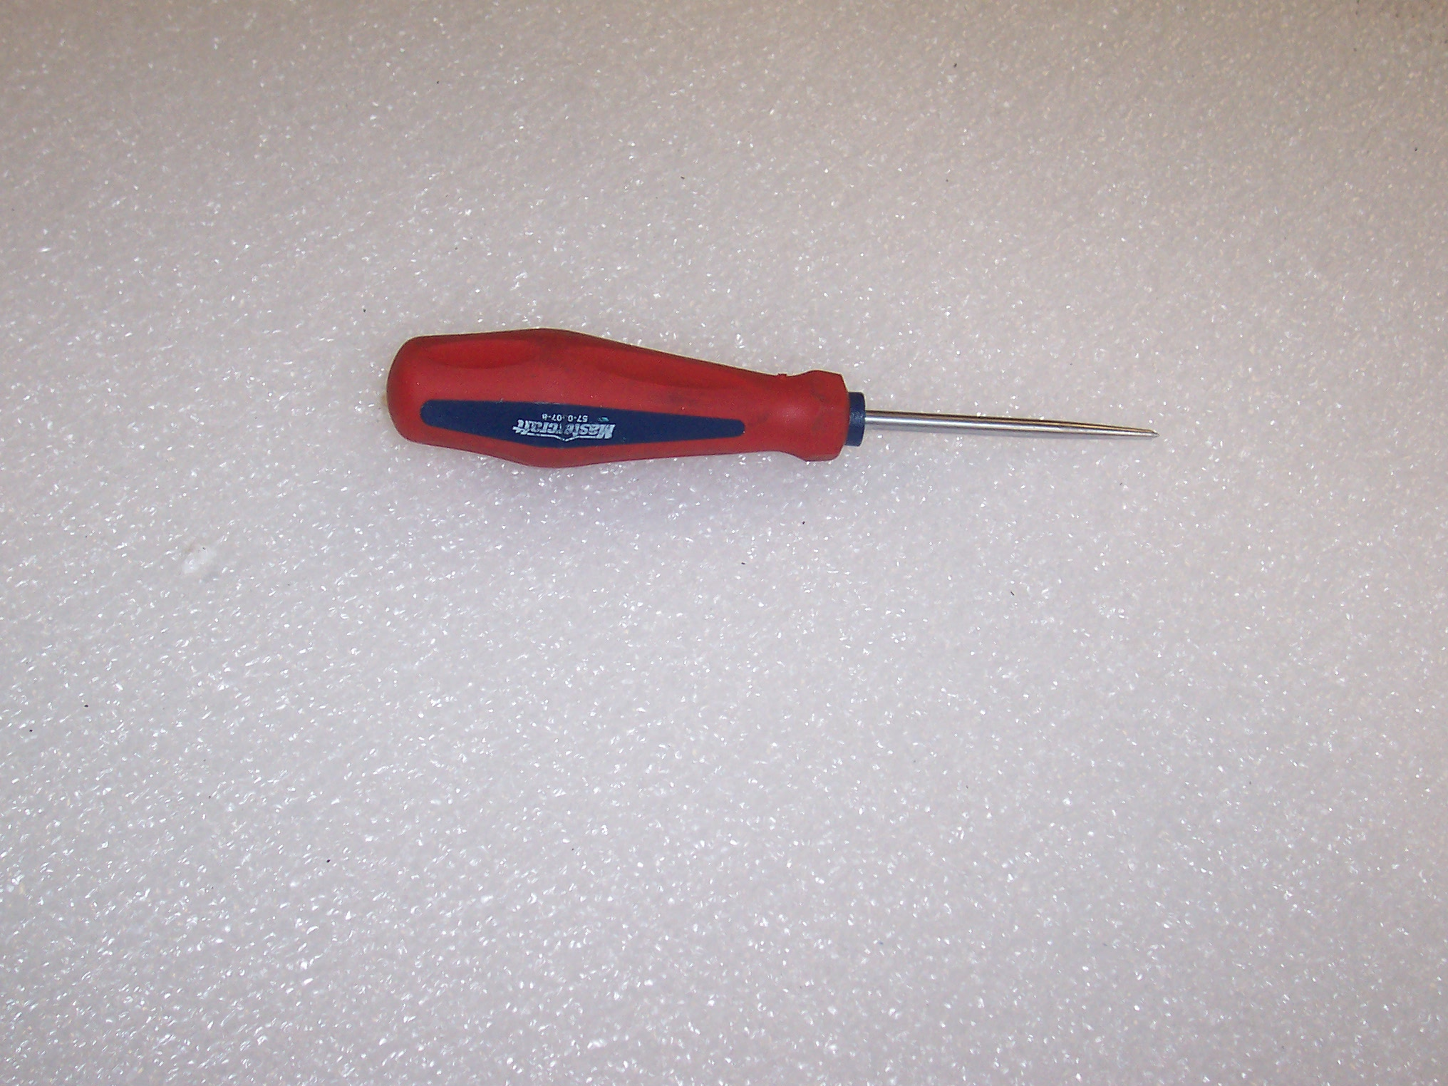

1. 3/8” nut driver or socket
2. 11/32” nut driver or socket
3. 5/16” nut driver or socket
4. 1/4” nut driver or socket
5. Phillips screwdriver
6. Flathead screwdriver
7. 1/8” Allen wrench
8. Diagonal cutters
9. Drift Pin/Tapered Awl (see photo)

**Scanner Parts List**

Item No. Part Number Description Quantity

4 SLA 03551 RTS Back Panel w/scanner cutout 1

26 EPD -00105 Symbolic Scanner MS-3207 1000R 1 (Existing)

51 MKE-08275 Scanner Mounting Plate 1

56 MKE 08278 Scanner Cover Plate 1

Please refer to the separate drawing provided with this manual.

**Scanner Retrofit**

**Section 1 - Power down the Kiosk**

With the unit set up in a store environment it is important to power it down during this replacement.

1. Follow Customer’s procedure to power down the kiosk: parts cannot be hot swapped
2. Disconnect power and network cable (Figure 1)
3. Remove rear back plate: retain screws (Figure 2)
4. Locate the Symbol Scanner and bracket assembly on the front door (Figure 3)
5. Observe that the PC is powered off if required

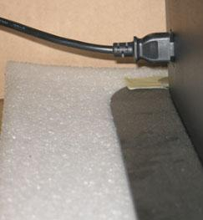

**Power Cable**

**Figure 1**

**Figure 2**

**Section 2 - Remove the Symbol Scanner and Mirror Bracket**

With the rear cover removed, follow the steps listed below (Figure 4):

1. Disconnect the serial cable from the rear of the Symbol Scanner
2. Remove the four (4) 8-32 Kep Nut that hold the scanner mounting plate and mirror assembly to the front door
3. Keep these four nuts for later use in this replacement
4. Carefully slide the bracket off the studs to avoid damaging the threads on the studs that are pressed into the front door
5. Remove the Symbol Scanner from the bracket (three screws) and set the scanner aside.
6. Discard the bracket and old cover

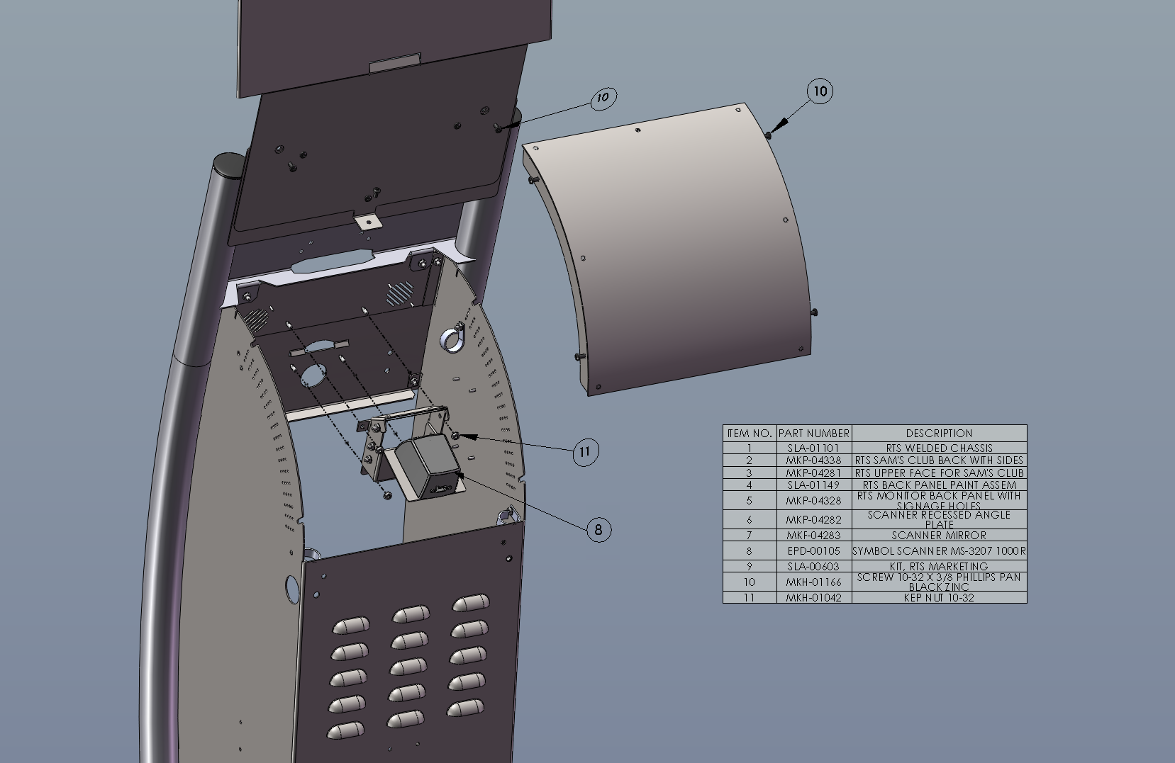

Kep nuts (x4)

Bracket

Serial Cable

Scanner

**Figure 3**

**Section 3 – Installation of Symbol Scanner**

1. Install the Symbol Scanner on the new bracket using the three screws (Step 2-5)
2. Install the cable clamp under the upper screw before completing the installation,
3. Install the new Symbol Scanner Bracket 8-32 Kep nuts (Step 1-1) (Figure 4)
4. Connect the serial cable to the back of the Symbol Scanner
5. Install the replacement cover and assemble with the new cover provided (Figure 5)
6. Replace the 110V 60 Hz power cord and Cat 5 cable in the rear of the kiosk and plug into the respective wall sockets.(Figure 1)

Kep nuts (x4)

**Figure 4**

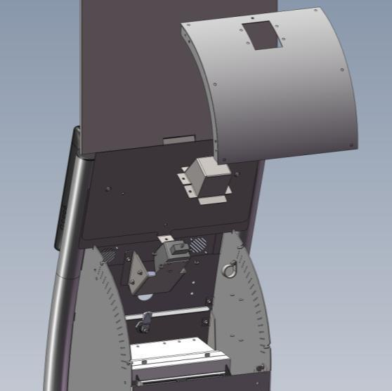

**Figure 5**

**Section 4 - Power up and Test**

With the door closed follow the steps listed below to place the kiosk back online.

1. Follow Customer’s procedure to power up the kiosk and to ensure that the PC comes back online correctly
2. The Scanner should “chirp” a few times and the Red beam will be visible as illustrated in photo below
3. Following customers procedure test the proper operation of the scanner
4. Upon successful testing ensure that the kiosk door is closed and locked and that unit is ready for customer use

**Figure 6**

**Monitor Retrofit**

**Section 1 - Power down the Kiosk**

With the unit set up in a store environment it is important to power it down during this replacement.

1. Follow Customer’s procedure to power down the kiosk: parts cannot be hot swapped

2. Disconnect power(Figure 7)

3. Remove rear cover: retain screws (Figure 8), Marketing Signage Kit and back plate (Figure 9)

4. Locate the Elo 17-inch touch monitor (Figure 10)

5. Observe that the PC is powered off if required



**Power Cable**

**Figure 7**

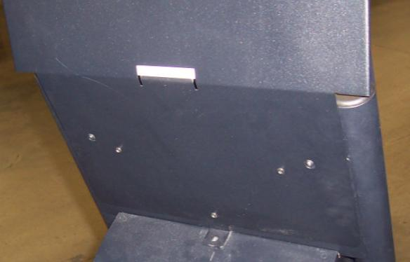

**Marketing kit screws (3)**

**Figure 8 Figure 9**

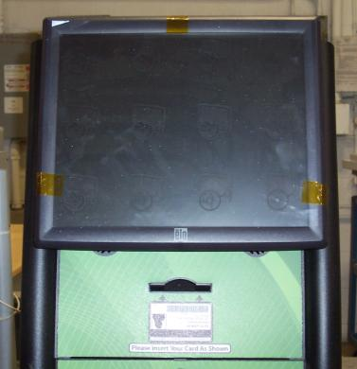 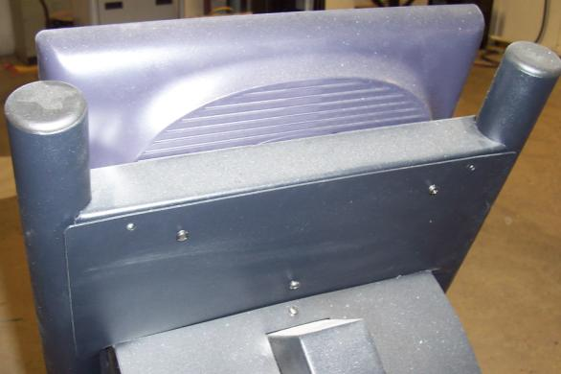

**Back Plate screws (2)**

Figure 10 Figure 11

**Section 2 - Remove the Monitor**

1. Remove the Signage kit held in place with 3 Screws identified in figure 9. Save the screws for re-assembly.
2. Remove the back plate held in place by two Phillips head screws. Save for the re-assembly of the unit. The cables to the monitor are now visible.
3. Loosen the cables from the cable clips as shown below to allow for the monitor to be handled later in procedure

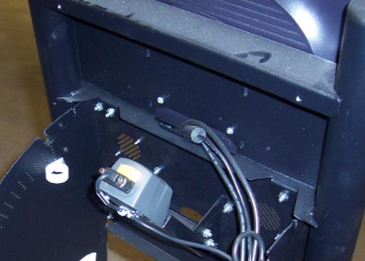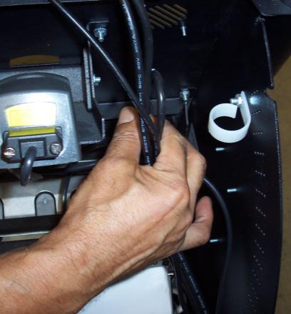

Figure 12 Figure 13

**Caution**

**When removing the Elo Monitor the spacer plates (2) may fall out, if the monitor is not tilted forward correctly as shown in Figure 15!**

**Warning**

**Before removing the Elo Monitor close the kiosk access door to prevent any potential internal damage due to possible falling spacers or tools!**

1. To remove the monitor from the support use a Phillips screw driver to loosen all 4 M4 Screws that hold the monitor housing onto the kiosk. Discard these screws.

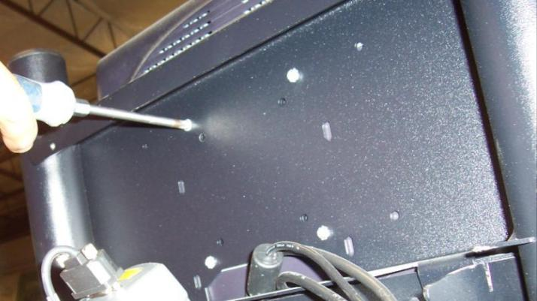

**Figure 14**

1. With the screws finger tight **step to the side of the kiosk in a comfortable position such that you can hold the monitor** and finish unscrewing the four M4-screws and then tilt the monitor in order to access the cables.

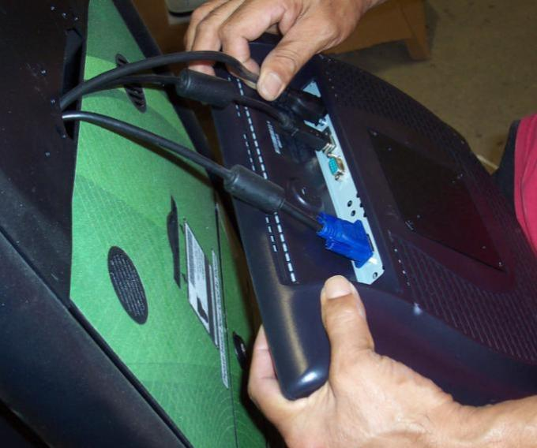

Figure 15

1. Disconnect the power cord first next the USB and last the VGA cable from the rear of the Elo Monitor.
2. Once the Elo is free take it to a clean working area and remove the spacers for re-use on the Planar 19 inch monitor.

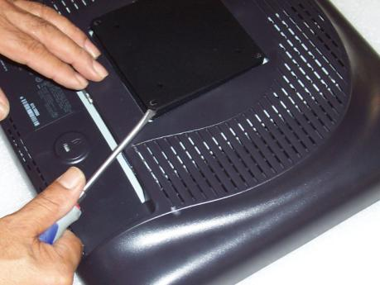 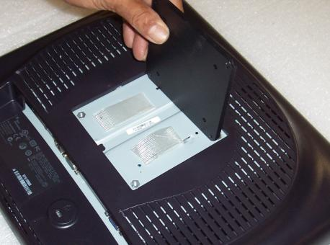

1. Remove the two spacers and transfer them to the Planar
2. Prepare the planar Vesa area with the two strips of double sided tape to hold the spacers in place as shown

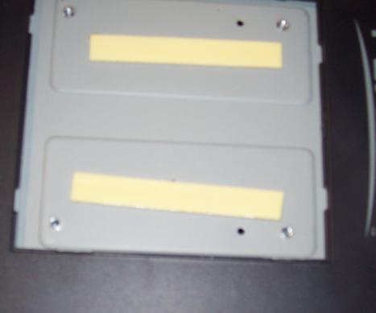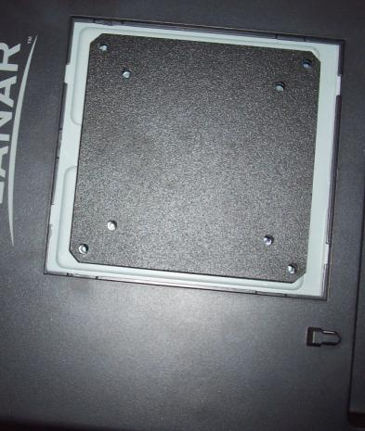

1. Change out monitor Power Cord from Elo style to the new IEC power cord for the Planar

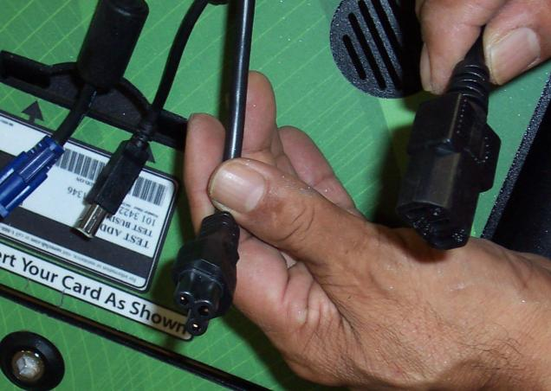

**Planar**

**Power Cable**

**Elo**

**Power Cable**

1. Connect the cables onto the Planar in the reverse order from step

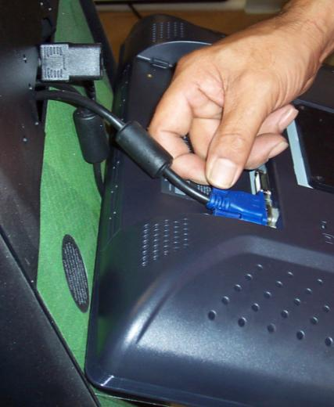 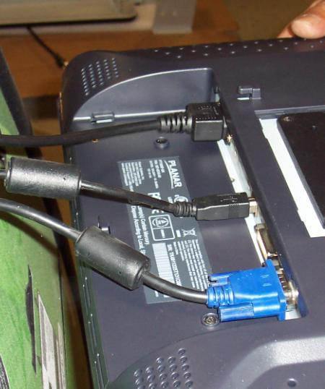

1. Now step back to the side of the kiosk and make sure that you have these tools and hardware at hand-and within reach:
   1. Tapered Awl
   2. New M4 Screws (4)
2. Using the Awl to line-up the lower left Vesa hole slowly raise the monitor into place and insert the lower right screw to begin securing the monitor into place. Repeat for all four screws (remove the Awl on last one) , hand tighten only.

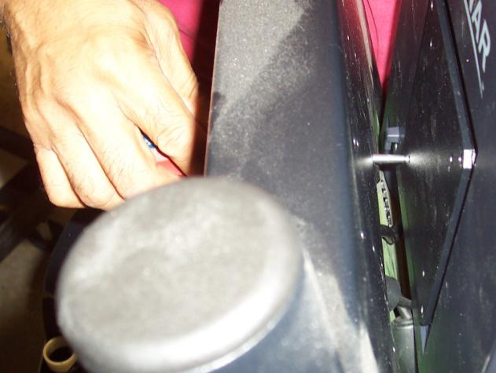

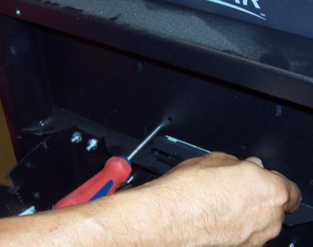 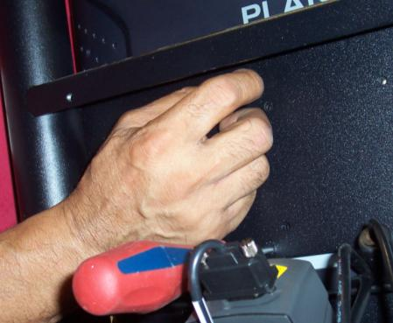

1. Next verify monitor alignment and fit, make sure cables are not pinched. Tighten the four screw with Phillips screw driver

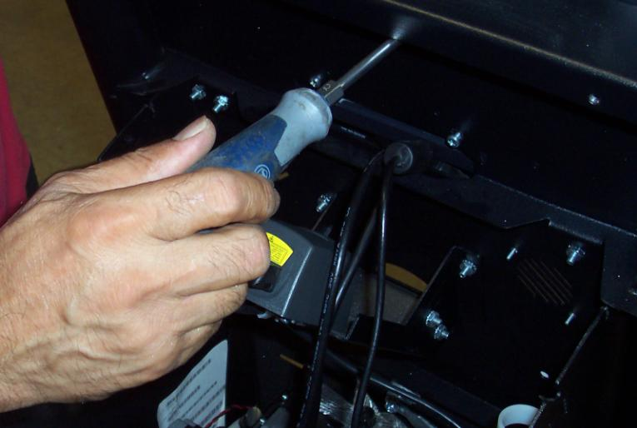

1. Reverse the dis-assembly steps to replace the back plate and rear cover onto the kiosk to button up the kiosk.
2. Now open the access door. Then remove the old Elo power cord after unplugging it from the power strip and replace and plug in the new Planar power cord

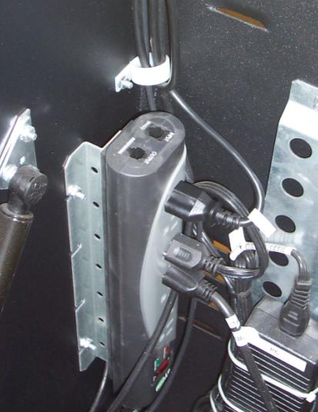

**Monitor**

**Power Cable**

1. Now check all internal cable-connections between all the devices and re-install cables into clips.
2. Follow WM guidelines to power the unit back up and return it back into service at the Sams Club.

Final Step – adding the plastic monitor bezel

1. Locate the black plastic monitor bezel.
2. Remove the tape on the back of the bezel to expose the adhesive back.
3. Apply the bezel directly to the front of the monitor (on the glass) to cover the black portion of the outside of the monitor. See photos below:

