Computational Simulation Report
Mission OR-EXAMPLE · Dual parachute deployment · Trajectory, aerodynamics and flight-dynamics analysis
BEYOND UP
BEYOND UP · Universidad Panamericana · México [EDIT: add the real team member names for this submission]
LASC (Latin America Space Challenge) | Generated 2026-09-29 04:09 UTC | App version section4 | Author: Diego Rocketeer
This report summarizes the predicted flight of Dual parachute deployment: an apogee of 1423.5 m at a peak speed of 161.6 m/s (Mach 0.477), with a minimum static margin of 5.82 cal through the ascent.
Apogee AGL | Max Mach | Min static margin | Flight time
1423.5 m | 0.477 | 5.82 cal | 59.0 s

Table of contents
Right-click and choose "Update Field" (or press F9) to populate this table of contents.

1. General information and set-up
This sample report uses an OpenRocket example file (Dual_parachute_deployment.ork) paired with a placeholder motor (Icarus I / K519) purely to demonstrate the report's layout on a real dual-deployment vehicle - it is not a real Beyond UP mission and the motor pairing does not represent this airframe's actual propulsion. This mission is submitted for LASC (Latin America Space Challenge). The objectives of this simulation are to predict the vehicle's ascent and descent trajectory, verify static stability throughout powered flight against the applicable safety requirements, characterize the expected landing footprint under wind uncertainty, and provide the flight cases and supporting data required for competition submission.

1.1 Analysis environment
Simulation engine | RocketPy 1.13.0 (Python 3.11.15)
Application build | section4
CPU | x86_64
Operating system | Linux-6.18.44-fc-v49-x86_64-with-glibc2.39
Computation time | 0.30 s

1.2 Model information
OpenRocket design file | Dual_parachute_deployment.ork
Motor data file (.eng) | Icarus_I_K519.eng
Drag curve source | user-supplied CSV files (power_off_drag.csv, power_on_drag.csv)

1.3 Simulation parameters
ODE solver | LSODA
Equations of motion | standard
Relative tolerance (rtol) | 1e-06
Absolute tolerance (atol) | 0.001 (position/velocity/quaternion components; see RocketPy's own Flight docs for the full 13-element vector)
Max. time step | unlimited (adaptive)
Min. time step | 0 s
Termination condition | full flight, through ground impact or landing under recovery

2. Vehicle configuration and mass properties
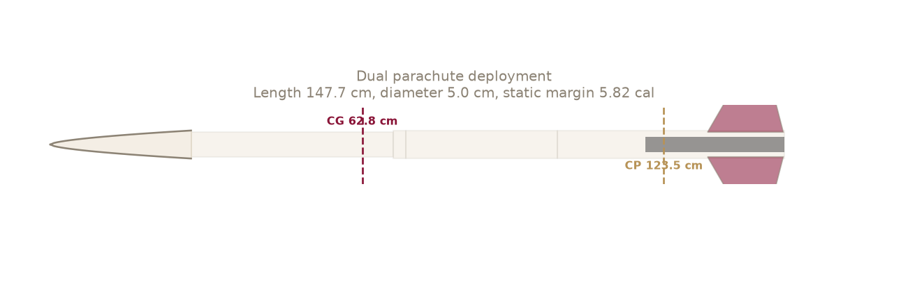
Figure 1. Vehicle side profile with CG/CP and static margin.
Figure 1 shows the vehicle's side profile with its center of gravity and center of pressure marked. Dual parachute deployment is 1.48 m long with a body diameter of 5.0 cm (reference area 0.00196 m2). The dry mass is 5.662 kg with the center of gravity at 0.628 m from the nose tip (user-entered override (LoadResult UI field)). Across the ascent the static margin ranges from 5.82 to 7.58 calibers, which is OUTSIDE the RCSM's required 1.5-4.0 cal band (FLT 4.3.5/4.3.6).
Length | 147.7 cm
Diameter | 5.0 cm
Reference area | 0.00196 m2
Dry mass | 5.662 kg
Dry CG | 0.628 m from nose
Static margin range (ascent min.) | 5.82 - 7.58 cal
Stable (FLT 4.3.5/4.3.6, 1.5-4 cal) | NO
Parachute | Diameter (m) | Area (m2) | Cd
Elliptical 12-Gore 42" Parachute | 1.07 | 0.894 | 1.50
Apex 12" Drouge Parachute | 0.30 | 0.073 | 0.61
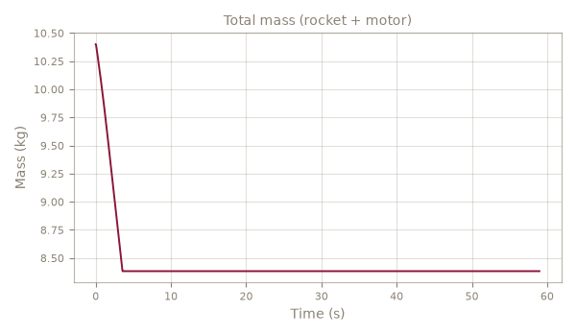
Figure 2. Total mass (rocket + motor) vs. time.

3. Propulsion
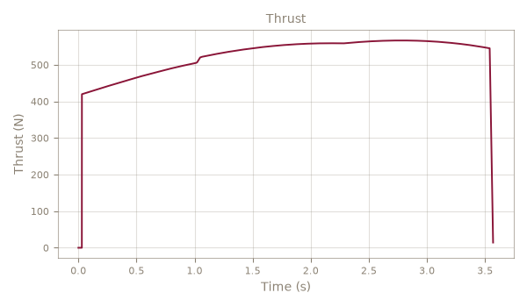
Figure 3. Thrust curve used for this simulation.
The vehicle is powered by a K519 motor (BeyondUP), delivering a total impulse of 1865.1 N*s over a 3.57 s burn (average thrust 522.4 N, peak 566.6 N). Figure 3 shows the thrust curve used for this simulation. Propellant mass is 2.017 kg out of a total loaded mass of 4.738 kg.
Motor | K519 (BeyondUP)
Total impulse | 1865.1 N*s
Average / peak thrust | 522.4 N / 566.6 N
Burn time | 3.57 s
Propellant / dry / total mass | 2.017 / 2.721 / 4.738 kg

4. Trajectory (nominal and ballistic)
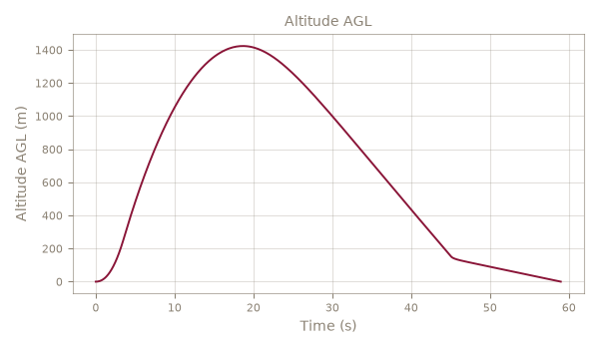
Figure 4. Ascent and descent trajectory - see remaining plots below for individual quantities.
Figure 4 shows the predicted altitude, velocity and acceleration through the ascent, together with the 3D trajectory and ground track. The nominal case (dual-deployment recovery) is compared against the ballistic case (no parachutes) later in Section 8, which bounds the vehicle's worst-case impact energy and downrange distance.

Vertical velocity
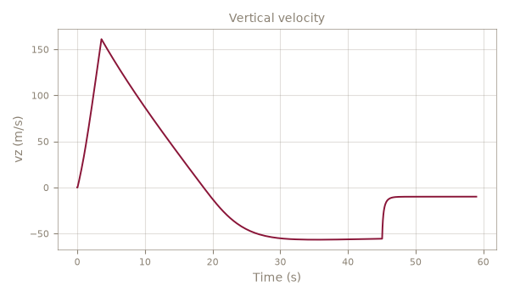

Total velocity
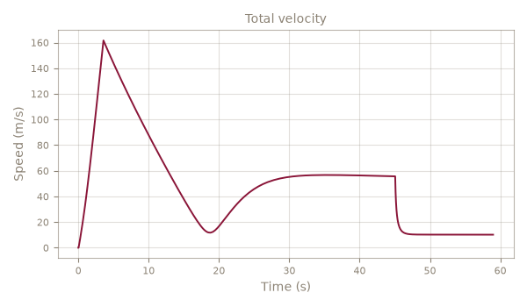

Acceleration (boost phase)
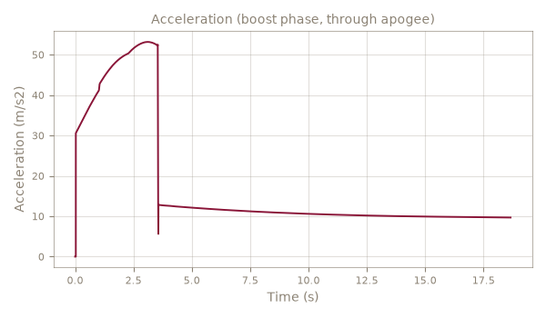

3D trajectory
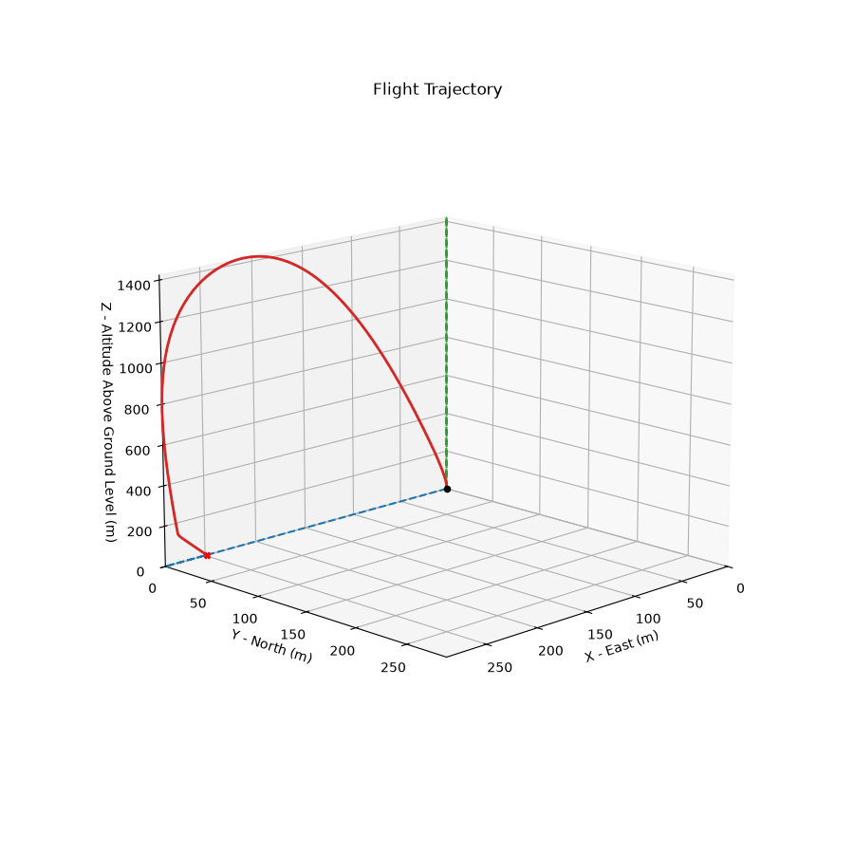

Ground track (top view)
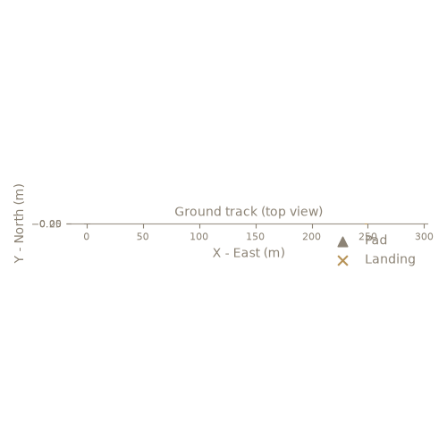

5. Aerodynamics
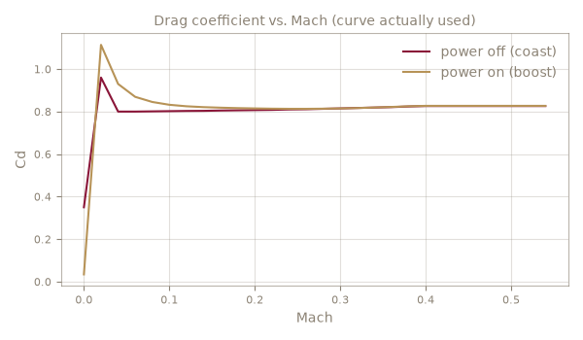
Figure 5. Drag coefficient vs. Mach (curve actually used).
The drag coefficient used in this simulation comes from user-supplied CSV files (power_off_drag.csv, power_on_drag.csv). Figure 5 shows the power-off (coast) and power-on (boost) drag curves actually used; the flight reaches Mach 0.48, past the drag curve's own 0.40 Mach coverage - results above that speed use a constant-Cd extrapolation, not measured drag, and should be treated with reduced confidence.

Mach number vs. time
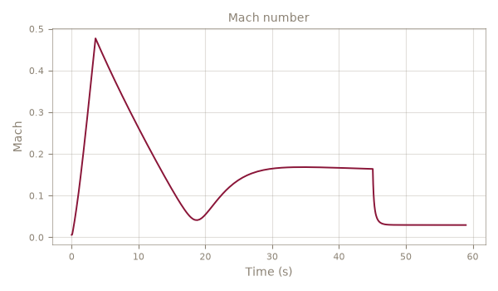

Dynamic pressure vs. time
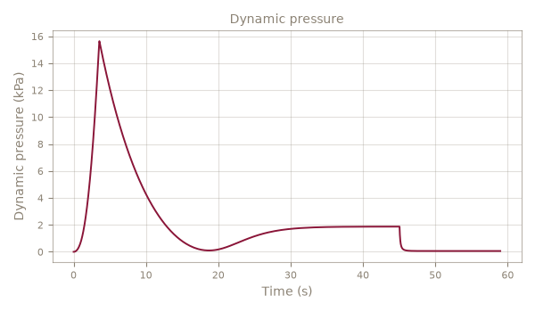

6. Stability
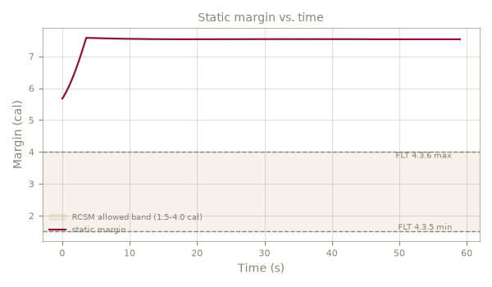
Figure 6. Static margin vs. time, with the RCSM's 1.5-4.0 cal allowed band shaded.
Figure 6 shows the static margin through the flight against the RCSM's required 1.5-4.0 cal band (FLT 4.3.5/4.3.6, shaded). The minimum margin is 5.82 cal and the maximum is 7.58 cal, so the vehicle is NOT compliant throughout the ascent. As an independent check, a hand calculation using the classical Barrowman (1966) method (Barrowman (1966), nose + fins only - body tube and transition normal-force contributions neglected (standard textbook simplification for a slender airframe).) places the center of pressure at 1.212 m from the nose tip, compared to 1.235 m from RocketPy's own (more complete) model - a difference of -1.8%.

CG and CP vs. time
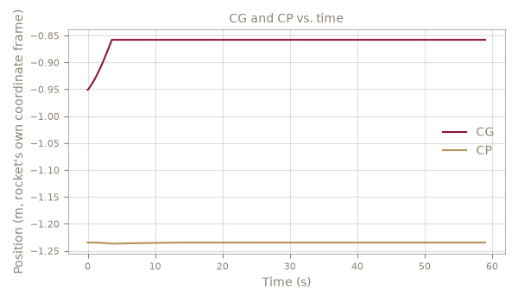

Angle of attack
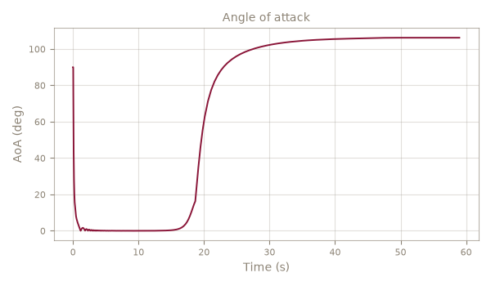

6.1 Independent analytical verification (Barrowman)
Barrowman (1966), nose + fins only - body tube and transition normal-force contributions neglected (standard textbook simplification for a slender airframe).
Nose CN-alpha / CP | 2.00 /rad @ 0.132 m from nose
Fins CN-alpha (total) / CP | 13.37 /rad @ 1.374 m from nose
Hand-calculated CP (total CN-alpha) | 1.212 m (15.37 /rad)
RocketPy's own CP (t=0) / agreement | 1.235 m (-1.8%)

6.2 Comparison against OpenRocket (Simulation 1)
"Static margin (ascent min.)" above is the worst point across the whole ascent - a different, safety-focused number from "Stability at Mach 0.3" below, which is OpenRocket's own default design-view snapshot (t=0 mass, Mach 0.3 aerodynamics only).
Quantity | Ours | OpenRocket | Diff
Overall length | 1.477 m | n/a | n/a
Max diameter | 0.050 m | 0.057 m | -12.28%
Mass without motor | 5.6622 kg | 1.3610 kg | +316.03%
Mass with motor (t=0) | 10.4000 kg | 1.6130 kg | +544.76%
CG with motor (t=0, from nose) | 0.9509 m | 0.9630 m | -1.25%
CP at Mach 0.3 | 1.2356 m | 1.2010 m | +2.88%
Stability at Mach 0.3 (t=0) | 5.693 cal | 5.001 cal | +13.84%
Apogee AGL | 1423.5 m | 592.7 m | +140.17%
Max Mach | 0.477 | 0.398 | +19.86%
CP-derived rows use a 2% tolerance (RocketPy and OpenRocket use slightly different body-lift models, a documented and expected difference); every other row uses 1%.

7. Recovery and landing footprint
Stage | Diameter (m) | Area (m2) | Cd*S (m2) | Deploy (s) | Sim descent (m/s) | Hand-calc descent (m/s)
Apex 12" Drouge Parachute | 0.30 | 0.073 | 0.045 | 18.7 | 60.2 | 54.9
Elliptical 12-Gore 42" Parachute | 1.07 | 0.894 | 1.341 | 45.1 | 10.2 | 10.0
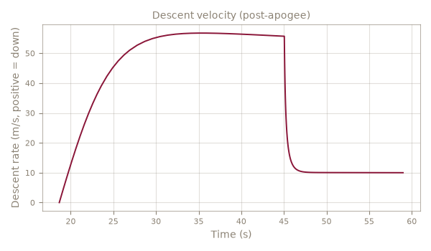
Figure 7. Descent velocity after apogee.
The recovery system uses 2 parachute(s): Apex 12" Drouge Parachute, Elliptical 12-Gore 42" Parachute. Figure 7 shows the descent rate after apogee; the simulated descent rates are compared against a hand-calculated terminal velocity for each stage in the table above, as a cross-check on the parachute Cd*S values used.

8. Flight cases (RCSM)
Case | Apogee AGL (m) | Max speed (m/s) | Rail exit (m/s) | Note
Ballistic | 1423.5 | 161.6 | 13.4
Nominal | 1423.5 | 161.6 | 13.4
DrogueOnly | 1423.5 | 161.6 | 13.4
MainAtApogee | 1423.5 | 161.6 | 13.4
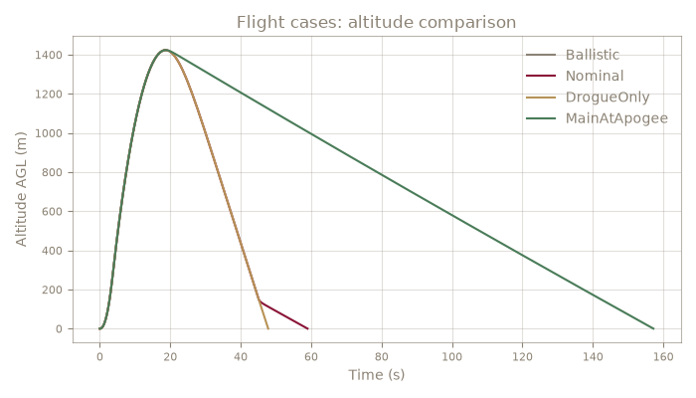
Figure 8. Altitude comparison across the required flight cases.

9. Monte Carlo dispersion
Monte Carlo dispersion analysis varies the uncertain inputs listed below across 30 simulated flights. The apogee is predicted at 1417.5 m with a 90% interval of [1390.2, 1450.0] m. The landing footprint (1/2/3-sigma ellipses) bounds where the vehicle is expected to land under wind uncertainty. With only 30 completed trajectories, this is a rough check, not a statistically meaningful dispersion estimate (fewer than 100 samples).
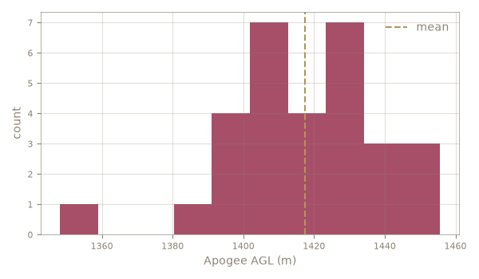
Figure 9. Apogee distribution across Monte Carlo trajectories.
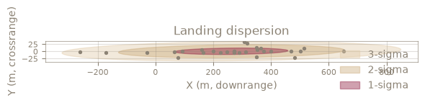
Figure 10. Landing dispersion footprint (1/2/3-sigma).
Uncertainty | Std dev | Source
wind_speed_ms | 1 | no source, low confidence - guessed as 30% of the OpenRocket-recorded wind speed
wind_direction_deg | 15 | no source, low confidence - typical launch-day wind direction variability
dry_mass_kg | 0.1132 | no source, low confidence - assumed 2% (typical scale + component-count uncertainty for a student rocket)
dry_cg_m | 0.01 | no source, low confidence - assumed +-1cm CG placement/measurement uncertainty. NOTE: rocketpy's StochasticRocket does NOT preserve an overridden center_of_mass_without_motor unless this is explicitly passed - found 2026-09-26, see PROGRESS.md
total_impulse_Ns | 37.12 | no source, low confidence - assumed 2%, typical SRAD motor-to-motor total impulse variation for KNSB
power_off_drag_factor | 0.05 | no source, low confidence - assumed 5% Cd curve uncertainty
power_on_drag_factor | 0.05 | no source, low confidence - assumed 5% Cd curve uncertainty
inclination_deg | 2 | no source, low confidence - typical rail-angle setup tolerance, +-2 deg
heading_deg | 5 | no source, low confidence - typical rail-heading setup tolerance, +-5 deg
parachute_lag_s | 0.5 | no source, low confidence - avionics/ejection-charge delay jitter
parachute_cd_s_factor | 0.1 | no source, low confidence - assumed 10% parachute Cd*S uncertainty

10. Global min-max table
Minimum and maximum of every key flight variable across the full simulated trajectory, with the time each occurs.
Variable | Minimum | at t (s) | Maximum | at t (s)
Altitude AGL (m) | -0.0 | 58.97 | 1423.5 | 18.66
Vertical velocity (m/s) | -56.74 | 35.01 | 161.02 | 3.57
Total velocity (m/s) | -0.00 | 0.03 | 161.63 | 3.57
Total acceleration (m/s2) | -0.00 | 0.03 | 274.81 | 45.05
Mach number (-) | 0.006 | 0.02 | 0.477 | 3.57
Dynamic pressure (kPa) | 0.00 | 0.01 | 15.64 | 3.57
Total mass (rocket + motor) (kg) | 8.383 | 3.57 | 10.400 | 0.00
Center of gravity (m from nose) | 0.858 | 3.57 | 0.951 | 0.00
Center of pressure (m from nose) | 1.235 | 0.00 | 1.237 | 3.57
Static margin (cal) | 5.68 | 0.00 | 7.58 | 3.57
Angle of attack (deg) | 0.00 | 5.42 | 106.22 | 55.34
Thrust (N) | 0.0 | 0.00 | 566.6 | 2.79

11. Discussion and conclusions

11.1 Discussion
The predicted apogee of 1423.5 m AGL is reached at t = 18.7 s, with a maximum velocity of 161.6 m/s (Mach 0.48) during the boost phase. The static margin stays within 5.82 to 7.58 calibers across the ascent, which is NOT compliant against the required 1.5-4.0 cal band.

11.2 Conclusions
Based on the results above, the vehicle is predicted to fly to 1423.5 m AGL and recover within the dispersion footprint described in Section 8. The vehicle does NOT satisfy the RCSM's static margin requirement (FLT 4.3.5/4.3.6) throughout the ascent and should be reconfigured before flight. The assumptions and data sources in this report should be reviewed before treating these numbers as final for a competition submission.

11.3 Files delivered
Item | Detail
Simulation report | report.pdf / report.docx (this document)
.ork design file | Dual_parachute_deployment.ork
.eng motor file | Icarus_I_K519.eng
Drag curve source | user-supplied CSV files (power_off_drag.csv, power_on_drag.csv)
Flight data CSV | flight_data.csv
OpenRocket-format flight data CSV | flight_data_openrocket_style.csv
Monte Carlo dispersion data | 30 completed trajectories
Per-case runnable .py scripts | see the LASC/competition .zip package (CRS 10.1.3/10.1.5/10.1.6)

11.4 Assumptions and data sources
- Dry mass: 5.6622 kg (user-entered override (LoadResult UI field))
- Dry CG: 0.6279 m from nose (user-entered override (LoadResult UI field))
- Drag curve: user-supplied CSV files (power_off_drag.csv, power_on_drag.csv)
- Atmosphere: standard atmosphere model with the .ork's own recorded average wind speed/direction (not a live weather download, not a full altitude profile).
- WARNING: this flight reaches Mach 0.48, past the drag curve's own 0.40 Mach coverage - results above that speed are constant-Cd extrapolation, not measured drag.

Appendix A — Input data

A.1 Motor
Designation | K519
Manufacturer | BeyondUP
Diameter | 75.0 mm
Length | 280.0 mm
Delays | 0
Propellant mass | 2.0167 kg
Total mass (loaded) | 4.7378 kg

A.2 Drag curve excerpt (evenly sampled)
Power-off (coast)
0.007 | 0.3500
0.029 | 0.8220
0.056 | 0.8000
0.083 | 0.8010
0.111 | 0.8020
0.141 | 0.8040
0.172 | 0.8060
0.207 | 0.8070
0.245 | 0.8100
0.288 | 0.8140
0.334 | 0.8180
0.369 | 0.8220
Power-on (boost)
0.006 | 0.0342
0.020 | 1.1140
0.030 | 1.0100
0.040 | 0.9300
0.050 | 0.8920
0.061 | 0.8670
0.072 | 0.8530
0.084 | 0.8420
0.106 | 0.8290
0.130 | 0.8230
0.156 | 0.8190
0.212 | 0.8140

A.3 Parachutes
Elliptical 12-Gore 42" Parachute: 1.07 m, Cd 1.50 - deploy: at 152 m AGL
Apex 12" Drouge Parachute: 0.30 m, Cd 0.61 - deploy: at apogee

A.4 Atmosphere, wind and rail
Launch site | 28.6100, -80.6000, 0 m MSL
Wind | 2.0 m/s from 90 deg
Launch rail | 3.0 m, 90.0 deg from vertical, heading 90 deg

