Computational Simulation Report
Mission 44 · PrometeoLasc2026 · Trajectory, aerodynamics and flight-dynamics analysis
BEYOND UP
BEYOND UP · Universidad Panamericana · México [EDIT: add the real team member names for this submission]
LASC (Latin America Space Challenge) | Generated 2026-09-29 04:08 UTC | App version section4 | Author: Diego Rocketeer
This report summarizes the predicted flight of PrometeoLasc2026: an apogee of 1074.4 m at a peak speed of 158.5 m/s (Mach 0.473), with a minimum static margin of 2.49 cal through the ascent.
Apogee AGL | Max Mach | Min static margin | Flight time
1074.4 m | 0.473 | 2.49 cal | 206.8 s

Table of contents
Right-click and choose "Update Field" (or press F9) to populate this table of contents.

1. General information and set-up
This report documents the computational flight simulation of PrometeoLasc2026, produced with Beyond UP's RocketPy-based simulation pipeline from the vehicle's OpenRocket design file and motor data file, with no hand-typed inputs beyond the overrides explicitly listed in Section 2 and the Assumptions section. This mission is submitted for LASC (Latin America Space Challenge). The objectives of this simulation are to predict the vehicle's ascent and descent trajectory, verify static stability throughout powered flight against the applicable safety requirements, characterize the expected landing footprint under wind uncertainty, and provide the flight cases and supporting data required for competition submission.

1.1 Analysis environment
Simulation engine | RocketPy 1.13.0 (Python 3.11.15)
Application build | section4
CPU | x86_64
Operating system | Linux-6.18.44-fc-v49-x86_64-with-glibc2.39
Computation time | 0.32 s

1.2 Model information
OpenRocket design file | PrometeoLasc2026.ork
Motor data file (.eng) | Icarus_I_K519.eng
Drag curve source | user-supplied CSV files (power_off_drag.csv, power_on_drag.csv)

1.3 Simulation parameters
ODE solver | LSODA
Equations of motion | standard
Relative tolerance (rtol) | 1e-06
Absolute tolerance (atol) | 0.001 (position/velocity/quaternion components; see RocketPy's own Flight docs for the full 13-element vector)
Max. time step | unlimited (adaptive)
Min. time step | 0 s
Termination condition | full flight, through ground impact or landing under recovery

2. Vehicle configuration and mass properties
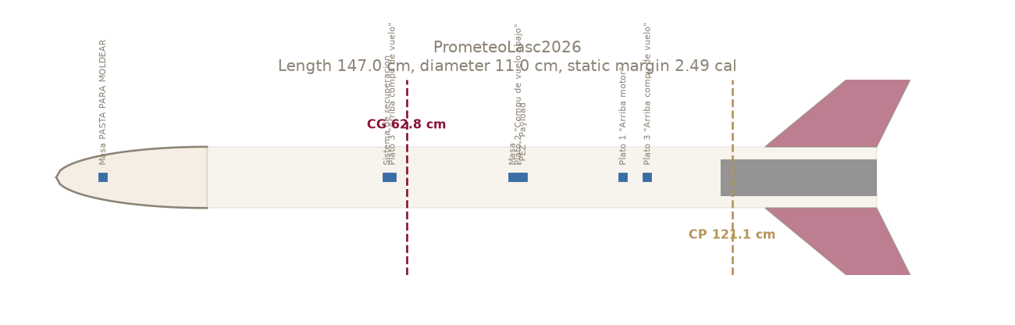
Figure 1. Vehicle side profile with CG/CP and static margin.
Figure 1 shows the vehicle's side profile with its center of gravity and center of pressure marked. PrometeoLasc2026 is 1.47 m long with a body diameter of 11.0 cm (reference area 0.00943 m2). The dry mass is 5.662 kg with the center of gravity at 0.628 m from the nose tip (user-entered override (LoadResult UI field)). Across the ascent the static margin ranges from 2.49 to 3.30 calibers, which is within the RCSM's required 1.5-4.0 cal band (FLT 4.3.5/4.3.6).
Length | 147.0 cm
Diameter | 11.0 cm
Reference area | 0.00943 m2
Dry mass | 5.662 kg
Dry CG | 0.628 m from nose
Static margin range (ascent min.) | 2.49 - 3.30 cal
Stable (FLT 4.3.5/4.3.6, 1.5-4 cal) | YES
Parachute | Diameter (m) | Area (m2) | Cd
Parachute | 2.80 | 6.158 | 0.75
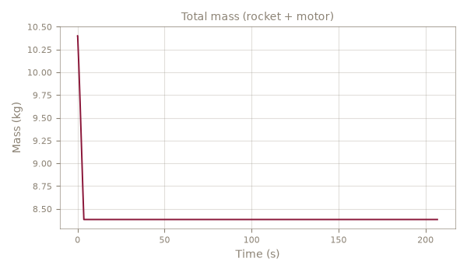
Figure 2. Total mass (rocket + motor) vs. time.

3. Propulsion
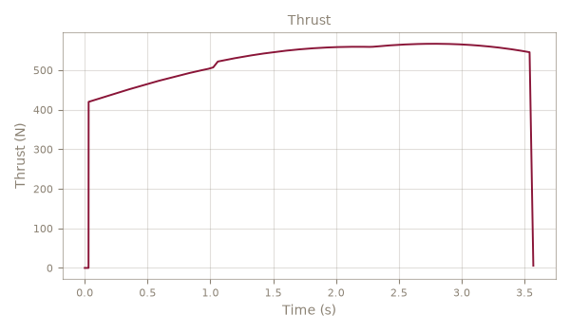
Figure 3. Thrust curve used for this simulation.
The vehicle is powered by a K519 motor (BeyondUP), delivering a total impulse of 1865.1 N*s over a 3.57 s burn (average thrust 522.4 N, peak 566.6 N). Figure 3 shows the thrust curve used for this simulation. Propellant mass is 2.017 kg out of a total loaded mass of 4.738 kg.
Motor | K519 (BeyondUP)
Total impulse | 1865.1 N*s
Average / peak thrust | 522.4 N / 566.6 N
Burn time | 3.57 s
Propellant / dry / total mass | 2.017 / 2.721 / 4.738 kg

4. Trajectory (nominal and ballistic)
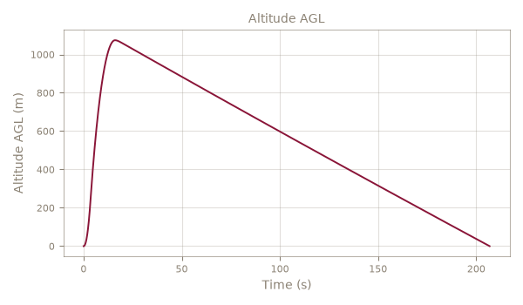
Figure 4. Ascent and descent trajectory - see remaining plots below for individual quantities.
Figure 4 shows the predicted altitude, velocity and acceleration through the ascent, together with the 3D trajectory and ground track. The nominal case (dual-deployment recovery) is compared against the ballistic case (no parachutes) later in Section 8, which bounds the vehicle's worst-case impact energy and downrange distance.

Vertical velocity
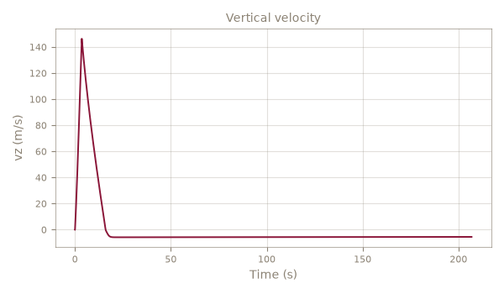

Total velocity
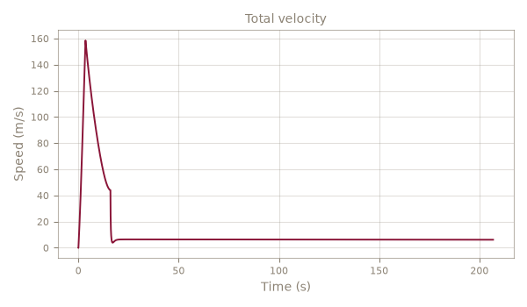

Acceleration (boost phase)
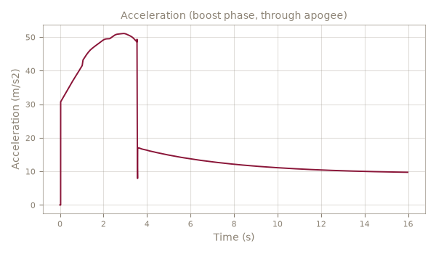

3D trajectory
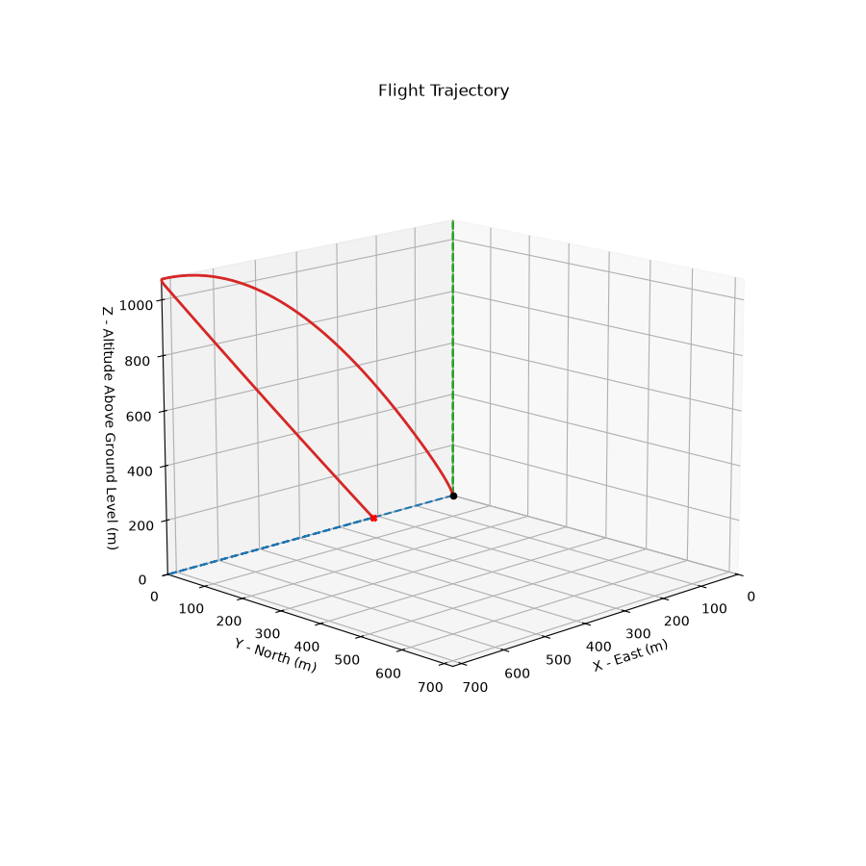

Ground track (top view)
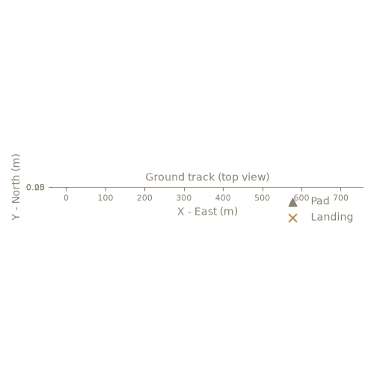

5. Aerodynamics
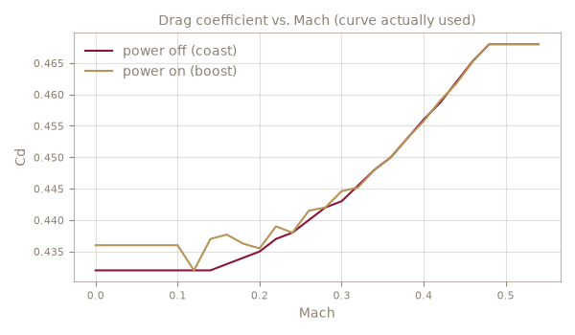
Figure 5. Drag coefficient vs. Mach (curve actually used).
The drag coefficient used in this simulation comes from user-supplied CSV files (power_off_drag.csv, power_on_drag.csv). Figure 5 shows the power-off (coast) and power-on (boost) drag curves actually used; the flight reaches Mach 0.47, past the drag curve's own 0.47 Mach coverage - results above that speed use a constant-Cd extrapolation, not measured drag, and should be treated with reduced confidence.

Mach number vs. time
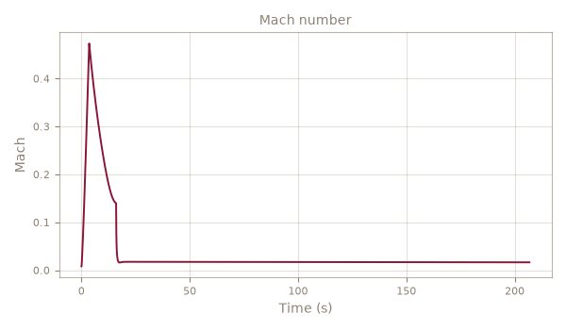

Dynamic pressure vs. time
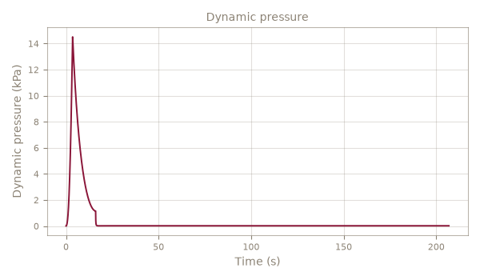

6. Stability
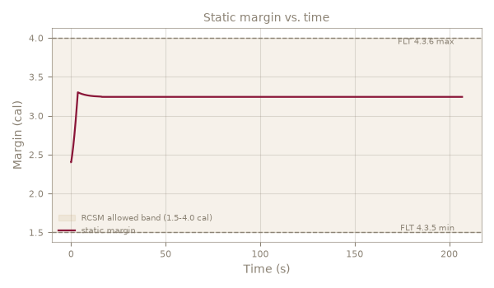
Figure 6. Static margin vs. time, with the RCSM's 1.5-4.0 cal allowed band shaded.
Figure 6 shows the static margin through the flight against the RCSM's required 1.5-4.0 cal band (FLT 4.3.5/4.3.6, shaded). The minimum margin is 2.49 cal and the maximum is 3.30 cal, so the vehicle is compliant throughout the ascent. As an independent check, a hand calculation using the classical Barrowman (1966) method (Barrowman (1966), nose + fins only - body tube and transition normal-force contributions neglected (standard textbook simplification for a slender airframe).) places the center of pressure at 1.221 m from the nose tip, compared to 1.211 m from RocketPy's own (more complete) model - a difference of +0.8%.

CG and CP vs. time
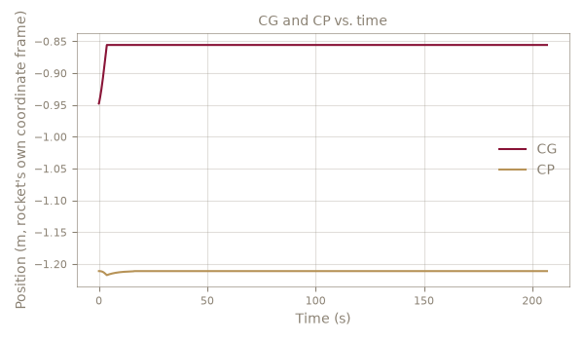

Angle of attack
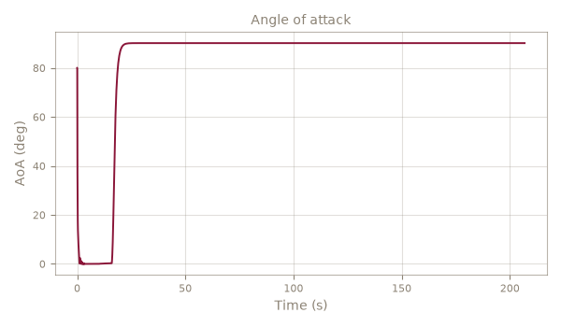

6.1 Independent analytical verification (Barrowman)
Barrowman (1966), nose + fins only - body tube and transition normal-force contributions neglected (standard textbook simplification for a slender airframe).
Nose CN-alpha / CP | 2.00 /rad @ 0.135 m from nose
Fins CN-alpha (total) / CP | 13.32 /rad @ 1.384 m from nose
Hand-calculated CP (total CN-alpha) | 1.221 m (15.32 /rad)
RocketPy's own CP (t=0) / agreement | 1.211 m (+0.8%)

6.2 Comparison against OpenRocket (Ballistic Brasil)
"Static margin (ascent min.)" above is the worst point across the whole ascent - a different, safety-focused number from "Stability at Mach 0.3" below, which is OpenRocket's own default design-view snapshot (t=0 mass, Mach 0.3 aerodynamics only).
Quantity | Ours | OpenRocket | Diff
Overall length | 1.470 m | n/a | n/a
Max diameter | 0.110 m | 0.110 m | -0.36%
Mass without motor | 5.6622 kg | 5.6590 kg | +0.06%
Mass with motor (t=0) | 10.4000 kg | 10.5230 kg | -1.17%
CG with motor (t=0, from nose) | 0.9477 m | 1.0000 m | -5.23%
CP at Mach 0.3 | 1.2137 m | 1.2120 m | +0.14%
Stability at Mach 0.3 (t=0) | 2.427 cal | 2.411 cal | +0.65%
Apogee AGL | 1074.4 m | 1054.7 m | +1.86%
Max Mach | 0.473 | 0.463 | +2.17%
CP-derived rows use a 2% tolerance (RocketPy and OpenRocket use slightly different body-lift models, a documented and expected difference); every other row uses 1%.

7. Recovery and landing footprint
Stage | Diameter (m) | Area (m2) | Cd*S (m2) | Deploy (s) | Sim descent (m/s) | Hand-calc descent (m/s)
Parachute | 2.80 | 6.158 | 4.618 | 16.0 | 6.1 | 5.5
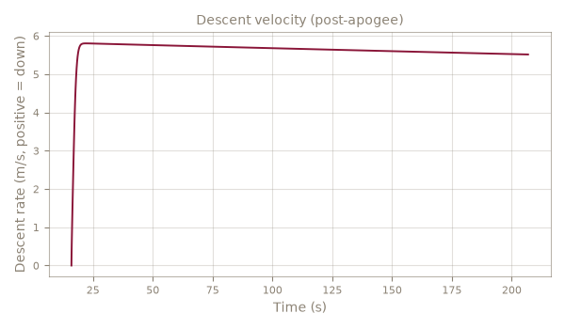
Figure 7. Descent velocity after apogee.
The recovery system uses 1 parachute(s): Parachute. Figure 7 shows the descent rate after apogee; the simulated descent rates are compared against a hand-calculated terminal velocity for each stage in the table above, as a cross-check on the parachute Cd*S values used.

8. Flight cases (RCSM)
Case | Apogee AGL (m) | Max speed (m/s) | Rail exit (m/s) | Note
Ballistic | 1074.4 | 158.5 | 16.6
Nominal | 1074.4 | 158.5 | 16.6
DrogueOnly | 1074.4 | 158.5 | 16.6 | This rocket has only ONE recovery event configured (not a real drogue+main dual-deployment topology - REC 8.1.1). Running with that single chute as if it were the drogue; treat this case as informational, not a real dual-deploy compliance check.
MainAtApogee | 1074.4 | 158.5 | 16.6 | This rocket has only ONE recovery event configured (not a real drogue+main dual-deployment topology - REC 8.1.1). Testing that single chute triggered at apogee instead of its normal altitude; treat this case as informational, not a real dual-deploy compliance check.
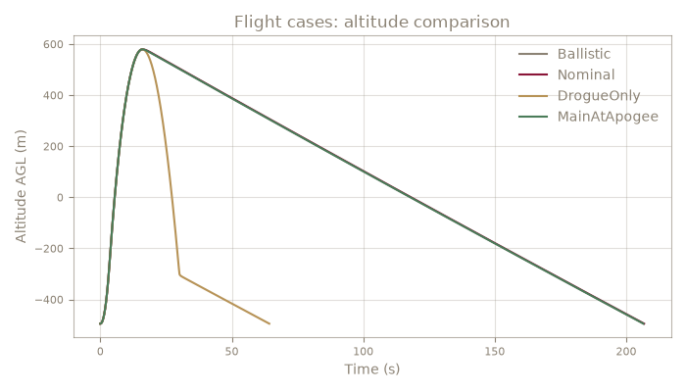
Figure 8. Altitude comparison across the required flight cases.

9. Monte Carlo dispersion
Monte Carlo dispersion analysis varies the uncertain inputs listed below across 30 simulated flights. The apogee is predicted at 1067.4 m with a 90% interval of [1018.1, 1116.3] m. The landing footprint (1/2/3-sigma ellipses) bounds where the vehicle is expected to land under wind uncertainty. With only 30 completed trajectories, this is a rough check, not a statistically meaningful dispersion estimate (fewer than 100 samples).
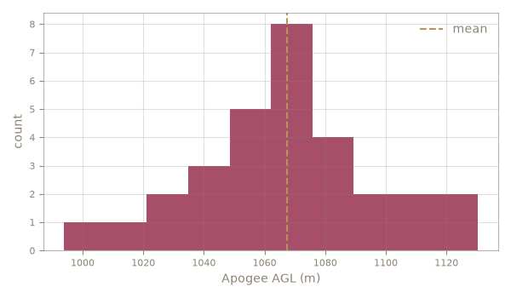
Figure 9. Apogee distribution across Monte Carlo trajectories.
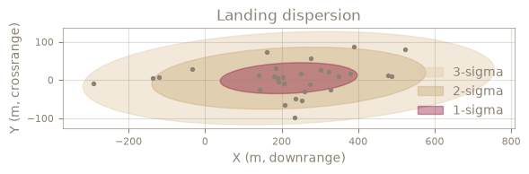
Figure 10. Landing dispersion footprint (1/2/3-sigma).
Uncertainty | Std dev | Source
wind_speed_ms | 1 | no source, low confidence - guessed as 30% of the OpenRocket-recorded wind speed
wind_direction_deg | 15 | no source, low confidence - typical launch-day wind direction variability
dry_mass_kg | 0.1132 | no source, low confidence - assumed 2% (typical scale + component-count uncertainty for a student rocket)
dry_cg_m | 0.01 | no source, low confidence - assumed +-1cm CG placement/measurement uncertainty. NOTE: rocketpy's StochasticRocket does NOT preserve an overridden center_of_mass_without_motor unless this is explicitly passed - found 2026-09-26, see PROGRESS.md
total_impulse_Ns | 37.12 | no source, low confidence - assumed 2%, typical SRAD motor-to-motor total impulse variation for KNSB
power_off_drag_factor | 0.05 | no source, low confidence - assumed 5% Cd curve uncertainty
power_on_drag_factor | 0.05 | no source, low confidence - assumed 5% Cd curve uncertainty
inclination_deg | 2 | no source, low confidence - typical rail-angle setup tolerance, +-2 deg
heading_deg | 5 | no source, low confidence - typical rail-heading setup tolerance, +-5 deg
parachute_lag_s | 0.5 | no source, low confidence - avionics/ejection-charge delay jitter
parachute_cd_s_factor | 0.1 | no source, low confidence - assumed 10% parachute Cd*S uncertainty

10. Global min-max table
Minimum and maximum of every key flight variable across the full simulated trajectory, with the time each occurs.
Variable | Minimum | at t (s) | Maximum | at t (s)
Altitude AGL (m) | -0.0 | 206.81 | 1074.4 | 15.98
Vertical velocity (m/s) | -5.81 | 22.13 | 146.33 | 3.57
Total velocity (m/s) | -0.00 | 0.02 | 158.48 | 3.57
Total acceleration (m/s2) | -0.00 | 0.03 | 364.45 | 15.99
Mach number (-) | 0.008 | 0.01 | 0.473 | 3.57
Dynamic pressure (kPa) | 0.00 | 0.02 | 14.51 | 3.57
Total mass (rocket + motor) (kg) | 8.383 | 3.57 | 10.400 | 0.00
Center of gravity (m from nose) | 0.856 | 3.57 | 0.948 | 0.00
Center of pressure (m from nose) | 1.211 | 0.00 | 1.218 | 3.57
Static margin (cal) | 2.40 | 0.00 | 3.30 | 3.57
Angle of attack (deg) | -0.00 | 2.45 | 90.14 | 32.22
Thrust (N) | 0.0 | 0.00 | 566.6 | 2.78

11. Discussion and conclusions

11.1 Discussion
The predicted apogee of 1074.4 m AGL is reached at t = 16.0 s, with a maximum velocity of 158.5 m/s (Mach 0.47) during the boost phase. The static margin stays within 2.49 to 3.30 calibers across the ascent, which is compliant against the required 1.5-4.0 cal band.

11.2 Conclusions
Based on the results above, the vehicle is predicted to fly to 1074.4 m AGL and recover within the dispersion footprint described in Section 8. The vehicle satisfies the RCSM's static margin requirement (FLT 4.3.5/4.3.6) throughout the ascent. The assumptions and data sources in this report should be reviewed before treating these numbers as final for a competition submission.

11.3 Files delivered
Item | Detail
Simulation report | report.pdf / report.docx (this document)
.ork design file | PrometeoLasc2026.ork
.eng motor file | Icarus_I_K519.eng
Drag curve source | user-supplied CSV files (power_off_drag.csv, power_on_drag.csv)
Flight data CSV | flight_data.csv
OpenRocket-format flight data CSV | flight_data_openrocket_style.csv
Monte Carlo dispersion data | 30 completed trajectories
Per-case runnable .py scripts | see the LASC/competition .zip package (CRS 10.1.3/10.1.5/10.1.6)

11.4 Assumptions and data sources
- Dry mass: 5.6622 kg (user-entered override (LoadResult UI field))
- Dry CG: 0.6279 m from nose (user-entered override (LoadResult UI field))
- Drag curve: user-supplied CSV files (power_off_drag.csv, power_on_drag.csv)
- Atmosphere: standard atmosphere model with the .ork's own recorded average wind speed/direction (not a live weather download, not a full altitude profile).
- WARNING: this flight reaches Mach 0.47, past the drag curve's own 0.47 Mach coverage - results above that speed are constant-Cd extrapolation, not measured drag.

Appendix A — Input data

A.1 Motor
Designation | K519
Manufacturer | BeyondUP
Diameter | 75.0 mm
Length | 280.0 mm
Delays | 0
Propellant mass | 2.0167 kg
Total mass (loaded) | 4.7378 kg

A.2 Drag curve excerpt (evenly sampled)
Power-off (coast)
0.138 | 0.4320
0.156 | 0.4330
0.175 | 0.4340
0.195 | 0.4350
0.217 | 0.4370
0.239 | 0.4380
0.264 | 0.4400
0.290 | 0.4420
0.318 | 0.4450
0.348 | 0.4490
0.380 | 0.4530
0.414 | 0.4580
Power-on (boost)
0.105 | 0.4360
0.116 | 0.4310
0.130 | 0.4340
0.173 | 0.4370
0.202 | 0.4360
0.232 | 0.4390
0.262 | 0.4420
0.293 | 0.4430
0.324 | 0.4460
0.356 | 0.4500
0.387 | 0.4540
0.419 | 0.4590

A.3 Parachutes
Parachute: 2.80 m, Cd 0.75 - deploy: simulated at apogee (.ork says "never")
OpenRocket 'never' deploy event (no automatic deployment is configured for this component in the .ork - typical of a real SRAD altimeter system OpenRocket's own deployment options don't model). Assumed apogee-triggered deployment - verify against the actual flight computer's configured deployment altitude/delay.

A.4 Atmosphere, wind and rail
Launch site | -21.9079, -48.9616, 495 m MSL
Wind | 2.7 m/s from 90 deg
Launch rail | 4.0 m, 80.0 deg from vertical, heading 90 deg

Appendix B — Model validation
This is the SIMULATION MODEL's own track record against 2 real flights of a different vehicle (PROMETEO) - not specific to the vehicle in this report. Included as evidence of how much to trust this application's predictions in general.
- V1 (2026-07-04, Pachuca profile): predicted 1132.1 m vs. real flight 1019.9 m (error +11.0%, INCONCLUSIVE against +-5%). Conditions: weather recorded by OpenRocket for this flight, not live/historical data. Input data incomplete: the design file for this specific flight configuration is not yet available, so this case reuses a center-of-gravity measurement taken from a different vehicle configuration instead of one specific to this flight. This case will become a real pass/fail once that file is added; until then its error number reflects that input gap as much as the flight model itself, so it is not scored as a plain pass or fail.
- V2 (LASC 2026, Iacanga): predicted 1098.3 m vs. real flight 1137.0 m (error -3.4%, PASS against +-5%). Conditions: the .ork's OWN recorded wind/atmosphere, NOT the actual Iacanga flight-day weather. At the Launch Readiness Review, LASC officials independently re-simulated this vehicle on-site and predicted 1138 m (RocketPy, CRS 10.2.1) - we did not reproduce their exact inputs; this is our own independent replication, not a claim of matching their number. Mass/CG source: OpenRocket computed (stored simulation 'Ballistic Brasil', t=0, minus motor, total mass overridden to 10.3700 kg).

Appendix C — RCSM compliance (Nominal case)
Rule | Check | Status | Detail
FLT 4.3.4 | Rail exit velocity >= 30 m/s | PASS | 23.4 m/s (see analysis)
FLT 4.3.5/4.3.6 | Static margin 1.5-4.0 cal | PASS | 1.92-2.57 cal
PRS 5.1.4 | Thrust-to-weight >= 5:1 | Verify at LRR | 4.98:1 modelled

