**ROBUST FUSION OF MULTIMODALITY MEDICAL IMAGES WITH FIDELITY DRIVEN OPTIMIZATION AND DETAIL -PRESERVATION**

***ABSTRACT* *---*** ***Medical image fusion is an important computer-aided technique that combines critical elements from diverse medical pictures to improve diagnostic detail and accuracy. Despite recent advances, many fusion systems fail to provide enough information and textures for accurate disease identification, generally due to insufficient noise removal from the original medical image. In response to these problems, we offer a unique fusion technique designed for multimodal medical imaging. Our method uses fidelity-driven optimized (FDO) reconstruction to maintain important information while reducing noise impacts. Furthermore, we present a rank-coefficient optimization strategy for reducing the impact of noise on multiple mediums medical imaging Furthermore, we recommend for the use of a repetitive detail preservation strategy to incorporate extra data as well as textures in the initial multimodal medical images while retaining high resilience. The final product demonstrates the capabilities of our innovative fusion technology. Extensive studies have proved the resilience of our technique, notably in dealing with noisy medical images, highlighting its potential for use in diagnostic applications.***  
***Key words: Weighted mean curvature, Multi-modality, Low-rank approximation, Detail preservation, and Image fusion.***

1. **INTRODUCTION**

Medical imaging is an essential component of modern healthcare procedures, providing practitioners with priceless insights into the complex the structures of the body of a person. These insights are critical in determining an accurate diagnosis and developing successful treatment solutions. As technology advances, there is a compelling need to use data from many imaging modalities to provide comprehensive and precise assessments of patient situations. As a result, the development of novel methods for picture restoration and fusing is now recognized as a critical area in medical imaging.

One such potential path of research is the combination of Details Preserving Guided Fusion and Fidelity-Driven Optimization Reconstruction. This novel fusion technique marks a substantial advancement in improving the quality of integrative health imaging. This method has enormous potential to revolutionize medical imaging practices by expertly conserving important data through targeted fusion techniques while also maximizing fidelity qualities during the reconstruction process. At its foundation, the fidelity-driven part of this technique focuses on increasing reconstruction efficiency via sophisticated techniques that concentrate the faithful version of the gathered data. The attentive mitigation of artifacts, the background noise, and distortions, all of which are inherent issues in the field of medical image reconstruction, is critical to the success of this attempt.

Furthermore, it is critical to understand the distinct difficulties that each type of imaging modality presents. In contrast, the use of single-photon emission computed tomography (SPECT) examination may not be able to sufficiently capture the subtle aspects of diseases within a single structure due to its limited spatial resolution. For example, positron emission tomography (PET) studies frequently show much greater FDG uptake in infected regions compared to normal tissues. This restriction highlights the value of MRI, also known as magnetic resonance imaging, which improves image interpretation accuracy by providing better anatomical and structural information.

By combining functional and structural images from multiple different types of imaging, the potential to improve the outcomes of patients becomes progressively tangible. The profound impact of medical image integration across diverse modalities on progressing medical treatment approaches and allowing advance in various knowledgeable medical subjects emphasizes its growing importance.

# **Literature review**

In 2022, K. He et al. [1] used an iterative technique called detail preserved guided fusion (DPGF) to combine textures along with comprehensive information from several modalities of medical pictures, focusing on high signal-to-noise ratios. Experimental results showed that their methodology outperformed numerous cutting-edge fusion methods. Notably, the approach demonstrated significant robustness when handling noisy medical pictures, indicating its possible utility in applications related to diagnosis. However, it is crucial to highlight that, while the method proved success in improving image quality and resilience, there might exist limitations in regard to computing complexity or usefulness to specific categories of clinical imaging data, necessitating additional research and validation.

Kavita et al. [2] investigated how to improve fusion image quality by combining neural network models and optimization strategies in a 2022 study. The paper dives into several fusion techniques as compares the results of various research attempts, with a particular emphasis on the use of pulse coupling neural network networks (PCNN) alongside distinct optimization tactics. Notably, the paper examines PCNN setups using various optimization strategies, with the swarming technique of salps standing out for performance enhancement. The combined use of PCNN with the Salp Swarm Optimization (SSO) technique is tested, and the findings are promising, with a peak the signal to noise rate ( PSNR ) of 45.93 as well as a structural similarities index (SSIM) of a coefficient of However, it is vital to recognize this method's limitations, such as computational cost, sensitivity to parameter adjustment, and generalizability across other datasets or different types of imaging. Furthermore, the efficiency of the suggested technique might differ based on individual application contexts, necessitating additional validation in situations in the real world.

Dinh et al.[3] used a strategy in their 2021 study to preserve key details transmitted from input photos, resulting in merged images with crucial information. Experimental results indicated that the proposed approach significantly improved the quality of fusion photographs while keeping edge information acquired from the input photos. However, it is crucial to note that this method has some shortcomings, including its vulnerability to artifacts or abnormalities created within the fusion process, in addition to its ability to perform variability among numerous kinds of input images and different types of imaging. Furthermore, the technique's computational difficulty and resource requirements may provide practical hurdles, especially in immediate form or resource-constrained applications. To completely assess its security and generalizability, it would require more validation across other datasets as well as careful evaluation against alternative fusion approaches.

In recent 2020 study, Ruichao Hou and al.[4] used inverse spatiotemporal variance thresholding (STVT) to recreate the final image by combining the restored images. The experimental findings show that the proposed strategy produces promising outcomes, outperforming numerous state-of-the-art methodologies. However, it is vital to recognize this method's possible limitations, which may include issues with computational complexity, parameter adjustment, and generalizability across varied datasets and imaging circumstances. Furthermore, parameters such as the quality of the picture, level of noise, and input data characteristics may all have an impact on the suggested scheme's effectiveness. As a result, further validation and modification may be required to fully assess its use and resilience in a variety of real-world scenarios.

In 2017, Shunren Xia et al.[5] used an inverse Non-Subsampled Shearlet Transformed (NSST) to extract the fused image out of the merged components. Their suggested fusion method was tested on a variety of healthcare CT and MRI scans, along with comparisons to numerous established fusion of images techniques. The experimental results show that the suggested strategy outperforms existing approaches when it comes to of both subjective and objective evaluation measures. However, it is critical to recognize potential constraints such as complexity of computation, susceptibility to parameter adjustment, and the need for additional validation across varied datasets and clinical circumstances to ensure generalizability along with robustness in applications that are practical.

In 2019, Achanta Dr. Durga Prasad et al. used a variety of quantitative metrics to demonstrate the advantage of the approach they used with image fusion, which includes visual data fidelity-based fusion of images quality indicators, spatial frequency error ratio, edge information-based pictures fusion quality metrics, and structural comparable index-based the picture fusion quality metrics. Furthermore, when compared to existing modern facilities picture fusion approaches, their proposed methodology outperformed the latter on average execution time. However, the method's shortcomings may include difficulties in managing sophisticated image features as well as variations in photographing settings, which could impair the accuracy and endurance of the procedure used for fusion.

# **METHODOLOGY**

1. **Proposed Methodology:**

Figure 1 depicts the proposed process, which begins with the collection of images from CT and MRI that reflect diverse medical imaging modalities. These photos are used as the starting feed for the fusion procedure. The initial phase of the methodology is preparing the images that are entered to improve their quality and readiness for fusion. This preprocessing stage employs noise reduction algorithms and brightness normalization to reduce artifacts and provide uniform image properties across modalities.

After preprocessing, the images are converted into the frequency domain using the Fourier or wavelet transform. This modification enables a more thorough study of image characteristics and makes the fusion process easier. The process then moves on to the frequency domain optimization, which involves optimizing fusion parameters based on the frequency properties of the images. This optimization process seeks to improve fusion quality while 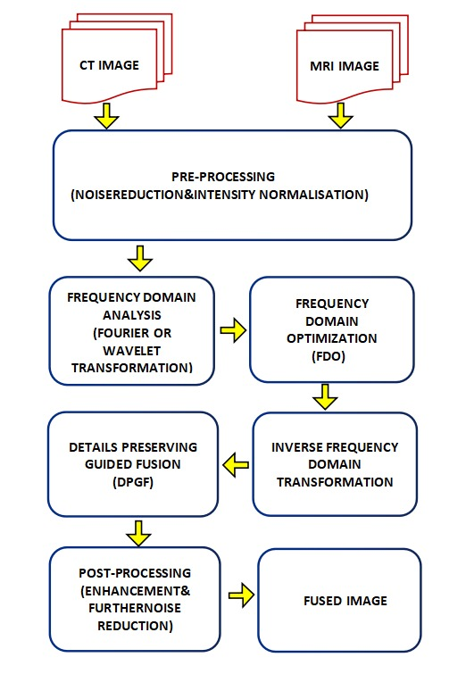conserving critical features from each modality.

**Fig 1.** Proposed Block Diagram.

After performing frequency domain optimization, a reverse frequencies domain transformation is utilized to generate the spatially fused image. This conversion reconstructs the fused image using the optimum frequency domain representation, combining information from both modes while maintaining pertinent information and minimizing artifacts.

Following the inverse conversion, the methodology employs Detail Preserving Guided Fuse (DPGF) approaches to improve the quality if the fused image even further. DPGF approaches stress the preservation of key details with successfully blending information from several modalities, yielding a fused image with critical diagnostic information. Post-processing procedures are then applied to the combined image, incorporating enhancing techniques and additional noise reduction, to improve the clarity and overall appearance. These post-processing stages refine the fused image to ensure that it fulfills the minimum requirements for clinical diagnosis and interpretation.

Finally, the process produces the fused image, which represents a strong integration of data from both the medical imaging modalities. This fused image captures the clinical insights from each modality while eliminating redundancies and artifacts, giving physicians a comprehensive and dependable depiction for effective medical evaluation and decision-making.

# **Result AND ANALYSIS**

**Fig 2**.Fused outcome1

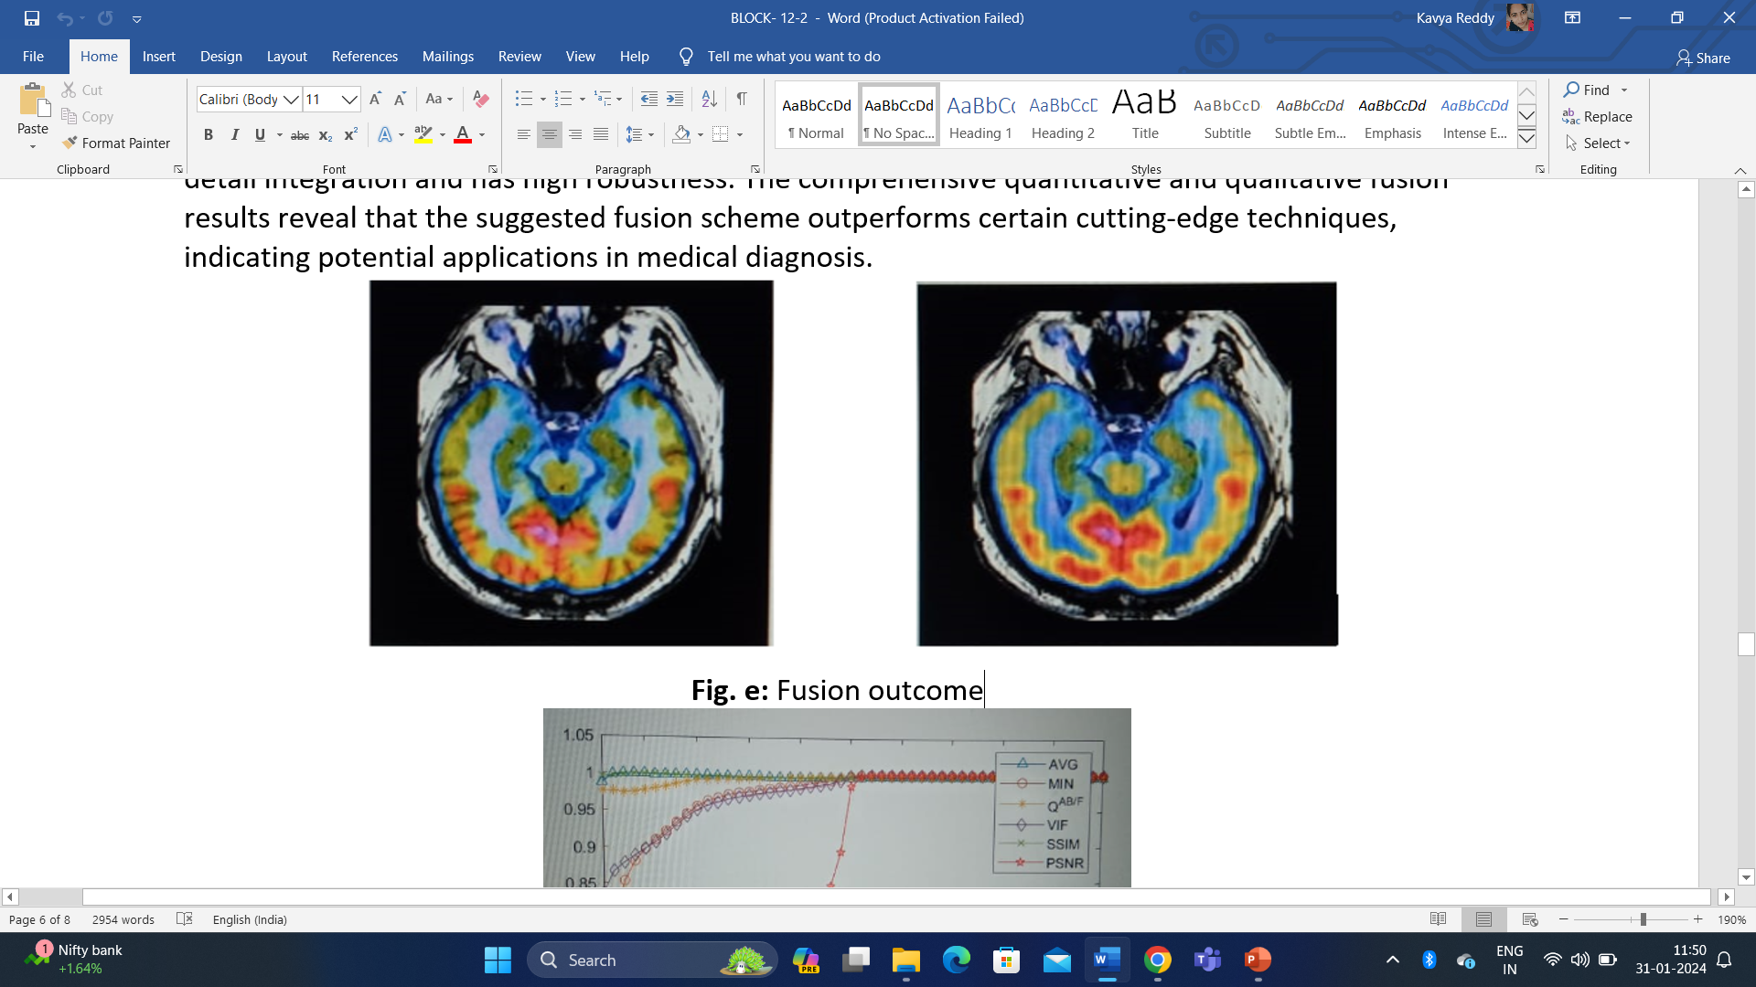

**Fig:3** Fused outcome2

The processed image obtained from the fused result of the previously described methods is shown in Figure 2. In order to make the original fused image suitable for additional evaluation and comprehension in medical situations, this intermediary step is essential. This image has undergone processing using methods like intensity normalization and noise reduction in an effort to minimize artifacts and guarantee consistency between modalities.

Because of this, the processed image is clearer and of higher quality than the original fused output, which paves the way for medical practitioners to make more accurate diagnostic judgments. Further information about the precise preprocessing techniques and settings used might be included in the captions or accompanying text, which would provide viewers with additional insight in the processing workflow. In summary, Figure 3 provides a graphical illustration of the significance of processing in improving the accuracy and consistency of fusion medical images for use in clinical decision-making, below Figure 4 shows the plot for different values like

AVG (The average): This metric determines the average value from a series of data points. In the realm of the processing of images, it could be the median brightness value of cells in a picture.

MIN (Minimum): The minimum value in a dataset. In the processing of images, it could refer to the lowest pixel intensity contained in a picture.

QAB/F (Quality Analysis of Binarized/Filtered Photos): This indicator measures the quality of visuals that have been processed by binarized or filtered. It could entail determining how well the consolidation or filtering preserves significant features or eliminates undesirable noise.

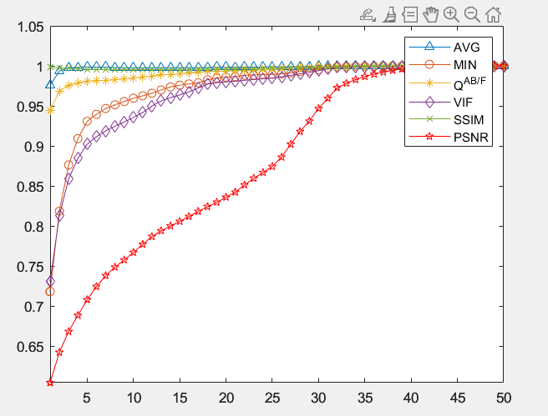

**Fig:4** plots of objective measurements

|  |  |  |  |  |  |
| --- | --- | --- | --- | --- | --- |
| **AVG** | **MIN** | **QAB/F** | **VIF** | **SSIM** | **PSNR** |
| 12.201 | 5.4015 | 0.77291 | 0.5202 | 0.69728 | 34.414 |

VIF (Visual Info Fidelity) is a metric for determining the similarity of two images based on both brightness and structural information. It measures the extent to which visual information is saved when one picture is compared to a different one and is commonly used to assess the quality of compressing images or restoration methods.   
  
SSIM (Structural Similarity Rating Measure) is a popular metric for comparing the similarity of two photographs. It considers luminance, contrast, etc structure to determine perceived quality. Higher SSIM scores suggest a stronger resemblance between photos.

PSNR (Peak Signals-to-Noise Ratio) is a statistic used to assess the resolution of reconstructed or condensed images. It is calculated by dividing the greatest possible strength of a signal by the power of noise that corrupts it that influences the accurateness of its representation. A higher PSNR number indicates better quality.   
  
These metrics are frequently used in photographic processing and artificial intelligence activities to objectively evaluate the effectiveness of techniques or processes in terms of image quality preservation, noise reduction, and faithfulness to the original photograph.

The various comparison of modality images are shown in below table 5

|  |  |  |  |  |  |  |
| --- | --- | --- | --- | --- | --- | --- |
| **S.no** | **AVG** | **MIN value** | **QAB/F** | **V(IF)** | **SSIM** | **PS/NR** |
| 1 | 10.462 | 4.5873 | 0.7281 | 0.47672 | 0.71081 | 20.543 |
| 2 | 10.336 | 5.0569 | 0.74658 | 0.51609 | 0.72164 | 33.694 |
| 3 | 10.371 | 4.909 | 0.74022 | 0.50087 | 0.71478 | 25.607 |
| 4 | 10.343 | 4.8551 | 0.77194 | 0.50988 | 0.71341 | 32.835 |
| 5 | 12.747 | 4.9061 | 0.812 | 0.52103 | 0.69913 | 32.005 |
| 6 | 12.206 | 5.2119 | 0.79578 | 0.51381 | 0.68185 | 32.653 |
| 7 | 10.009 | 4.4593 | 0.78328 | 0.50535 | 0.73462 | 30.674 |
| 8 | 10.012 | 4.6117 | 0.74959 | 0.49987 | 0.73413 | 30.727 |

**Fig:5** Table for comparison for various modality images

# **Conclusion**

Finally, the suggested process for robust fusing of multimodality medical imaging, which incorporates fidelity driven optimization and detail preservation, provides a comprehensive strategy for effectively integrating information from CT and MRI. The methodology, which includes pretreatment, domain of frequency evaluation, optimizing, detailed preservation, and post-processing, ensures the development of fused pictures that maintain key diagnostic information while eliminating artifacts and redundancy. The suggested method uses methods like reduction of noise, guided fusion, and optimization to improve both the reliability and quality of fused pictures, allowing for better healthcare interpretation and decision-making. However, more validation and improvement are required to reach its full efficiency in clinical settings.

# **FUTURE SCOPE**

In the future, there are various promising avenues for developing the proposed methodology for robust fusion of multi-modality medical pictures. One promising area of research is the incorporation of methods based on deep learning, which could significantly improve performance by allowing for more efficient extraction and fusion procedures that can be tailored to different imaging conditions. Furthermore, broadening the methodology to include fusion of other modality between MRI and CT, such as PET or an ultrasound, has the potential to increase its utility and flexibility in clinical situations. Creating algorithms that adapt for dynamically modifying fusing factors based on image attributes and clinical needs would enhance the method's robustness and adaptability. Rigorous testing along with cooperation with medical specialists are required to confirm the method's efficacy and facilitate its implementation in real-world clinical settings. Exploring strategies for quantifying uncertainty in fused pictures could boost diagnostic confidence and simplify clinical interpretation. Developing new fusion methods beyond those already in use may result in further improvements in fusing quality and efficiency. Furthermore, adopting the method for real-time use in intraoperative imaging or other time-critical applications would greatly increase its utility and influence in medical practice. Continuous study and improvement activities in these areas are critical to moving the suggested approach forward and achieving its potential for better medical picture fusion and interpretation.

# **REFERENCE**

1. K. He, X. Zhang, D. Xu, J. Gong and L. Xie, "Fidelity-driven Optimization Reconstruction and Details Preserving Guided Fusion for Multi-Modality Medical Image," in IEEE Transactions on Multimedia, vol. 25, pp. 4943-4957, 2023.
2. Study of image fusion optimization techniques for medical application by Pydi kavita ,June 2022.
3. Multi-modal medical image fusion based on equilibrium optimizer algorithm and local energy functions by Phu-Hung Dinh 2021
4. Multimodal medical image fusion based on the spectral total variation and local structural patch measurement by Hou July 2020.
5. Image Fusion of CT and MR with Sparse Representation in NSST Domain by Shunren Xia,Nov 2017.
6. Medical image fusion based on laws of texture energy measures in stationary wavelet transform domain by Padma Ganasala, Achanta Durga Prasad,Dec 2019.
7. A. Kumar, M. Fulham, D. Feng, and J. Kim, “Co-learning feature fusion maps from PET-CT images of lung cancer,” IEEE Trans. Med. Image., vol. 39, no. 1, pp. 204–217, Jan. 2020.
8. X. Li et al., “Laplacian redecomposition for multimodal medical image fusion,” IEEE Trans. Instrum. Meas., vol. 69, no. 9, pp. 6880–6890, Sep. 2020.
9. J. Gao, P. Li, Z. Chen, and J. Zhang, “A survey on deep learning for multimodal data fusion,” Neural Comput., vol. 32, no. 5, pp. 829–864, 2020.
10. Z. Ning, Q. Xiao, Q. Feng, W. Chen, and Y. Zhang, “Relation-induced Multi-modal shared representation learning for Alzheimer’s disease diagnosis,” IEEE Trans. Med. Image., vol. 40, no. 6, pp. 1632–1645, Jun. 2021, doi: 10.1109/TMI.2021.3063150.
11. W. Kong, Y. Chen, and Y. Lei, “Medical image fusion using guided filter random walks and spatial frequency in framelet domain,” Signal Process., vol. 181, 2021, Art. no. 107921.
12. D. Tao, J. Cheng, Z. Yu, K. Yue, and L. Wang, “Domain-Weighted majority voting for crowdsourcing,” IEEE Trans. Neural Netw. Learn. Syst., vol. 30, no. 1, pp. 163–174, Jan. 2019.
13. R. Liu, J. Liu, Z. Jiang, X. Fan, and Z. Luo, “A bilevel integrated model with data-driven layer ensemble for multi-modality image fusion,” IEEE Trans. Image Process., vol. 30, pp. 1261–1274, 2021.
14. A. P. James and B. V. Dasarathy, “Medical image fusion: A survey of the state of the art,” Inf. Fusion, vol. 19, pp. 4–19, 2014.
15. J. Ma, H. Xu, J. Jiang, X. Mei, and X.-P. Zhang, “DDcGAN: A dual-discriminator conditional generative adversarial network for multi-resolution image fusion,” IEEE Trans. Image Process., vol. 29, pp. 4980–4995, 2020.
16. R. Nie, C. Ma, J. Cao, H. Ding, and D. Zhou, “A total variation with joint norms for infrared and visible image fusion,” IEEE Trans. Multimedia., vol. 24, pp. 1460–1472, 2022, doi: 10.1109/TMM.2021.3065496.
17. B. Wang et al., “Latent representation learning model for multi-band imsssages fusion via low-rank and sparse embedding,” IEEE Trans. Multimedia., vol. 23, pp. 3137–3152, 2021.
18. M. Diwakar et al., “A comparative review: Medical image fusion using SWT and DWT,” Mater. Today Proc., vol. 37, pp. 3411–3416, 2021.
19. G. Bhatnagar, Q. Wu, and L. Zheng, “Directive contrast based multimodal medical image fusion in NSCT domain,” IEEE Trans. Multimedia., vol. 15, no. 5, pp. 1014–1024, Aug. 2013.
20. K. He et al., “Infrared and visible image fusion based on target extraction in the nonsubsampled contourlet transform domain,” J. Appl. Remote Sens., vol. 11, no. 1, 2017, Art. no. 15011.