**Lab Quiz** (Midterm Lab Quiz)

**1. Webex API Tasks (30 pts.)**

You will be using the Webex Teams API to interact with meetings and rooms. Here are the tasks and the approximate time allocations:

* **Install required libraries (5 minutes):**

pip install webexteamssdk

* **Task 1: Create a Meeting** Write a Python script to create a meeting using the Webex API.
* **Task 2: Create a Room and Add People** Extend your script to create a room and add a participant using their email address.  
  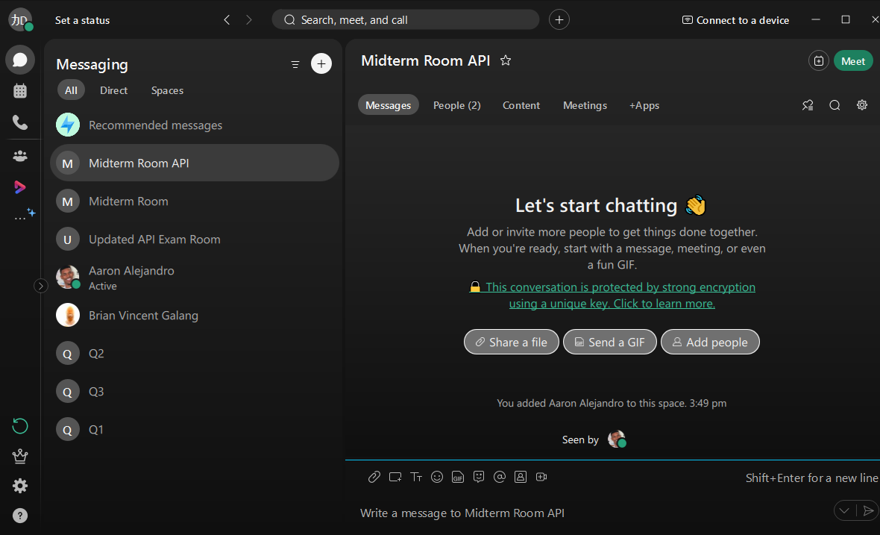

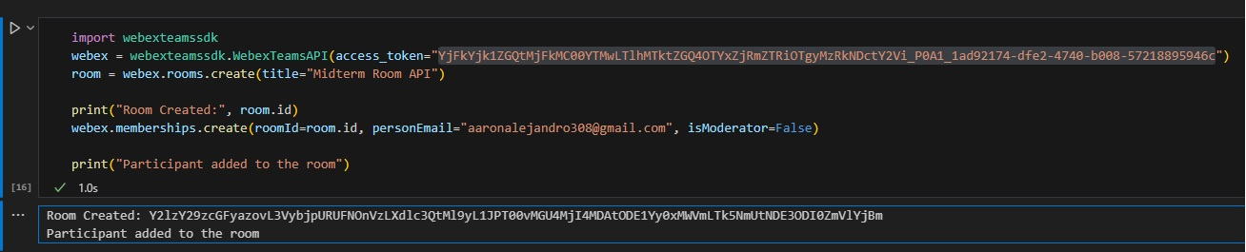

* **Task 3: Send a Message to the Room** After adding a participant, send a message to the room using the API.  
  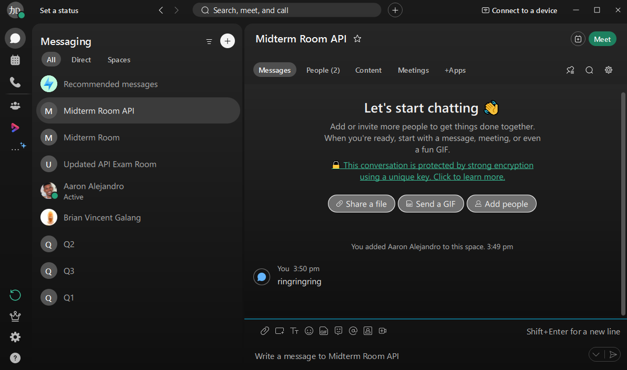

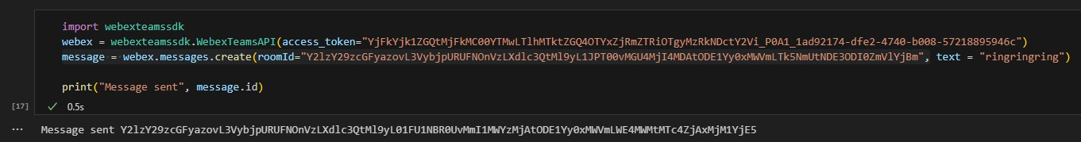

* **Task 4: List Messages** List all messages in the room and display them in the console.

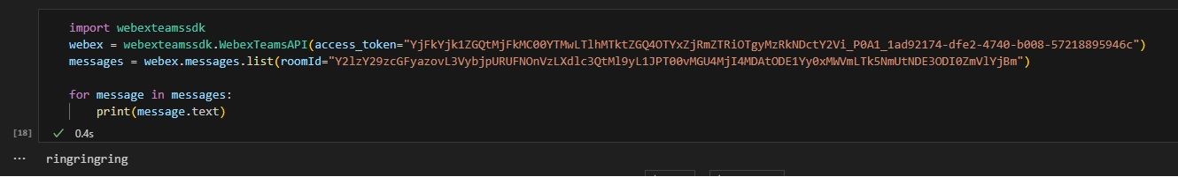

* **Task 5: Delete a Message** Write a function to delete a specific message using its message ID.

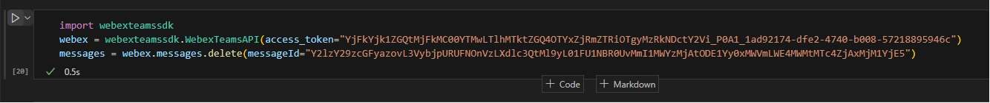

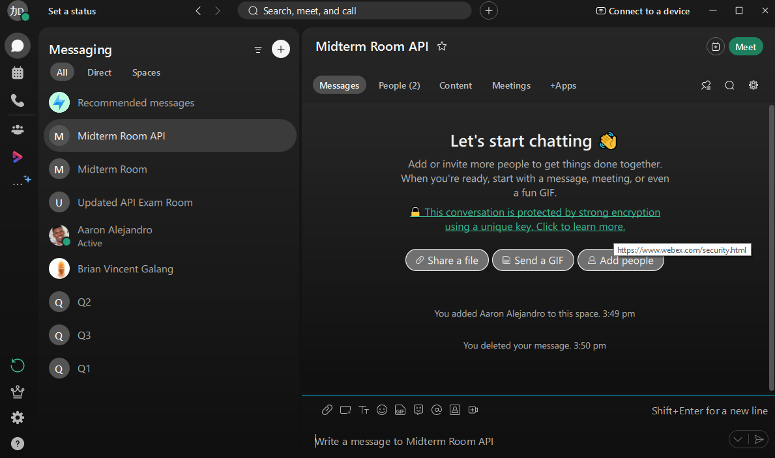

* **Task 6: Test and Take Screenshots** Test the complete script by running it in your terminal. After each task, take a screenshot of the terminal output as proof of completion.

**2. Faker Program**

Use the Faker library to generate random data such as names, emails, and phone numbers. Perform the following tasks:

* **Install Faker library**

pip install faker

* **Task 1: Generate Fake Data** Write a Python script that uses Faker to generate and print 10 fake names, emails, and phone numbers.
* **Task 2: Test and Take Screenshot** Run the script and take a screenshot of the output.

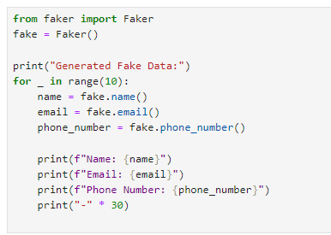

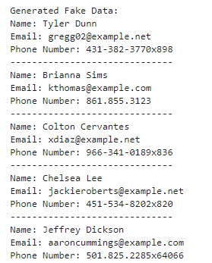 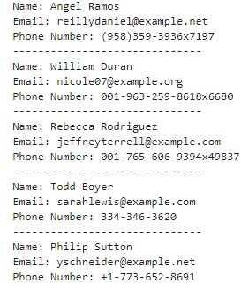

**3. Push Files and Screenshots to GitHub via Linux Command Line**

* **Step 1: Initialize a Git repository**
* **Step 2: Add Files**
* **Step 3: Commit Files Step 4: Push**