**PROJECT TITLE: CREATING A CHATBOT DEPLOYMENT WITH IBM CLOUD WATSON ASSISTANT**

**PHASE 3: DEVELOPMENT PART I**

**1.Access My IBM Cloud Watson Assistant:**

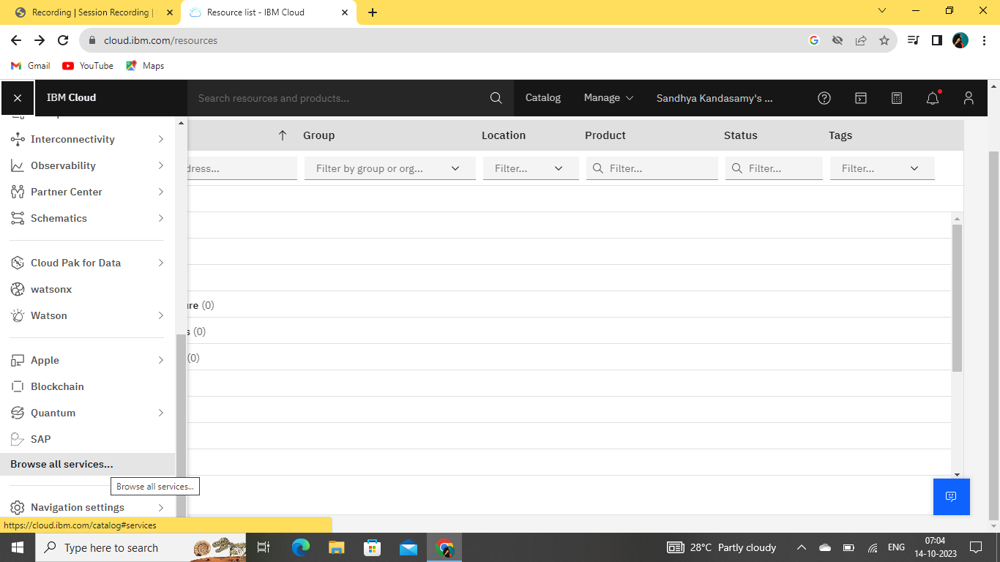

**IBM Watson Assistant**  
It is a cloud-based AI service offered by IBM that allows you to build, deploy, and manage chatbots and virtual assistants for a wide range of applications.

It leverages natural language processing (NLP) and machine learning to understand and interact with users in a conversational manner.

**2.I Define the Chatbot's Persona:**

* The persona defines the chatbot's character and communication style. Consider factors like formality, friendliness, and expertise.
* For a professional chatbot, maintain a formal tone. For a customer support chatbot, a friendly and empathetic persona may be more suitable.
* Ensure your persona aligns with your brand's voice and the expectations of your target audience.

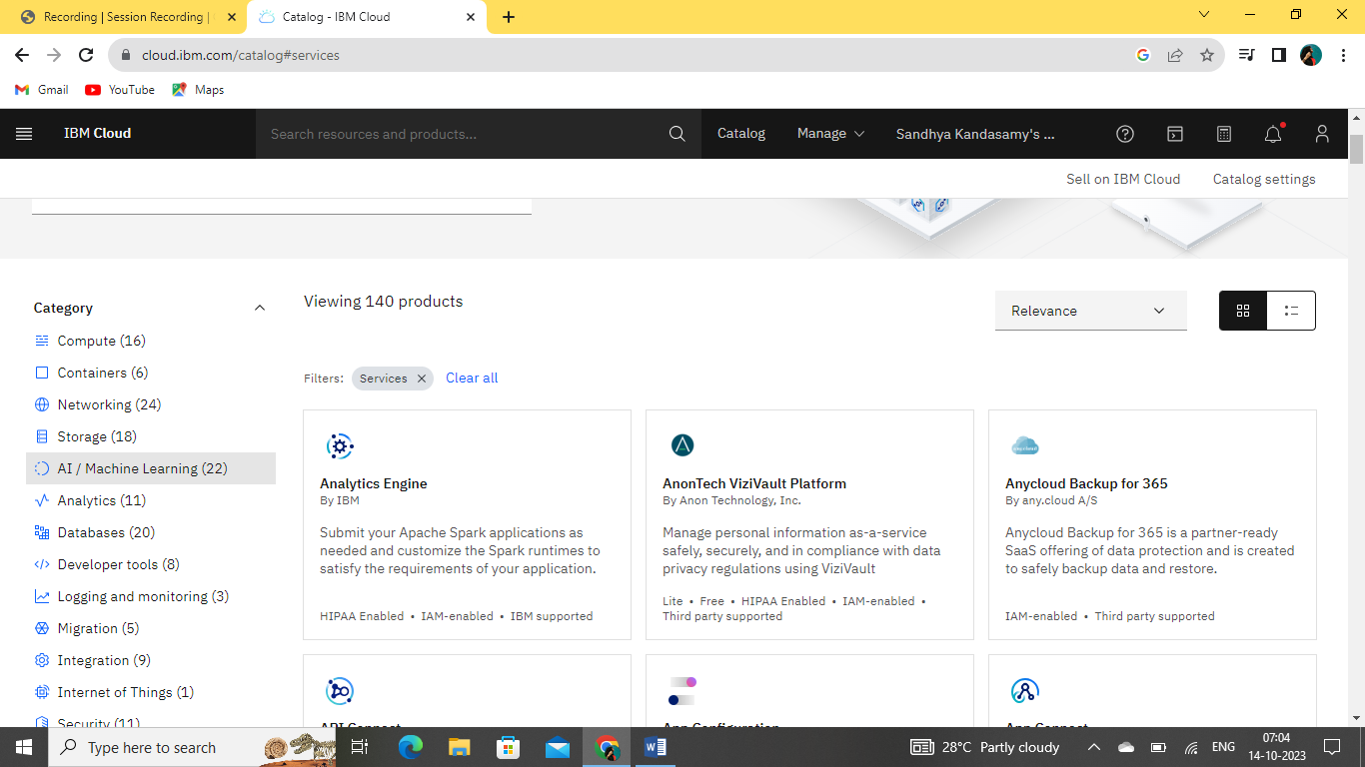

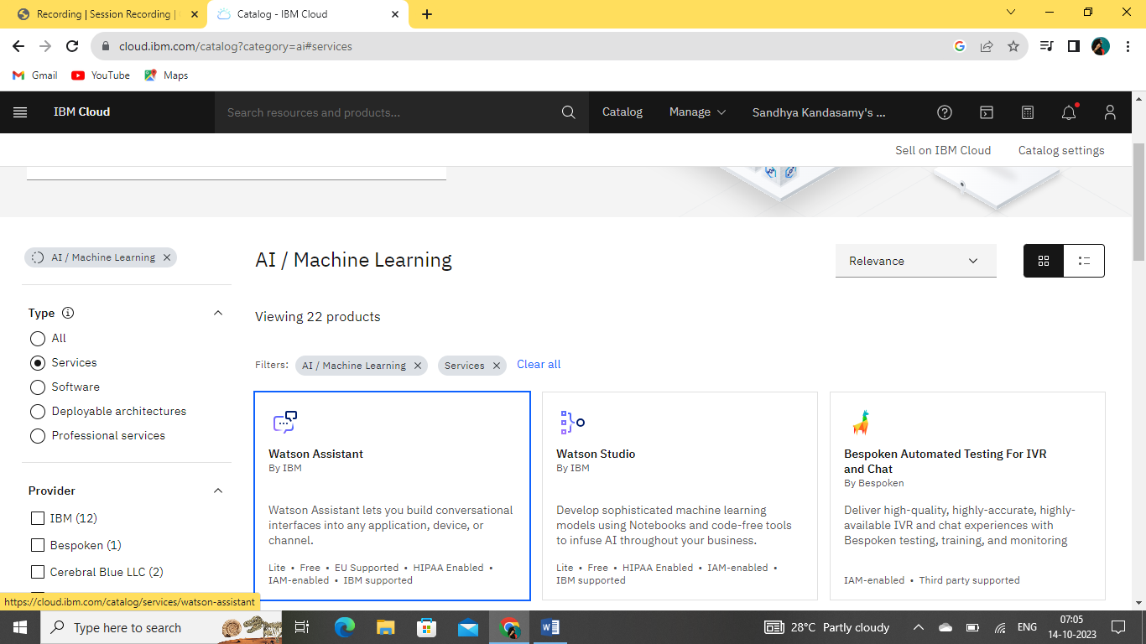

**3.Now I am creating a Watson assistant:**

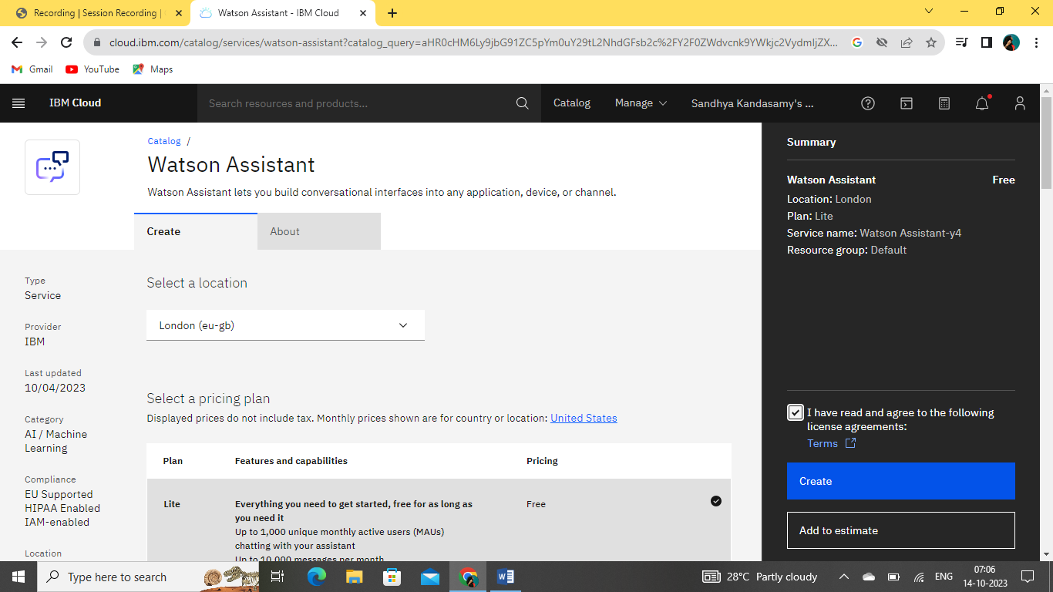

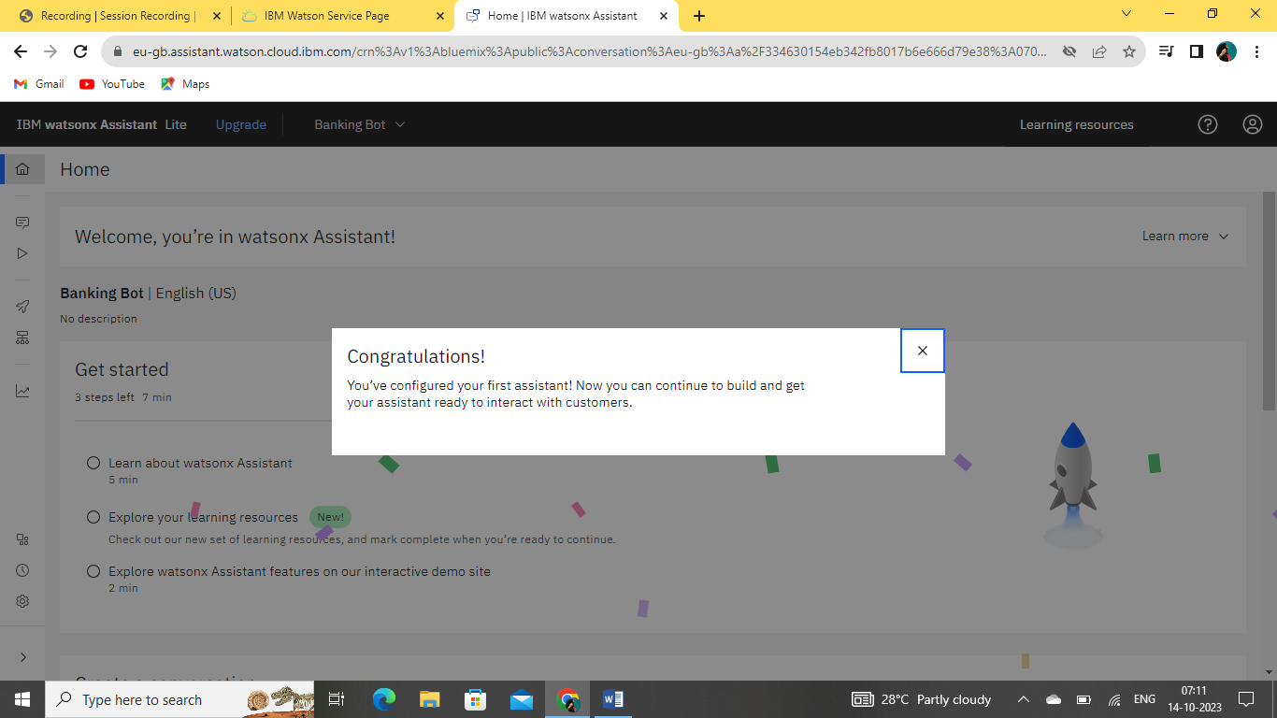

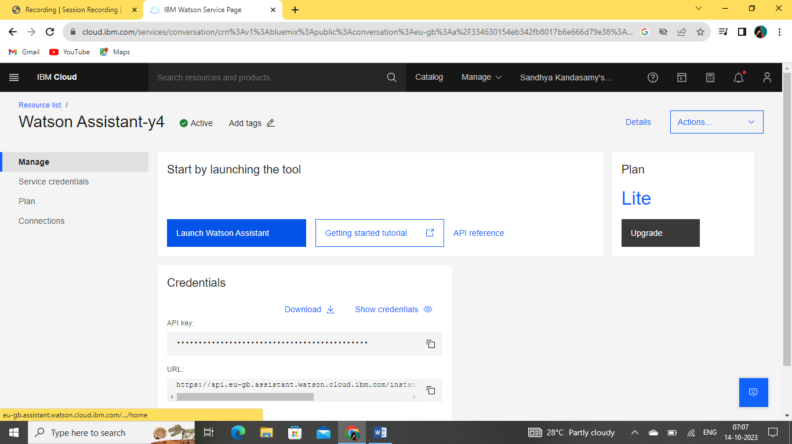

**4.Now I am Design the Conversation Flow:**

* Outline the typical user interactions and define the primary goals of your chatbot.
* What are the common user queries, and what responses do you want to provide?
* Create a flowchart or diagram that represents the conversation flow.
* This will serve as a visual guide for structuring your chatbot's dialog.

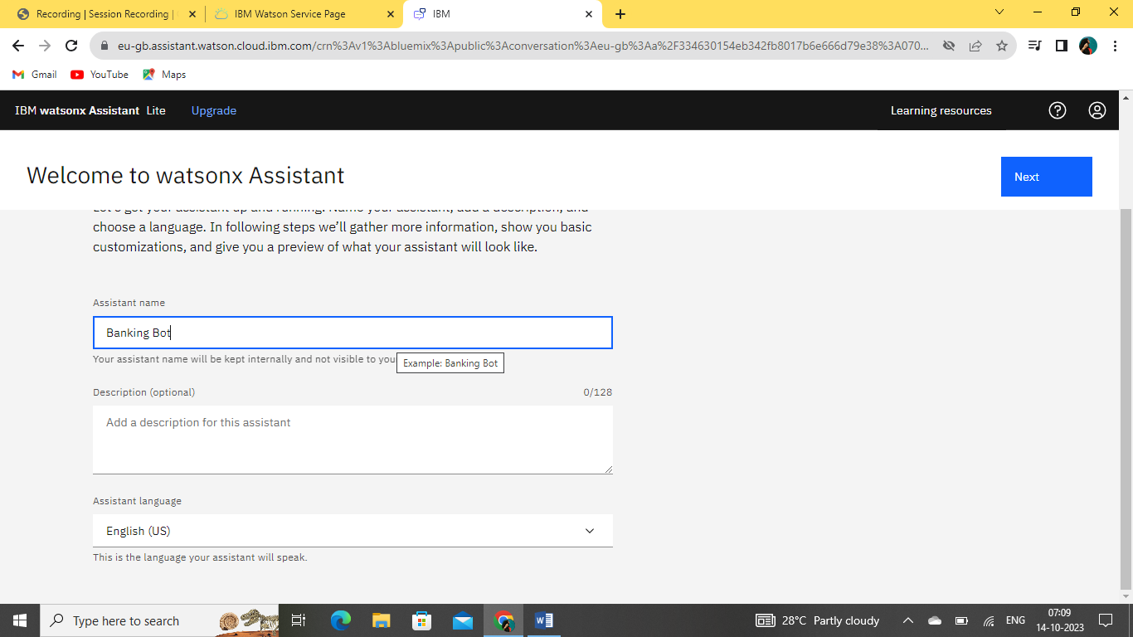

**5.I give sample model in some of actions to begin conversation:**

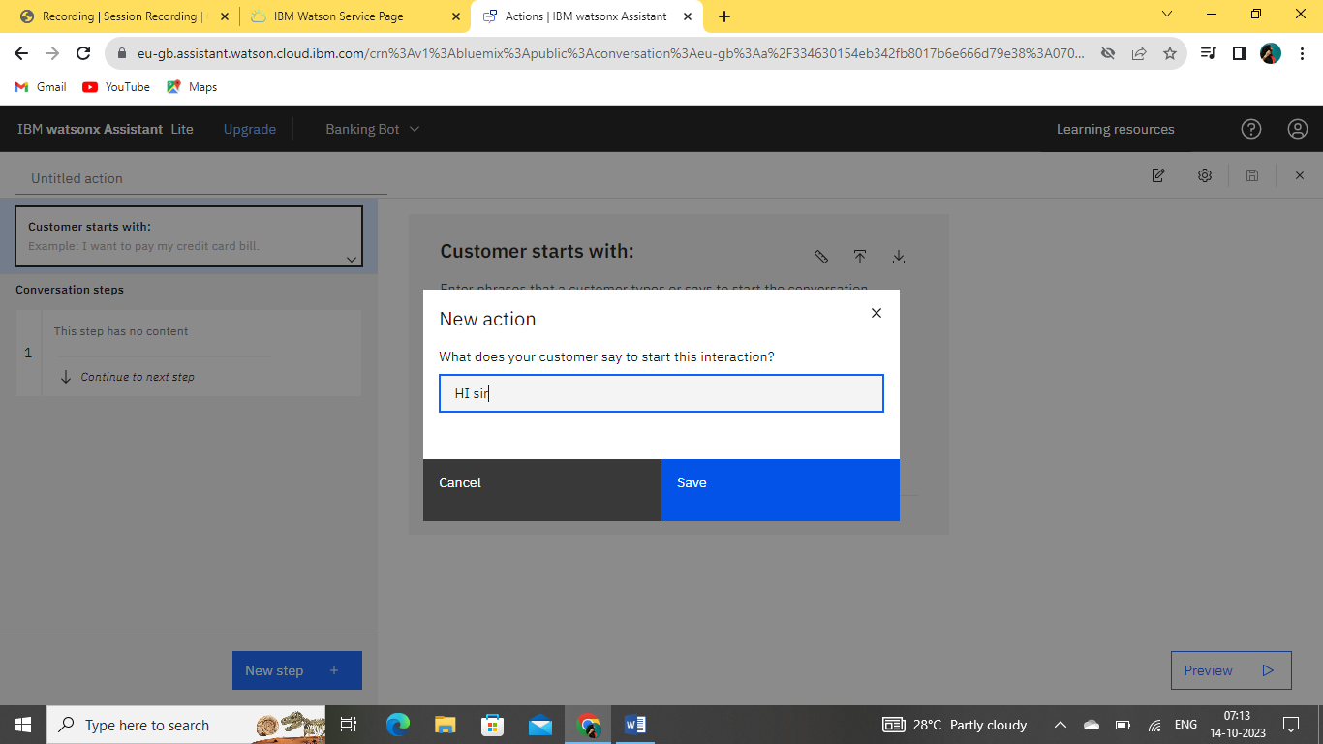

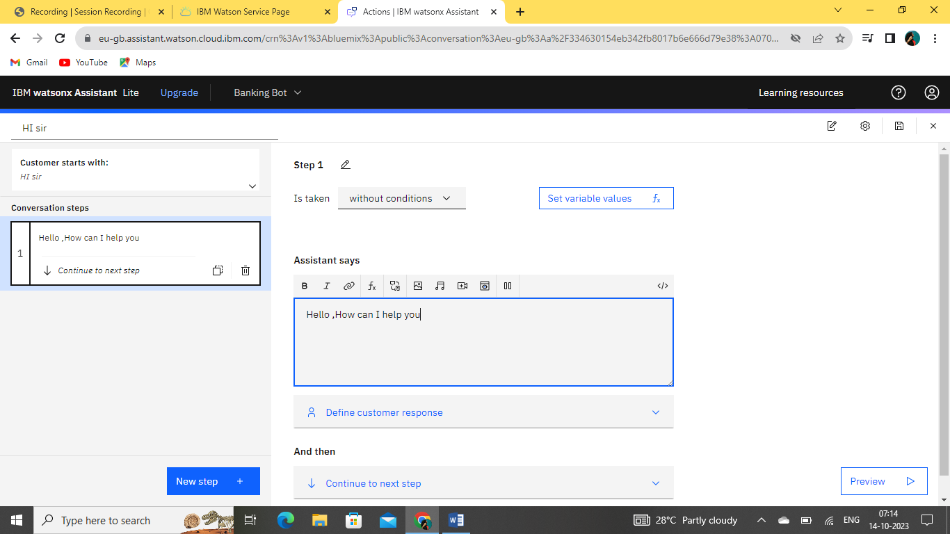

**CREATION OF INTENT, DIALOGUE, ENTITIES:**

**Intents**

**Purpose**: Intents represent the primary goals or intentions behind user queries or statements.

**Usage**: You define intents to help the chatbot understand what the user wants. For example, "Order Product" or "Get Weather Forecast" can be intents.

**Training**: You provide a list of example user inputs that are associated with each intent. Watson Assistant uses these examples to learn and recognize similar user inputs.

**creation:**

**Here I create an intent like “welcome” greeting “good evening”**

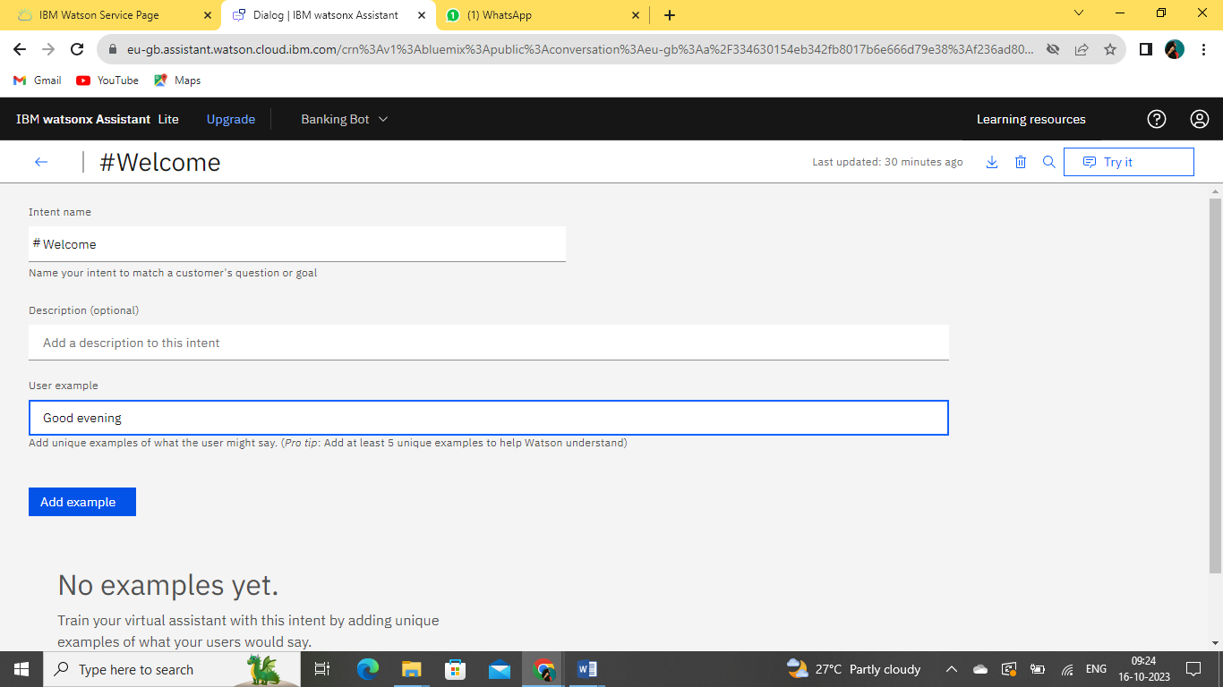

Created intent is displayed here:

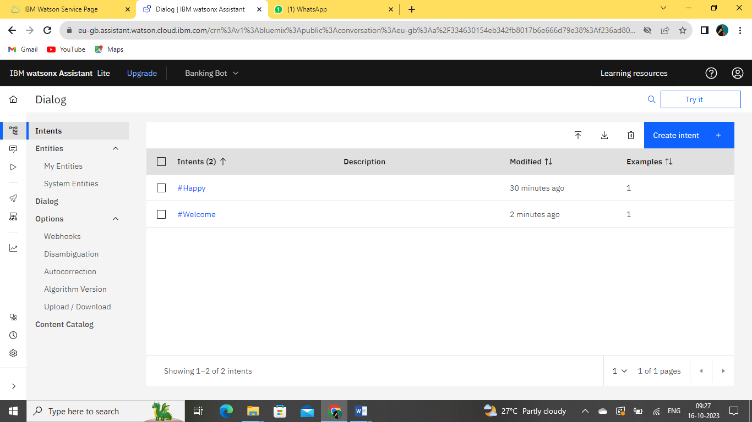

Now I test the created Intent:

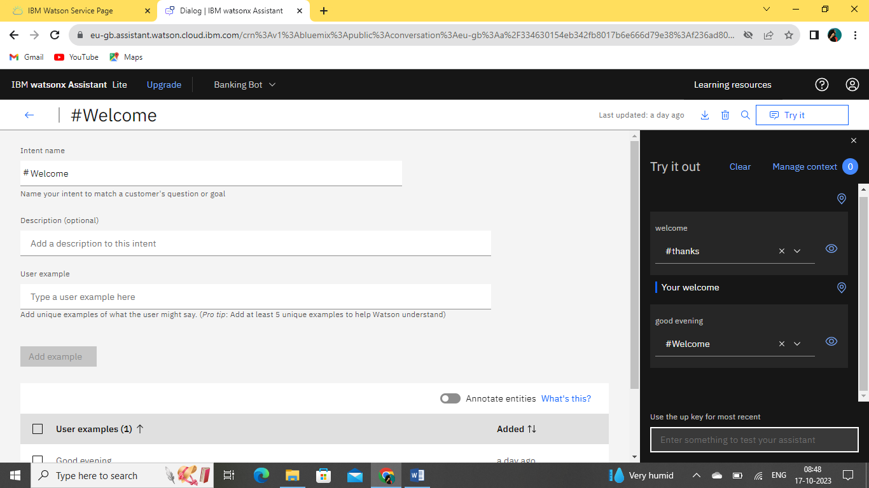

**Dialog Nodes:**

**Purpose:** Dialog nodes define how the chatbot responds to user inputs and guide the conversation.

**Usage:** You use dialog nodes to create a structured conversation flow. Each node represents a step in the dialogue and can be triggered based on user intents or conditions.

**Configuration:** In dialog nodes, you specify the chatbot's responses, as well as any logic or context variables needed to manage the conversation. Conditions can be used to direct the flow based on user input or context.

**Dialog Nodes creation:**

**Here I created a dialog node child “welcome”**

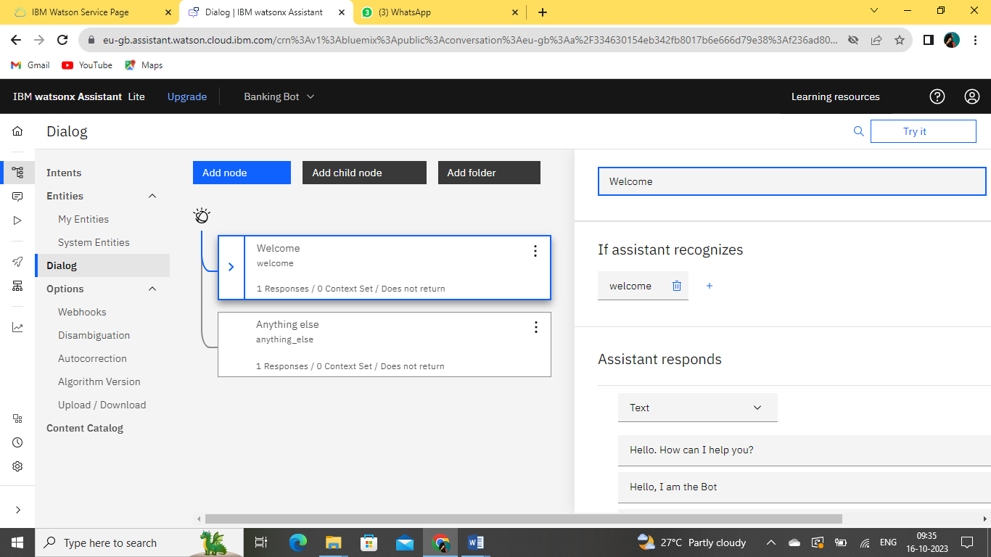

**Now I give some condition for assistant recognizes “#welcome”**

**This was I already created intent. I just give that as a condition here:**

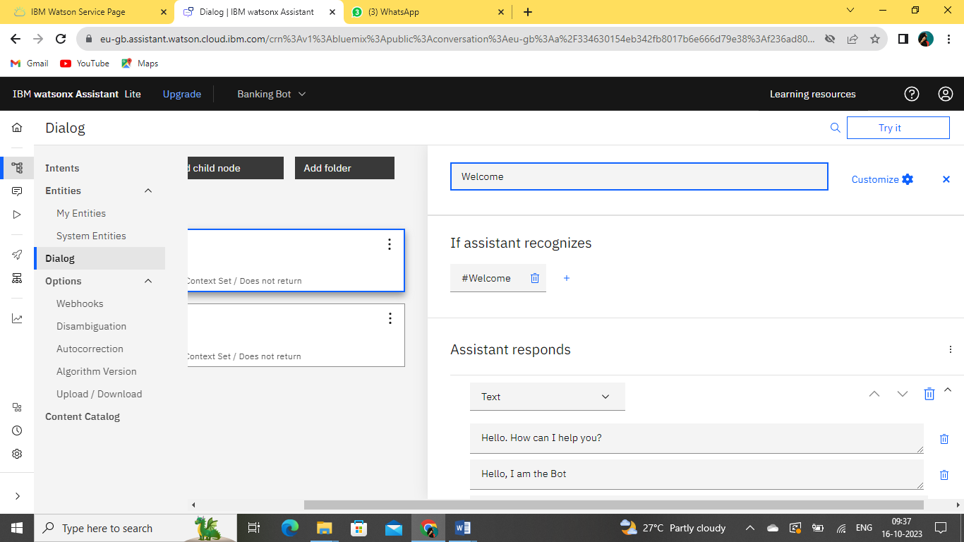

**Add more Dialog nodes here:**

If a customer want to order ice cream here.

So I add upon an option to choose

1)Chocolate

2)Vannila

3)StrawBerry

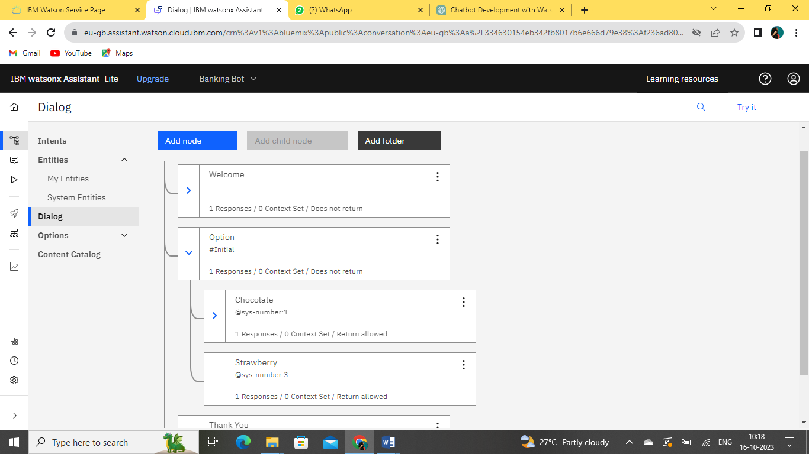

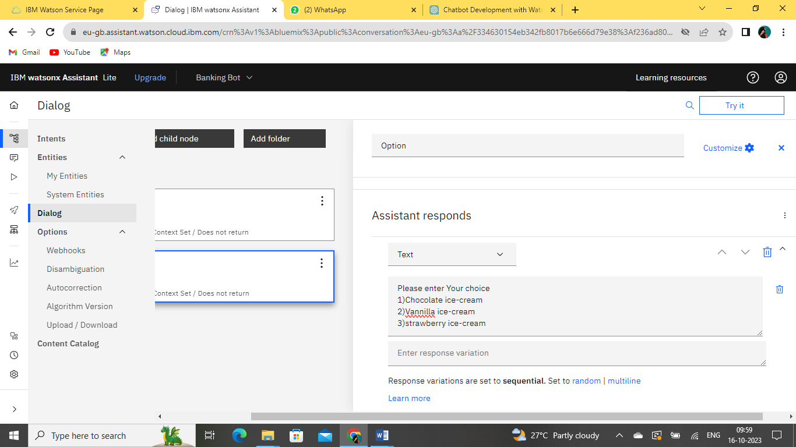

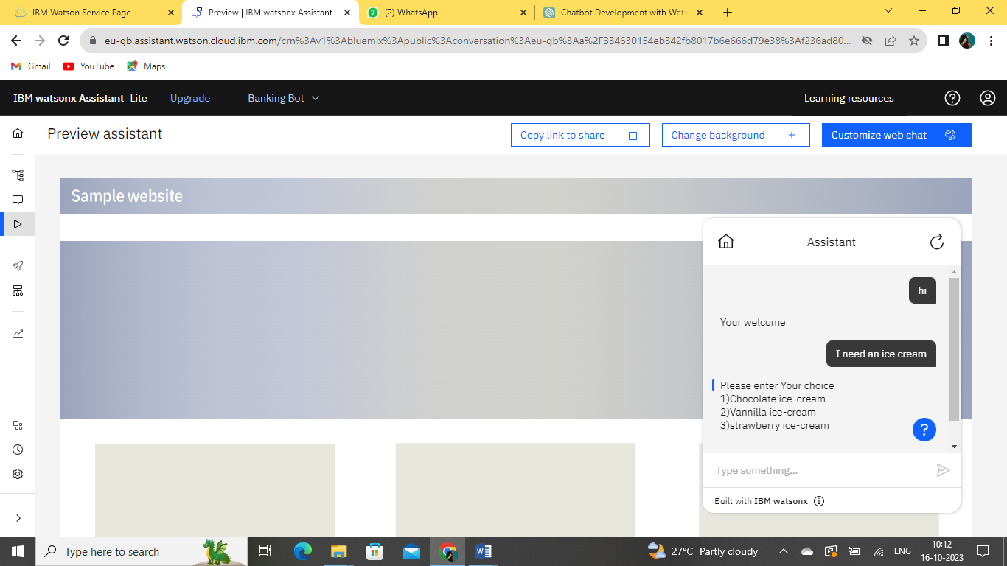

**FINALLY I PREVIEW MY ASSISTANT:**

* Test your chatbot thoroughly to ensure it recognizes intents and entities correctly and provides appropriate responses.
* Use the Watson Assistant interface to simulate conversations and make adjustments as needed.
* Continuously train and improve your chatbot by adding more examples and refining its responses

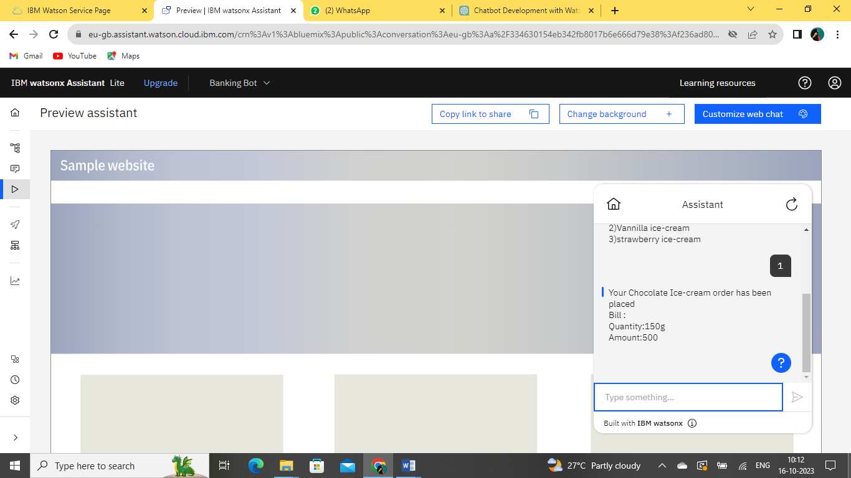

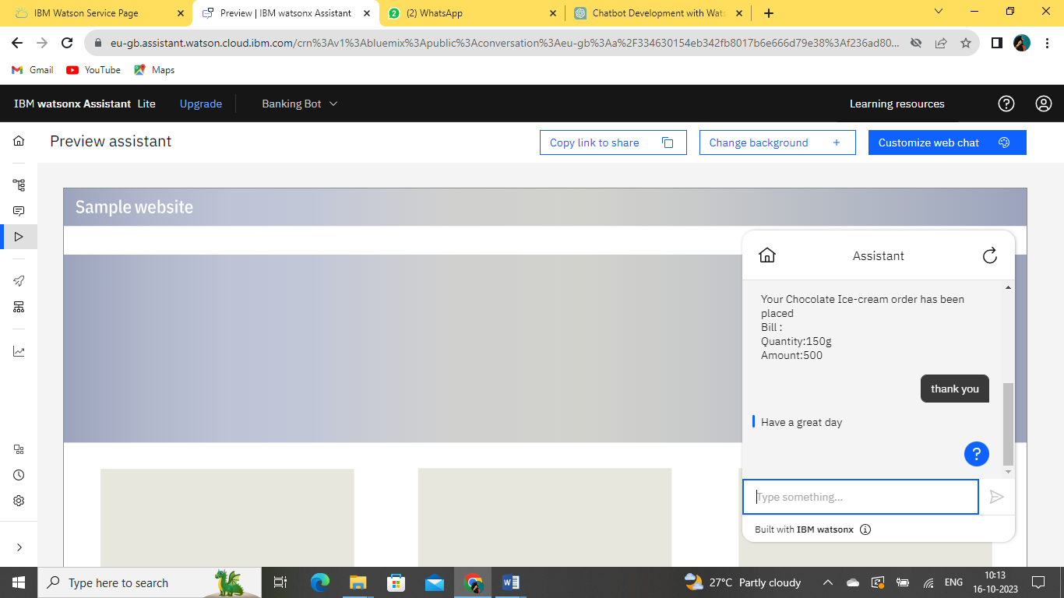

In these phase, we learn intents define what the user wants, entities extract specific details from user inputs, and dialog nodes determine how the chatbot responds and guides the conversation. These elements are integral to creating a chatbot that can effectively understand and interact with users.