**Cloud Watch**

**Here you will learn how to create Cloud Watch Dashboard.**

1. Go to advanced setting of bucket, in that create on events.

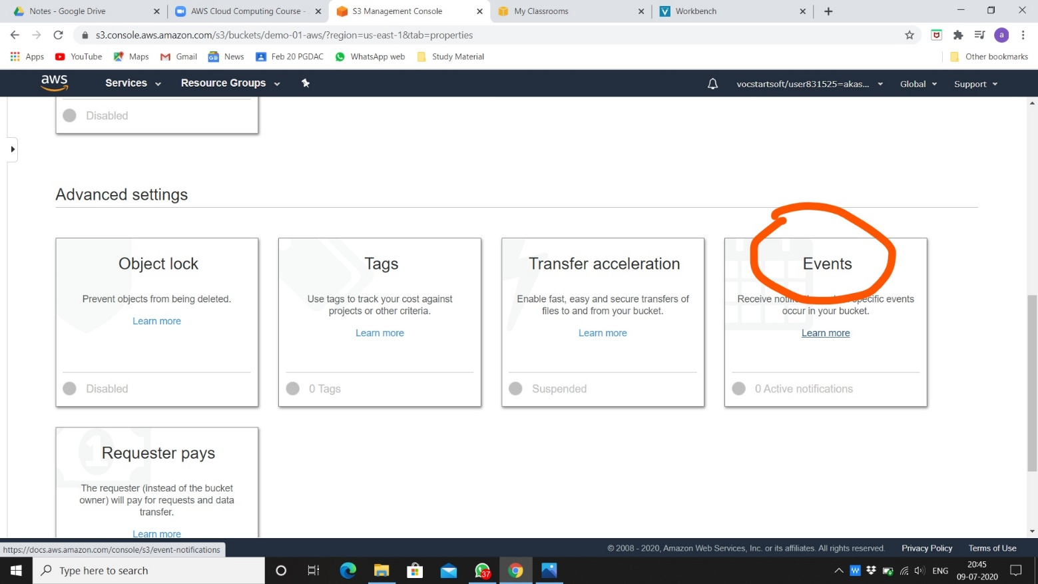

1. Click on add notification.

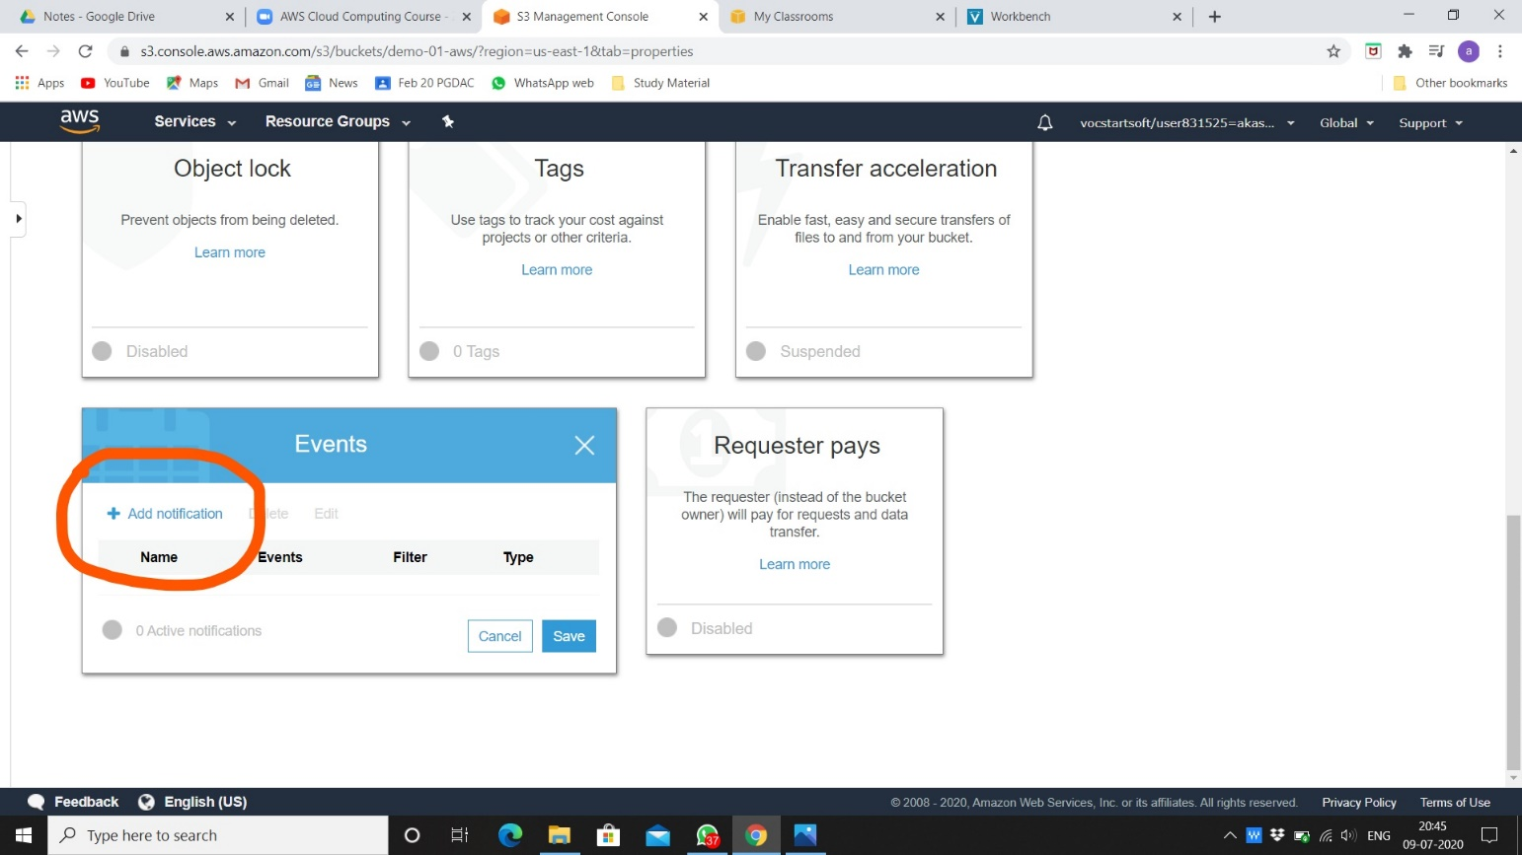

1. Mark on all object create events. You can add prefix and suffix, select lambda function for send to after that choose lambda and click on save.

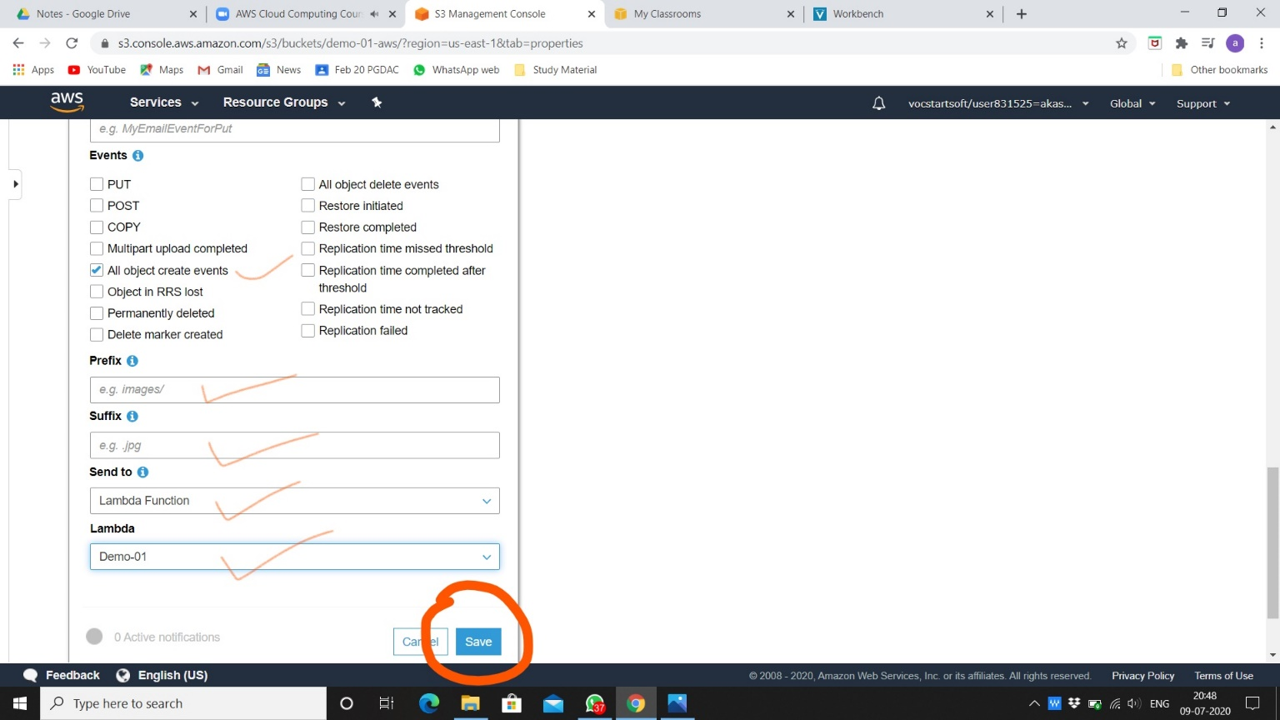

1. After saving there will be one active notification.

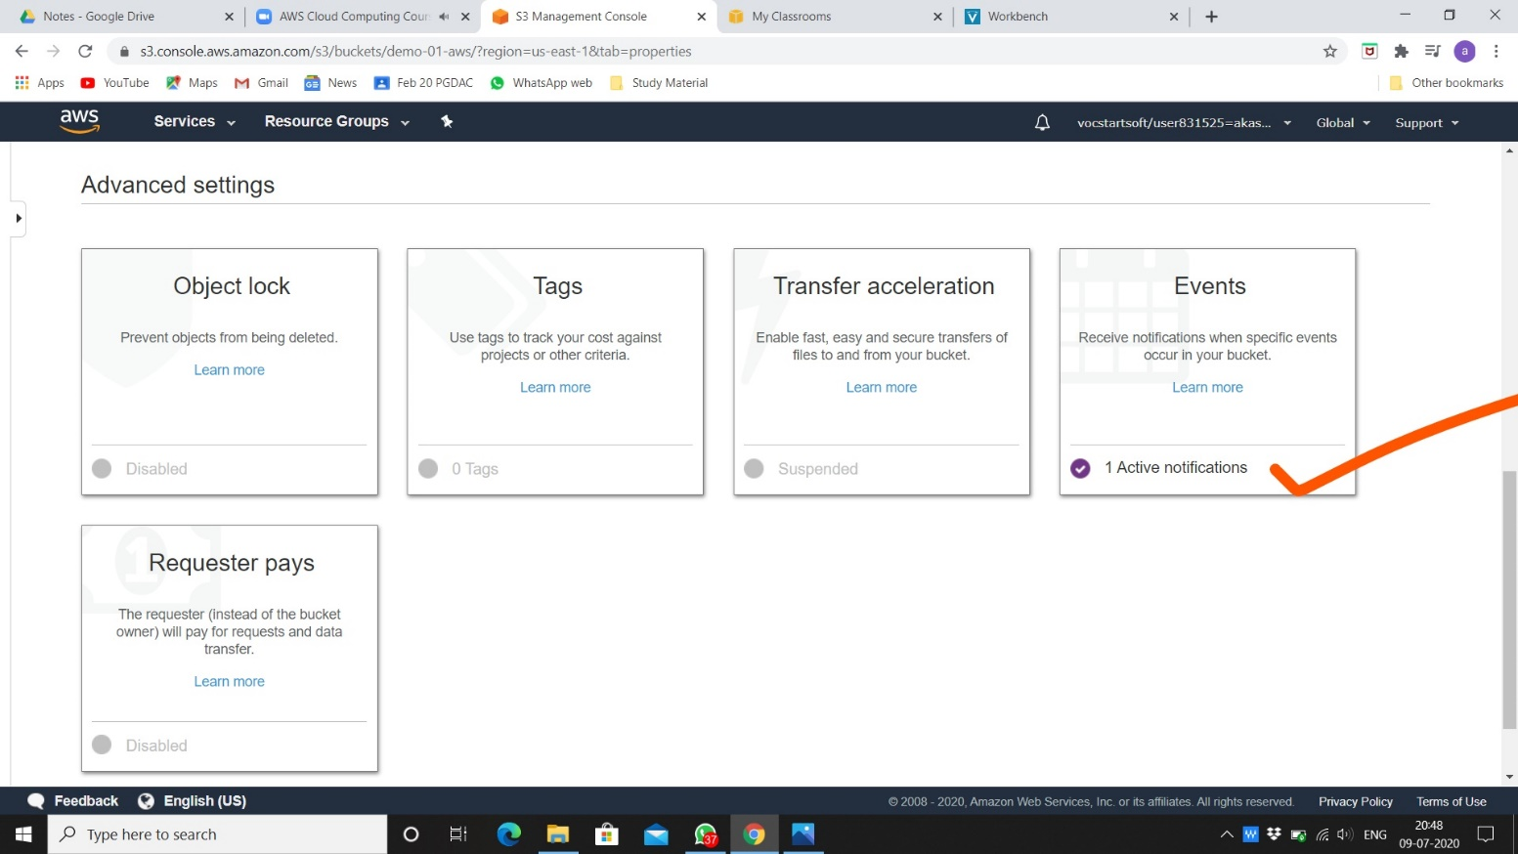

1. Go to lambda function on monitoring option. Click on view logs in CloudWatch.

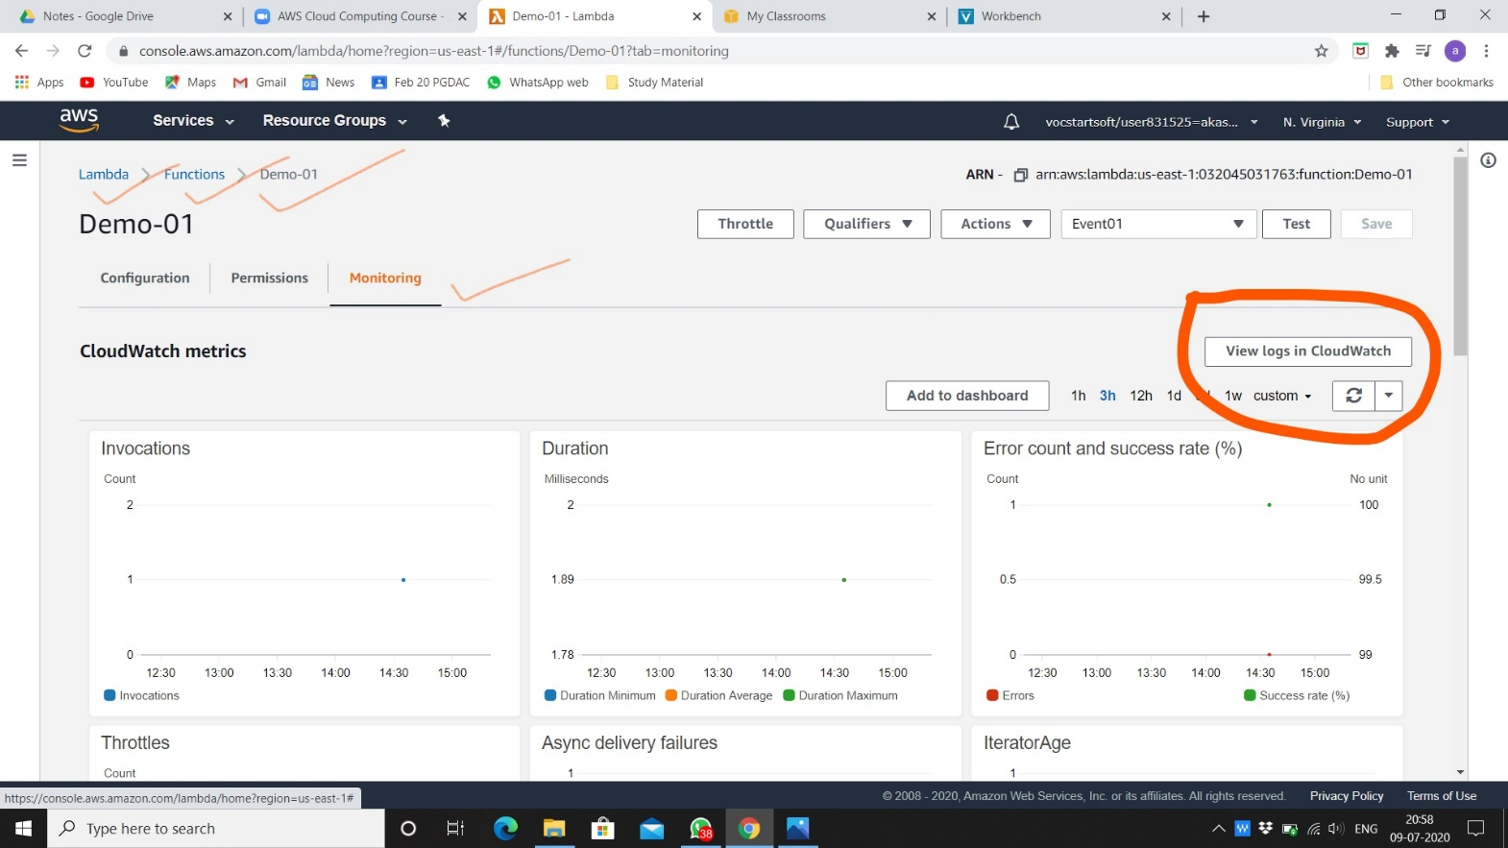

1. Here is all recent events occurs in S3 bucket.

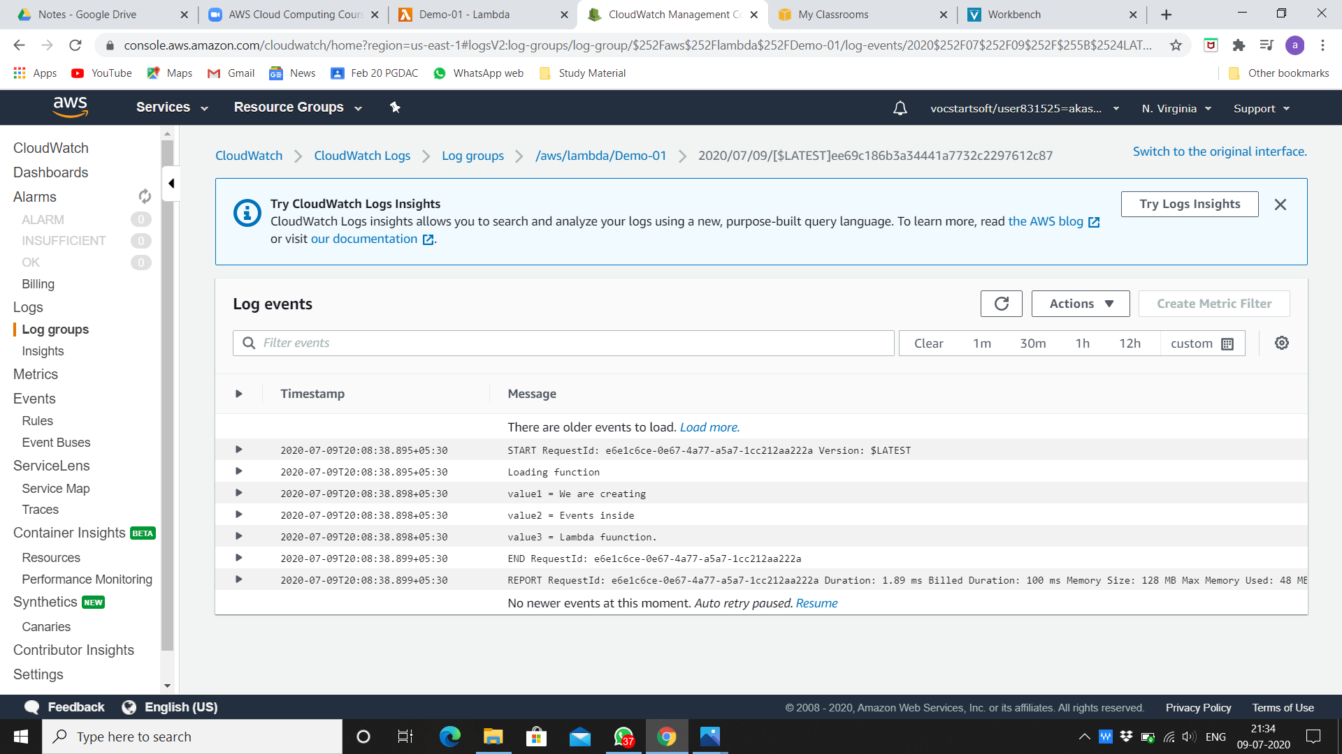

1. Log Streams.

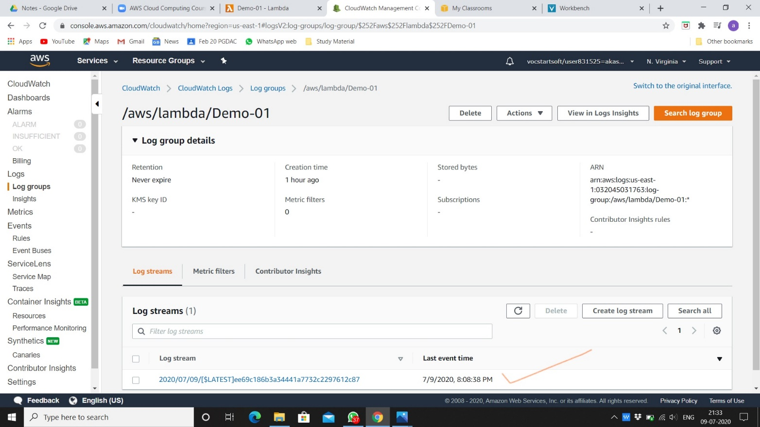

1. We are adding file to S3 bucket to see latest event.

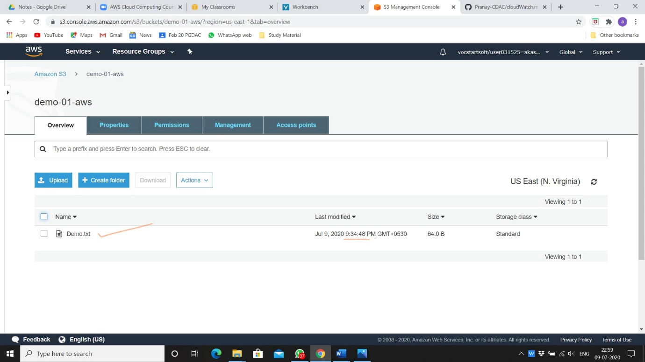

1. Here is the latest added file event.

