### 

# Experiment -2

### (a) To find your current shell

Command : $ echo $shell



### (b) To find all available shells

Command : $ cat /etc/shells

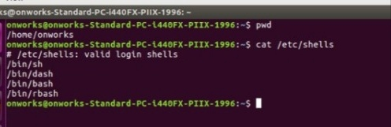

### c. Using

Command : $ cat /etc/passwd

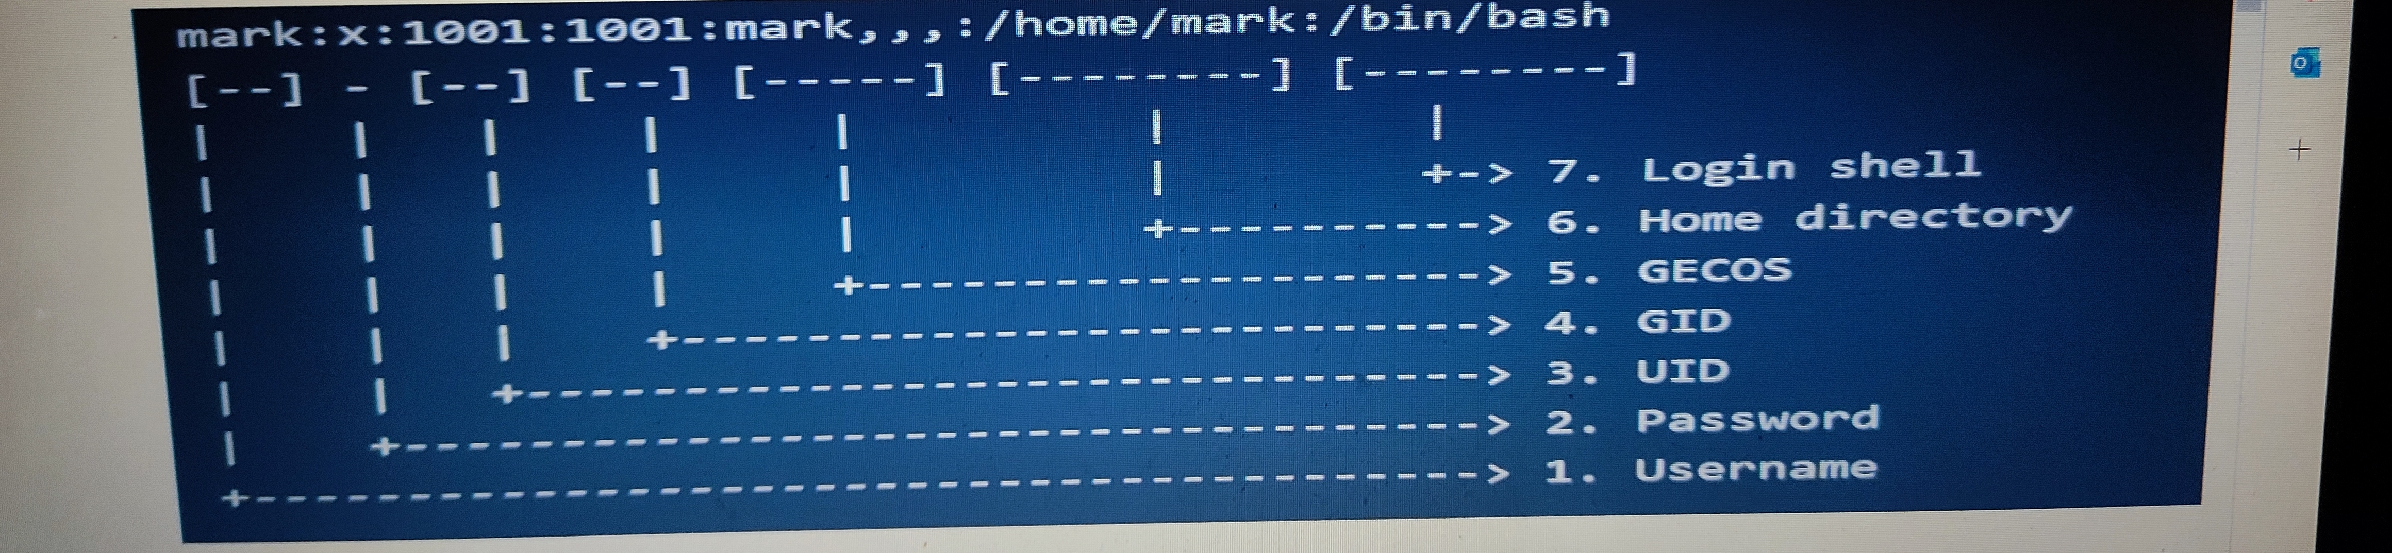

### (d) Use of

Command : $ who -H > myfile.txt

$ who -d myfile.txt

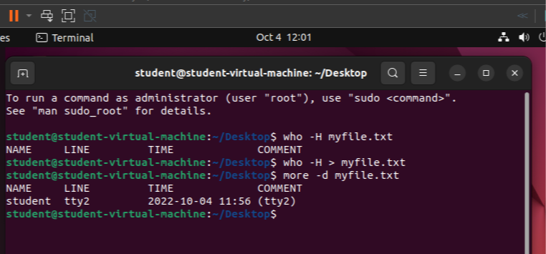

### (e) Use of

Command : $ who -H > myfile.txt

### $ more -d myfile.txt

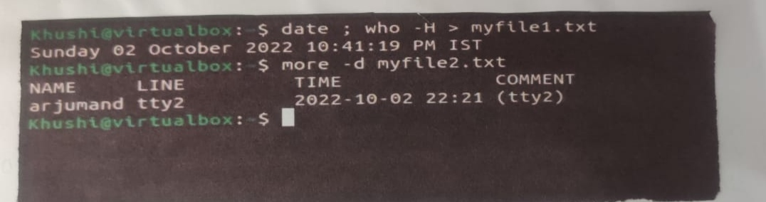

### (f) To swap the first and second word in each line in a file

Command : $ sed 's/\([^ ]*\) \([^ ]*\)/\2\1/g' test.txt

