**KEERTHANA. P 192125008**

**MODEL EXAMINATION**

**ITA1443 – ETHICAL HACKING**

1.

**OUTPUT:**

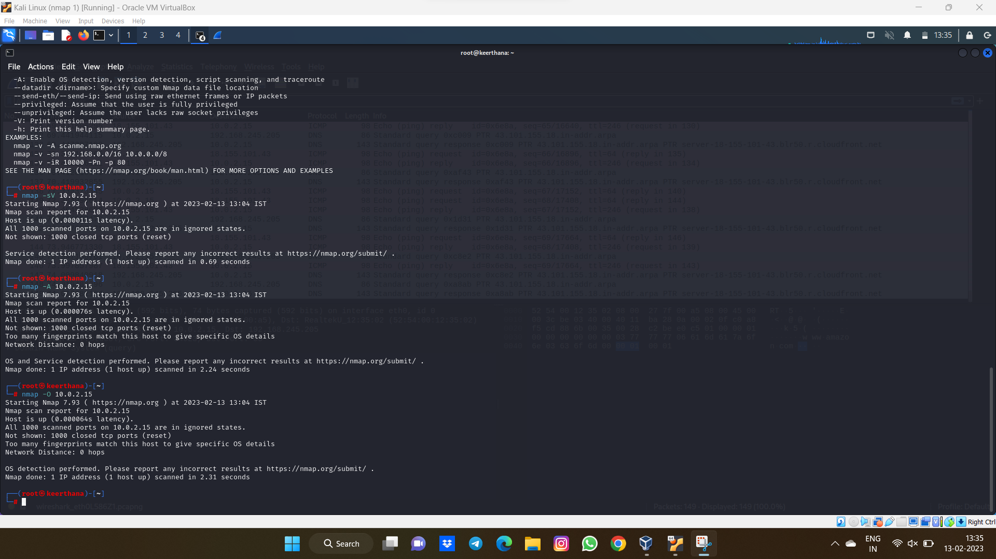

2.

**OUTPUT:**

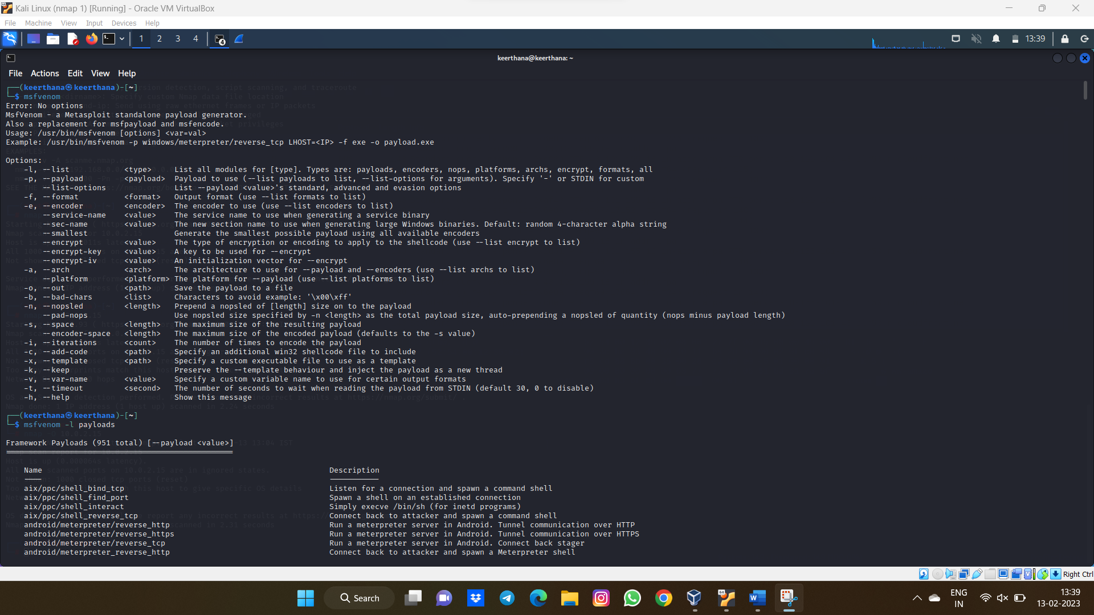

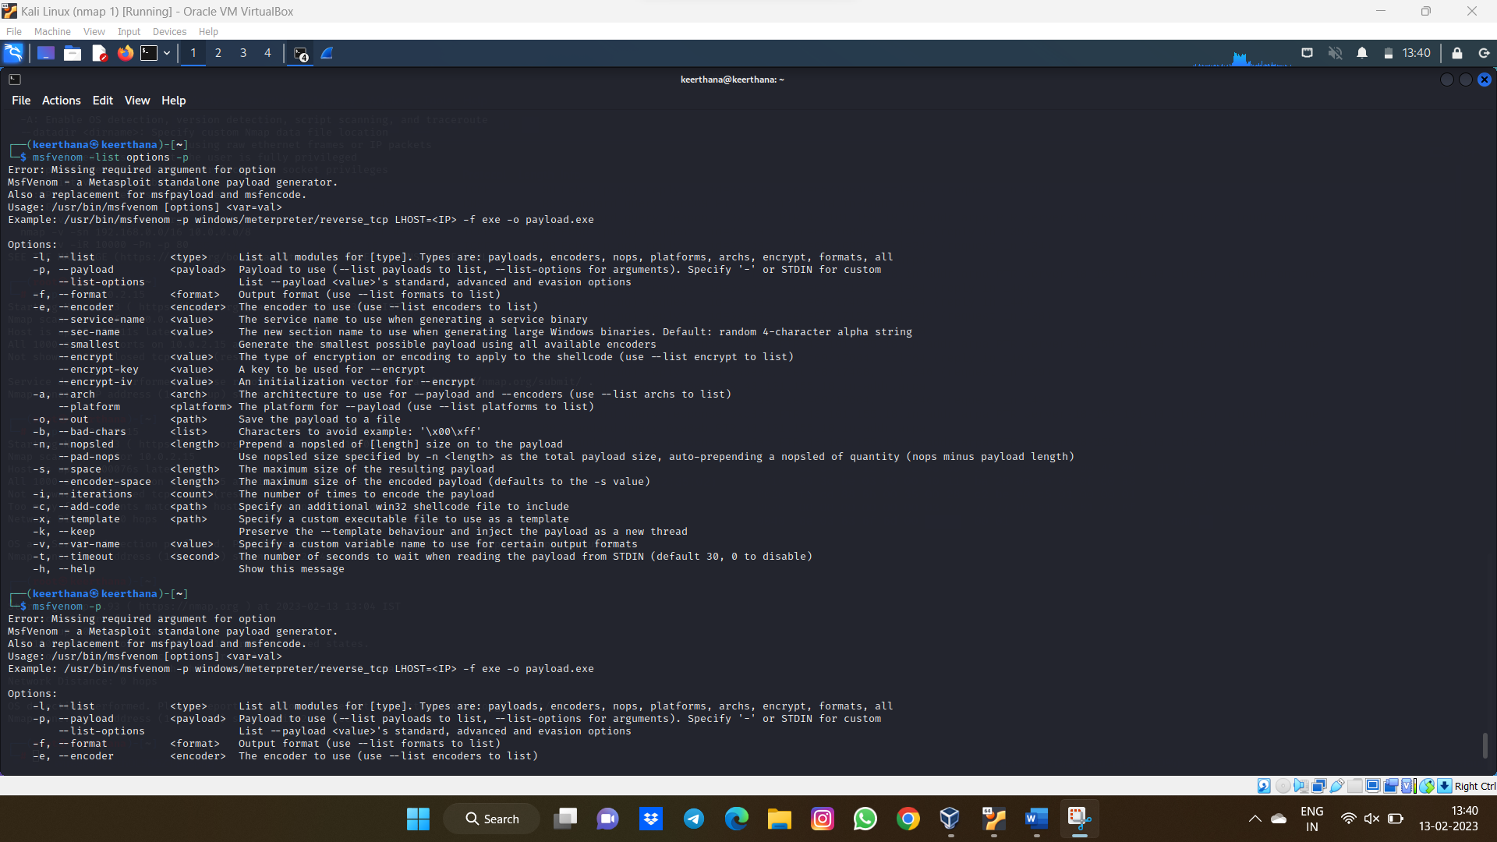

3.

**OUTPUT:**

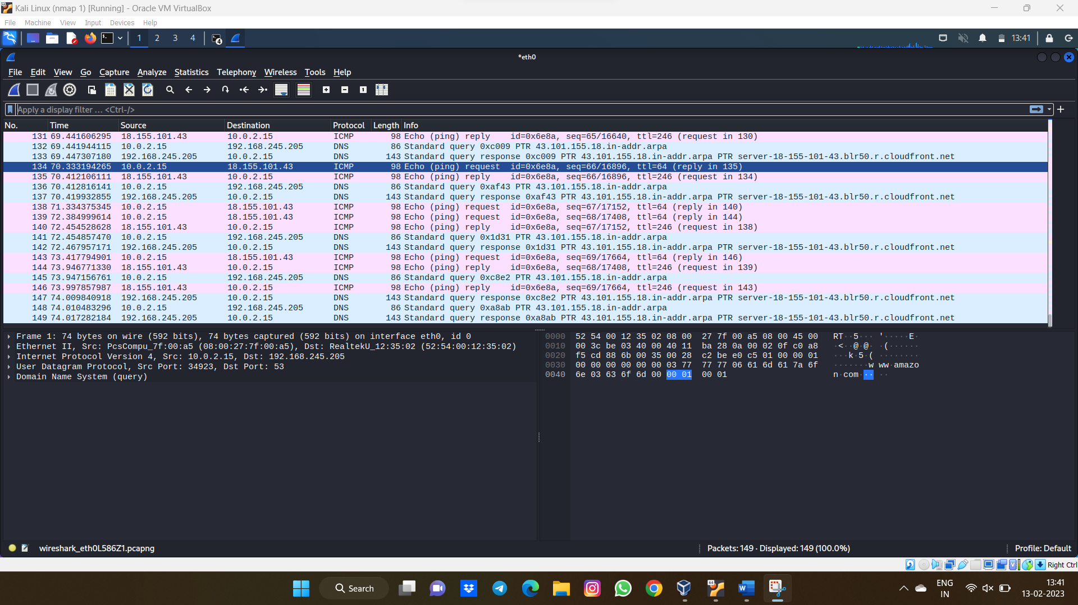

4.

OUTPUT:

