**EX NO:11. Python program to implement Decision Tree**

**INPUT:**

from collections import deque

class Graph:

def __init__(self, adjac_lis):

self.adjac_lis = adjac_lis

def get_neighbors(self, v):

return self.adjac_lis[v]

# This is heuristic function which is having equal values for all nodes

def h(self, n):

H = {

'A': 1,

'B': 1,

'C': 1,

'D': 1

}

return H[n]

def a_star_algorithm(self, start, stop):

# In this open_lst is a lisy of nodes which have been visited, but who's

# neighbours haven't all been always inspected, It starts off with the start

#node

# And closed_lst is a list of nodes which have been visited

# and who's neighbors have been always inspected

open_lst = set([start])

closed_lst = set([])

# poo has present distances from start to all other nodes

# the default value is +infinity

poo = {}

poo[start] = 0

# par contains an adjac mapping of all nodes

par = {}

par[start] = start

while len(open_lst) > 0:

n = None

# it will find a node with the lowest value of f() -

for v in open_lst:

if n == None or poo[v] + self.h(v) < poo[n] + self.h(n):

n = v;

if n == None:

print('Path does not exist!')

return None

OUTPUT:

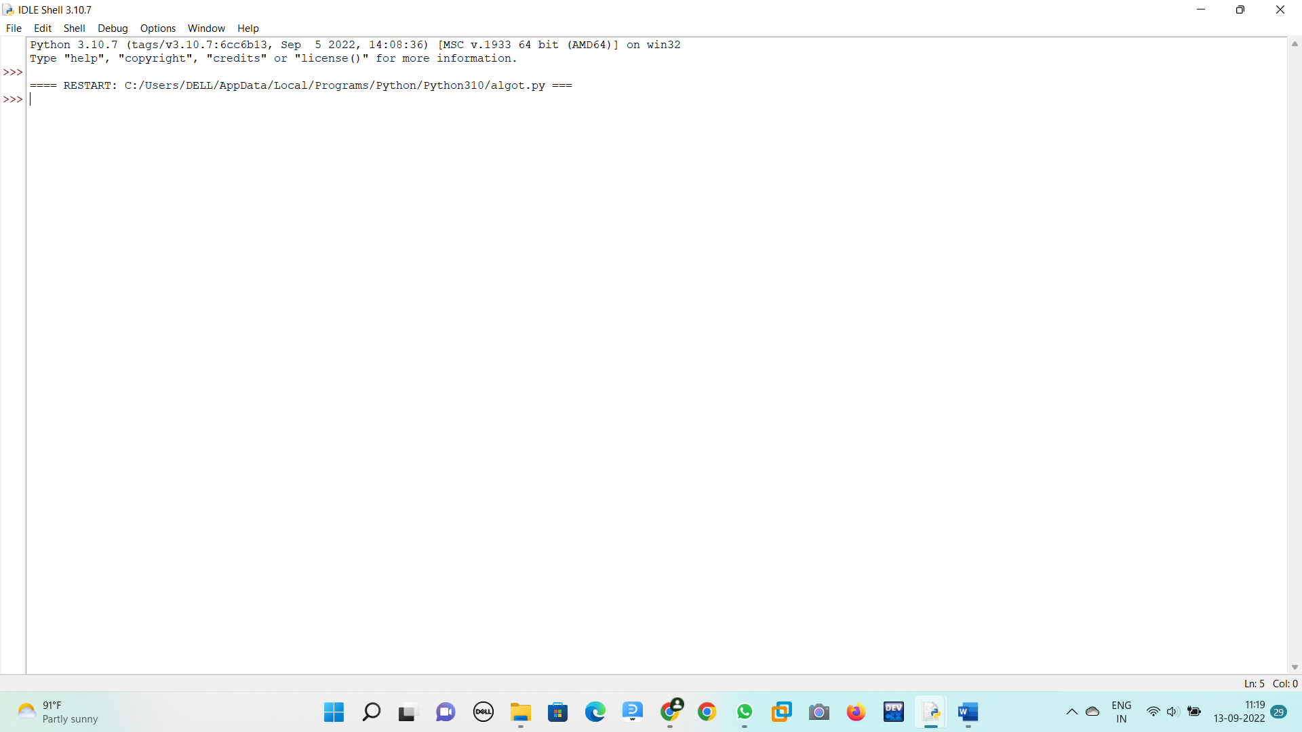

**EX NO:12.Python program to solve the 8-Puzzle Problem**

**INPUT:**

class Node:

def __init__(self,data,level,fval):

""" Initialize the node with the data, level of the node and the calculated fvalue """

self.data = data

self.level = level

self.fval = fval

def generate_child(self):

""" Generate child nodes from the given node by moving the blank space

either in the four directions {up,down,left,right} """

x,y = self.find(self.data,'_')

""" val_list contains position values for moving the blank space in either of

the 4 directions [up,down,left,right] respectively. """

val_list = [[x,y-1],[x,y+1],[x-1,y],[x+1,y]]

children = []

for i in val_list:

child = self.shuffle(self.data,x,y,i[0],i[1])

if child is not None:

child_node = Node(child,self.level+1,0)

children.append(child_node)

return children

def shuffle(self,puz,x1,y1,x2,y2):

""" Move the blank space in the given direction and if the position value are out

of limits the return None """

if x2 >= 0 and x2 < len(self.data) and y2 >= 0 and y2 < len(self.data):

temp_puz = []

temp_puz = self.copy(puz)

temp = temp_puz[x2][y2]

temp_puz[x2][y2] = temp_puz[x1][y1]

temp_puz[x1][y1] = temp

return temp_puz

else:

return None

def copy(self,root):

""" Copy function to create a similar matrix of the given node"""

temp = []

for i in root:

t = []

for j in i:

t.append(j)

temp.append(t)

return temp

def find(self,puz,x):

""" Specifically used to find the position of the blank space """

for i in range(0,len(self.data)):

for j in range(0,len(self.data)):

if puz[i][j] == x:

return i,j

class Puzzle:

def __init__(self,size):

""" Initialize the puzzle size by the specified size,open and closed lists to empty """

self.n = size

self.open = []

self.closed = []

def accept(self):

""" Accepts the puzzle from the user """

puz = []

for i in range(0,self.n):

temp = input().split(" ")

puz.append(temp)

return puz

def f(self,start,goal):

""" Heuristic Function to calculate hueristic value f(x) = h(x) + g(x) """

return self.h(start.data,goal)+start.level

def h(self,start,goal):

""" Calculates the different between the given puzzles """

temp = 0

for i in range(0,self.n):

for j in range(0,self.n):

if start[i][j] != goal[i][j] and start[i][j] != '_':

temp += 1

return temp

def process(self):

""" Accept Start and Goal Puzzle state"""

print("Enter the start state matrix \n")

start = self.accept()

print("Enter the goal state matrix \n")

goal = self.accept()

start = Node(start,0,0)

start.fval = self.f(start,goal)

""" Put the start node in the open list"""

self.open.append(start)

print("\n\n")

while True:

cur = self.open[0]

print("")

print(" | ")

print(" | ")

print(" \\\'/ \n")

for i in cur.data:

for j in i:

print(j,end=" ")

print("")

""" If the difference between current and goal node is 0 we have reached the goal node"""

if(self.h(cur.data,goal) == 0):

break

for i in cur.generate_child():

i.fval = self.f(i,goal)

self.open.append(i)

self.closed.append(cur)

del self.open[0]

""" sort the opne list based on f value """

self.open.sort(key = lambda x:x.fval,reverse=False)

puz = Puzzle(3)

puz.process()

**OUTPUT:**

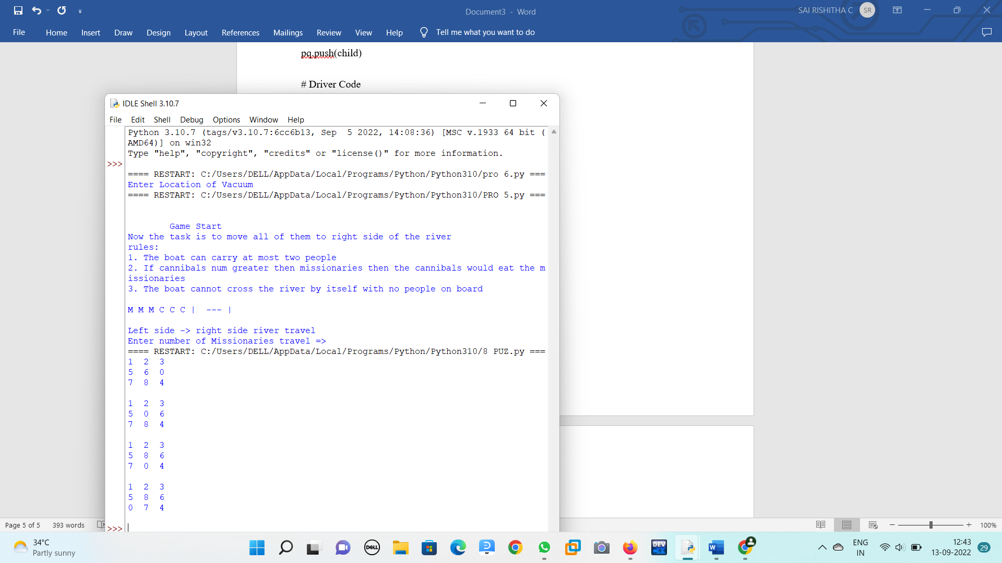

**EX NO:13 Python program to implement Feed forward neural Network**

import numpy as np

import pandas as pd

from sklearn.metrics import confusion_matrix

from sklearn.model_selection import train_test_split

from sklearn.tree import DecisionTreeClassifier

from sklearn.metrics import accuracy_score

from sklearn.metrics import classification_report

# Function importing Dataset

def importdata():

balance_data = pd.read_csv(

'https://archive.ics.uci.edu/ml/machine-learning-'+

'databases/balance-scale/balance-scale.data',

sep= ',', header = None)

# Printing the dataswet shape

print ("Dataset Length: ", len(balance_data))

print ("Dataset Shape: ", balance_data.shape)

# Printing the dataset obseravtions

print ("Dataset: ",balance_data.head())

return balance_data

# Function to split the dataset

def splitdataset(balance_data):

# Separating the target variable

X = balance_data.values[:, 1:5]

Y = balance_data.values[:, 0]

# Splitting the dataset into train and test

X_train, X_test, y_train, y_test = train_test_split(

X, Y, test_size = 0.3, random_state = 100)

return X, Y, X_train, X_test, y_train, y_test

# Function to perform training with giniIndex.

def train_using_gini(X_train, X_test, y_train):

# Creating the classifier object

clf_gini = DecisionTreeClassifier(criterion = "gini",

random_state = 100,max_depth=3, min_samples_leaf=5)

# Performing training

clf_gini.fit(X_train, y_train)

return clf_gini

# Function to perform training with entropy.

def tarin_using_entropy(X_train, X_test, y_train):

# Decision tree with entropy

clf_entropy = DecisionTreeClassifier(

criterion = "entropy", random_state = 100,

max_depth = 3, min_samples_leaf = 5)

# Performing training

clf_entropy.fit(X_train, y_train)

return clf_entropy

# Function to make predictions

def prediction(X_test, clf_object):

# Predicton on test with giniIndex

y_pred = clf_object.predict(X_test)

print("Predicted values:")

print(y_pred)

return y_pred

# Function to calculate accuracy

def cal_accuracy(y_test, y_pred):

print("Confusion Matrix: ",

confusion_matrix(y_test, y_pred))

print ("Accuracy : ",

accuracy_score(y_test,y_pred)*100)

print("Report : ",

classification_report(y_test, y_pred))

# Driver code

def main():

# Building Phase

data = importdata()

X, Y, X_train, X_test, y_train, y_test = splitdataset(data)

clf_gini = train_using_gini(X_train, X_test, y_train)

clf_entropy = tarin_using_entropy(X_train, X_test, y_train)

# Operational Phase

print("Results Using Gini Index:")

# Prediction using gini

y_pred_gini = prediction(X_test, clf_gini)

cal_accuracy(y_test, y_pred_gini)

print("Results Using Entropy:")

# Prediction using entropy

y_pred_entropy = prediction(X_test, clf_entropy)

cal_accuracy(y_test, y_pred_entropy)

# Calling main function

if __name__=="__main__":

main()

OUTPUT:

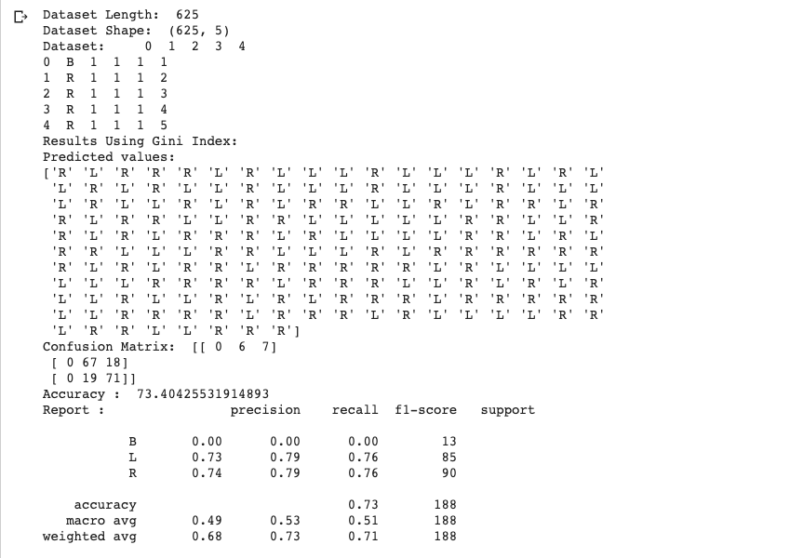

**EX NO:14. PROLOG PROGRAM TO IMPLEMENT FAMILY TREE.**

male(jack).

male(oliver).

male(ali).

male(james).

male(simon).

male(harry).

female(helen).

female(sophie).

female(jess).

female(lily).

parent_of(jack,jess).

parent_of(jack,lily).

parent_of(helen, jess).

parent_of(helen, lily).

parent_of(oliver,james).

parent_of(sophie, james).

parent_of(jess, simon).

parent_of(ali, simon).

parent_of(lily, harry).

parent_of(james, harry).

/* Rules */

father_of(X,Y):- male(X),

parent_of(X,Y).

mother_of(X,Y):- female(X),

parent_of(X,Y).

grandfather_of(X,Y):- male(X),

parent_of(X,Z),

parent_of(Z,Y).

grandmother_of(X,Y):- female(X),

parent_of(X,Z),

parent_of(Z,Y).

sister_of(X,Y):- %(X,Y or Y,X)%

female(X),

father_of(F, Y), father_of(F,X),X \= Y.

sister_of(X,Y):- female(X),

mother_of(M, Y), mother_of(M,X),X \= Y.

aunt_of(X,Y):- female(X),

parent_of(Z,Y), sister_of(Z,X),!.

brother_of(X,Y):- %(X,Y or Y,X)%

male(X),

father_of(F, Y), father_of(F,X),X \= Y.

brother_of(X,Y):- male(X),

mother_of(M, Y), mother_of(M,X),X \= Y.

uncle_of(X,Y):-

parent_of(Z,Y), brother_of(Z,X).

ancestor_of(X,Y):- parent_of(X,Y).

ancestor_of(X,Y):- parent_of(X,Z),

ancestor_of(Z,X)

**OUTPUT :**

?-mother_of(X,jess).

?-parent_of(X,simon).

?-sister_of(X,lily).

?-ancestor_of(X,lily).

**EX NO:15 PROLOG PROGRAM TO IMPLEMENT FIBONACCI SERIES**

fib(0, 1) :-

!.

fib(n, f) :-

fib(1, n, 1, 1, f).

fib(n, n, _, f, f) :-

!.

fib(n0, n, f0, f1, f) :-

n1 is n0 + 1,

f2 is f0 + f1,

fib(n1, n, f1, f2, f).

**OUTPUT:**

**Fib** = 1346269

?- time(fib(30, Fib)).

**EX NO:16. PROLOG PROGRAM TO FIND FACTORIAL NUMBER**

INPUT:

predicates

factorial(integer, real)

go

clauses

go if

write("Enter a positive integer number:"),

readint(N),

factorial(N,Result),

write("Factorial of", N, "is=", Result).

factorial(0, 1)

factorial(N, Result) if N>0,

N1=N-1,

factorial(N1, Res),

Result=N*Res.

**OUTPUT:**

goals:

factorial(5, Answer)

Answer=120

**EX NO: 17. GCD OF TWO NUMBERS**

**INPUT:**

gcd(X,Y):-X=Y,write('GCD of two numbers is '),write(X);

X=0,write('GCD of two numbers is '),write(Y);

Y=0,write('GCD of two numbers is '),write(X);

Y>X,Y1 is Y-X,gcd(X,Y1);

X>Y,Y1 is X-Y,gcd(Y1,Y).

**OUTPUT:**

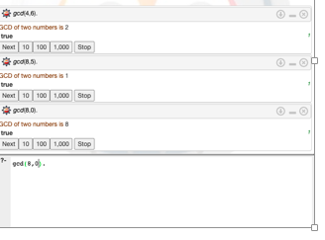

**EX NO:18. PROLOG PROGRAM to PRINTING ALL ELEMENTS OF A LIST**

**INPUT:**

printlist([]).

printlist([X|List]) :- write(X),nl, printlist(List).

**OUTPUT:**

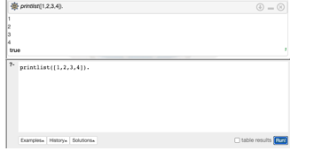

**EX NO:19. PROLOG PROGRAM TO APPEND AN INTEGER INTO THE LIST**

**INPUT:**

append([],L,L).

append([X|L1],L2,[X|L3]) :- append(L1,L2,L3).

**OUTPUT:**

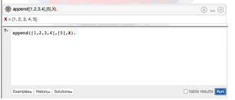

**EX NO:20. PROLOG PROGRAM TO LIST MEMBERSHIP**

**INPUT:**

member(X,List):- delete(X,List,_).

delete(X,[X|Tail],Tail). delete(X,[Y|Tail1],[Y|Tail2]):-

delete(X,Tail1,Tail2).

**OUTPUT:**

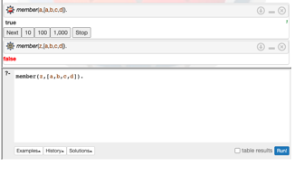

**EX NO21:. PROLOG PROGRAM FOR Healthcare Data**

**INPUT:**

domains disease,indication,name=symbol predicates

hypothesis(name,disease) symptom(name,indication)

clauses

symptom(yamini,fever). symptom(yamini,rash) . symptom(yamini,headache). symptom(yamini,runn_nose). symptom(hemanth,chills). symptom(hemanth,fever). symptom(hemnth,headache). symptom(radhika,runny_nose). symptom(radhika,rash). symptom(radhika,flu). hypothesis(Patient,measels): symptom(Patient,fever), symptom(Patient,cough), symptom(Patient,conjunctivitis), symptom(Patient,r ash). hypothesis(Patient,german_measl es): symptom(Patient,f ev er ), symptom(Patient,headache), symptom(Patient,runny_nose), symptom(Patient,rash).

**OUTPUT:**

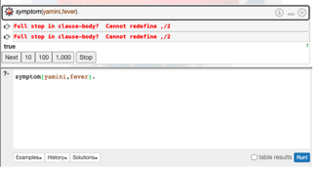

**EX NO:22 Eliminate consecutive duplicates of list elements.**

If a list contains repeated elements they should be replaced with a single copy of the element. The order of the elements should not be changed.  
  
Example:  
?- compress([a,a,a,a,b,c,c,a,a,d,e,e,e,e],X).  
X = [a,b,c,a,d,e]

**EX NO:23  Run-length encoding of a list.**

Use the result of problem P09 to implement the so-called run-length encoding data compression method. Consecutive duplicates of elements are encoded as terms [N,E] where N is the number of duplicates of the element E.  
  
Example:  
?- encode([a,a,a,a,b,c,c,a,a,d,e,e,e,e],X).  
X = [[4,a],[1,b],[2,c],[2,a],[1,d][4,e]]

**EX NO:24 Truth tables for logical expressions.**

Define predicates and/2, or/2, nand/2, nor/2, xor/2, impl/2 and equ/2 (for logical equivalence) which succeed or fail according to the result of their respective operations; e.g. and(A,B) will succeed, if and only if both A and B succeed. Note that A and B can be Prolog goals (not only the constants true and fail).

A logical expression in two variables can then be written in prefix notation, as in the following example: and(or(A,B),nand(A,B)).

Now, write a predicate table/3 which prints the truth table of a given logical expression in two variables.

Example:  
?- table(A,B,and(A,or(A,B))).  
true true true  
true fail true  
fail true fail  
fail fail fail

**EX NO:25 Prolog - Monkey and Banana Problem**

on(floor,monkey).

on(floor,chair).

in(room,monkey).

in(room,chair).

in(room,banana).

at(ceiling,banana).

strong(monkey).

grasp(monkey).

climb(monkey,chair).

push(monkey,chair):-

strong(monkey).

under(banana,chair):-

push(monkey,chair).

canreach(banana,monkey):-

at(floor,banana);

at(ceiling,banana),

under(banana,chair),

climb(monkey,chair).

canget(banana,monkey):-

canreach(banana,monkey),grasp(monkey).