
NUS DOTA2023

LAB2 REPORT

Name YUENBO
Number t0929913
Lecture Professor Hugh Anderson

Writeup task 3.1: Encryption Mode – ECB vs. CBC
before
The original initial picture is shown below:


Steps
1．Check the bits at the header of the picture with Winhex and find that there is no problem and it conforms to the .bmp format

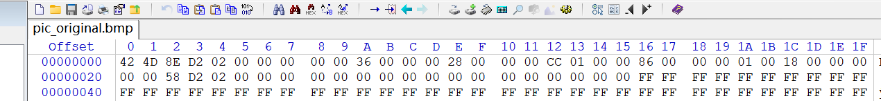

Here is the standard format of .bmp file:
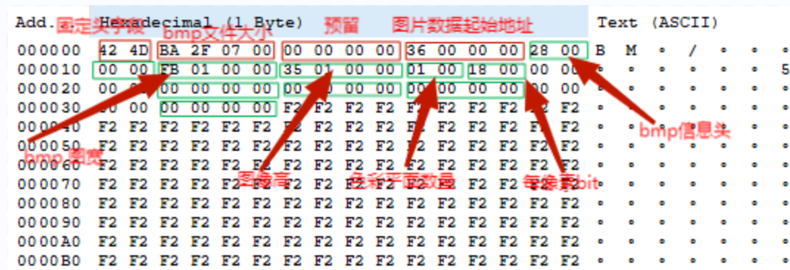

2.The image is encrypted in ECB and CBC modes, respectively
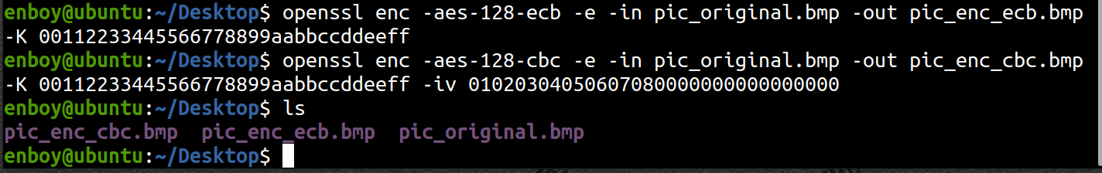

After ECB is encrypted:
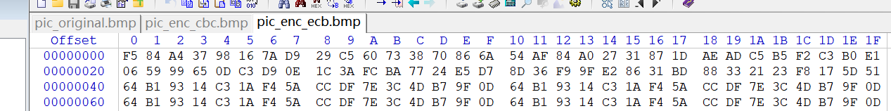

After CBC encryption:
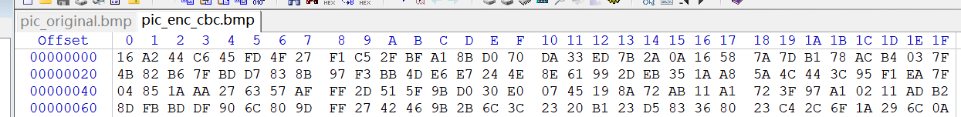

Then we will find that both files will not open, and the file headers are corrupted


3. Restore them to their original separately bmp file header
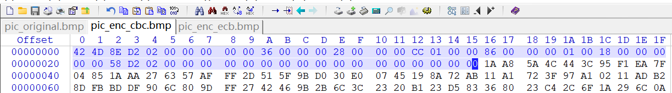

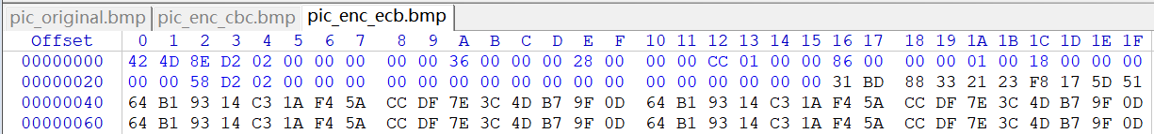

4. Open the picture again, the findings are as follows:
CBC：(In this mode, we can almost see nothing of the graph)



EBC:(In this mode, we can also see the outline of the graph)
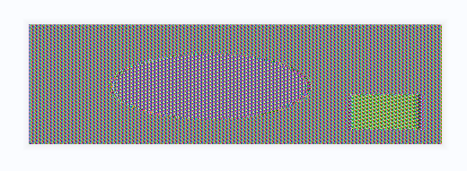

Writeup task 3.2: Encryption Mode – Corrupted Cipher Text
Steps
- Create a text file that is at least 64 bytes long.


- Encrypt the file using the AES-128 cipher.
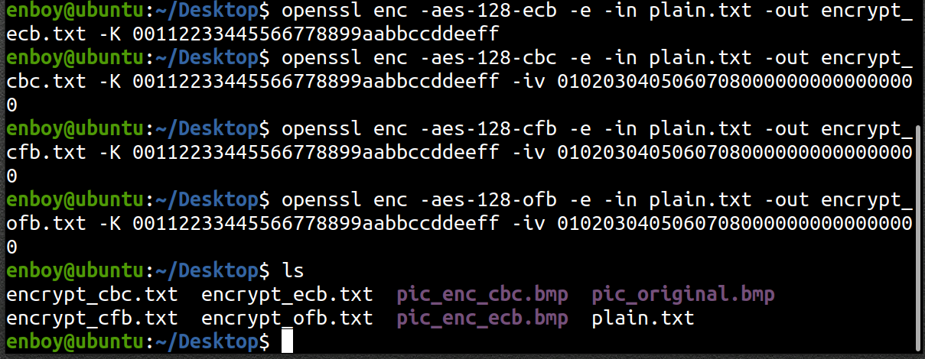

- Unfortunately, a single bit of the 30th byte in the encrypted file got corrupted. Using a hex editor，we artificially corrupt the thirtieth piece of data

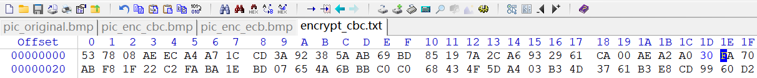
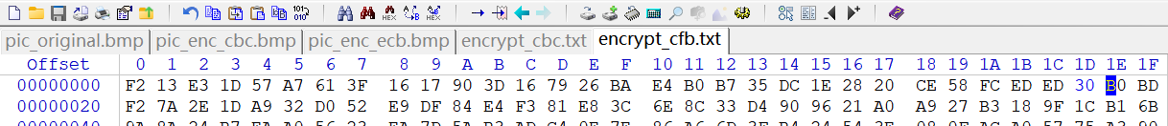
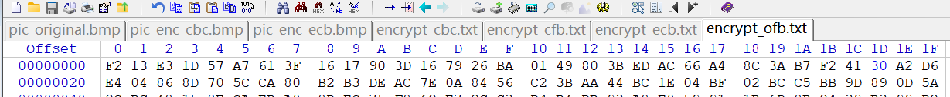
- Decrypt the corrupted file (encrypted) using the correct key and IV.
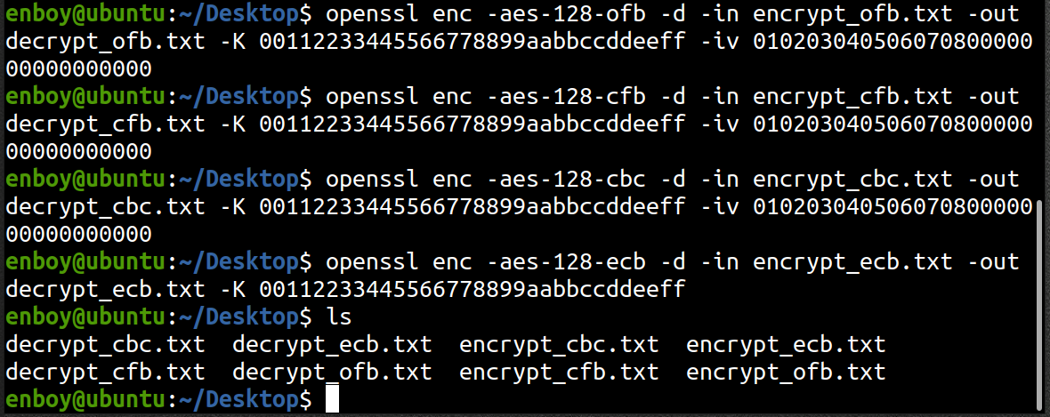
This is the four plaintexts decrypted in four group formats(ECB、CBC、CFB、OFB) after the 30th bit error
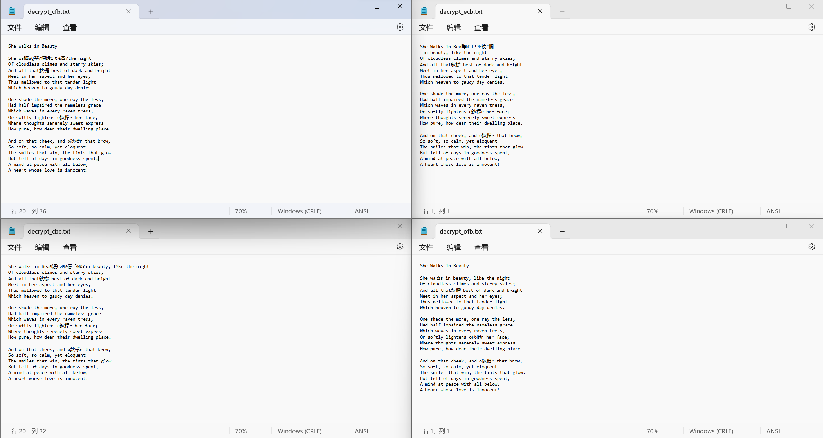
The answers to the questions
- How much information can you recover by decrypting a corrupted file, if the encryption mode is ECB, CBC, CFB, or OFB, respectively?

In ECB, CBC, CFB, OFB mode, the error spread range is generally not large, and most of the information can be recovered.

In ECB mode, if a change is made to a block in plaintext, only the encryption result of that block changes, but the encryption result of other blocks is not affected.

In CBC mode, if a change is made to a block in plaintext, the encryption results of that block and all subsequent blocks change. This is because the change affects the encryption of subsequent blocks.

In CFB mode, if a change is made to a block in plaintext, the encryption results of that block and all subsequent blocks change.

The OFB mode is not affected by the change. Because the output of the encryptor is independent of plaintext and ciphertext, changes to the plaintext do not affect the output of the encryptor.

- Please explain why.
（1）ECB Mode: ECB mode divides the plaintext into blocks of equal length and encrypts each block separately. Therefore, if a block in the plaintext is modified, only the encryption result of that block will change, and the encryption results of other blocks will not be affected. Therefore, the error diffusion of ECB mode is poor.

（2）CBC Mode: CBC mode uses the encryption result of the previous block to encrypt the current block. Therefore, if a block in the plaintext is modified, the encryption results of that block and all subsequent blocks will be changed. This is because the modification will affect the encryption of subsequent blocks, resulting in error diffusion.

（3）CFB Mode: CFB mode divides the plaintext into blocks of equal length and uses the encryption result of the previous block to encrypt the current block. Unlike CBC mode, CFB mode uses the output of the cipher as the keystream, rather than directly applying the encryption result of the previous block to the current block. Therefore, if a block in the plaintext is modified, the encryption results of that block and all subsequent blocks will be changed, because the modification will affect the output of the cipher for subsequent blocks, resulting in error diffusion.

（4）OFB Mode: OFB mode divides the plaintext into blocks of equal length and uses the encryption result of the previous block to encrypt the current block. Similar to CFB mode, OFB mode uses the output of the cipher as the keystream, rather than directly applying the encryption result of the previous block to the current block. Unlike CFB mode, OFB mode is not affected by modifications. Because the output of the cipher is independent of the plaintext and ciphertext, even if the plaintext is modified, it will not affect the output of the cipher. Therefore, the error diffusion of OFB mode is good.

- What are the implication of these differences?
These differences represent that the degree of uncoded diffusion of different operating modes in block ciphers is different, and this degree mainly depends on the principle of operation mode to implement encryption.
ECB:
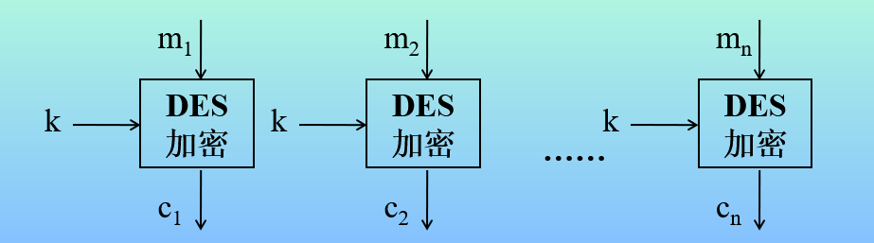
CBC:
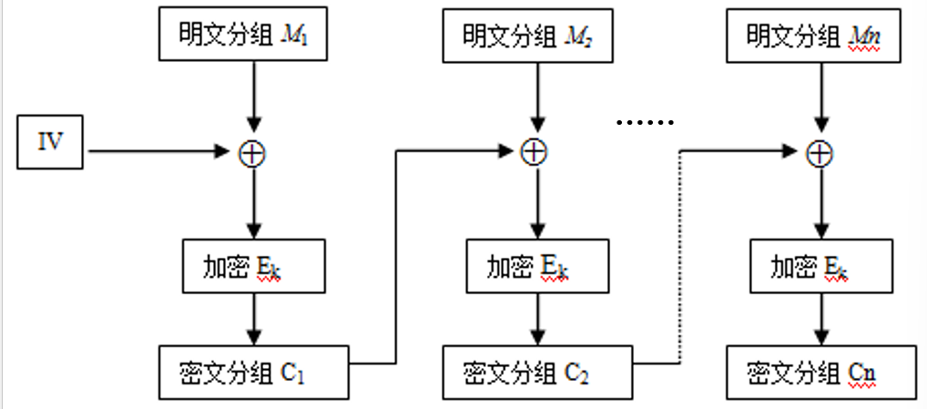
CFB:
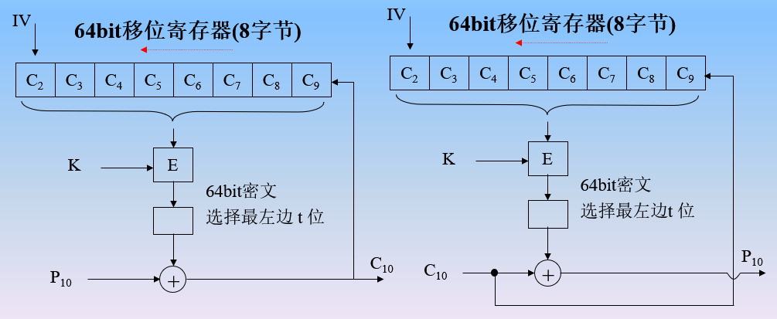
OFB:
