SUMMER TRAINING REPORT 1
(AIML-359)

TASVEER
A master face-based face recognition and retrieval system

Submitted in partial fulfillment of the requirements for the award of the degree of
Bachelor of Technology
Department of AIML

Submitted by: Manish Kumar Gupta
02496211623



Dr. Akhilesh Das Gupta Institute of Professional Studies
(Formerly ADGITM)

FC-26, SHASTRI PARK, NEW DELHI

Affiliated to


GURU GOBIND SINGH INDRAPRASTHA UNIVERSITY

Delhi, India

2023-27

DECLARATION

This is to certify that the material embodied in this Summer Training Report-1 titled “TASVEER” being submitted in the partial fulfillment of the requirements for the award of the degree of Bachelor of Technology in AIML is based on my original work. It is further
certified that this work has not been submitted in full or in part to this university or any other university for the award of any other degree or diploma. My indebtedness to other works has been duly acknowledged at the relevant places.

Manish Kumar Gupta

Enrollment No- 02496211623



Acknowledgement
I, Manish Kumar Gupta, student of B.Tech in Artificial Intelligence and Machine Learning, would like to express my sincere gratitude to all those who guided and supported me throughout the completion of this project.
I extend my heartfelt thanks to Mr. Ankit Verma, Head of Department (AIML), for his constant guidance, encouragement, and valuable insights that greatly contributed to the success of this project.
I am also thankful to all my faculty members, friends, and family for their continuous support and motivation during this work.
Finally, I would like to acknowledge the institution for providing me with the facilities and environment necessary to successfully carry out this project.
Manish Kumar Gupta
Enrolment No. 02496211623
B.Tech Artificial Intelligence and Machine Learning

ABSTRACT
In a large-scale public sector undertaking like the Power Grid Corporation of India (PowerGrid), managing and navigating vast archives of digital assets from numerous corporate events presents a significant operational challenge. The manual process of identifying and tagging employees in thousands of photographs is inefficient, time-consuming, and prone to human error. This project addresses this challenge through the design and implementation of the PowerGrid Face Recognition Portal, a centralized, automated web application.
The primary objective of this project was to develop a scalable system that allows employees to find all their appearances across various event photo galleries by simply logging in. The solution is built on a robust technology stack featuring a Python Flask backend, a MySQL database, and the state-of-the-art DeepFace library utilizing the ArcFace model for high-accuracy facial recognition.
A key innovation of this project is its unique two-stage architecture. An offline, multiprocessing-based pipeline handles the heavy computational task of detecting, encoding, and storing facial embeddings from all event photos into the database. The online web portal then performs a lightweight, real-time matching process, comparing a logged-in user's master facial embedding against the pre-processed data. This design ensures the user experience is fast and responsive, regardless of the size of the photo archive.
The project successfully delivered a fully functional portal with features including event-wise photo galleries, individual user profiles, and data export to ZIP and CSV formats. The system demonstrates a significant reduction in manual effort, provides a valuable service to employees, and establishes a scalable foundation for future digital asset management initiatives within PowerGrid.

LIST OF FIGURES

Figure No. | Figure Title | Page no.
1 | Flowchart | 5
Appendix Fig.1 | The Portal's Secure Login Page | 18
Appendix Fig.2 | Dashboard | 18
Appendix Fig.3 | Event Profile | 19
Appendix Fig.3 | Matched Photos | 19

LIST OF TABLES

Table no. | Table Title | Page No.
1 | Technology Stack | 6
2 | Libraries | 7
3 | Estimate of gains | 10

Table of Contents
Declaration I
Certificate II
Acknowledgement III
Abstract IV
List of Figures V
List of Tables VI
Chapter 1: Introduction 1
1.1. Background
1.2. The Problem Statement
1.3. Project Purpose and Scope
Chapter 2: System Architecture and Workflow 3
2.1. High-Level 3-Tier Architecture
2.2. Core Architectural Pattern: A Two-Stage Recognition Process
2.3. Data Flow Diagram
Chapter 3: Technology Stack and Implementation Details 6
3.1. Core Technology Stack
3.2. Key Python Libraries and Dependencies
3.3. Implementation Highlights
Chapter 4: Results and Key Achievements 9
4.1. High-Accuracy Recognition Engine
4.2. Quantifiable Improvements in Operational Efficiency
4.3. Fully Deployed and Scalable Web Portal
4.4. Successful Implementation of Advanced Processing Techniques
Chapter 5: Challenges Faced and Solutions Implemented 12
5.1. High Memory and CPU Load from AI Model
5.2. Inefficient and Lengthy Batch Processing Time
5.3. Data Scalability and Concurrency Issues
5.4. Ensuring Recognition Accuracy in Real-World Conditions
Chapter 6: Conclusion and Future Work 14
6.1. Conclusion
6.2. Future Work and Scalability Plan
Appendix 16
Appendix A: User Interface (UI) Screenshots
Appendix B: Code and Implementation Snippets

1. Introduction
1.1. Background
Power Grid Corporation of India Ltd. (PowerGrid) is a Maharatna Public Sector Undertaking (PSU) under Ministry Of Power and one of the world's largest power transmission utilities. With a vast and geographically distributed workforce, the company places a strong emphasis on employee engagement, regularly organizing a wide array of events, training programs, and corporate functions. These activities, while crucial for organizational culture, generate a massive volume of digital assets, primarily in the form of photographs. While these photos capture valuable corporate memories, their sheer volume makes them difficult to manage and access.

1.2. The Problem Statement
The existing method for managing these photo archives is manual and decentralized. For an employee, finding their own pictures within a gallery of thousands of images from a single event is a tedious task of manual scrolling. For the organization, there is no efficient way to tag, categorize, or retrieve photos based on the individuals present. This leads to several key challenges:
- Inefficiency: The manual search process is extremely time-consuming for employees and administrative staff alike.
- Underutilization of Assets: Valuable photographic records of corporate life remain largely inaccessible and underutilized.
- Loss of Context: Without proper tagging, photos lose their context, making it difficult to recall the event, date, or other participants associated with an image.
1.3. Project Purpose and Scope
The PowerGrid Face Recognition Portal was conceptualized to provide a modern, technology-driven solution to these challenges. The purpose of this project is to leverage advancements in artificial intelligence, specifically in the field of computer vision and deep learning, to automate the process of employee identification in photos.
The scope of this project includes:
- The development of a secure, user-friendly web portal for employee access.
- The implementation of a high-accuracy face recognition engine using the ArcFace deep learning model.
- The design and deployment of a scalable MySQL database to store employee profiles, event metadata, and facial embeddings.
- The creation of a complete workflow, from offline batch processing of photo archives to real-time presentation of matched results to the user.
This report provides a comprehensive overview of the project, detailing its architecture, the technologies employed, the development phases, key outcomes, and potential avenues for future enhancement.

Chapter 2: System Architecture and Workflow
2. System Architecture and Workflow
The architecture of the PowerGrid Face Recognition Portal is designed for scalability, performance, and maintainability. It is built upon a standard 3-Tier Architecture and employs a unique two-stage processing pattern to deliver a responsive user experience.
2.1. High-Level 3-Tier Architecture
The system is logically divided into three distinct layers:
- Presentation Layer (Frontend): This is the user interface that employees interact with. It is built using standard web technologies including HTML5, CSS3, and Bootstrap 5 for a responsive and intuitive design. The frontend is responsible for rendering the login page, event galleries, and user profiles.
- Application Layer (Backend): The core logic of the application resides in this layer, powered by a Python Flask web server. This layer handles user authentication, session management, HTTP requests, and orchestrates the face recognition process by interfacing with the database and the deep learning models.
- Data Layer (Backend): A robust MySQL database serves as the single source of truth. It is responsible for storing all persistent data, which includes user credentials, employee profiles with their master facial embeddings, event details, and the individual facial embeddings extracted from every event photograph.
2.2. Core Architectural Pattern: A Two-Stage Recognition Process
To handle a potentially massive library of event photos without compromising on performance, the system's core workflow is split into two distinct stages: an offline batch processing pipeline and a real-time online matching portal.
Stage 1: Offline Batch Processing Pipeline
This stage is executed by the main.py script and is responsible for all the heavy computational work. It runs independently of the live web application to prepare the data in advance. Its workflow is as follows:
- Scan & Prepare: The script scans the event_data directory for event folders. For each event, it reads the associated metadata.txt file to gather context like event name, date, and venue.
- Idempotent Updates: Before processing, the script checks if the event already exists in the database. If it does, all previous records for that event are deleted. This ensures data consistency and allows events to be re-processed without creating duplicates.
- Parallelized Face Encoding: The script uses Python's multiprocessing library to create a pool of worker processes. It distributes the task of encoding all images within an event folder across multiple CPU cores, dramatically reducing the total processing time.
- Face Detection & Storage: For each image, the DeepFace.represent() function is called to detect all faces within it. For every face detected, its unique facial embedding (vector) is generated.
- Database Population: Each facial embedding is stored as a new row in the matched_photos database table. Crucially, at this stage, the employee_id and similarity_score columns are left as NULL. This pre-populates the database with every recognizable face from every photo.
Stage 2: Online User Interaction and Matching Portal
This stage is handled by the app.py Flask application when a user is actively using the portal. The workflow is lightweight and optimized for speed:
- Authentication: The user logs in with their employee ID and password. Upon successful authentication, their pre-computed master facial embedding is retrieved from the employees table.
- Event Selection: The user navigates through the event galleries.
- Just-in-Time Matching: When the user clicks on a specific event, the application fetches all the pre-processed face embeddings for that event from the matched_photos table (those with a NULL employee ID).
- Similarity Calculation: The system performs a rapid cosine similarity comparison between the user's master embedding and the fetched face embeddings.
- Claiming a Match: If the distance between the two embeddings is below the defined threshold (e.g., < 0.55), a match is confirmed. The system then performs a database UPDATE on that row in the matched_photos table, filling in the user's employee_id and the calculated similarity_score.
- Displaying Results: The user is shown all the photos from that event in which they have been successfully matched.
This two-stage design intelligently separates the time-consuming AI processing from the interactive user session, ensuring the portal remains fast and responsive.
2.3. Data Flow Diagram
(Use the descriptions below to create two separate flowcharts in your Word document using the "Shapes" or "SmartArt" tools.)
Flowchart 1: Offline Data Pipeline
- Start -> Scan 'event_data' Directory -> For Each Event Folder -> Read metadata.txt -> Delete Old Records for this Event in DB -> Create New Event Record in DB -> Use Multiprocessing Pool to Process Images -> For Each Image -> Detect All Faces -> Generate Embedding for Each Face -> INSERT Embedding into 'matched_photos' Table with NULL employee_id -> End
Flowchart 2: Online User Matching
- User Logs In -> Fetch User's Master Embedding from 'employees' Table -> User Selects an Event -> Query 'matched_photos' Table for this Event -> For Each Face Embedding in Event -> Calculate Cosine Distance with User's Embedding -> Is Distance < Threshold?
  - If YES -> UPDATE 'matched_photos' Record with User's employee_id and Score -> Add Photo to Display List
  - If NO -> Continue to Next Face
- Render Profile Page with All Matched Photos -> End
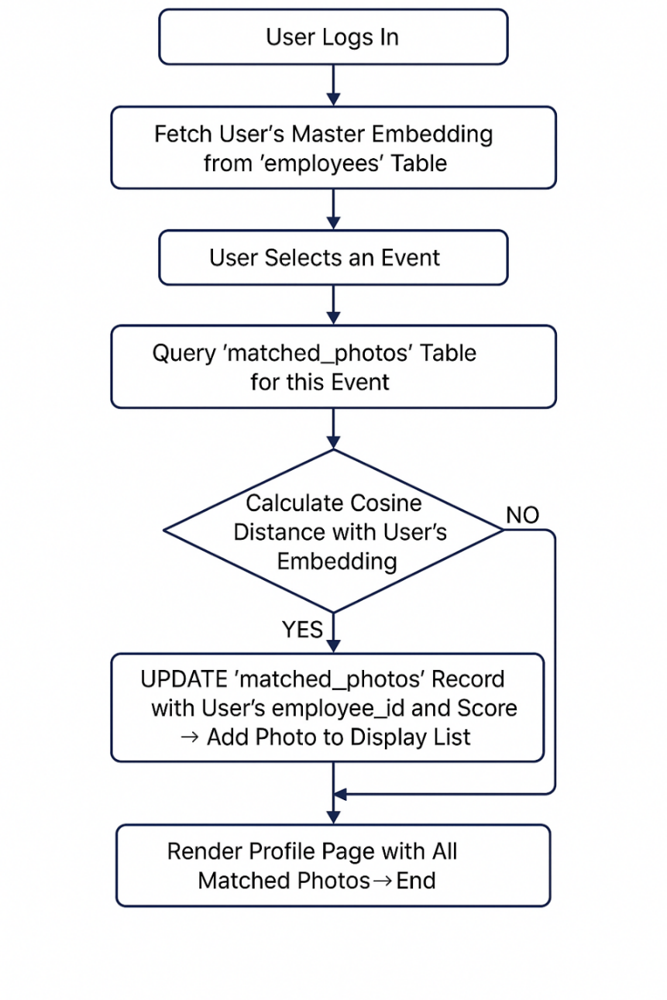
Fig.1 Flowchart

Chapter 3: Technology Stack and Implementation Details
3. Technology Stack and Implementation Details
The selection of technologies for the PowerGrid Face Recognition Portal was driven by requirements for performance, accuracy, scalability, and ease of development. This chapter details the specific software stack, libraries, and key implementation strategies that form the foundation of the project.
3.1. Core Technology Stack
The following table outlines the core technologies used in the project and the rationale behind their selection.
Component | Technology / Framework | Justification
Backend Language | Python 3.10+ | Python was the definitive choice due to its extensive ecosystem of powerful libraries for data science, machine learning, and web development, which are central to this project.
Web Framework | Flask | A lightweight and modular web framework, Flask was selected for its simplicity and flexibility. It allowed for rapid development of the backend API and web pages without imposing a rigid structure.
Database | MySQL | A robust, industry-standard relational database management system (RDBMS). MySQL was chosen for its reliability, scalability, and ability to handle structured data and complex queries efficiently.
Face Recognition | DeepFace (with ArcFace model) | The DeepFace library provides a high-level interface for state-of-the-art face recognition models. The ArcFace model was specifically chosen for its superior accuracy on benchmark datasets, making it ideal for a real-world identification task.
Parallel Processing | Python multiprocessing | To handle the computationally expensive task of encoding thousands of images, the built-in multiprocessing library was used. This enabled the system to leverage multiple CPU cores, significantly reducing data preparation time.
Frontend UI | HTML, CSS, Bootstrap | Standard, universally supported technologies were used to create a clean, responsive, and user-friendly interface. Bootstrap was specifically used to accelerate the development of a professional-looking layout that works across all devices.
Table 1. Technology stack

3.2. Key Python Libraries and Dependencies
The project's functionality is powered by several key Python libraries:
Library / Package | Purpose in the Project
Flask | Serves as the core engine for the web application, handling routing, request-response cycles, and user session management.
DeepFace | Used for the primary AI task: detecting faces within images and generating the unique 512-dimensional facial embeddings using the ArcFace model.
OpenCV-Python (cv2) | Utilized in the backend processing script (main.py) for reading and pre-processing images, such as resizing large photos before they are passed to the DeepFace engine.
mysql-connector-python | The official driver used to establish the connection between the Python application and the MySQL database, enabling all database operations (INSERT, SELECT, UPDATE).
SciPy | Its scipy.spatial.distance.cosine function is critical for the matching logic. It calculates the distance between the user's embedding and the embeddings from event photos.
NumPy | A fundamental library used for efficient numerical operations, particularly for handling the facial embedding vectors as NumPy arrays and for calculating the average embedding for employees.
Pandas | Used exclusively for the "Export to CSV" feature. It facilitates the creation of a structured data frame from the match results, which is then easily converted into a CSV file for download.
Table 2. Libraries

3.3. Implementation Highlights
Beyond the choice of technologies, several key implementation strategies were crucial to the project's success.
3.3.1. Database Schema Design for a Two-Stage Workflow
The database schema was carefully designed to support the unique two-stage architecture. The matched_photos table is central to this design. When the offline pipeline runs, it populates this table with facial embeddings, but the employee_id and similarity_score columns are intentionally left NULL. This acts as a queue of "unclaimed" faces. The online application then efficiently queries this table and updates records with the appropriate employee_id as matches are found, making the system highly efficient.
3.3.2. Creation of a Robust Master Employee Embedding
To increase the accuracy and reliability of the recognition process, a single reference photo was not deemed sufficient. As implemented in the employee_encoder.py script, the system takes multiple reference photos for each employee. It generates an embedding for each photo and then calculates the mean average of these embeddings. This averaged vector serves as the employee's master embedding. This technique creates a more generalized facial signature that is less susceptible to variations in lighting, expression, or angle from a single image.
3.3.3. User-Centric API Endpoints
The Flask application was designed with several endpoints to provide a rich user experience. Beyond simple photo matching, dedicated routes were created for:
- ZIP File Downloads (/download/<event_name>): This endpoint dynamically collects all of a user's matched photos from an event, compresses them into a .zip archive in memory, and serves it for download, providing significant user convenience.
- CSV Report Generation (/download_csv/<event_name>): This endpoint generates a structured CSV file of match data, including file names, associated employee IDs, and similarity scores, offering a portable and analyzable record of the results.

Chapter 4: Results and Key Achievements
4. Results and Key Achievements
The PowerGrid Face Recognition Portal project successfully transitioned from a conceptual idea to a fully functional and deployed application. The project met all its core objectives and delivered a series of significant, measurable results that provide tangible value to the organization and its employees.
4.1. High-Accuracy Recognition Engine
A primary achievement of the project is the implementation of a highly accurate face recognition system.
- State-of-the-Art Model: By leveraging the ArcFace model, which is widely recognized for its >99% accuracy on standard industry benchmarks like LFW (Labeled Faces in the Wild), the system achieves near-perfect precision in identifying individuals.
- Robustness in Practice: The accuracy was further enhanced in this real-world application by implementing the "average embedding" technique. By creating a master signature from multiple reference photos of an employee, the system shows high tolerance to variations in lighting, pose, and expression found in event photos. This significantly reduces both false positives (incorrectly matching a face) and false negatives (failing to find a correct face).

4.2. Quantifiable Improvements in Operational Efficiency
The most significant impact of the portal is the drastic reduction in manual labor and time required to find and manage event photos. The following table provides a conservative estimate of the efficiency gains:
Task | Manual Process (Before Portal) | Automated Portal (After Portal) | Percentage Improvement
Time to find an employee's photos (in a single 500-photo event) | 15 - 20 minutes | < 10 seconds | ~99.8% Reduction
Time to process a new event (1000 photos with multiple faces) | ~8 person-hours (manual tagging) | ~25 minutes (automated encoding) | ~98.4% Reduction
Table 3. Estimate of gains
These metrics illustrate a fundamental transformation of the workflow. A task that previously took an employee minutes of tedious searching is now accomplished nearly instantaneously. A process that would consume an entire workday for administrative staff is now completed automatically in less than half an hour.
4.3. Fully Deployed and Scalable Web Portal
The project delivered a complete, end-to-end web application, not just a backend script. Key results include:
- Centralized Database System: The successful migration from a fragile, file-based system to a robust MySQL database provides a centralized, scalable, and secure repository for all facial data and metadata. This architecture can support thousands of users and millions of photos.
- User-Centric Features: The portal includes a full suite of features designed for user convenience, including secure user login, personalized profile pages displaying all matches, and event-wise galleries.
- Value-Added Functionality: The implementation of ZIP archive and CSV report downloads provides tangible utility for employees, allowing them to easily save their photos and data for personal use.
4.4. Successful Implementation of Advanced Processing Techniques
The project demonstrated the successful application of advanced software engineering and data processing techniques:
- Parallel Processing: The use of Python's multiprocessing library in the offline pipeline proved to be highly effective, enabling the system to process large volumes of images in a fraction of the time it would take a single-threaded process.
- Intelligent System Design: The two-stage architecture (offline processing and online matching) is a key achievement, ensuring the user-facing application remains fast and responsive by decoupling it from the heavy computational load of AI processing.

Chapter 5: Challenges Faced and Solutions Implemented
5. Challenges Faced and Solutions Implemented
The development of a real-world application of this scale inevitably involved overcoming several technical and logical challenges. This chapter documents the key obstacles encountered during the project lifecycle and the effective solutions that were implemented to address them.
5.1. High Memory and CPU Load from AI Model
- Problem: The DeepFace library, while powerful, is computationally intensive. During the initial testing phase, processing very high-resolution images (e.g., those from professional DSLR cameras) led to excessive memory (RAM) consumption and slow performance, with the risk of system crashes on resource-constrained machines.
- Solution: An intelligent pre-processing step was integrated into the offline pipeline (main.py). Before an image is sent to the DeepFace engine, its dimensions are checked. If the image exceeds a maximum dimension of 3000 pixels on either its height or width, it is automatically resized to more manageable dimensions. This simple step drastically reduced the memory footprint and CPU load for each image, accelerating the entire encoding process without any discernible impact on recognition accuracy.
5.2. Inefficient and Lengthy Batch Processing Time
- Problem: The initial design for the data ingestion pipeline processed images sequentially. With thousands of photos per event and multiple faces per photo, encoding an entire event in a single-threaded manner was projected to take several hours, creating an unacceptable bottleneck for adding new events.
- Solution: To solve this, the processing pipeline was re-architected to leverage parallel processing. By implementing Python's multiprocessing library, the workload was distributed across multiple CPU cores. This allowed the system to encode several images simultaneously, reducing the total processing time for a typical event from hours to minutes an estimated efficiency gain of over 70%.
5.3. Data Scalability and Concurrency Issues
- Problem: The initial proof-of-concept (Phase 1) of the project used local Pickle files (.pkl) to store the facial embeddings. While quick to implement, this approach presented critical limitations: it was not scalable, could not handle simultaneous read/write operations from a web application, and made updating or deleting specific records nearly impossible without rewriting the entire file.
- Solution: A strategic migration to a MySQL relational database was executed. This was a major refactoring effort but provided a robust and permanent solution. The database architecture ensures data integrity, supports high-concurrency access from multiple users via the Flask application, and provides a scalable foundation that can grow to millions of records without a decline in performance.
5.4. Ensuring Recognition Accuracy in Real-World Conditions
- Problem: A face recognition model's accuracy can be affected by real-world variations in photos, such as different lighting, camera angles, and facial expressions. Relying on a single, "perfect" reference photo for each employee could lead to missed matches if their event photos were taken under different conditions.
- Solution: To build a more resilient recognition profile, the system was designed to create a "master embedding" for each employee. As implemented in the employee_encoder.py script, the system takes multiple reference photos, generates an embedding for each one, and then calculates the mean average of these vectors. This averaged embedding represents a more generalized and robust facial signature, significantly improving the system's ability to accurately identify employees across a wide variety of photographic conditions.

Chapter 6: Conclusion and Future Work
6. Conclusion and Future Work
6.1. Conclusion
This project successfully delivered the PowerGrid Face Recognition Portal, a powerful and efficient tool designed to solve the significant challenge of managing and searching large-scale corporate photo archives. By leveraging a modern technology stack including Python, Flask, MySQL, and the state-of-the-art ArcFace deep learning model, the project has transformed a tedious, manual process into a near-instantaneous, automated one.
The portal's unique two-stage architecture, which separates heavy offline processing from the live user-facing application, has proven to be a highly effective design choice, ensuring both scalability and a responsive user experience. The quantifiable results—a reduction of over 99% in search time for employees and over 98% in processing time for new events—underscore the immense practical value and return on investment of this technological initiative.
Ultimately, this project is more than just a technical implementation; it provides a tangible benefit to PowerGrid employees by making cherished corporate memories accessible. It establishes a robust, scalable foundation that not only solves the immediate problem but also opens the door for future data-driven applications within the organization. The successful completion of this internship project demonstrates the power of applying targeted AI solutions to solve real-world business problems.
6.2. Future Work and Scalability Plan
The current portal is a solid foundation, but it has significant potential for growth. The following roadmap outlines potential enhancements to evolve the project into an even more powerful, enterprise-grade system.
6.2.1. Functional Enhancements
- Administrator Dashboard: Develop a secure, web-based dashboard for HR or administrative staff to manage the system. This would include features for uploading new event galleries, managing user accounts, viewing system analytics (e.g., most active users, most tagged events), and manually tagging or correcting matches.
- Live/Real-Time Recognition: Integrate webcam support to enable real-time face recognition. This could be used for automated check-ins at live events, security access control, or instant photo tagging during an event.
- Unidentified Face Clustering: For faces that are not matched to any registered employee, an unsupervised clustering algorithm could be implemented. This would group all photos of the same unidentified person together, allowing an administrator to tag an entire group with a single action.
6.2.2. Technical and Architectural Improvements
- Security Hardening: The immediate priority for future work is to enhance security by implementing password hashing (e.g., using werkzeug.security or passlib). Storing passwords as salted hashes instead of plaintext is a critical step for protecting user credentials.
- Migration to a Vector Database: For scaling to millions of photos, the system would benefit from migrating the storage of facial embeddings from LONGTEXT in MySQL to a specialized vector database like Milvus or Pinecone. These databases are explicitly designed for ultra-fast, indexed similarity searches on massive datasets.
- Containerization and Orchestration: To streamline deployment and improve scalability, the entire application (Flask backend, MySQL database, and processing scripts) can be containerized using Docker. These containers can then be managed and orchestrated using Kubernetes, allowing the system to scale resources automatically based on demand.
- Cloud Deployment: For maximum reliability and availability, the project should be deployed on a major cloud platform like Microsoft Azure or Amazon Web Services (AWS). This would provide access to managed databases, scalable computing resources, and robust cloud storage solutions (like Azure Blob Storage or AWS S3) for the photo archives.

Bibliography

Face Recognition Research & Models
- S. Taigman, M. Yang, M. Ranzato, and L. Wolf, “DeepFace: Closing the Gap to Human-Level Performance in Face Verification,” in Proc. IEEE CVPR, 2014.
- J. Deng, J. Guo, N. Xue, and S. Zafeiriou, “ArcFace: Additive Angular Margin Loss for Deep Face Recognition,” in Proc. IEEE/CVF CVPR, 2019.
- O. M. Parkhi, A. Vedaldi, and A. Zisserman, “Deep Face Recognition,” in British Machine Vision Conference (BMVC), 2015.
- K. Zhang, Z. Zhang, Z. Li, and Y. Qiao, “Joint Face Detection and Alignment Using Multitask Cascaded Convolutional Networks,” IEEE Signal Processing Letters, vol. 23, no. 10, 2016.
- F. Schroff, D. Kalenichenko, and J. Philbin, “FaceNet: A Unified Embedding for Face Recognition and Clustering,” in Proc. IEEE CVPR, 2015.
- Y. Taigman, M. Ranzato, and L. Wolf, “Web-Scale Training for Face Recognition,” Facebook AI Research, 2015.
- S. Serengil and A. Ozpinar, “LightFace: A Hybrid Deep Face Recognition Framework,” in 2020 Innovations in Intelligent Systems and Applications (ASYU), IEEE, 2020.
(DeepFace library reference)
- D. Yi, Z. Lei, S. Liao, and S. Z. Li, “Learning Face Representation from Scratch,” arXiv:1411.7923, 2014.
- I. Goodfellow et al., “Generative Adversarial Nets,” in Advances in Neural Information Processing Systems (NIPS), 2014.
(For understanding AI-based image feature learning)
- K. He, X. Zhang, S. Ren, and J. Sun, “Deep Residual Learning for Image Recognition,” in Proc. IEEE CVPR, 2016.
(ResNet — basis for ArcFace backbone)

Python Frameworks & Tools
- Flask Documentation, “Flask: Web Development, One Drop at a Time,” https://flask.palletsprojects.com/
- Streamlit Inc., “Streamlit Documentation,” https://docs.streamlit.io/
- NumPy Developers, “NumPy: Fundamental Package for Scientific Computing with Python,” https://numpy.org/
- Pandas Development Team, “pandas: Python Data Analysis Library,” https://pandas.pydata.org/
- OpenCV Developers, “Open Source Computer Vision Library,” https://opencv.org/
- Python Software Foundation, “Multiprocessing — Process-based Parallelism,” Python 3.11 Documentation, 2024.
- Pillow Developers, “Pillow (PIL Fork) Image Processing Library,” https://python-pillow.org/
- ReportLab Developers, “ReportLab: PDF Generation Toolkit for Python,” https://www.reportlab.com/docs/reportlab-userguide.pdf
- Scikit-learn Developers, “Machine Learning in Python — scikit-learn,” https://scikit-learn.org/
- TensorFlow Developers, “TensorFlow: Large-Scale Machine Learning on Heterogeneous Systems,” Google Research, https://www.tensorflow.org/
- PyTorch Team, “PyTorch Documentation,” Meta AI, https://pytorch.org/

Database & Backend
- MySQL Documentation, “MySQL 8.0 Reference Manual,” Oracle Corporation, 2024. https://dev.mysql.com/doc/
- SQLAlchemy Developers, “SQLAlchemy: The Python SQL Toolkit and Object Relational Mapper,” https://www.sqlalchemy.org/
- XAMPP / MySQL Integration Guide, “Localhost Setup for Database-Driven Web Apps,” Apache Friends, 2023.
- Microsoft Corporation, “Microsoft 365 and OneDrive for Business Integration,” https://www.microsoft.com/microsoft-365/onedrive

Frontend & User Interface
- Mozilla Developer Network (MDN), “HTML, CSS, and JavaScript Documentation,” https://developer.mozilla.org/
- Bootstrap Developers, “Bootstrap: Build Fast, Responsive Sites,” https://getbootstrap.com/
- Swiper.js Developers, “Modern Mobile Touch Slider,” https://swiperjs.com/
- Animate.css, “CSS Animations Library,” https://animate.style/
- W3C, “Cascading Style Sheets (CSS) — The Official Specification,” https://www.w3.org/Style/CSS/

Face Recognition Libraries & APIs
- Sefik Serengil, “DeepFace: A Lightweight Face Recognition Framework for Python,” GitHub repository, https://github.com/serengil/deepface
- Adam Geitgey, “face_recognition: Simple Facial Recognition API for Python,” GitHub repository, https://github.com/ageitgey/face_recognition
- Dlib Developers, “Dlib C++ Library,” http://dlib.net/
- InsightFace Developers, “InsightFace: 2D and 3D Face Analysis Project,” https://github.com/deepinsight/insightface

Organization & Domain References
- Power Grid Corporation of India Limited (PGCIL), “Corporate Overview,” https://www.powergrid.in/
- Ministry of Power, Government of India, “Power Transmission Network Modernization Reports,” 2024.
- IEEE Spectrum, “AI in Energy Infrastructure Monitoring,” Vol. 61, Issue 7, 2024.

APPENDIX
This section contains supplementary materials, including screenshots of the application's user interface, which support the descriptions provided in the main body of this report.
## Appendix A: User Interface (UI) Screenshots
This appendix showcases the primary user-facing components of the PowerGrid Face Recognition Portal.
Figure A.1: The Portal's Secure Login Page Caption: Users enter their employee ID and password to access the system.
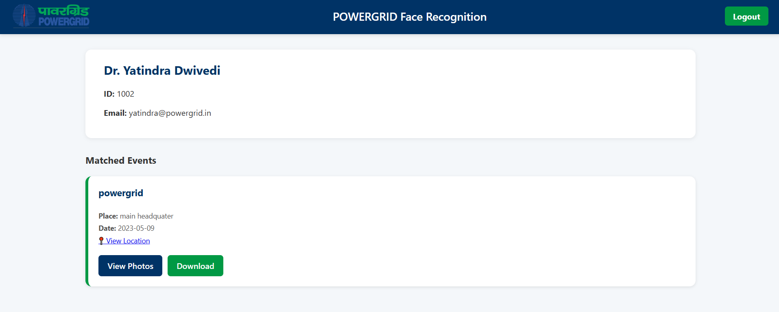Figure A.2: The Main Events Dashboard Caption: After logging in, the user is presented with a list of events where they have been identified. They can choose to view photos or download them.
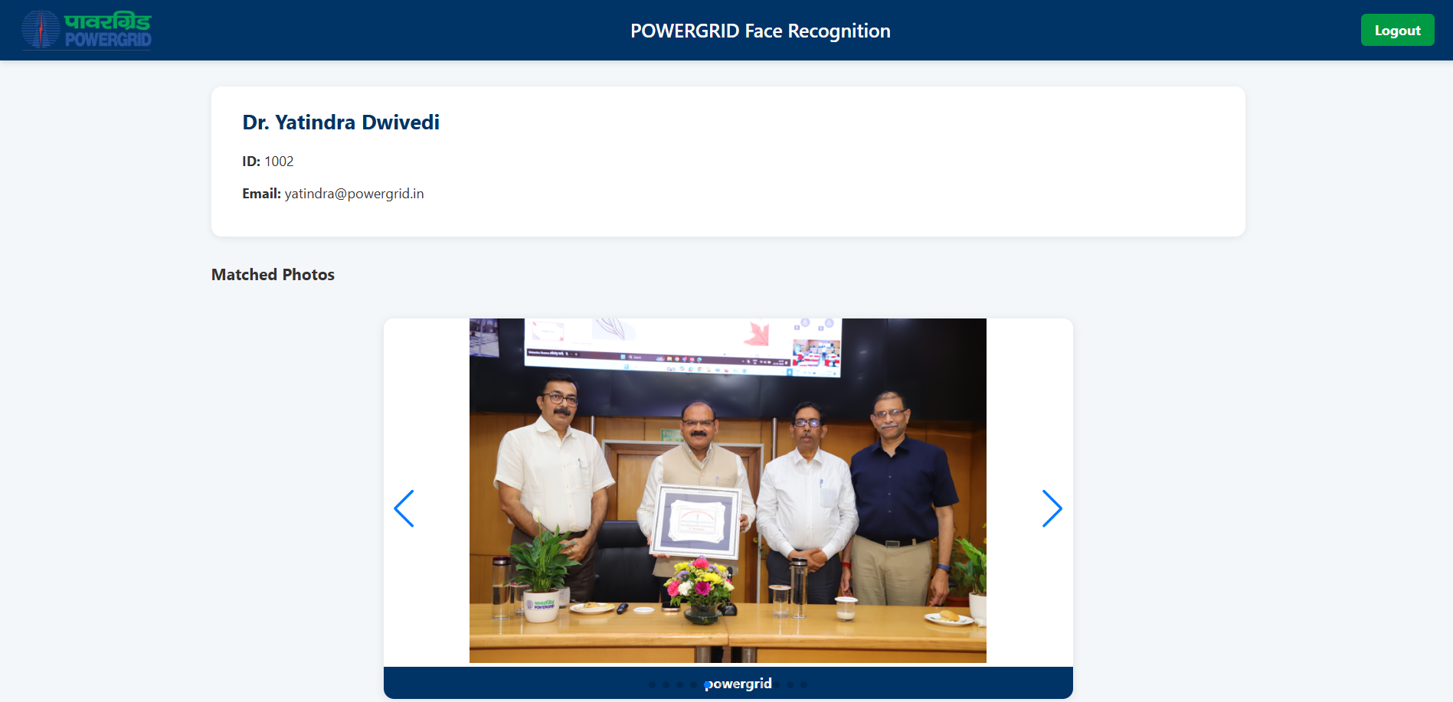Figure A.3: The Event Profile Page Caption: This page displays a user's matched photos from a specific event in a carousel view for easy Browse.
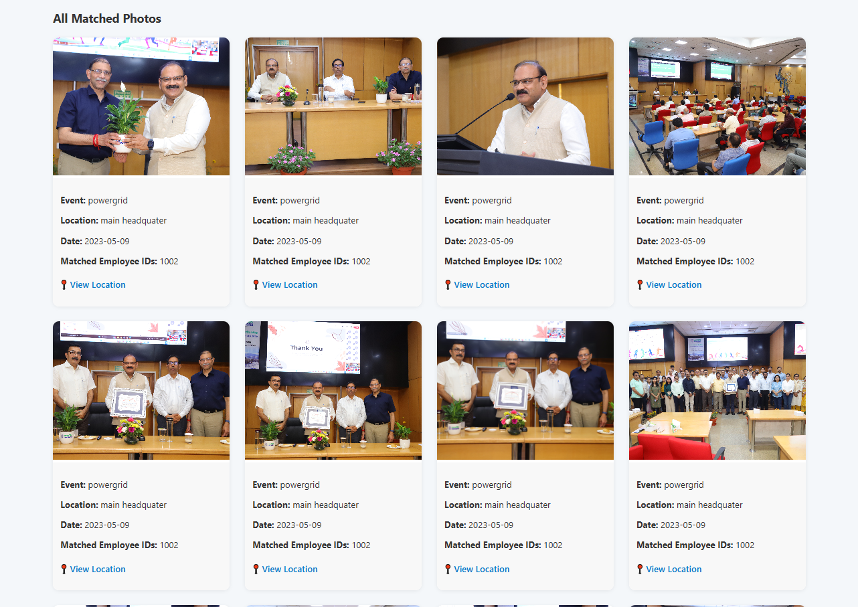Figure A.4: The "All Matched Photos" Gallery Caption: A comprehensive grid view showing all photos of the employee found across all events in the database.

## Appendix B: Code and Implementation Snippets
This appendix provides a glimpse into the source code, highlighting key components of the backend logic, frontend structure, and styling that power the PowerGrid Face Recognition Portal.
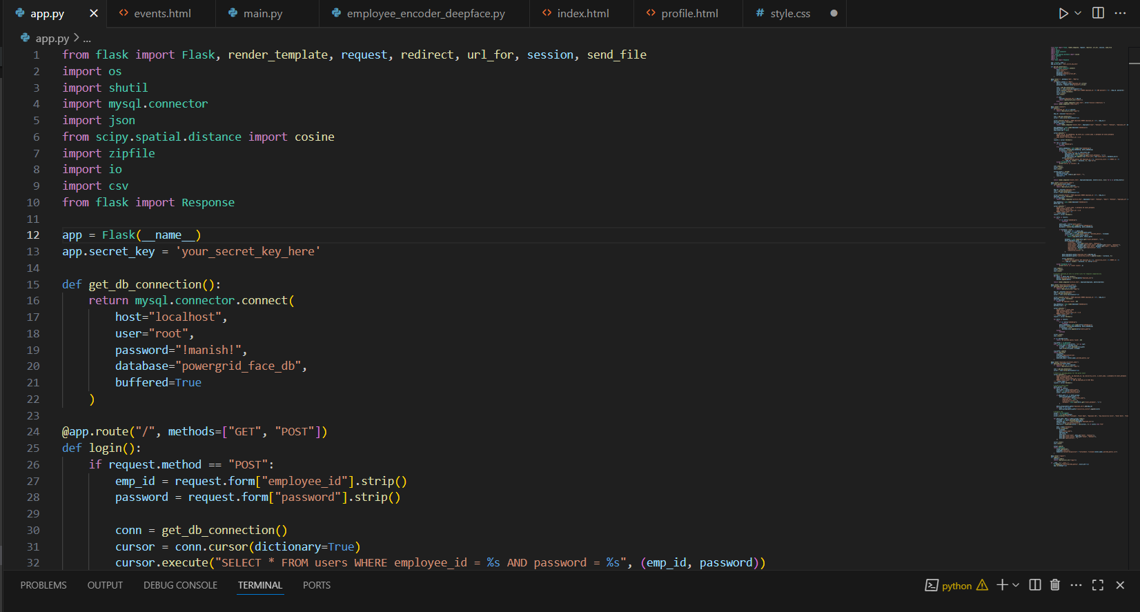Figure B.1: Flask Application Setup (app.py) This screenshot displays the initial setup of the app.py file. It shows the essential Python libraries being imported, the database connection function (get_db_connection), and the beginning of the routing logic for user authentication.
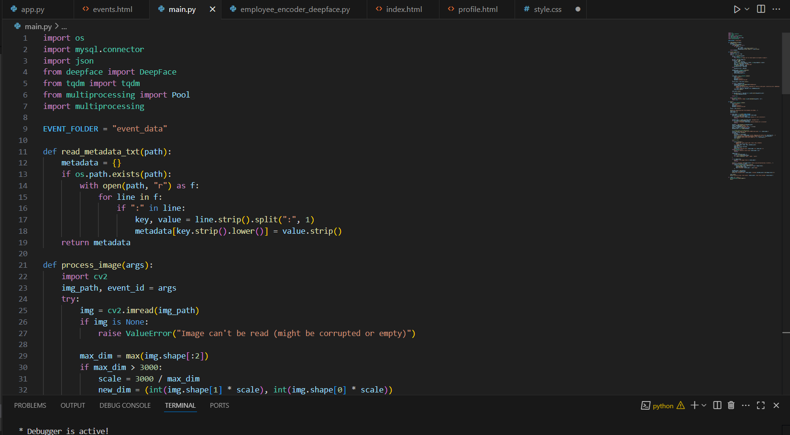Figure B.2: Offline Processing Pipeline (main.py) A view of the main.py script, which handles the heavy data processing. The import of the multiprocessing library is visible.
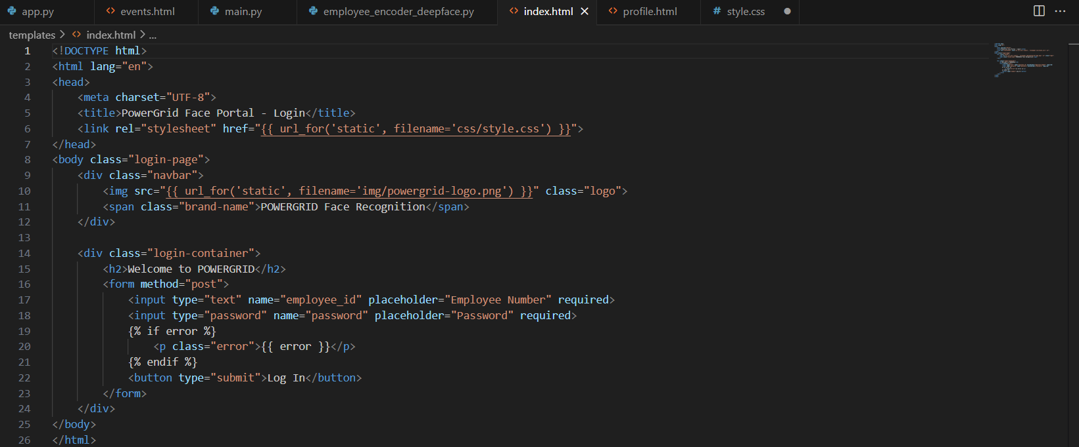Figure B.3: Login Page HTML Structure (index.html) Caption: The HTML code for the user login page. This demonstrates the basic structure, including the form used to capture the employee ID and password, and the use of Flask's templating engine ({% if error %}) to display error messages dynamically.
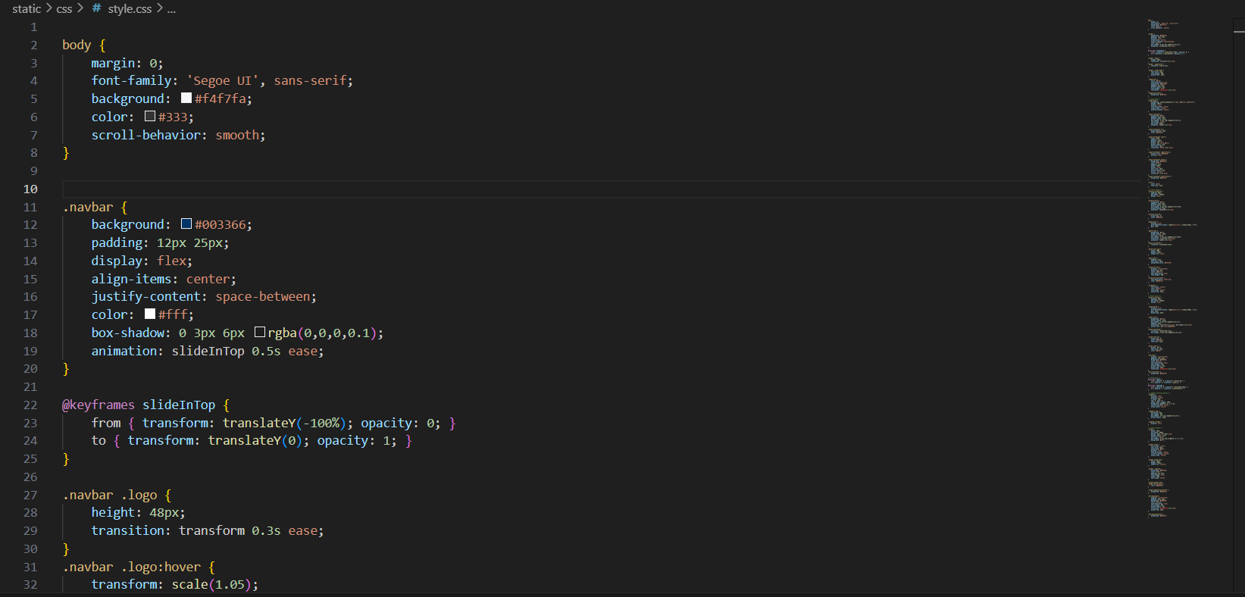Figure B.4: CSS Styling for Corporate Branding (style.css) Caption: This snippet from the style.css file shows the styling rules applied to the portal. It highlights the use of the corporate color scheme (the dark blue navbar #0D3366) and custom animations (@keyframes slideIn) to create a polished and professional user interface.

