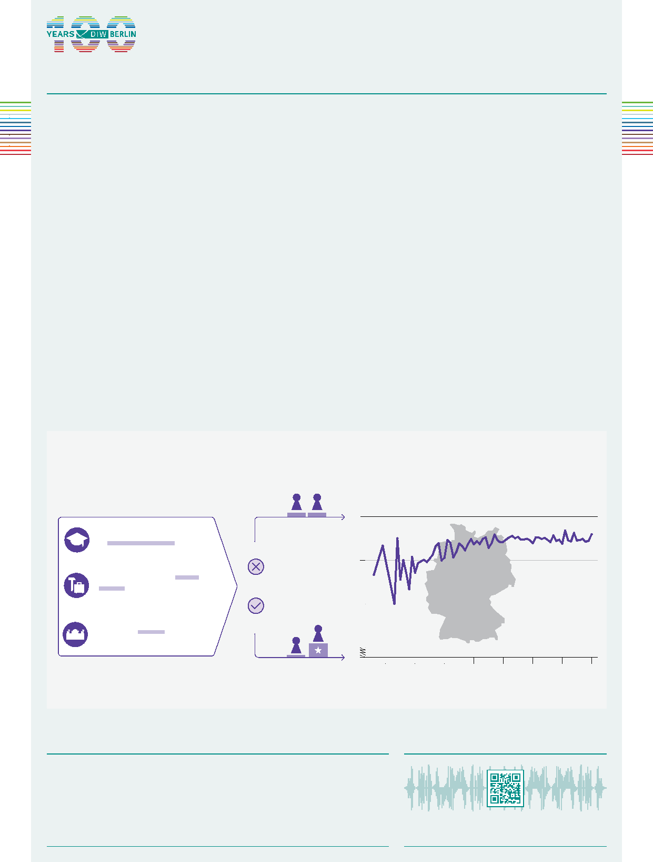
2025
45+46
MEDIA
FROM THE AUTHORS
Audio Interview with Lukas Menkhoff (in German) www.diw.de/mediathek
“Relatively egalitarian attitudes are established in Germany, but this has reached its limits in recent decades. Differences in attitudes are increasing globally. Some countries have increasingly egalitarian attitudes, while others remain very traditional; in some countries, younger people are more traditional than their parents.”
— Lukas Menkhoff —
AT A GLANCE
Traditional attitudes toward gender roles are increasing among young people in some countries
By Lukas Menkhoff and Katharina Wrohlich
- Study examines changes in attitudes toward gender equality across education, work, and political domains worldwide and over time
- Support for equality tends to be higher in countries with higher per capita income
- Egalitarian attitudes are on the rise worldwide, including in Germany
- In almost all countries, while support for women’s equality is higher among younger respondents, this effect is less pronounced among younger generations or is reversed, as in Italy and Poland, for example
- The trend toward more egalitarian attitudes is weakening in Germany and many other European countries
Attitudes toward the role of women are becoming more egalitarian in Germany—however, this trend is less pronounced among younger respondents
Source: Integrated Values Survey (wave 7, 2017). Age © DIW Berlin 2025
INDEX OF ATTITUDES
in the areas of education, work, and politics
”Men should have more rights to a job than women when jobs are scarce”
”Men are better political leaders than women”
”University education
is more important
for boys than for girls”
DISAGREE
AGREE
Equality-oriented Attitudes
Traditional Attitudes
0.25
0.75
0.5
0
1
92 82 72 62 52 42 32 22
ATTITUDES TOWARD GENDER EQUALITY
by age in Germany (2017)


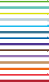 | Traditional attitudes toward gender roles  are increasing among young people in  some countries | 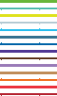

By Lukas Menkhoff and Katharina Wrohlich
ABSTRACT
Attitudes toward the roles of women and men in society have become more egalitarian in Germany and most countries around the world since World War II. Recently, however, this process has slowed significantly, even reversing in some places. In most countries, the attitudes of the youngest ten age groups surveyed are hardly any more egalitarian than those of the ten age groups before them. In about a third of countries, the trend is even negative among the youngest 20 age groups. This suggests that attitudes toward gender roles are becoming more traditional again in some places. Thus, the disparity in the global development of attitudes toward gender roles could intensify. Even in Europe, there are signs of a reversal in some countries. In Germany, the trend toward more egalitarian attitudes is still progressing, but this process is experiencing a slowdown and may come to a standstill here as well.
The possible answers are always collected within a range and coded in such a way that they lie between zero and one. Higher values indicate rejection of the statement and are interpreted as a more egalitarian attitude. On this basis, an index (“equality index”) is formed in which these three attitudes are weighted equally and divided by the number of attitudes, such that the value of the index must also lie between zero and one.³
Attitudes toward the roles of women and men in the corporate sector and society have changed significantly in Germany over the past 75 years. Attitudes have become more egalitarian from decade to decade. This type of attitude shift toward egalitarianism has become almost a matter of course in German society and its neighboring countries.¹ The extent to which this also applies globally is studied in this report on the basis of representative data from more than 80 countries, representing almost 85 percent of the world’s population, over the last few decades.
Identifying attitudes toward the roles of women and men
Attitudes toward the roles of women and men in society have many aspects that can only be measured approximately in empirical terms. In order to reflect various dimensions, attitudes are recorded in three areas: education, work, and politics. Three statements were included in the survey, where respondents could (strongly) agree or (strongly) disagree:² “University education is more important for boys than for girls”; “Men should have more rights to a job than women when jobs are scarce”; and “Men are better political leaders than women.”
1 See Ronald Inglehart and Pippa Norris (2003): Rising Tide: Gender Equality and Cultural Change around the World. Cambridge University Press; Johannes Bergh (2007): Gender Attitudes and Modernization Processes. International Journal of Public Opinion Research 19 (1), 5–23; Stephanie Seguino (2007): Plus Ca Change? Evidence on Global Trends in Gender Norms and Stereo types. Feminist Economics 13(2), 1–28.
2 This does not take the private sphere into account and cannot cover all aspects in the three mentioned ranges.
3 In an earlier publication, attitudes toward the issue of family were included as a fourth dimension for the equality index (or the score for the image of women). Not enough observations were available prior to this aspect being taken into account over time in many countries. See Lukas Menkhoff and Katharina Wrohlich (2024): Attitudes toward gender roles have become more egalitarian in Germany over time. DIW Weekly Report no 46, 717–724 (available online, accessed on October 10, 2025. This also applies to all other online sources in this report, unless otherwise noted).
312 DIW Weekly Report 45+46/2025 DOI: https://doi.org/10.18723/diw_dwr:2025-45-1

Box
Availability of items used for the equality index across waves of the World Values Survey
The World Values Survey (WVS) is conducted approximately every 5 years. Although participation by countries is generally increasing over time, it is irregular. Furthermore, the same questions are not always asked in every country. This means that, when conducting a study across countries and over time (i.e., a panel study), there is a trade-off between broad coverage and completeness of items. Only from the third wave of the WVS onwards, at least three of the four items of interest on gender roles are collected; previously in the first and second waves, only one was collected. Four items, however, are only available for a good part of all countries in the seventh, most recent wave. Therefore, the equality index is formed from three items.
Thus, five waves are available for analyses over time, from the third wave around 1995 to the seventh wave in 2017–2022. Countries that contribute only to items in one wave are excluded from the analysis. Furthermore, only countries for which the most recent information is available for the sixth or seventh wave are included. With these additional restrictions, the result is a panel of 83 countries, which nevertheless represents almost 85 percent of the world's population and 93 percent of global GDP.
In the final step, missing data prior to the third wave in 1995 is estimated based on the responses of the birth cohorts.

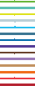
Figure 1
Correlation between income and attitudes toward gender roles Per capita income (in thousands of USD) and equality index
0.2 0.4 0.6 0.8 1.0
Equality index
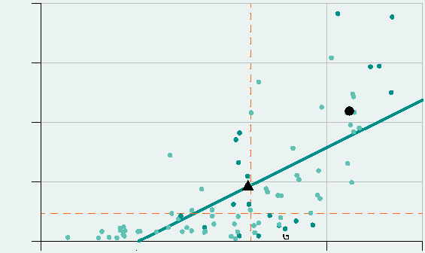
Per capita income (in thousands of USD)
100
50
25
75
0
Maledives
Czech Repub
Montenegro
Belarus
Kenya
Ja
Macao
pan
Cyprus
lic Chile
Serbia Ukraine G
Mexic
uatemala
o Brazil
Germany
Switzerland
Albania
Denmark
Norway
Sweden
Iceland
Note: The equality index is based on agreement with gender equality in education, politics, and the labor market. Value range: 0 (low equality) to 1 (high equality). The black triangle marks the average for all countries. Five countries per quadrant are shown on a chart based on index and income. The regression line is based on data from 87 countries; the correlation coefficient is 0.7. Each dashed red line divides the graph into two equally sized groups of countries; left/right and top/bottom.
Source: World Bank World Development Indicators; WVS – Integrated Values Survey; authors’ own calculations.
© DIW Berlin 2025
In higher income countries, attitudes towards gender roles are typically more egalitarian.
Data allows for global comparisons
The data for this study comes from the World Values Survey.⁴ This survey is conducted approximately every five years worldwide using a questionnaire that is essentially identical in every wave. Although the participating countries vary and the specific questions asked differ in some ways, we still end up with a repeated sample that, with these limitations, provides a good picture of attitudes around the world. The selection of the above three statements is not only based on content, it also takes data availability into account (Box).
The survey has been repeated seven times (waves) since 1980, with the seventh wave of data from 87 participating countries collected between 2017 and 2022. The data used here to calculate the equality index covers 87 countries, accounting for 88 % of the world’s population and 95 percent of global gross domestic product (Figure 1).
In 2022, per capita income in Germany was US$53,800, with an equality index of 0.85 (last calculated in 2017). Globally, there is a positive correlation between higher incomes and more egalitarian attitudes. This is particularly evident in the Nordic countries.
Deviations from the overall picture can occur in two directions: for high-income countries, the value of the equality index may be comparatively low. This applies, for example, to Cyprus, Malaysia, and Singapore. Conversely, for lower-income countries, the value of the index may be unusually high. This is the case for some African countries, such as Kenya and Zimbabwe.
Egalitarian attitudes evolved between 1955 and 2020
The next step is to record the change in gender roles globally. To do this, the equality index is calculated for each country
4 The authors would like to thank Farid Orangi for his valuable support in data preparation and
Julia Redelings for literature review.
and each wave for which data is available. Since this is normalized to a range between zero and one, it can be compared across time and countries.
Attitudes toward gender roles have clearly changed
In an initial analysis of possible changes over time, all countries with values for the third (or fourth) and seventh (or sixth) wave are included. The temporal focus of these early and late values is around 1995 and 2020, respectively. For these

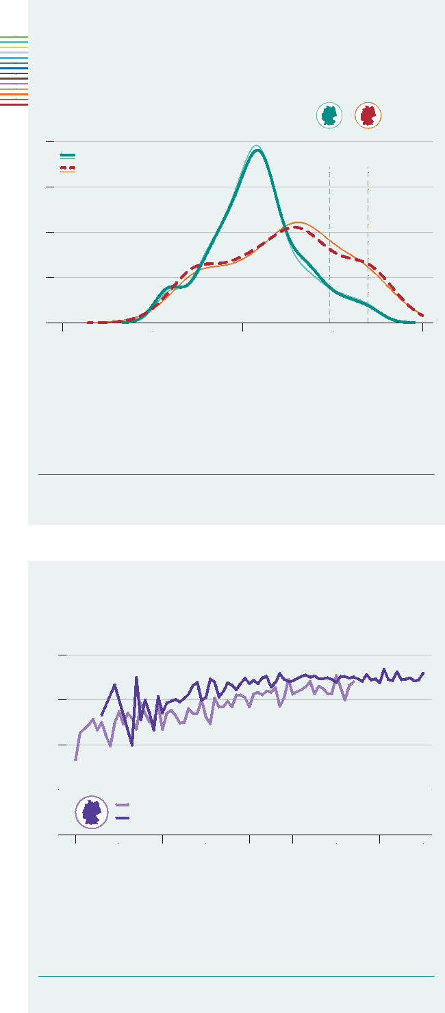
0.75
0.5
Figure 2
Comparison of global gender role attitudes between the first
and last survey waves
Density functions
Earlier wave Later wave
GER
(earlier wave
1997)
GER
(later wave
2017)
3
2
1
0
4
0 0.25 0.5 0.75 1.0
Equality index
Note: The equality index is based on attitudes toward gender roles in education, politics, and the labor market. Value range: 0 (traditional role model) to 1 (equality-oriented role model). Thick lines: flexible sample, thin lines: restricted sample. The flexible sample includes 68 countries in the early wave and 102 countries in the later wave. The restricted sample includes 62 countries in both waves. Green: earlier wave (3 or 4); red: later wave (7 or 6). Vertical lines mark Germany’s score (GER).
Source: WVS – Integrated Values Survey.
© DIW Berlin 2025
Between survey waves, attitudes toward gender roles have become significantly more egalitarian.
Figure 3
Attitudes toward gender roles by year of birth in Germany Equality index
1.0
0.25
Wave 3 (1997) Wave 7 (2017)
1915 1925 1935 1945 1955 1965 1975 1985 1995
Year
Note: The equality index is based on attitudes toward gender roles in education, politics, and the labor market. Value range: 0 (traditional role model) to 1 (equality-oriented role model). The chart shows the average score by year of birth for Germany in two survey waves. Wave 3 (1997) represents the first available observation with complete data, wave 7 (2017) the most recent available information.
Source: Integrated Values Survey (waves 3 and 7).
© DIW Berlin 2025
Younger generations have more egalitarian attitudes toward gender roles.
0
points in time, the distributions of the index values are calculated for all participating countries (Figure 2). The latest values are significantly to the right of the older values. Thus, attitudes toward gender roles have become more egalitarian worldwide between 1995 and 2020. The mean went from 0.53 to 0.62. For Germany, the mean rose from 0.74 to 0.85.
To rule out the influence of a different composition of countries, only those countries for which information on the equality index is available at least twice are considered (Figure 2). Both distributions roughly correspond to those for all available countries.
In addition to the increase in mean values, the increase in dispersion in the comparison of the two distributions is striking. The values of the equality index show greater dispersion in the seventh wave than in the third, indicating that attitudes toward gender roles are more diverse worldwide today than 25 years ago.⁵ However, this does not necessarily apply to all countries.⁶
Unfortunately, the World Values Survey does not go back far enough to track long-term changes over time. This means that, for the period prior to 1995, it is not possible to refer to entire waves; a different approach must be taken. Here, we make use of the fact that individual data is available, in particular, the birth year of each respondent. In Germany, the youngest responses in the 1995 wave were 18 years old, thus they were born around 1977. Other respondents may have been as old as 80, meaning they were born in 1915. The mean for each year of birth, calculated from the individual responses of around 1,000 people per survey wave in the 1995 and 2017 waves of the German Social Survey shows that younger age groups have a more egalitarian view of women than older age groups (Figure 3). In addition, attitudes are also becoming more egalitarian within most age groups.
“Retrospective calculation” of attitudes shows trend toward egalitarianism
Based on the available responses from the oldest wave, comprising cohorts born between 1915 and 1977, retroactive calculations can be made on the basis of certain assumptions. Specifically, it is assumed that the cohorts born from 1915 onwards would always respond as they did in the 1995 survey. For those born prior to 1915, it is assumed that they would respond in the 1995 survey in the same way as those born
5 See also Xiaoling Shu, Bowen Zhu, and Kelsey D. Meagher (2025): Classifying and Mapping Gender Ideologies Globally: Gender Attitudes in 47 Countries at the Turn of the 21st Century. Journal of Marriage and Family 87(2), 724–750; Carly R. Knight and Mary C. Brinton (2017): One Egalitarianism or Several? Two Decades of Gender-Role Attitude Change in Europe. American Journal of Sociology 122(5), 1485–1532.
6 For Germany, see Christian Ebner, Michael Kühhirt, and Philipp M. Lersch (2020): Cohort Changes in the Level and Dispersion of Gender Ideology after German Reunification: Results from a Natural Experiment. European Sociological Review 36(5), 814–828.
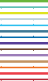

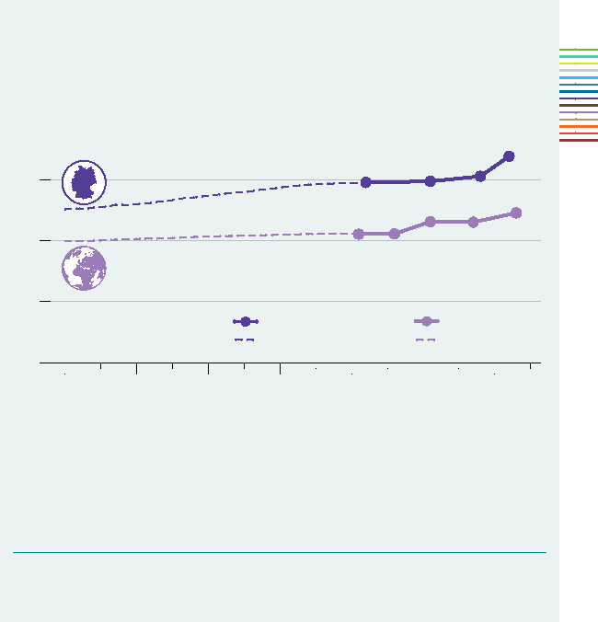
0.75
0.50
Figure 4
Projection of the equality index for Germany and the world Index values (0–1)
1.0
0.25
0
1955 1965 1975 1985 1995 2005 2015
Year
Note: The equality index is based on attitudes toward gender roles in education, politics, and the labor market. Value range: 0 (traditional role model) to 1 (equality-oriented role model). The chart shows the average index value for Germany and the world in the respective waves collected or projected. Wave 3 (1997) represents the first available observation with complete data, wave 7 (2017) the most recent available information.
Source: Integrated Values Survey; authors’ own calculations.
© DIW Berlin 2025
The equality index has risen over time; in Germany, the index is consistently higher than worldwide.
Germany (real) Germany (projected)
World (real) World (projected)
between 1915 and 1924.⁷ Given the clear trend over time, these seem to be reasonable, even conservative, assumptions.⁸
This process can be extended to 60 cohorts and a requirement for “real” responses for, say, 20 cohorts by 40 years compared to the last decade recorded. Thus, the estimated wave of 1955 is based on the actual responses of 60–80-year-olds from 1995 and the assumption that the 40 cohorts before that, i.e., the cohorts from 1875 to 1914, would have responded in the same way as the cohorts from 1915–24 in 1995.
Based on this approach, values for fictitious surveys prior to 1995 can be calculated (Figure 4). Both the average values across all countries and the values for Germany increase over time.
Convergence of attitudes toward gender roles across countries is unclear
Looking at the world as a whole over the longer term, there is a clear process of shifting attitudes toward gender roles in society. This is derived from the responses at the respective points in time of a survey wave and an estimate of earlier waves based on the responses of older age groups. However, this development cannot be projected into the future.
Indications of changes in attitudes toward equality
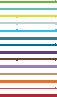
Previous analyses provide three indications that global attitudes toward egalitarianism may not continue along the same path.⁹ First, countries with the most egalitarian attitudes, such as Sweden, are already quite close to the theoretical maximum of egalitarian attitudes (Figure 1). Second, even in Germany, which still lags significantly behind Sweden in this respect, the cohort effect has recently become less clear-cut than before. The value of the equality index for the younger wave has remained almost unchanged from the 1965 cohort to the most recent cohorts up to 1995 (Figure 3). Third, the greater dispersion of the index values for individual countries in the most recent wave suggests that the global trend is no longer as standardized as it may once have been.
7 The reality is more complicated. On the one hand, the chosen modus operandi does not allow for non-linear influences, such as possible shocks caused by World War I. On the other hand, age effects may differ across cohorts, cf. Francisco Perales, Philipp M. Lersch, and Janeen Baxter (2019): Birth Cohort, Ageing, and Gender Ideology: Lessons from British Panel Data. Social Science Research 79 (March), 85–100. The retroactive calculation only takes into account a conservatively estimated cohort effect and neither an age effect nor time-dependent influences (period effects).
8 In fact, there are indications of two further influences, meaning that the earlier responses may have been even more traditional than assumed here: On the one hand, it can be observed for Germany that attitudes toward gender roles have become increasingly egalitarian across all available waves; on the other hand, it is evident that the same age groups provide a more egalitarian response over time (cf. Menkhoff and Wrohlich (2024), ibid).
9 For evidence of this from the US, see, for example, David Cotter, Joan M. Hermsen, and Reeve Vannemann (2011): The End of the Gender Revolution? Gender Role Attitudes from 1977 to 2008. American Journal of Sociology 117(1), 259–289; Jaoling Shu and Kelsey D. Meagher (2018): Beyond the Stalled Gender Revolution: Historical and Cohort Dynamics in Gender Attitudes from 1977 to 2016. Social Forces 96(3), 1243–1274. For evidence on European countries, see, for example, Katia Begall, Daniela Grunow, and Sandra Buchler (2023): Multidimensional Gender Ideologies across Europe: Evidence from 36 Countries. Gender & Society 37(2), 177–207.
To say more precisely how things are developing at the end of the time series, the attitudes of younger people are compared with those of other respondents. For this purpose, the responses are evaluated by age group for the most recent wave of the survey, which is usually wave seven or wave six.
The youngest 10 age groups are no more egalitarian in their attitudes than the 10-year cohort before them.
The starting point is the finding from Germany that no major changes in attitudes toward gender roles can be observed among the youngest age groups. The study examines whether this is also the case in other countries and whether the youngest age groups still show clearly more egalitarian attitudes than the slightly older ones, thus indicating that respondents in the 18 to 27 age group are more egalitarian in their attitudes than those in the 28 to 37 age group.¹⁰ The comparison shows that younger people are clearly more egalitarian in their attitudes in only a few countries (Figure 5). Globally, attitudes toward egalitarianism are comparatively unchanged between 18- to 27-year-olds versus 28- to 37-year-olds: in many countries, the attitudes toward gender roles among 18- to 27-year-olds correspond to those of 28- to 37-year-olds. Thus, German developments are not atypical.¹¹
10 This again ignores age effects, so the estimate is probably conservative.
11 See, among others, Cotter et al. (2011), ibid, and Begall et al. (2023), ibid.

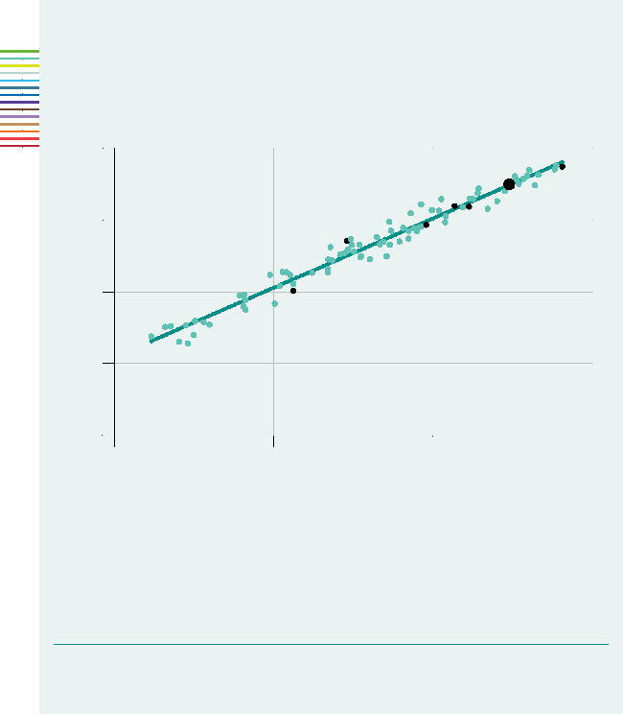
Figure 5
Correlation between global equality indices across two cohorts Average index value (age group 18–27) and average index value (age group 28–37)
0.25 0.5 0.75 1.0
Average index value (age group 28–37)
Note: For each country with available data in wave 7, the equality indices were calculated for two young cohorts (age groups 18–27 and 28–37). The straight line in the figure applies to identical index values in both age groups.
Reading aid: For values below the diagonal, older people between the ages of 28 and 37 are more egalitarian than younger people between the ages of 18 and 27.
Source: Integrated Values Survey (wave 7 or 6); authors’ own calculations.
© DIW Berlin 2025
Only in a Few countries do younger people have signiFicantly more egalitarian attitudes toward gender roles than older people.
SE
IT Germany US
 |  | CN | PL
 | TR

1.0
Average index value (age group 18–27)
0.75
0.5
0.25
0
A further analysis looks not at the levels, but at the changes among young people and the overall population. To this end, linear regressions are used to determine separately for each country how attitudes differ systematically by age. The coefficient, which measures the slope of the regression line and thus the strength of the age effect, indicates the degree of shifts in attitudes toward egalitarianism in each respective country: positive values indicate that the younger the respondents, the more egalitarian their attitudes; negative values mean that the younger the respondents, the more traditional their attitudes. In order to compare the influence of age among younger people with that of the overall population, the data from the most recent wave is studied separately for the overall population and for the youngest 20 age groups. Thus, it is not simply a question of whether younger people’s responses are more egalitarian than those of older people, but whether this trend toward egalitarian attitudes among younger people is still as strong as in the overall population.
A total of 83 countries (plus the world) are included in this analysis (Figure 6). Countries to the right of the vertical axis show a positive long-term trend toward egalitarianism for the overall population. Countries to the left of the axis tend to have increasingly traditional attitudes toward gender roles (in almost all cases with a weak tendency). The situation is different when only the youngest 20 age groups in the survey are taken into account. Countries above the horizontal line
show a positive trend among the youngest 20 age groups, while countries below show a negative trend. It is striking that around 40 percent of countries show a negative trend among the youngest 20 age groups. This means that, in these countries, the youngest 20 age groups surveyed are more traditional the younger they are. If this continues, the trend toward egalitarianism could one day reverse. In some countries, this reversal can already be observed, such as in Bulgaria (–0.125), Switzerland (–0.135), and Italy (–0.136), as well as South Africa (–0.077), the US (–0.206), Brazil (–0.110), and Uruguay (–0.192).
This slowdown in attitudes shifting toward egalitarianism with respect to gender roles is shown in further analysis. The diagonal line from the bottom left to the top right in Figure 6 represents all situations in which young people show the same trend in shifting attitudes as the overall population. The vast majority of countries lie below this diagonal line. Young people are becoming more egalitarian more slowly than the overall population.¹²
Projections may change, but a break in the increasing appreciation of egalitarian attitudes is likely
In the older waves of the World Values Survey, younger age groups were typically more egalitarian in their attitudes toward gender roles than older age groups. Based on this finding, it is possible to make well-estimated projections of the database into the past. Of course, the back-calculations depend on assumptions: these are chosen cautiously, because older people were not only more traditional than younger people at a given point in time, but they also became more egalitarian over time. In this respect, the assumption that the cohorts that are not included in the dataset would have responded as traditionally as the oldest recorded cohorts is rather conservative.
In the other direction, statements about the projection for the future are much more difficult to make for the aforementioned reasons. In particular, the youngest generation is not necessarily more egalitarian in their attitudes than those immediately prior to them. However, if no clear trend can be identified, projections for the future become quite uncertain. The mere fact that this is the case already indicates a break with past trends.
Conclusion: The trend toward more egalitarian attitudes toward gender roles is stalling
Once, it seemed like the issue of gender roles would ultimately resolve itself over time: not only were young people “always” more egalitarian in their attitudes than older people, but the older people themselves became more egalitarian over time. These effects are well supported by evidence
12 This result was also found in earlier studies for the US, see Joanna R. Pepin and David A. Cotter (2018): Separating Spheres? Diverging Trends in Youth’s Gender Attitudes about Work and Family. Journal of Marriage and Family 80(1), 7–24.


Figure 6
Influence of age on attitudes toward equality among all respondents and among the 20 youngest age groups. Regression coefficients
–0.4 –0.2 0 0.2 0.4 0.6
Age on attitudes towards equality among all respondents
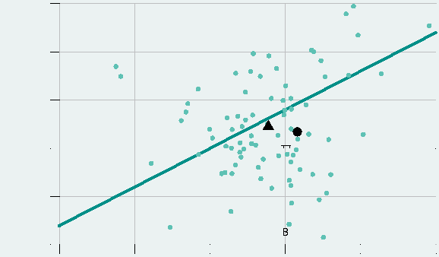
Age on attitudes towards equality among the 20 youngest age groups
–0.25
–0.5
0.75
0.25
0.5
0
MY
AZ
ZA
KG
JO
ET
CA
RU
GT
LB
GH
BY
TH AM LT SK
AR
ZW MD World LV
AL^{FI}
CZ
NO NL
TN
BG
KZ
CY
NG
SE
PK
PR
MA
ME
JP
US UY
LY
RO
EG
HR
RW
BD
TT
GB
SI
A
HU D
ID
AD
IR
Germany
FR
BR
MK
Z
CH
GE
NZ
CL
VN
PL
EC
RS
ES
IT
HK
CO
CN
SG
AU
KR
TW
Note: The chart shows the correlation between age and the equality index for numerous countries. The x-axis shows the linear regression coefficient for the entire age distribution, while the y-axis shows the corresponding coefficient for only the youngest 20 single years of age in the sample.
Source: Integrated Values Survey (wave 7 or 6); authors’ own calculations.
Reading aid: In Germany, the younger the respondents, the more egalitarian their attitudes; this also applies within
the youngest 20 age groups, but the influence of age is weaker for this young group than for the population as
a whole.
© DIW Berlin 2025
In most countries, the age effect is less pronounced among younger age groups than in the population as a whole.
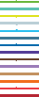
from Germany.¹³ If this process were to continue at the “old” pace, the equality index value for Germany (which currently stands at around 0.78) would reach the current value (0.9 out of a maximum possible 1.0) of the most egalitarian countries (the Nordic countries) in about 2035.
In reality, however, it appears the process is slowing. Germany might catch up with the Nordic countries, but it might take longer and is not a certainty. After all, the shift toward egalitarianism continues in Germany because there are still older generations with traditional attitudes.
In many countries around the world, in contrast, the trend among younger people is actually negative. This means that the youngest people in these countries are no longer “automatically” more egalitarian than those who are slightly older, and this at a level far removed from Nordic attitudes. The trends no longer point unreservedly toward egalitarianism. This may lead to a further increase in the observable disparity in attitudes toward gender roles across countries and to a slowdown in the global process of shifting attitudes toward egalitarian beliefs.
13 See also Alice Barth and Miriam Trübner (2018): Structural Stability, Quantitative Change: A Latent Class Analysis Approach towards Gender Role Attitudes in Germany. Social Science Research 72, 183–193; Ebner et al. (2020), ibid.

Lukas Menkhoff is a Research Associate at the Socio-Economic Panel (SOEP) Katharina Wrohlich is head of the Gender Economics research group at
research infrastructure at DIW Berlin | lmenkhoff@diw.de DIW Berlin | kwrohlich@diw.de
JEL: J16, N30, Z13
Keywords: social norms, gender equality, historical development


LEGAL AND EDITORIAL DETAILS
DIW Berlin — Deutsches Institut für Wirtschaftsforschung e. V.  Anton-Wilhelm-Amo-Straße 58, 10117 Berlin  www.diw.de  Phone: +49 30 897 89 – 0 Fax: – 200  Volume 15 November 5, 2025  Publishers  Prof. Anna Bindler, Ph.D.; Prof. Dr. Tomaso Duso; Sabine Fiedler; Prof. Marcel  Fratzscher, Ph.D.; Prof. Dr. Peter Haan; Prof. Dr. Claudia Kemfert;  Prof. Dr. Alexander S. Kritikos; Prof. Dr. Alexander Kriwoluzky; Prof. Karsten  Neuhoff, Ph.D.; Prof. Dr. Sabine Zinn  Editors-in-chief  Prof. Dr. Pio Baake; Claudia Cohnen-Beck; Sebastian Kollmann;  Kristina van Deuverden  Reviewer  Prof. Dr. M. Philipp Lersch  Editorial staff  Dr. Hella Engerer; Petra Jasper; Adam Mark Lederer;  Frederik Schulz-Greve; Sandra Tubik | Layout  Roman Wilhelm; Stefanie Reeg; Eva Kretschmer, DIW Berlin  Cover design  © imageBROKER / Steffen Diemer  Composition  Satz-Rechen-Zentrum Hartmann + Heenemann GmbH & Co. KG, Berlin  Subscribe to our DIW and/or Weekly Report Newsletter at  www.diw.de/newsletter_en  ISSN 2568-7697  Reprint and further distribution—including excerpts—with complete reference and consignment of a specimen copy to DIW Berlin’s Customer Service (kundenservice@diw.de) only.

