1. Identify the type of HPPC data (Charge Only Pulse, Discharge Only Pulse, SoC from 100-0 or 0-100).

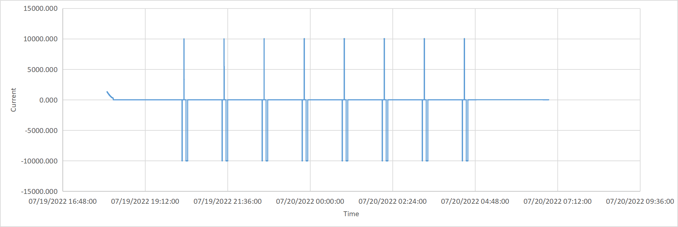

Start

If you look at a typical HPPC data (above figure), it starts with a short discharge pulse (where current is negative), followed by a short positive pulse (current is positive), and then a relatively long discharge pulse. These three pulses form a cycle. This cycle is repeated over time. In this example, state of charge (SOC) of the battery decreases due to the presence of the long negative discharge pulse (the third one we discussed earlier). There are also other HPPC tests where the third pulse could be a positive pulse. In that case, SOC of the battery will increase after conducting the HPPC test. There is also a possibility of a third kind of test, where it could be a mixture of positive and negative long pulse (I.e. the third pulse could be a mixture of positive and negative one).

We need to find out the nature of the long pulses in an HPPC data. So, first read the HPPC data, then identify the cycles that comprises of short and long pulses, and then finally determine the nature of the long pulse (it is positive or negative).

1. Support for csv, xlsx and txt formats for HPPC data

The HPPC file I am sharing is in csv and xlsx format. Your could should be able to read the HPPC data for csv, xls, xlsx, and txt formats also.

1. Identify type of drive cycle (velocity vs time, power vs time, current vs time).

A drive cycle can be of three types: a) velocity vs time, b) power vs time, c) current vs time. Once again this could be in xls, xlsx, csv and txt format. You need to read that file and from the column name should be able to identify whether it is of type a, b, or c. Remember, the column name in the drive cycle can bary from user to user. But it will contain the keyword **velocity**, **power**, **current**, **time** etc. For example, for a velocity vs time drive cycle, the velocity column names could be velocity or Velocity or velocity[m/s] or Velocity(m/s) etc. The time column name could be time, Time, Time(s), time(second) etc. So your code should be able to read the column based on the availability of the keywords.

1. If x,y vs elevation convert to local distance vs elevation in terrain data

I am attaching one x, y vs elevation data. Here, you need to convert this to distance vs elevation data. Now distance is, (del_x^2+del_y^2)^0.5 . The elevation column remains unchanged. Between two successive points you need to calculate distance using the formula and this distance should add cumulatively. For example, lets the first three points are (x1, y1, e1), (x2, y2, e2), (x3, y3, e3). Here, e is elevation points that remains unchanged. Distance between first and second points is:

[(x2-x1)^2 + (y2 - y1)^2]^0.5. Similarly, you can calculate distance between second and third points. Finally your output should like like:

(0, e1), (distance_1, e2), (distance_2, e3).

Note, the distance at the first point should always be zero. Then distance_1 is the distance between first and second points and distance_2 is the summation of distance_1 and distance between second and third points.