***Artificial Intelligence LAB***

***Lab Journal Solution***



**Department of Computer Science**

**BAHRIA UNIVERSITY, ISLAMABAD**

Lab Journal 9:

*Task 1*

Code:

|  |
| --- |
| import numpy as np  data = np.random.randint(10, 50, 60).reshape(10, 6) print("Original Data:\n", data) |
| standardized_data = (data - np.mean(data, axis=0)) / np.std(data, axis=0) print("\nStandardized Data:\n", standardized_data) |
|  |
| covariance_matrix = np.cov(standardized_data.T) print("\nCovariance Matrix:\n", covariance_matrix) |
|  |
| # Computing the eigenvectors and eigenvalues  eigenvalues, eigenvectors = np.linalg.eig(covariance_matrix) print("\nEigenvectors:\n", eigenvectors) print("\nEigenvalues:\n", eigenvalues) |
|  |
| # Make a list of (eigenvalue, eigenvector) tuples  eigen_pairs = [(np.abs(eigenvalues[i]), eigenvectors[:, i]) for i in range(len(eigenvalues))] |
|  |
| eigen_pairs.sort(key=lambda x: x[0], reverse=True) print("\nEigenpairs sorted by decreasing eigenvalues:\n", eigen_pairs) |
|  |

matrix_w = np.hstack((eigen_pairs[0][1].reshape(6, 1),

eigen_pairs[1][1].reshape(6, 1))) print('\nMatrix W:\n', matrix_w)

# Transforming the original dataset transformed_data = standardized_data.dot(matrix_w) print("\nTransformed Data:\n", transformed_data)

Output:

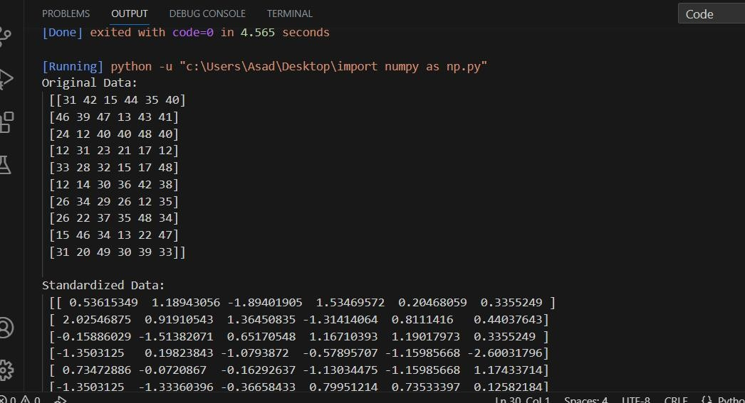

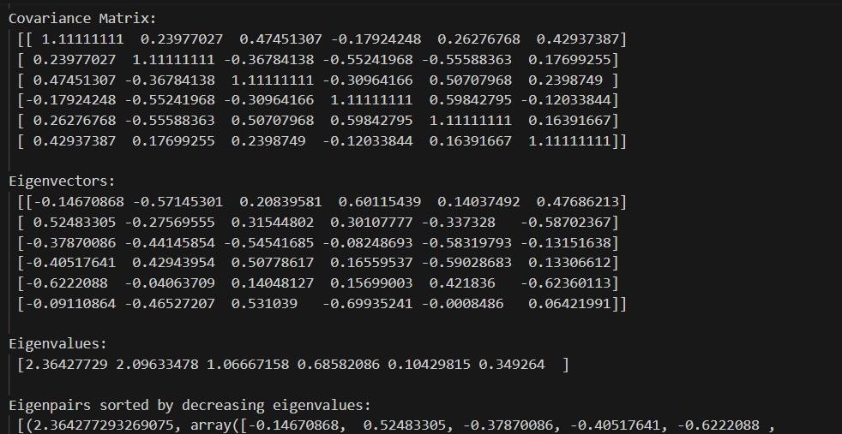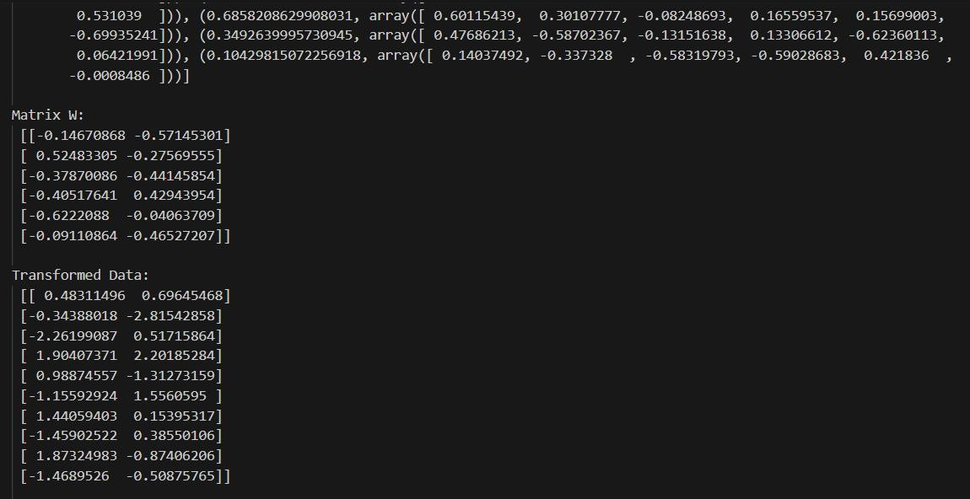

Task 2

Code:

|  |
| --- |
| import pandas as pd  import matplotlib.pyplot as plt import seaborn as sns  data = pd.read_csv('onlineretail.csv', encoding='ISO-8859-1') |
| sns.boxplot(x=data['Quantity']) plt.show() |
|  |
| # Define a function to remove outliers using IQR (Interquartile Range) def remove_outliers(df, column):  Q1 = df[column].quantile(0.25) Q3 = df[column].quantile(0.75)  IQR = Q3 - Q1  return df[~((df[column] < (Q1 - 1.5 * IQR)) | (df[column] > (Q3 + 1.5 * IQR)))] |
|  |
| # Remove outliers from 'Quantity' column data = remove_outliers(data, 'Quantity') |
|  |
| # Plotting the boxplot after removing outliers sns.boxplot(x=data['Quantity'])  plt.show() |
|  |

Output:

