***Mobile Application Development***

***CSL 341***

***Lab Journal 6***



**Student Name**

**Enrolment No.**

**Class and Section**

**Department of Computer Science**

**BAHRIA UNIVERSITY, ISLAMABAD**

**Lab # 6: Implicit Intents**

**Objectives:**

**Tools Used:**

**Submission Date:**

**Evaluation: Signatures of Lab Engineer:**

**Task # 1:**

1. Make 2 apps

First App should have edittext, imageview and a button in a layout of your choice, click on button should send implicit intent of the text and image in edittext by user to the **second app.**

**Second App,**  should be able to receive implicit intents and display the text and image received.

**Program/Procedure:**

**Analysis:**

**SCREENSHOT:**

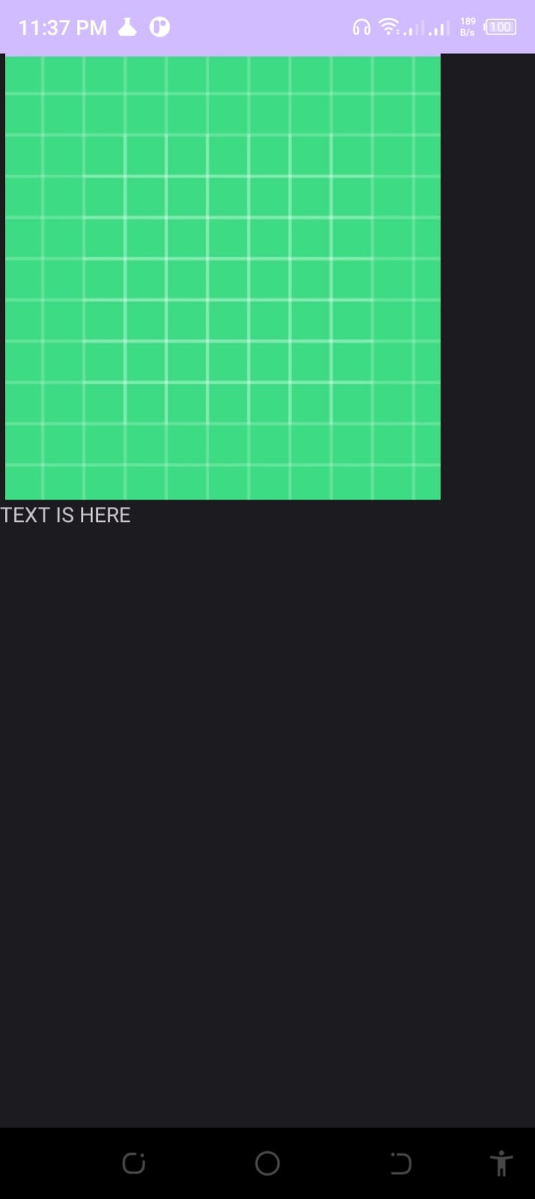

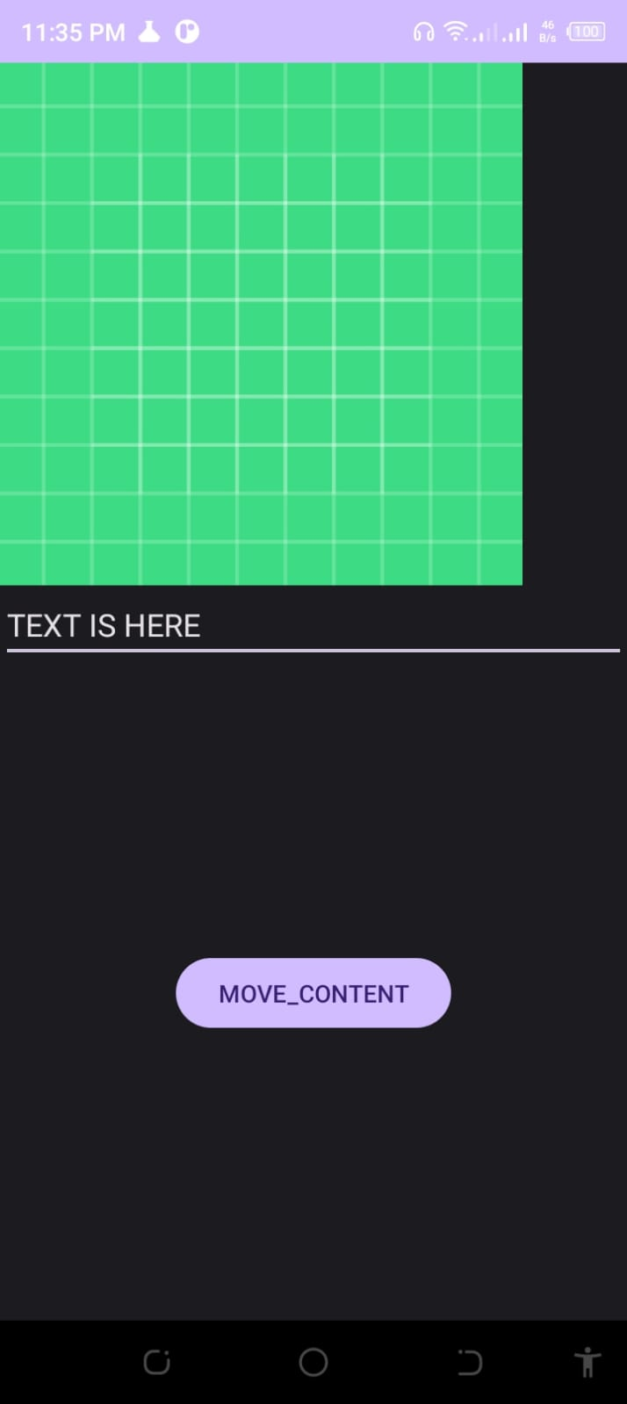

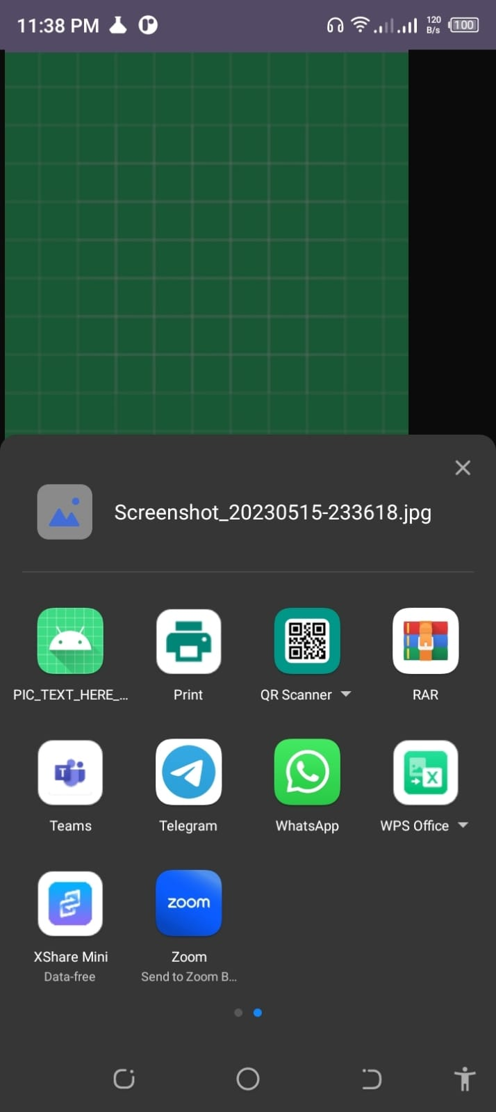

**SENDERAPP.XML**

*<?***xml version="1.0" encoding="utf-8"***?>*<**androidx.constraintlayout.widget.ConstraintLayout xmlns:android="http://schemas.android.com/apk/res/android"  
 xmlns:app="http://schemas.android.com/apk/res-auto"  
 xmlns:tools="http://schemas.android.com/tools"  
 android:layout_width="match_parent"  
 android:layout_height="match_parent"  
 tools:context=".MainActivity"**>  
 <**ImageView  
 android:layout_width="300dp"  
 android:layout_height="300dp"  
 android:id="@+id/img1"  
 android:src="@drawable/ic_launcher_background"  
 app:layout_constraintLeft_toLeftOf="parent"  
  
 app:layout_constraintTop_toTopOf="parent"** />  
 <**EditText  
 android:layout_width="match_parent"  
 android:layout_height="wrap_content"  
 android:id="@+id/et1"  
 android:hint="ENTER TEXT"  
 app:layout_constraintLeft_toLeftOf="parent"  
 app:layout_constraintTop_toBottomOf="@id/img1"**/>  
  
 <**Button  
 android:id="@+id/btn1"  
 android:text="MOVE_CONTENT"  
 android:layout_width="wrap_content"  
 android:layout_height="wrap_content"  
 app:layout_constraintBottom_toBottomOf="parent"  
 app:layout_constraintEnd_toEndOf="parent"  
 app:layout_constraintStart_toStartOf="parent"  
 app:layout_constraintTop_toBottomOf="@+id/et1"** />  
  
</**androidx.constraintlayout.widget.ConstraintLayout**>

**SENDERAPP.Java**

**package** com.example.myapplication;  
**import** android.content.Intent;  
**import** android.graphics.Bitmap;  
**import** android.net.Uri;  
**import** android.os.Bundle;  
**import** android.provider.MediaStore;  
**import** android.view.View;  
**import** android.widget.Button;  
**import** android.widget.EditText;  
**import** android.widget.ImageView;  
**import** android.widget.Toast;  
  
**import** androidx.appcompat.app.AppCompatActivity;  
  
**import** java.io.IOException;  
  
**public class** MainActivity **extends** AppCompatActivity {  
  
 **private static final int *PICK_IMAGE_REQUEST*** = 1;  
  
 **private** EditText **editText**;  
 **private** ImageView **imageView**;  
 **private** Button **sendButton**;  
  
 **private** Uri **selectedImageUri**;  
  
 @Override  
 **protected void** onCreate(Bundle savedInstanceState) {  
 **super**.onCreate(savedInstanceState);  
 setContentView(R.layout.*activity_main*);  
  
 **editText** = findViewById(R.id.*et1*);  
 **imageView** = findViewById(R.id.*img1*);  
 **sendButton** = findViewById(R.id.*btn1*);  
  
 **imageView**.setOnClickListener(**new** View.OnClickListener() {  
 @Override  
 **public void** onClick(View v) {  
 openImagePicker();  
 }  
 });  
  
 **sendButton**.setOnClickListener(**new** View.OnClickListener() {  
 @Override  
 **public void** onClick(View v) {  
 String text = **editText**.getText().toString();  
 **if** (text.isEmpty()) {  
 Toast.*makeText*(MainActivity.**this**, **"Please enter text"**, Toast.***LENGTH_SHORT***).show();  
 **return**;  
 }  
  
 **if** (**selectedImageUri** == **null**) {  
 Toast.*makeText*(MainActivity.**this**, **"Please select an image"**, Toast.***LENGTH_SHORT***).show();  
 **return**;  
 }  
  
 sendImplicitIntent(text, **selectedImageUri**);  
 }  
 });  
 }  
  
 **private void** openImagePicker() {  
 Intent intent = **new** Intent();  
 intent.setType(**"image/*"**);  
 intent.setAction(Intent.***ACTION_GET_CONTENT***);  
 startActivityForResult(Intent.*createChooser*(intent, **"Select Picture"**), ***PICK_IMAGE_REQUEST***);  
 }  
  
 **private void** sendImplicitIntent(String text, Uri imageUri) {  
 Intent sendIntent = **new** Intent();  
 sendIntent.setAction(Intent.***ACTION_SEND***);  
 sendIntent.putExtra(Intent.***EXTRA_TEXT***, text);  
 sendIntent.putExtra(Intent.***EXTRA_STREAM***, imageUri);  
 sendIntent.setType(**"image/*"**);  
  
 Intent shareIntent = Intent.*createChooser*(sendIntent, **null**);  
 **if** (sendIntent.resolveActivity(getPackageManager()) != **null**) {  
 startActivity(shareIntent);  
 } **else** {  
 Toast.*makeText*(MainActivity.**this**, **"No app can handle this action"**, Toast.***LENGTH_SHORT***).show();  
 }  
 }  
  
 @Override  
 **protected void** onActivityResult(**int** requestCode, **int** resultCode, Intent data) {  
 **super**.onActivityResult(requestCode, resultCode, data);  
  
 **if** (requestCode == ***PICK_IMAGE_REQUEST*** && resultCode == ***RESULT_OK*** && data != **null** && data.getData() != **null**) {  
 **selectedImageUri** = data.getData();  
 **try** {  
 Bitmap bitmap = MediaStore.Images.Media.*getBitmap*(getContentResolver(), **selectedImageUri**);  
 **imageView**.setImageBitmap(bitmap);  
 } **catch** (IOException e) {  
 e.printStackTrace();  
 }  
 }  
 }  
}

**RECEiVERAPP.XML**

*<?***xml version="1.0" encoding="utf-8"***?>*<**androidx.constraintlayout.widget.ConstraintLayout xmlns:android="http://schemas.android.com/apk/res/android"  
 xmlns:app="http://schemas.android.com/apk/res-auto"  
 xmlns:tools="http://schemas.android.com/tools"  
 android:layout_width="match_parent"  
 android:layout_height="match_parent"  
 tools:context=".MainActivity"**>  
 <**ImageView  
 android:layout_width="300dp"  
 android:layout_height="300dp"  
 android:id="@+id/img1"  
 app:layout_constraintLeft_toLeftOf="parent"  
 app:layout_constraintTop_toTopOf="parent"** />  
 <**TextView  
 android:layout_width="wrap_content"  
 android:layout_height="wrap_content"  
 android:id="@+id/tv1"  
 app:layout_constraintLeft_toLeftOf="parent"  
 app:layout_constraintTop_toBottomOf="@id/img1"** />  
  
  
  
</**androidx.constraintlayout.widget.ConstraintLayout**>

**RECEiVERAPP.Java**

**package** com.example.pic_text_here_display;  
**import** android.content.Intent;  
**import** android.net.Uri;  
**import** android.os.Bundle;  
**import** android.widget.ImageView;  
**import** android.widget.TextView;  
  
**import** androidx.appcompat.app.AppCompatActivity;  
  
**public class** MainActivity **extends** AppCompatActivity {  
  
 **private** TextView **textView**;  
 **private** ImageView **imageView**;  
  
 @Override  
 **protected void** onCreate(Bundle savedInstanceState) {  
 **super**.onCreate(savedInstanceState);  
 setContentView(R.layout.*activity_main*);  
  
 **textView** = findViewById(R.id.*tv1*);  
 **imageView** = findViewById(R.id.*img1*);  
  
 *// Retrieve the incoming intent* Intent receivedIntent = getIntent();  
 **if** (receivedIntent != **null**) {  
 String text = receivedIntent.getStringExtra(Intent.***EXTRA_TEXT***);  
 Uri imageUri = receivedIntent.getParcelableExtra(Intent.***EXTRA_STREAM***);  
  
 **if** (text != **null**) {  
 **textView**.setText(text);  
 }  
  
 **if** (imageUri != **null**) {  
 **imageView**.setImageURI(imageUri);  
 }  
 }  
 }  
}