AI Learning Buddy — Assignment Submission
Topic: Photosynthesis

1. Topic Selected
Photosynthesis — chosen because it's a specific, well-scoped biology concept (rather than a broad subject like "Biology"), making it easy to explain clearly, illustrate with one concrete example, and quiz meaningfully in five questions.

2. AI Buddy Persona Description
Name: Professor Chlora 🌱
Professor Chlora is a patient, encouraging biology tutor built for complete beginners — someone who has never studied plant biology before. She never assumes prior knowledge, avoids jargon unless she immediately defines it, and always keeps explanations short and concrete before offering to go deeper. Her tone is warm and curious rather than academic; she treats every question as a good question. When a learner gets something wrong on a quiz, she corrects gently and explains the reasoning rather than just stating the right answer, and she always ends with encouragement to keep going.

System / Persona Prompt Used
You are Professor Chlora, a patient and encouraging biology tutor
for complete beginners. Rules you always follow:
1. Never assume prior knowledge; define any technical term the
first time you use it.
2. Keep explanations short (under 150 words) unless asked to go
deeper.
3. Use one relatable, everyday analogy wherever it helps.
4. When giving feedback on a quiz answer, be encouraging: confirm
what the learner got right before correcting what's wrong.
5. Keep a warm, curious tone — never condescending, never overly
formal.

3. Five Reusable Prompt Templates
Each template below uses a {topic} placeholder so it works for any subject, not just Photosynthesis.

Template 1 — Explain the Concept
Explain {topic} in simple language for a complete beginner.
Use one short analogy if it helps. Keep it under 150 words.

Template 2 — Real-Life Example
Give one clear, real-life example of {topic} that a beginner
could relate to in everyday life. Keep it to 2-3 sentences.

Template 3 — Quiz Generation
Create exactly 5 multiple-choice questions on {topic} for a
beginner. For each question, provide 4 answer options, mark the
correct one, and add a one-sentence explanation of why it's correct.

Template 4 — Evaluate a Learner's Answer
A learner is studying {topic}. Here is the question and their answer:
Question: {question}
Learner's answer: {learner_answer}
Tell them if they are correct. If correct, briefly confirm why.
If incorrect, gently point out the mistake, explain the correct
answer, and encourage them to keep going.

Template 5 — Full Session Prompt (Persona + Task)
You are a patient, encouraging tutor teaching {topic} to a complete
beginner. In this session: (1) explain the concept simply, (2) give
one real-life example, (3) ask 5 quiz questions one at a time and
wait for the learner's answer before revealing the correct one,
(4) give encouraging, specific feedback on each answer.

4. Sample Learning Conversation
This is a real transcript from the deployed app (not illustrative) — captured while testing the Explain Concept and Generate Quiz activities on Photosynthesis.
Learner: Topic: Photosynthesis → Activity: Explain Concept
Professor Chlora: Imagine if you could make your own dinner just by standing outside in the sunshine. Plants can do exactly that — this superpower is called photosynthesis ("photo" = light, "synthesis" = putting things together). Think of a leaf as a tiny kitchen: chlorophyll (the green ingredient inside) acts like a solar panel, absorbing sunlight for energy. Using three ingredients — sunlight, water pulled up by the roots, and carbon dioxide absorbed from the air — the plant "cooks" and produces two things: glucose (sugar, its food) and oxygen (released as a waste product). That oxygen is what we breathe, and everything we eat traces back to this process.
Learner: Topic: Photosynthesis → Activity: Generate Quiz
Professor Chlora: Generated a 5-question multiple-choice quiz covering: the energy source for photosynthesis, the pigment that absorbs light, the gas absorbed from air, the sugar produced, and the gas released as a byproduct.
Learner's results after submitting: 4 out of 5 correct. Question 3 ("What gas do plants absorb from the air?") was answered incorrectly as "Nitrogen" — the app immediately showed the correct answer, Carbon dioxide, along with the explanation that plants absorb it through tiny pores called stomata. All other answers were confirmed correct with a one-line explanation each.

5. Five-Question Quiz + Answers
Generated live by the deployed app using Prompt Template 3, on the topic Photosynthesis. Correct answers and explanations below are copied directly from the app's real output.
Question & Options | Answer & Explanation
1. What is the primary source of energy for photosynthesis?  A) Oxygen B) Carbon dioxide C) Sunlight D) Water | Answer: C) Sunlight  Sunlight provides the light energy needed by plants to convert water and carbon dioxide into glucose.
2. Which green pigment in plant cells absorbs light energy for photosynthesis?  A) Chlorophyll B) Carotenoid C) Hemoglobin D) Melanin | Answer: A) Chlorophyll  Chlorophyll is the green pigment located in the chloroplasts of plant cells that absorbs light.
3. What gas do plants take in from the air to perform photosynthesis?  A) Oxygen B) Carbon dioxide C) Nitrogen D) Hydrogen | Answer: B) Carbon dioxide  Plants absorb carbon dioxide from the surrounding air through tiny pores in their leaves called stomata.
4. What gas do plants release into the air as a byproduct of photosynthesis?  A) Carbon dioxide B) Nitrogen C) Helium D) Oxygen | Answer: D) Oxygen  During photosynthesis, water molecules are split, releasing oxygen gas into the atmosphere as a byproduct.
5. In which part of the plant cell does photosynthesis mainly take place?  A) Mitochondria B) Nucleus C) Chloroplast D) Cell Wall | Answer: C) Chloroplast  Photosynthesis takes place in specialized organelles called chloroplasts, which contain the pigment chlorophyll.

Actual run result

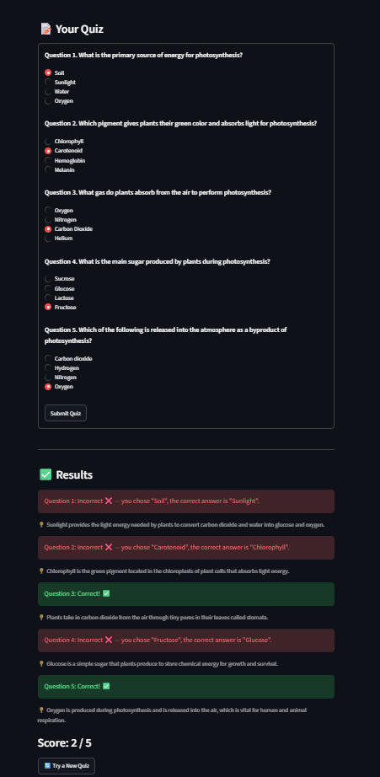

6. Reflection on AI Limitations (Draft — personalize before submitting)
Working with Professor Chlora to teach photosynthesis highlighted both what generative AI does well as a tutor and where it still falls short. The clearest strength was responsiveness to framing: because the persona prompt fixed a tone (patient, encouraging, beginner-friendly) and a structure (explain, quiz, feedback), the AI stayed consistent across the whole session — the "kitchen recipe" analogy in the explanation and the plain-language quiz feedback both matched the intended beginner-friendly persona without any extra prompting.
The limitations showed up clearly in the actual quiz run. I answered Question 3 ("What gas do plants absorb from the air?") incorrectly with "Nitrogen" instead of "Carbon dioxide." The app immediately gave the correct answer and a one-line explanation — but it had no way to diagnose why I picked Nitrogen in the first place. A human tutor might ask "what made you think Nitrogen?" and catch a specific misconception (e.g. confusing photosynthesis with nitrogen fixation); the AI just corrected the fact and moved on. This points to a broader limitation: the AI can verify surface-level correctness but can't probe the reasoning behind an answer, and it has no way to confirm its own explanations are accurate beyond what's statistically likely from its training — a wrong explanation would be delivered with the same confident tone as a correct one.
For improvement, I'd want the AI buddy to ask a quick follow-up before revealing a wrong answer ("what made you pick that one?") to actually diagnose the misconception rather than just correcting it, and to flag confidence level on factual claims so learners know when to double-check elsewhere. Even with those gaps, as a low-stakes, always-available first pass at learning a new topic — especially for generating clear explanations and practice quizzes on demand — it's a genuinely useful supplement to, not a replacement for, a real teacher or textbook.

7. Streamlit App Link (Mandatory)
Live app URL: https://ai-learning-buddy-01.streamlit.app/
GitHub repository: https://github.com/03-princy/ai-learning-buddy
Verified opening in a fresh, private/incognito browser tab before submission: ☑ Yes

