**P2 Proposal - SpaceBook**

**Team ATMC Members:**

Trevor Graham : Team Leader

Chris Sophiea

Alan Munoz

Matt DeMonaco

**Sales Description:**

SpaceBook is a social media site for space nerds. SpaceBook allows you to see a space picture of the day, save pictures to your Favorites Gallery, comment on pictures, and post space pictures of your own. You can also meet, follow, and send messages to other space nerds on SpaceBook.

**Minimum Viable Product:**

The website can display photos and information with a third-party API. Users can engage with each other through posting pictures, favoriting pictures, commenting, direct messaging, and following other users.

**3rd Party API:** We will use Nasa’s APOD to retrieve the Astronomy Picture of the Day to display to users.

<https://github.com/nasa/apod-api>

**Kanban Board:**

<https://trello.com/invite/b/eLyn6yPS/6325d055504c9c459f5047b535983650/p2projectname>

**User Stories:**

* As a user, I want to be able to create an account and log in.
* As a user, I want to be able to view photos of and learn new facts about space.
* As a user, I want to be able to post pictures and save my favorite pictures.
* As a user, I want to be able to communicate with other people interested in space through direct messaging and a following system.
* As a user, I want to be able to express my opinion on photos of space with a rating and/or a comment.

**Stretch Goals:**

* Users can share photos on other social media platforms.
* Users can purchase prints of their favorite photos
* Admins can control what users can post.

**UI Model:**

<https://drive.google.com/file/d/13czDeuvPHzw_7w4QFOw_etbapfgb9EMf/view?usp=sharing>

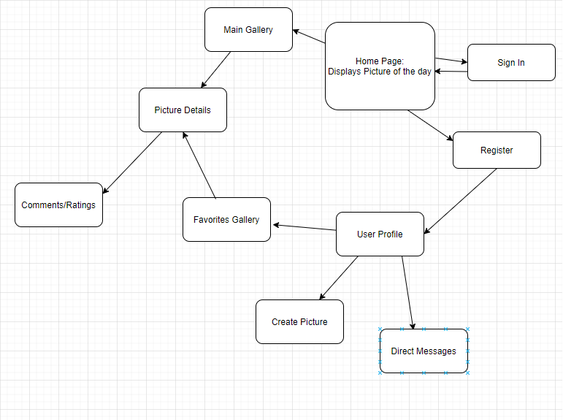

**DB Model:**

<https://drive.google.com/file/d/1eNhUWNO1GYCRI0xy6SteQGA_O4dPZveP/view?usp=sharing>

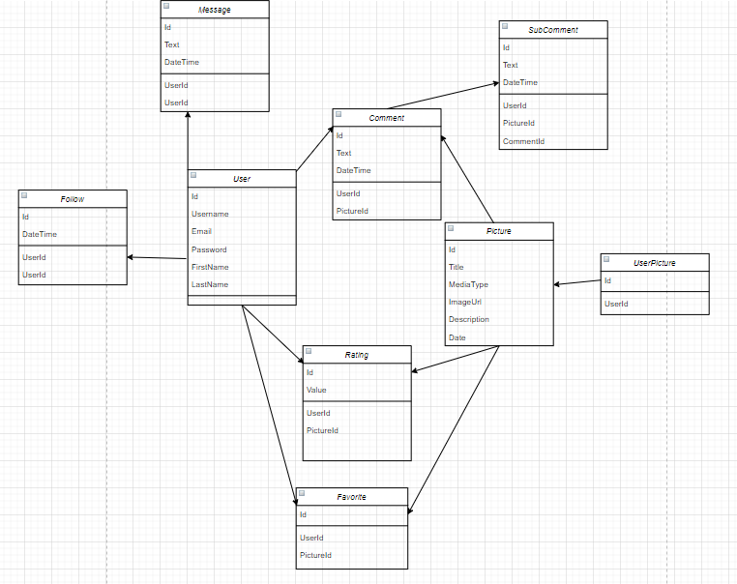

**Github Repository:**

<https://github.com/12142020-dotnet-uta/P2_ATMC>