**The Null Returners**

*Daniel Baker* - Leader

Anthony Mungle

Travis Martin

Joshua Raneri

**Sports Club Management - Project 2**

**Description**

We will be creating an application to help Owners, Coaches, Trainers, and Players manage an NFL football team. From gameday prep to scheduling practices to communication, this application will serve as the central hub for all football operations. Upon successful login, users will be able to view scheduled meetings/practices, view and analyze team and personal statistics, and communicate with other users.

**Minimum Viable Product**

The application will start at the login page, and after logging in, will direct the user to their dashboard.

From their dashboard the user will be able to perform various actions. There will be 3 levels of access: all, coach, admin. The level of access will determine any extra capabilities the user will have.

* Any user will be able to edit their profile from the dashboard, but only the admin can delete a profile.
* Any user can access their team schedule from the dashboard, but only the coach will be able to create, delete, or edit items in their schedule such as meetings.
* All users will be able to directly message other users. Any user can view the player status/IR list, but only the admin will be able to add players to the list.

**3rd Party APIs**

<https://api.nfl.com/docs/getting-started/index.html>

* We will use the NFL API to get team statistics, player statistics, game statistics, and game recaps. We will use this information to populate views, and run our own queries off of.

<https://developers.google.com/calendar>

* Calendar provides a vast toolbox for scheduling

**User Stories**

1. Users can log in and view/edit their profile.
2. Users can access the team calendar.
3. Users can send messages to other users.
4. Users can access the team play book.
5. Users can view current player status/IR list.

**Stretch Goals**

* Can customize and edit personal dashboard
* Email notifications
* Users can view game tape
* Users can view a live game cast
* GM/Head Coach can submit a request to NFL/opposing teams to make a trade
* Anonymous reporting service for ethics/discrimination issues
* Live BBS

**Kanban:**

<https://github.com/12142020-dotnet-uta/P2_NullReturners/projects/1?add_cards_query=is%3Aopen>

**Repo:**

<https://github.com/12142020-dotnet-uta/P2_NullReturners>

**User Interaction Model:**

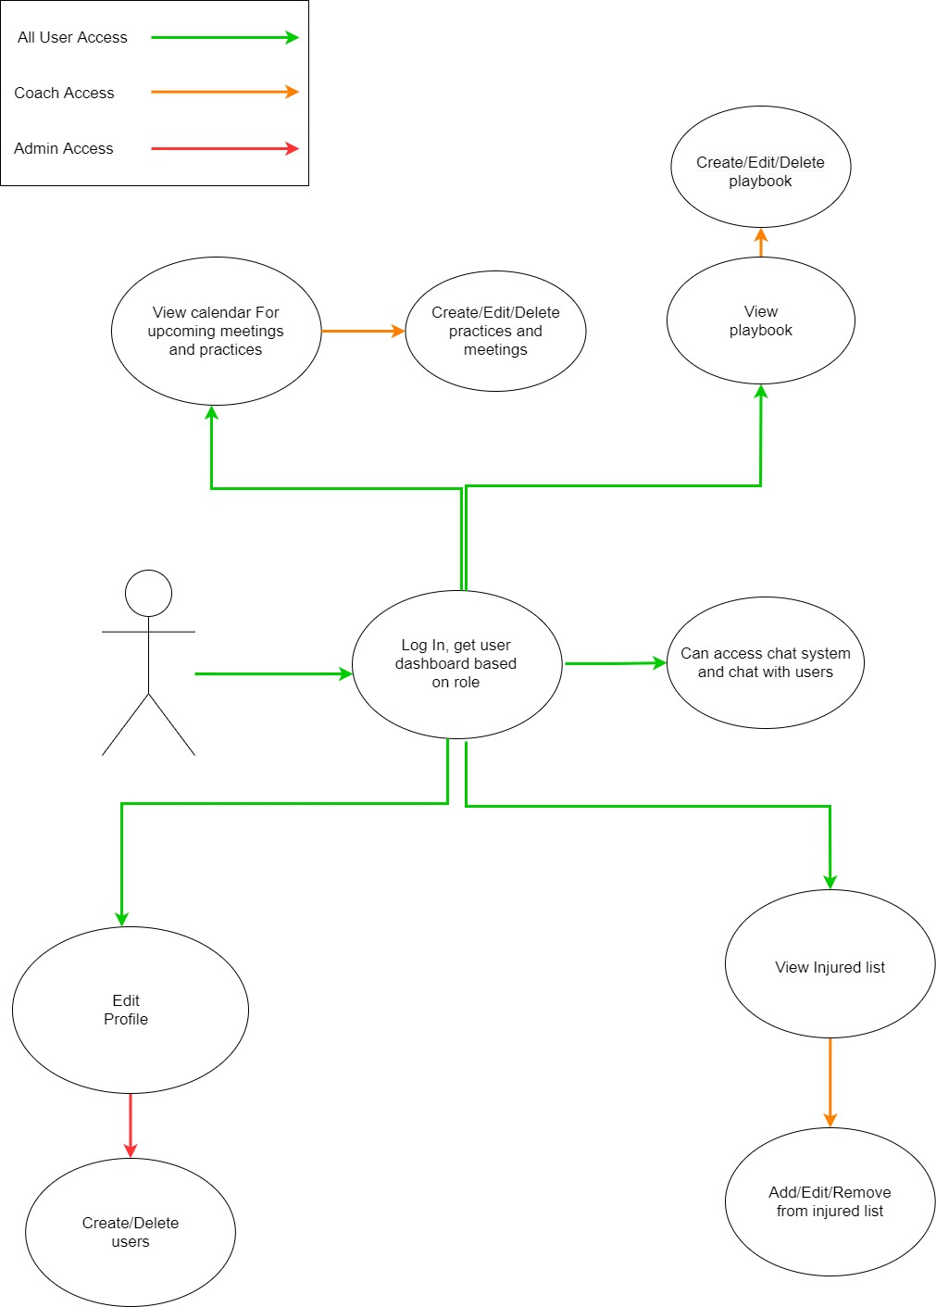

**Database Model:**