**The Null Returners**

*Daniel Baker* - Leader

Anthony Mungle

Travis Martin

Joshua Raneri

**Sports Club Management - Project 2**

**Description**

We will be creating an application to act as a central hub for coaches, parents, and players of a youth sports team. Upon successful login, users will be able to view scheduled meetings and practices, communicate with other users, organize carpooling, view team announcements, view the playbook, view/add statistics, and request new gear.

**Minimum Viable Product**

The application will begin with the user logging in. Upon logging in the user is directed to the user dashboard. From the dashboard the user will be able to perform various actions based on whether or not they are a Coach, parent, or player. Any player will have the option to view their teams’ playbook while the Coach will have an additional option to edit the playbook. Any user will have the option to view the calendar and schedules. Players will be able to view team and personal statistics, coaches will be able to upload statistics The coach will also have the option to edit calendars and schedules. Parents will be able to request team-provided equipment replacements such as uniforms or specialized pads at the coach’s approval, and will be able to see the current status of the request. There will be a chat system in which all users will be able to chat directly or in groups and parents will have a specialized area for arranging carpooling.

**3rd Party APIs**

* <https://developers.google.com/calendar/overview>

Calendar API to be used for scheduling practices and training

* <http://rafaelescala.com/ng2-konva/>

API that will be used to allow the user to draw in plays for the playbook

**User Stories**

1. Users can log in and view/edit their profile.
2. Users can access the team calendar.
3. Users can send messages to other users and groups of users.
4. Players and coaches can access the team play book.
5. Parents can request new equipment.
6. Parents and players can view and Coaches can upload statistics.
7. Parents can arrange carpooling.
8. Coaches can illustrate and save plays that players can view.

**Stretch Goals**

* Can customize and edit personal dashboard
* Tailored themes for UIs
* Email notifications
* Users can view past/future workouts
* Coach can toggle diet hub
* Users can view game tape
* Users can view a live game cast
* Anonymous reporting service for ethics/discrimination issues
* Pay team dues through app

**Kanban:**

<https://github.com/12142020-dotnet-uta/P2_NullReturners/projects/1?add_cards_query=is%3Aopen>

**Repo:**

<https://github.com/12142020-dotnet-uta/P2_NullReturners>

**User Interaction Model:**

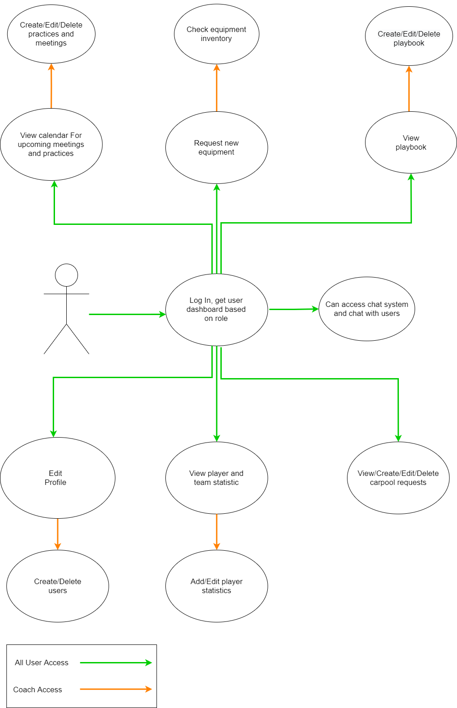

**Database Model:**

