Group Name: the-pretzelmen

Group Leader: Kemo Allen

Secondary Leader: Tong Duangboudda

Members: Daniel Geiser, Tyler Cadena

Front End (Angular) : Tong Duangboudda

Back End (Rest Api) : Daniel Geiser

DevOps : Tyler Cadena

Tests : Tyler Cadena

Possible options :

* Texas holdem game with a chat box and a way to send other players little objects (daniel votes for this one)(Kemo voted)

Sales Description

Have you ever wanted a place where you were able to play some hands of Texas Holdem. A place where open discussions can happen and some indirect or maybe direct negative comments. A way to get under someone's skin so you can win the pot. Send another player a wedding ring along with a proposal. Now if the proposal is accepted then we hold no responsibility for the impending marriage. Send people a personalized chip, a beer, flowers, candy, or a drink. Play some hands and win some unreal money.

Minimum Viable Product

Texas holdem game with a chat box and a way to send other players little objects.

External API

<https://poker.readthedocs.io/en/latest/api/hand.html>

<https://poker.readthedocs.io/en/latest/api/room.html>

User Stories

1. Sending funny little objects to another player
2. Allowing a space for open communication
3. Based on what has been seen odds of winning
4. Making a custom room for you and your friends.
5. Customize the deck you will use.

Stretch Goals

1. Play live against another human
2. Incorporate other types of card games
3. Have a Calculation view optional for the Player which will have card odds, pot odds, and hand combinations.

User Interaction Model

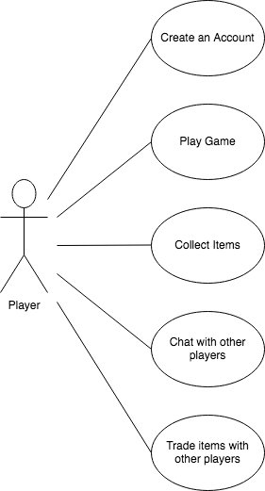

Kanban Board

<https://trello.com/b/r1GmKzPd/the-pretzelman-kanban-board>

Group Repo

GitHub: <https://github.com/the-pretzelmen>

Database Model

