Group Name: the-pretzelmen

Group Leader: Kemo Allen

Secondary Leader: Tong Duangboudda

Members: Daniel Geiser, Tyler Cadena

Front End (Angular) : Tong Duangboudda

Back End (Rest Api) : Daniel Geiser

DevOps : Tyler Cadena

Tests : Tyler Cadena

Sales Description

Our project will allow users to collect and play a simple game using Magic the Gathering cards. A website will be deployed to house user accounts that contain their card collect, profile information, and win/loss record. The user will start off with a certain amount of tokens when they sign-up. Those can then be used to buy card packs. There is also a log-in bonus for signing into the website. Another way to earn more tokens is to participate in some of the games. It is possible to simply look at a gallery of the cards, but the user won’t officially own them. You can also trade cards with users that are your friends, or win them from opponents. A player will be able to see what past games they were in, and a full breakdown of which player picked which cards.

Minimum Viable Product

A website that allows users to have a digital collection of Magic the Gathering cards. Being able to trade them with one another. A player would post up the possible trade and others can view the trade. If the viewer likes the cards then they can offer something up for the cards. The original poster of the trade can then agree or disagree to the trade. You will also be able to play a game memory using your collection. The cards are put on the line and whoever gets the most found pairs wins. They win the paired cards they selected during the game.

External API

This is a mapper which wraps around the magicthegathering.io for .Net

<https://github.com/MagicTheGathering/mtg-sdk-dotnet> so we can call the API. This API will allow a user to look up a card by their Ids or just by name.

User Stories

1. A place where you can store your digital collection of magic cards
2. The more you participate in the game the more tokens you're able to get. Allowing you to get more cards from packs.
3. Able to look up cards to see how they look like. Or just put a random number to see which card matches it.
4. Without any risk the reward does taste as sweet. Putting the cards you have in your collection up against your opponents cards.
5. Customize the deck you will use.

Stretch Goals

1. Have a collection and be able to trade with another player on the site.
2. Both players put up an agreed upon number of cards and play a memory game with those cards up for grabs.
3. Able to Play a game against another player with just basic rules. The winner gets a random card from the deck used.

User Interaction Model

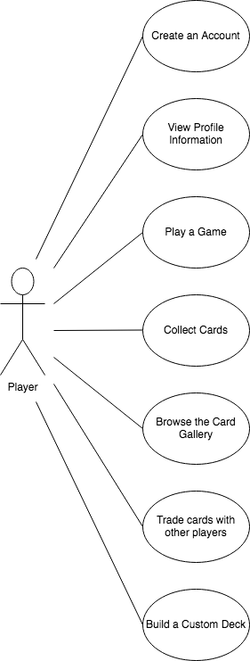

Kanban Board

<https://trello.com/b/r1GmKzPd/the-pretzelman-kanban-board>

Group Repo

<https://github.com/12142020-dotnet-uta/P2_the-pretzelmen>

Database Model

