The Pretzelmen

**Group Leader:** Kemo Allen

**Secondary Leader:** Tong Duangboudda

**Members:** Daniel Geiser, Tyler Cadena

**Front End (Angular):** Tong Duangboudda

**Back End (Rest Api):** Daniel Geiser

**DevOps:** Tyler Cadena

**Tests:** Tyler Cadena

**Sales Description**

Our project will allow users to collect *Magic the Gathering* cards and play a simple game of *Magic the Gathering*. A website will be deployed to house user accounts that contain their card collection, profile information, and win/loss record. The user will start off with a certain amount of tokens when they sign-up. Those can then be used to buy card packs. There is also a log-in bonus for signing into the website. Another way to earn more tokens is to participate in the memory game or the battle game. It is possible to simply look at a gallery of the cards, but the user won’t officially own them. You can also trade cards with users that are your friends, or win them from opponents. A player will be able to see what past games they were in, and a full breakdown of which player picked which cards.

**Minimum Viable Product**

A website that allows users to have a digital collection of Magic the Gathering cards. On the website users will be able to trade their cards with one another. A player would post up the possible trade and others can view the trade. If the viewer likes the cards they can then offer their own cards for the trade. Having a sense of community and sharing our luck of the draw by allowing trades.

You will also be able to play a memory game. The memory game has a predetermined number of cards. The cards are laid out in a grid pattern. One player starts by picking two cards. If the cards match then the player gets a point for finding a matching pair. Whoever gets the most found pairs wins the match. Both players get some tokens for playing the game. The winner will get five times as much as the losing player. The wins and losses are recorded under each player's account.

**External API**

This is a mapper which wraps around the magicthegathering.io for .Net

<https://github.com/MagicTheGathering/mtg-sdk-dotnet> so we can call the API. This API will allow a user to look up a card by their Ids or just by name.

**User Stories**

* As a Magic the Gathering player, I want to be able to have a digital collection of *Magic the Gathering* cards.
* As a Gamer, I will be able to gain in-game tokens so that I can open digital card packs and not have to pay real money for tokens.
* As a user, I should have the ability to look up the cards that are available or be able to search for them by their card id.
* As a user, I want to customize decks using the cards that I own.
* As a user, I want to be able to trade cards with others on the website.

**Stretch Goals**

1. Have a Trading hub allowing the user to see what other people have put up for a trade. Allowing them to make an offer with one of their own cards.
2. To up the challenge both players put up an agreed upon number of cards and play a memory game with those cards up for grabs.
3. Be able to Play a basic Magic the Gathering card game against another player with just basic rules. Also, the winner gets a random card from the losers deck.

**User Interaction Model**

**Users will be able to see the Blocks**

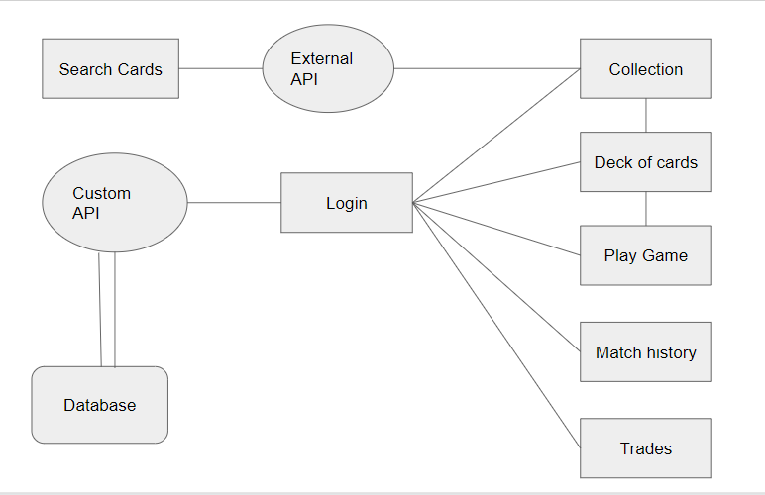

**Kanban Board**

<https://trello.com/b/r1GmKzPd/the-pretzelman-kanban-board>

**Group Repo**

<https://github.com/12142020-dotnet-uta/P2_the-pretzelmen>

**Database Schema**  
