Team: 2 Many Cooks

# Project Name: In The Kitchen

## By: Anis Medini, Beau Crumley, Noureldin Kamel

## Team Lead: Beau Crumley

Date: 4/1/2021

# Overview

## Project Description

Cookbooks and recipe guides are everywhere. Everybody uses them. Everybody has struggled with them. The goal of *In The Kitchen* is to provide a product that takes the hassle out of finding and following a new recipe. No longer will people need to check, double-check and triple-check their recipes before moving on to the next step. Instead the application will provide a streamlined, step-by-step, easy-to-use guide that will provide would-be chefs all the information they need to prepare the perfect dish. There will be directions and images to show and describe what their dish should look like at every step. Users will also be able to share their own recipes.

*In The Kitchen* will allow users to share their feedback and experiences. Users will be able to give recipes a rating and leave comments for other users to see. Recipes will also be easy to find. Users will be able to browse or search for recipes by name or tags to always find what they're looking for.

## 

## Minimum Viable Product

* 1. Account creation/login.
  2. Step-by-step guide on preparing recipes.
  3. Recipes will have nutritional information(Pulled from 3rd party API)
  4. Recipes can be rated and commented on.
  5. Recipes can be searched/filtered by name, tag or popularity
  6. User accounts can have permissions. Admins can delete users/reviews/comments and change user permissions
  7. New recipes can be added.

### 3rd Party API

An API for getting nutritional information about ingredients: <https://rapidapi.com/msilverman/api/nutritionix-nutrition-database?endpoint=53aa3213e4b07e1f4ebe9a53>

## User Stories

* 1. Users shall be able to login and register
  2. Users shall be able to search for recipes by recipe names or by tags (tags includes ingredients)
  3. Users shall be able to view information about a recipe including ingredients, nutritional info, ratings, comments and how many times the recipe has been made by users.
  4. Users shall be able to build new Recipes complete with steps using our recipe builder
  5. Users shall be able to follow a step by step guide on how to cook the recipe
  6. Users shall be able to leave the website and then resume the guide at the same step on opening the website again
  7. Users will see nutritional information about recipes both when browsing recipes and while preparing them (API)
  8. Users shall be able to save a recipe in their favorites list for later reference
  9. Users shall be able to review the recipe and rate it

## Stretch Goals

* 1. Users can get ratings based on recipes they have created
  2. Able to select ingredients and return recommended recipes using these ingredients (imagine wanting to make something out of whatever you had laying around)
  3. Ingredients can be added to a shopping-list and said list can be emailed to a user.

## UI Models

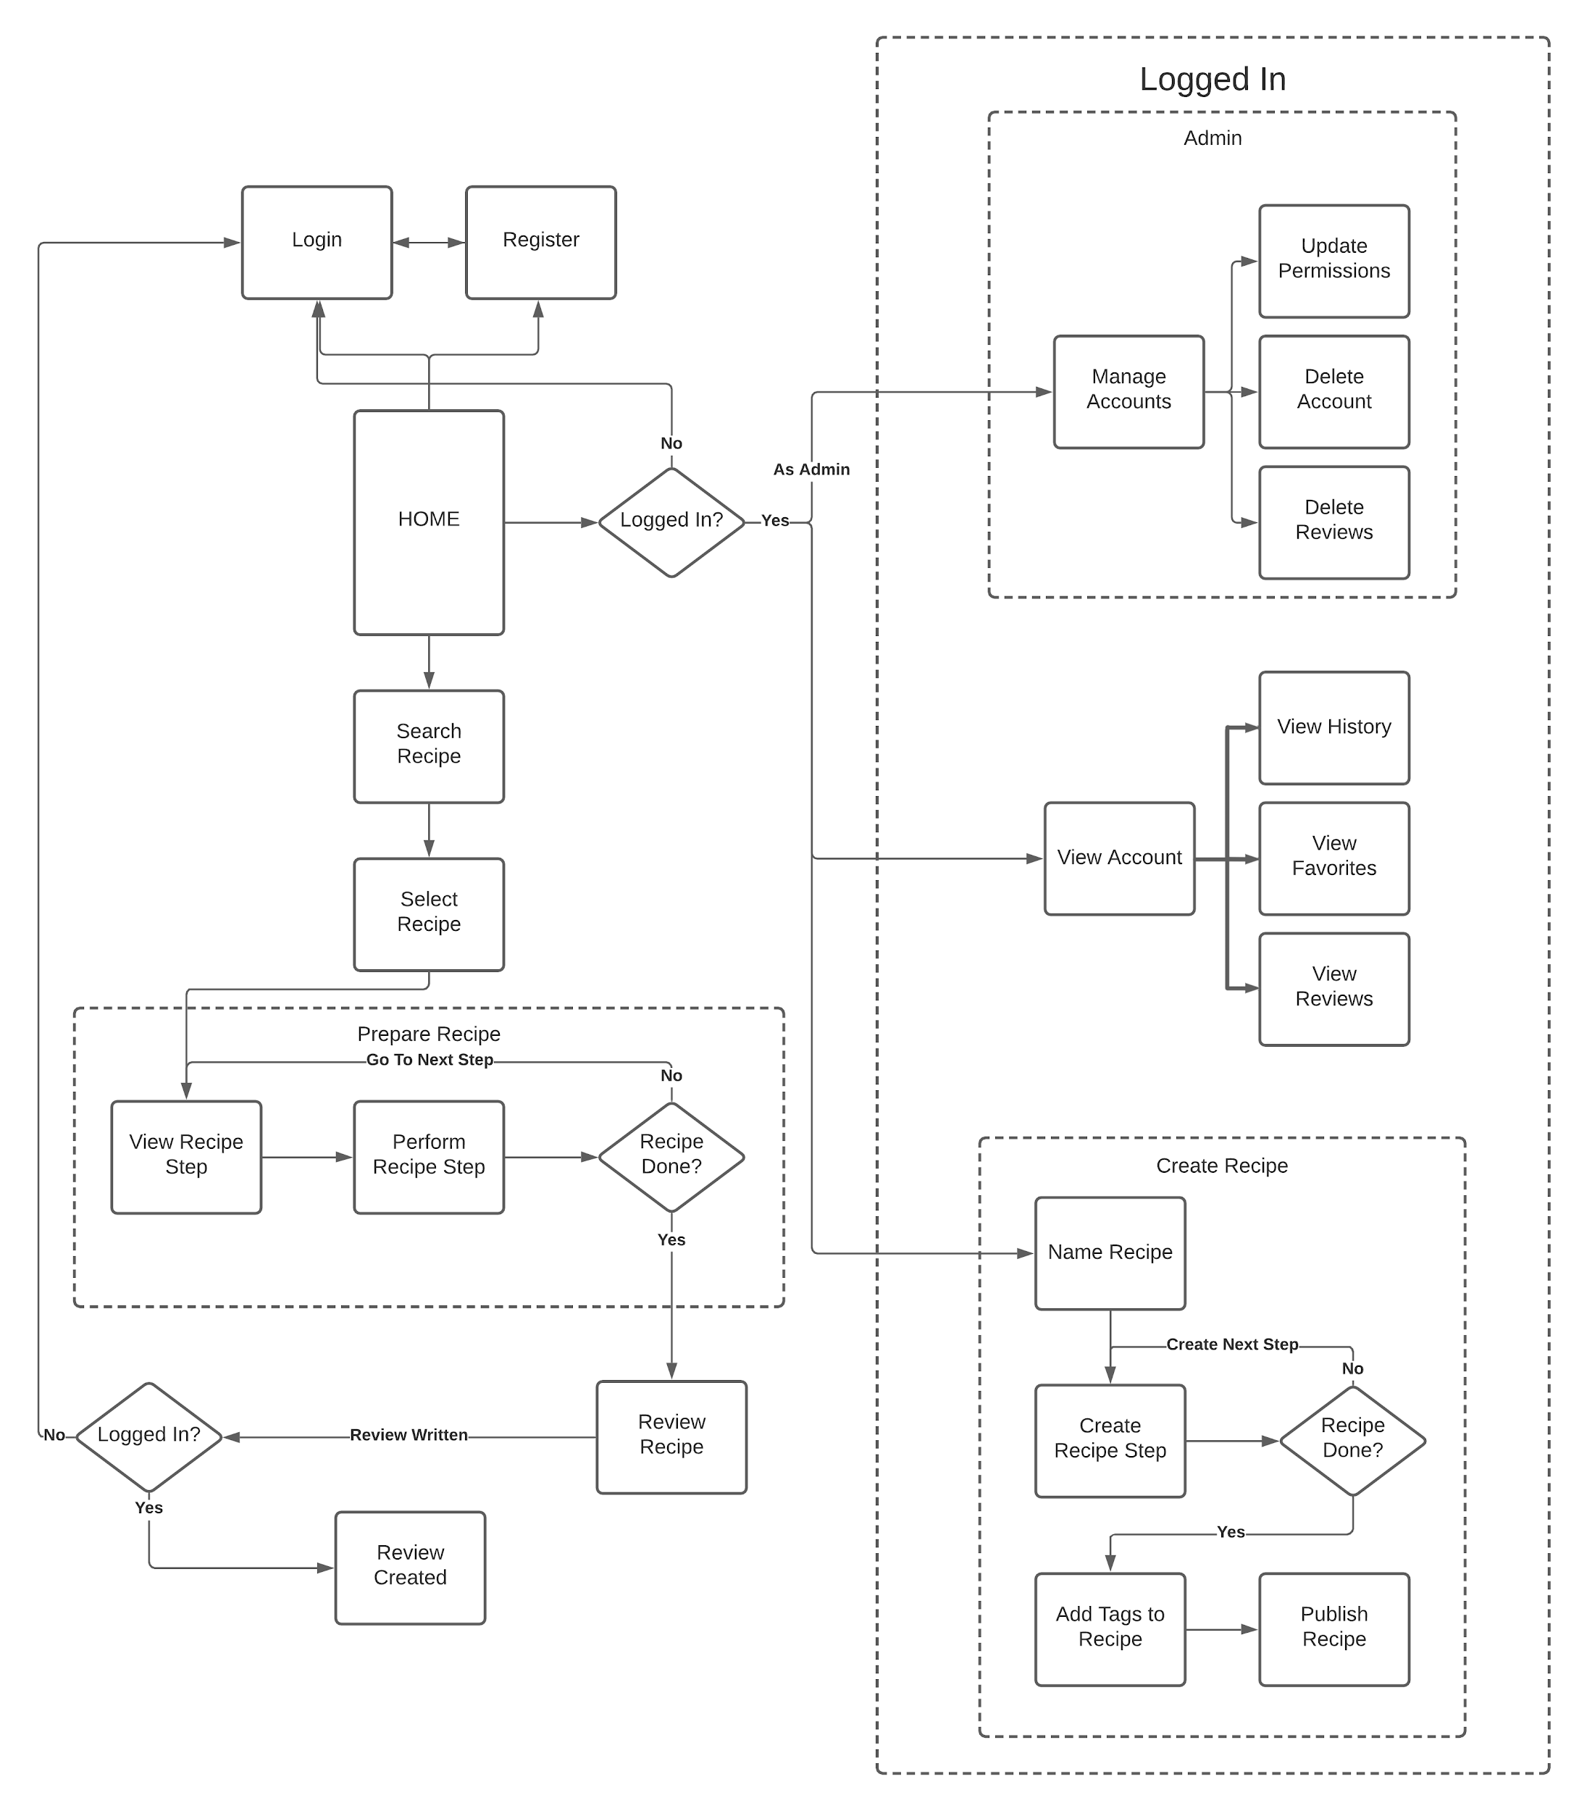

## DB Model

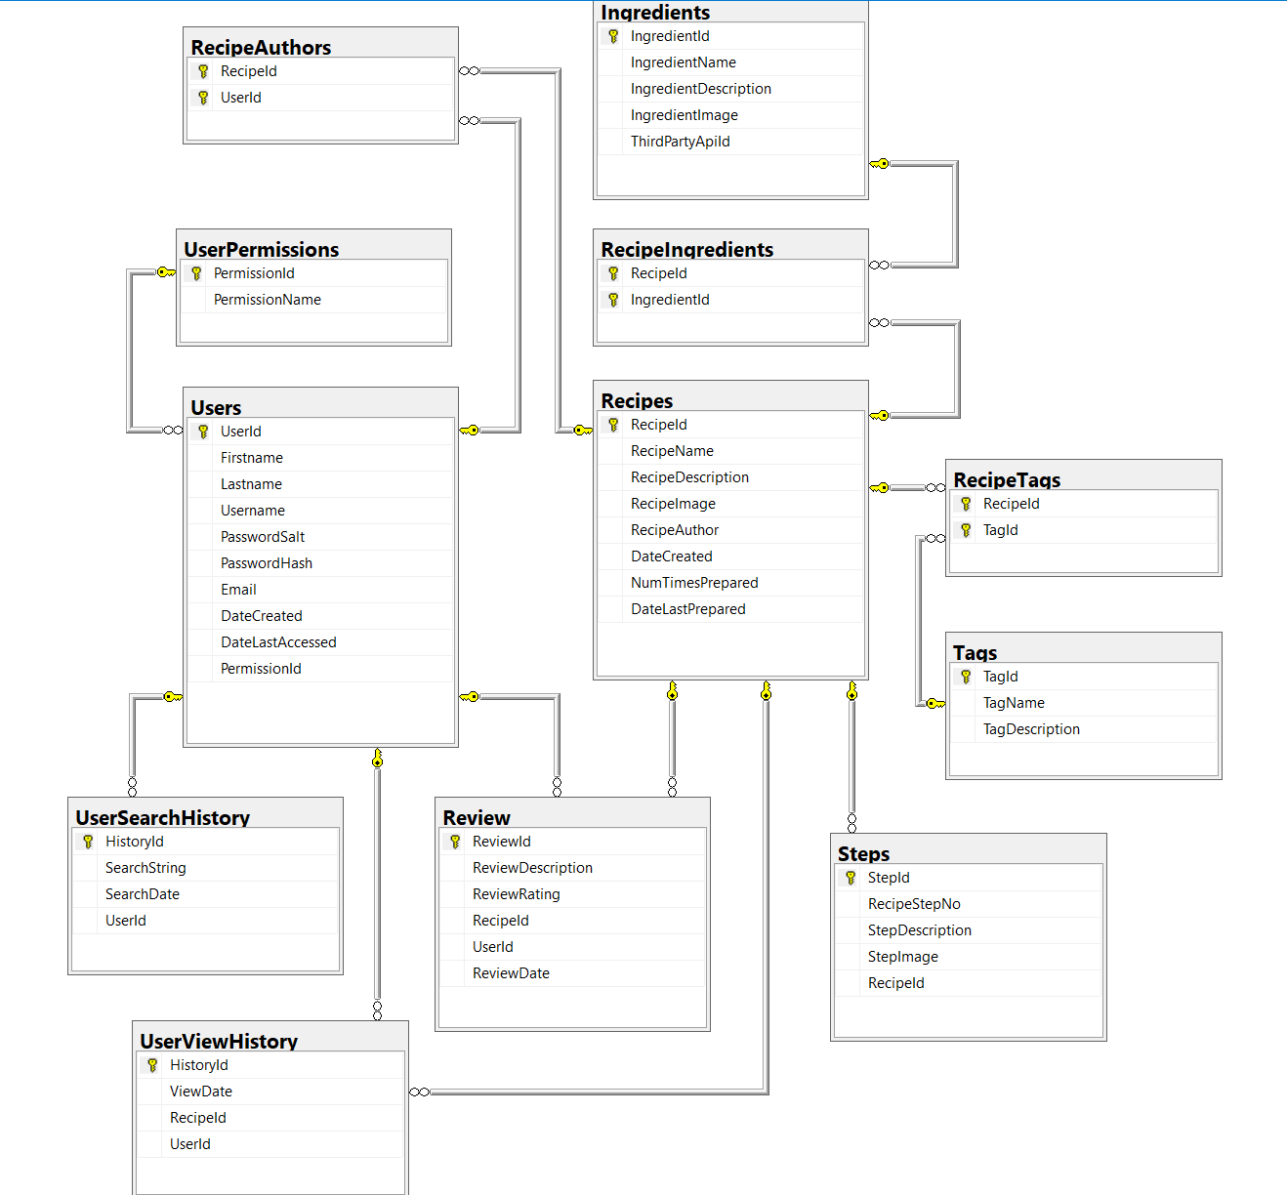

## Kanban board

<https://trello.com/b/WjKzLyF3/agile-sprint-board>

## Github Repository

<https://github.com/BC12807/P2_2ManyCooks>