**Team Name:** Cinephiliacs

**Team Members:** Tristyn Linde (Team Leader), Matt Grimsley, Roger Plyler

**Sales Description:**

This application will allow users to find movie information and reviews, as well as be able to leave ratings and reviews to guide other users. We will retrieve movie information, such as overall rating, genre, actors, and the movie summary, using the Movie Database API. Users will be able to add movies to a want-to-watch list, as an easy way to keep track of that movie and its ratings. They will also be able to choose their favorite genres, actors, and directors, to guide future searches. These lists of favorites, as well as their previously reviewed movies, will be available to them for easy curation.

**MVP:**

* Having users be able to sign in to the site.
* Able to search movies by titles.
* Users can rate movies they have watched.
* Store a list of movies a user has rated.
* Users can add movies to a list of movies that they would like to watch.

**3rd Party APIs:**

[Movie Database API (IMDb Alternative)](https://rapidapi.com/rapidapi/api/movie-database-imdb-alternative) - Searches movies by title or ID and returns information such as genre, director(s), release date, and posters.

[Verimail](https://verimail.io/docs/v3) - Verifies users email addresses to ensure that there are no syntax errors, invalid domains, or duplicate emails being stored by our system.

**User Stories:**

1. As a viewer, I want to store movies I want to watch, so that I can come back to them later.
2. As a viewer, I want to store movies I have watched, so that I can see my view statistics later on.
3. As a viewer, I want to search for movies, so that I can find more info about that movie my friend recommended to me.
4. As a viewer, I want to rate and review movies, so that other people can use my opinions to inform their viewing decisions.
5. As a viewer, I want to view ratings and reviews, so that I can decide if I want to view a movie.

**Stretch Goals:**

1. Suggest movies by highest rating
2. Recommend similar movies based on watch history
3. Favorite genres, directors, actors
4. Highlight movies in search results that contain a favorite genre, director, or actor

**User Interaction Model:** <https://pdfhost.io/v/qXuaqF37I_Cinephiliacs_User_Interaction_Modelpdf.pdf>

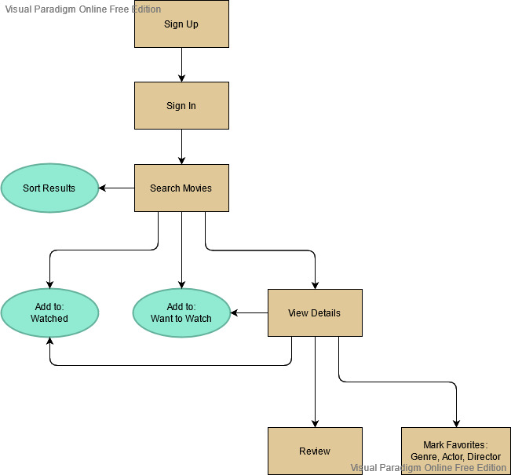**Kanban Board:** <https://trello.com/cinephiliacs/>

**Repo:** <https://github.com/03012021-dotnet-uta/P2_Cinephiliacs>

**Database Model:** <https://pdfhost.io/v/LNgDsbS2X_Cinephiliacs_Database_Modelpdf.pdf>

