**APPROVED**

**Proposal Link:** [G4_CinephiliacsProposal_4](https://docs.google.com/document/d/1bW5guWnXh6Q_83CFEbft2JuK1A31B4Azgnzyt88dNXQ/edit?usp=sharing)

**Team:** The Cinephiliacs - Tristyn Linde (Team Leader), Matt Grimsley, Roger Plyler

**Sales Description:**

Cinephiliacs is a forum for users to review, discuss, and learn about movies. Each movie has an information page and a discussion page. The information page displays overall rating, genre, actors, and a movie summary is retrieved using the Movie Database API, and users are able to leave reviews for a movie. The discussion pages are for more casual discussions, such as fan theories or film analysis. Each discussion page will include user-made posts, which will either create a new thread or be in response to an existing thread. Each thread will have tags, so that users are able to scroll through the discussions without seeing information that they might not want to see. Users will be notified of new responses to their posts and are also able to follow forums and users to receive updates when a new post is made.

**MVP:**

* Users can sign in to the site.
* Users are able to search movies by title.
* Site displays a page with movie info (from 3rd party API) and reviews (from db).
* Discussion pages are populated with previous posts.
* Users can leave reviews and create discussion posts.
* Tagging has been implemented for discussion threads.
* Users can add movies to their following list.

**3rd Party APIs:**

[Movie Database API (IMDb Alternative)](https://rapidapi.com/rapidapi/api/movie-database-imdb-alternative) - Searches movies by title or ID and returns information such as genre, director(s), release date, and posters.

[Verimail](https://verimail.io/docs/v3) - Verifies users email addresses to ensure that there are no syntax errors, invalid domains, or duplicate emails being stored by our system.

**User Stories:**

1. As a viewer, I want to search for movies by the words in their title, so that I can find movies without needing to know the full title.
2. As a viewer, I want to rate and review movies, so that other people can use my opinions to inform their viewing decisions.
3. As a viewer, I want to post on discussion pages, so that I can have conversations with other movie fans about my favorite films
4. As a viewer, I want to utilize a tagging system, so that I can avoid any major spoilers but still see what other people are discussing about a film.
5. As a viewer, I want to follow forums and users, so that I can make sure I don’t miss a post that I would like to see.

**Stretch Goals:**

1. Recommend movies based on what others who have watched a movie have watched.
2. A system to friend users that will have some sections show results based on their friends list.
3. Admin users with increased functionality such as tagging or deleting other users’ discussion posts.
4. Able to block tags and users.
5. Able to add content warnings to a film and filter out films with certain warnings.
6. Search films by keywords such as genre, director, etc.

**User Interaction Model:** 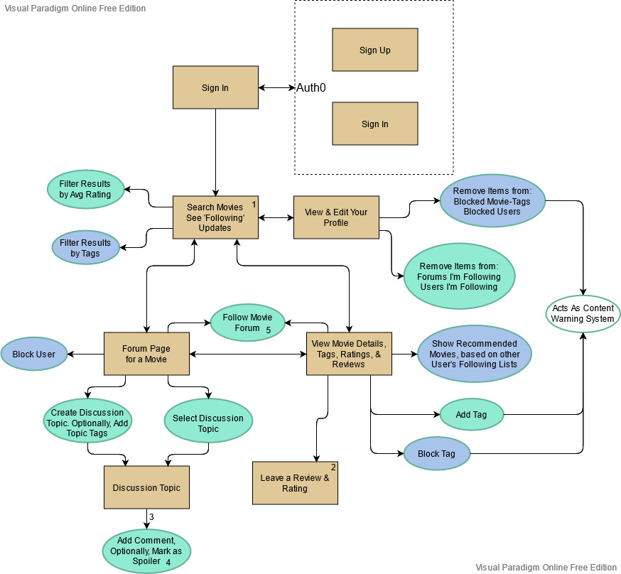

**Kanban Board:** <https://trello.com/cinephiliacs/>

**Repo:** <https://github.com/03012021-dotnet-uta/P2_Cinephiliacs>

**Database:**

