P2 Proposal - EventHookUp

**Team Members:**

Nicholas Wong - Team Leader

Christopher Trimmer

Muhammad Tahir Monir

**Sales Description:**

EventHookUp is a web application for finding things to do. Using EventHookUp, event managers will be able to create and post events for consumers to see. The event managers will be able to provide a variety of information about the event. The consumers will be able to find events near them and sign up for such events.

**Minimum Viable Product:**

Users will be able to register and login, either as a customer or an event manager. Event managers will be able to create an event and provide all the necessary information. Customers will be able to view events and sign up for the events.

**3rd Party Api:**

Google Calendar API: <https://developers.google.com/calendar>

We’re going to use google’s calendar api to mark and keep track of the dates of the events, and use it for events that a user has signed up for.

Mapbox API: <https://docs.mapbox.com/api/overview/>

We’re using the mapbox api for map information. We’re going to display a static image of the map and a marker of where the event is.

**User Stories:**

All Users:

1. Create an account and log in
2. VIew all events that are going on
3. View all events that I have been to before
4. View all events that I have signed up for
5. View information about events that I have signed up

Event Managers:

1. Create an event
2. Edit an event they created

**Stretch Goals:**

1. Visual map of the location on webpage
2. Another api(ticket master(?)) to bring in more events
3. Another api for booking information(hotels/cars/airplane)

**User Interaction Model:**

<https://drive.google.com/file/d/1JiFVpPDSolZOYwz-hc9n032NTfMHGLGH/view>

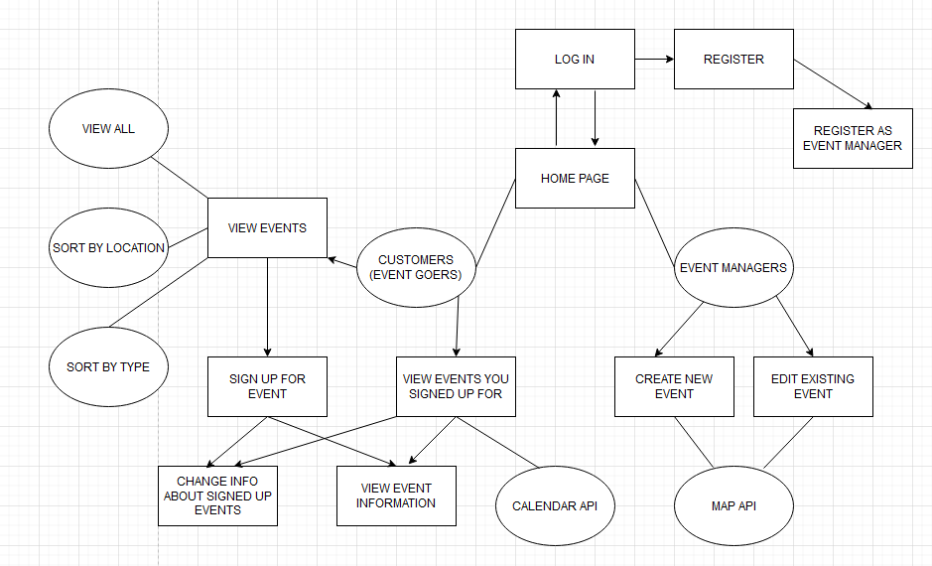

**Kanban Board:**

<https://trello.com/b/1nXw7oZb/main-board>

**GitHub Repository:**

<https://github.com/03012021-dotnet-uta/P2_EventHookUp>

**Database Model:**

