**Approved**

P2 Proposal - EventFunctions

**Team Members:**

Nicholas Wong - Team Leader

Christopher Trimmer

Muhammad Tahir Monir

**Sales Description:**

EventFunctions is a web application for managing, tracking, and planning events including private functions, seminars, and concerts. Using EventFunctions, event managers will be able to create and post events for consumers to see and sign up for. The event managers will be able to provide a variety of information about the event. The event-goers will be able to find events near them and sign up for such events.

**Minimum Viable Product:**

Users will be able to register and login either as a customer or an event manager. Event managers will be able to access a manager-only page where they will be able to create and edit events. When creating an event, event managers will be able to see data about potential revenue, average tickets sold, and expected number of attendees based on past events. Event managers will also be able to view additional information about events that they have created including how many customers registered for the events, names of the people that have registered, and sales information(number of tickets sold and available). Once the event is over, the organizers will be able to view information about revenue, tickets sold, number of attendees, and their cost as part of a profit tool. Customers will be able to view events, sign up for the events, or remove themselves from events that they signed up for. These customers will be able to sort upcoming events based off distance and event type, if desired. Once registered, the attendee will receive an email notification confirming that they are registered for the event. When looking at event information, from either the attendee or manager side, a visual map will be shown on the web page to show the location of the event. After the event is over, the users will be able to leave a review and a rating of the event. The user will be able to edit or delete their own reviews after they leave it. Users can also go back to see past reviews of any events.

**3rd Party Api:**

Google Calendar API: <https://developers.google.com/calendar>

We’re going to use google’s calendar api to mark and keep track of the dates of the events, and use it for events that a user has signed up for.

Mapbox API: <https://docs.mapbox.com/api/overview/>

We’re using the mapbox api for map information. We’re going to display a static image of the map and a marker of where the event is.

**User Stories:**

* As a user, I want to create an account and log in.
* As a user, I want to view all events that are in my area.
* As a user, I want to be able to sort and filter events.
* As a user, I want to be able to sign up for an event.
* As a user, I want to view all events that I have been to before.
* As a user, I want to view all upcoming events that I have signed up for.
* As a user, I want to view information about events that I have signed up for.
* As a user, I want to be able to leave a review for an event that I have been to.
* As a user, I want to receive email notifications so that I can confirm my attendance.
* As an event manager, I want to create an event.
* As an event manager, I want to edit an event that I have created.
* As an event manager, I want to be able to see a list of people that have registered for my event.
* As an event manager, I want to be able to see the total number of tickets sold and how many are available(left and total).
* As an event manager, I want to see estimated revenues based on past events.
* As an event manager, I want to see total revenue and profits on my event.

**Stretch Goals:**

* Use another api to bring in more events.
* Use another api for booking information(hotels/cars/airplanes).
* Use OAuth2 industrial standard for login and registration.
* Provide directions from user current location to event location.

**User Interaction Model:**

<https://drive.google.com/file/d/1JiFVpPDSolZOYwz-hc9n032NTfMHGLGH/view>

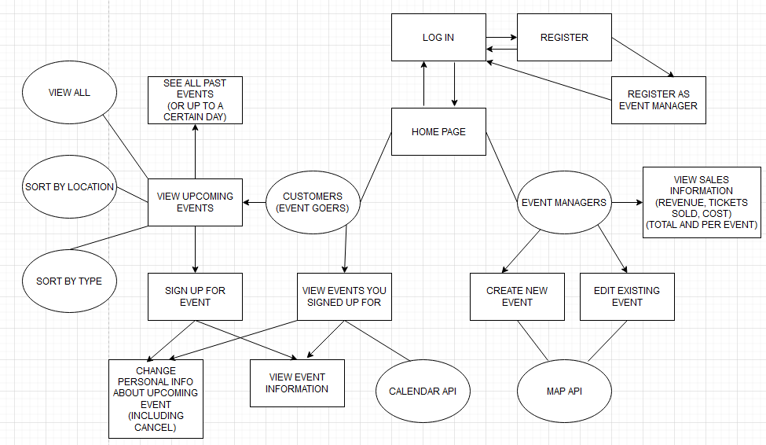

**Kanban Board:**

<https://trello.com/b/1nXw7oZb/main-board>

**GitHub Repository:**

<https://github.com/03012021-dotnet-uta/P2_EventFunctionsGroup>

**Database Model:**

