**RGB Color Sensor and Calibration**

**RGB Sensor**

First method of sensing color

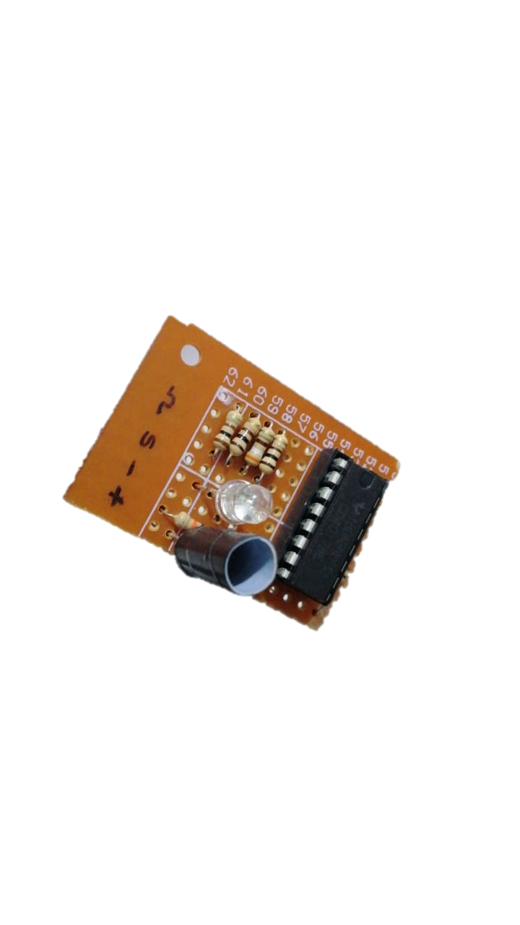

Component list of the sensor:

* 100 Resistors x 3
* 10K Resistors x 1
* CD4017 Switching IC
* LDR x 1

Design of the Sensor:

The LDR is used without any filters on it. CD4017 is a decade counting IC activated by a clock pulse. 4th pin of the counting IC is connected to the RESET pin of the IC. Hence, it will reset and go to 1st after 3rd pin. And 1-3 pins are connected to a RGB LED through 100Ω resistors. The LDR is covered with a black 3cm high cylinder to prevent unwanted light and focus only on the object. 4 wires are provided to the sensor module. 2 for Power supply, one for clock pulse input, one for analog output from the LDR.

Hypothesis:

In the initial state the Counting IC (CD4017) RESETS. Since the 1, 2, 3 output pins are connected to RED, GREEN, BLUE of the LED respectively, RED will light up. RED light will reflect from the object in front. The changed resistance of the LDR is converted to a voltage using voltage divider and sent to the micro controller. After reading, a clock pulse is sent to the IC, and it will switch to GREEN and BLUE. Three read values are saved on an array.

Advantages:

* Didn’t want to use RGB filters.
* Cost effective (Least amount of components used)
* Only 4 wires and LOW power.

Problems Encountered:

* The hypothesis works in the ideal environment. But in the initial stage we noticed IC doesn’t guarantee RESET.
* Since we read sensor data only in a specific period, there is no way to establish synchronization between IC and the micro controller.
* To get an accurate reading average of at least 3 samples are required. But in this method it takes time to read color.

Second method of sensing color

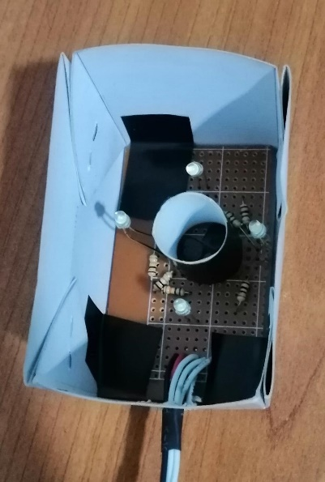

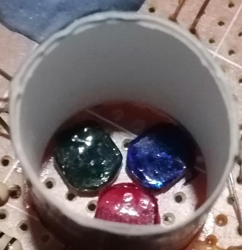

Component list of the sensor:

* 10K Resistors x3
* LDRS x3
* White LEDS x4
* RGB Filters
* 100Ω Resistors x4

Design of the Sensor:

RGB filters are made of 4 layers of RED, GREEN, BLUE vinyl sheets. 3 same type LDRs are taken and added 3 filters separately and placed as close as possible. All three LDRS are covered with a black 4cm high cylinder to prevent unwanted light and to focus only on the object. Most importantly there are 4 white LEDs around the cylinder to provide light to shine on the object. 5 Wires are provided to the sensor module, 2 for power and 3 for RGB analog values. Finally, there is a box around the sensor module to block environmental light.

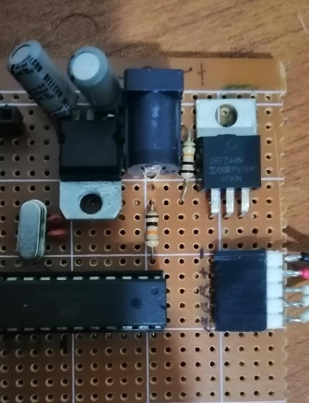Hypothesis:

Power for the sensor is supplied via an n-channel MOSFET (IRFZ44N). Using the MOSFET, sensor is set to sleep mode of active mode. In the active mode all 4 white LEDs are turned on. White light is reflected from the object and shined on the LDRs. Then RGB filters filter out RED, GREEN, and BLUE from the reflected light and changes resistances of LDRs. Those Resistances are converted in to voltages using 3 voltage dividers and sent to the micro controller.

Advantages:

* Didn’t had to use TDM.
* Sampling can be done in any frequency
* No issues with synchronization.

Problems Encountered and solutions:

* Power dissipation is high for four white LEDs. As the solution an n-channel MOSFET is used to switch on LED only when reading is required.
* Filters are not ideal. For the solution, a calibration algorithm and regressing is used to correct readings.

Out of these two methods, we continued with the second method as we could find solutions for each problem we encountered.

**Sensor Callibration**

$$x=ay^{2}+by+c$$

$$\sum{x}=a\sum{y^{2}}+b\sum{y}+cn ---------------(1)$$

$$\sum{x}y=a\sum{y^{3}}+b\sum{y^{2}}+c\sum{y }------------(2)$$

$$\sum{x}y^{2}=a\sum{y^{4}}+b\sum{y^{3}}+c\sum{y^{2}-----------(3)}$$

$$\left[\begin{matrix}\sum{x} \\ \sum{x}y \\ \sum{x}y^{2}\end{matrix}\right]=\left[\begin{matrix}\sum{y^{2}} & \sum{y} & n \\ \sum{y^{3}} & \sum{y^{2}} & \sum{y} \\ \sum{y^{4}} & \sum{y^{3}} & \sum{y^{2}}\end{matrix}\right]\left[\begin{matrix}a \\ b \\ c\end{matrix}\right]$$

$$\left[\begin{matrix}a \\ b \\ c\end{matrix}\right]={\left[\begin{matrix}\sum{y^{2}} & \sum{y} & n \\ \sum{y^{3}} & \sum{y^{2}} & \sum{y} \\ \sum{y^{4}} & \sum{y^{3}} & \sum{y^{2}}\end{matrix}\right]}^{-1}\left[\begin{matrix}\sum{x} \\ \sum{x}y \\ \sum{x}y^{2}\end{matrix}\right]$$