**Lab no 5**

**OBJECTIVE:**

**TO BECOME FAMILIAR WITH RMI OBJECT SERIALIZATION**

**Task:**

Develop any simple application to demonstrate object passing in RMI. (Expl: Make a class of your own and use its objects as arguments and return types for RMI)

**Interface:**

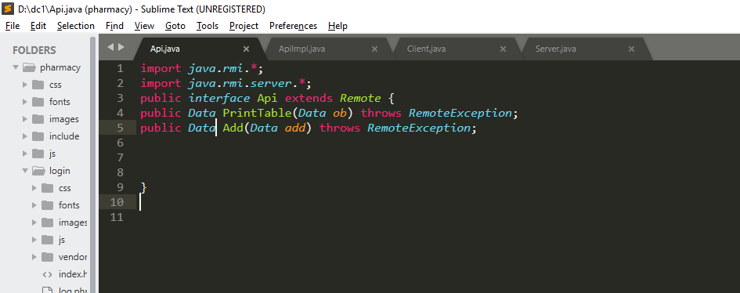

**RemoteObject:**

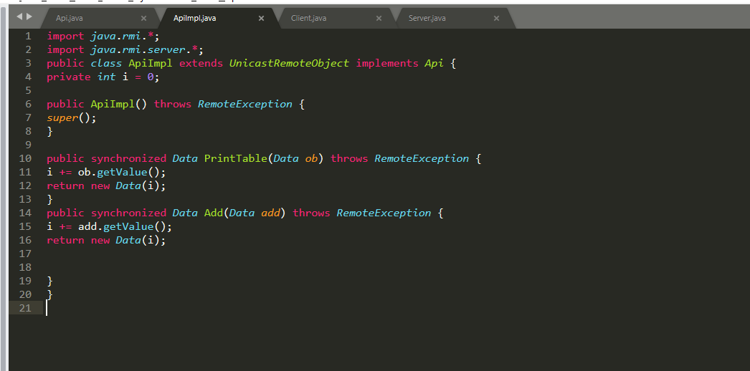

**Server:**

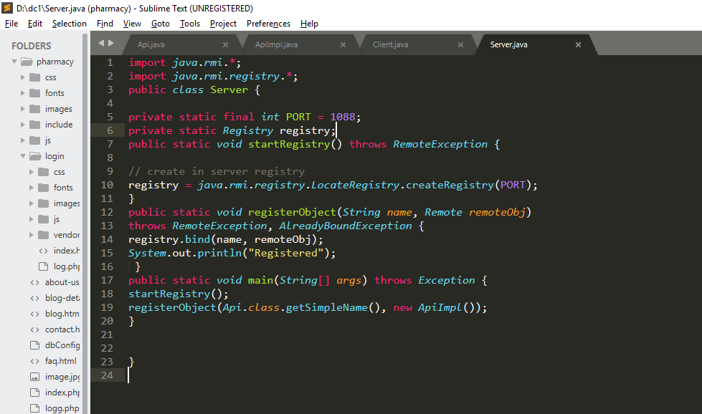

**Client:**

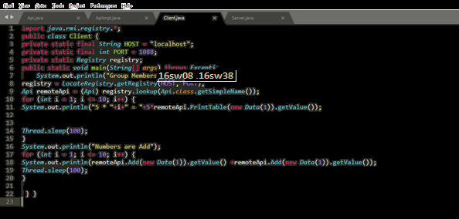

**Outputs:**

