**Lab no 8**

**Objective:**

**To learn XML schema and parsing an XML document.**

1. **Create an XML document structuring information for a store. (shopping store of your choice)**

**<?xml version="1.0"?>**

**<store xmlns="http://www.w3schools.com"**

**xmlns:xsi="http://www.w3.org/2001/XMLSchema-instance"**

**xsi:schemaLocation="http://www.w3schools.com store.xsd">**

**<product> Bike</product>**

**<model>24-inch Boys Mountain Bike</model>**

**<price>$200.00</price>**

**<color>Black</color>**

**<product> Bike</product>**

**<model>24-inch Boys Cruiser Bike</model>**

**<price>$150.00</price>**

**<color>Blue</color>**

**<product>skateboards</product>**

**<model>Acme Sportsmen Skateboard</model>**

**<price>$75.00</price>**

**<color>Black</color>**

**<product> skateboards</product>**

**<model>Deluxe Boys Skateboard</model>**

**<price>$35.00</price>**

**<color>Blue</color>**

**</store>**

1. **Create DTD for store XML Document. And validate on** [**http://www.w3schools.com/xml/xml_validator.asp**](http://www.w3schools.com/xml/xml_validator.asp)

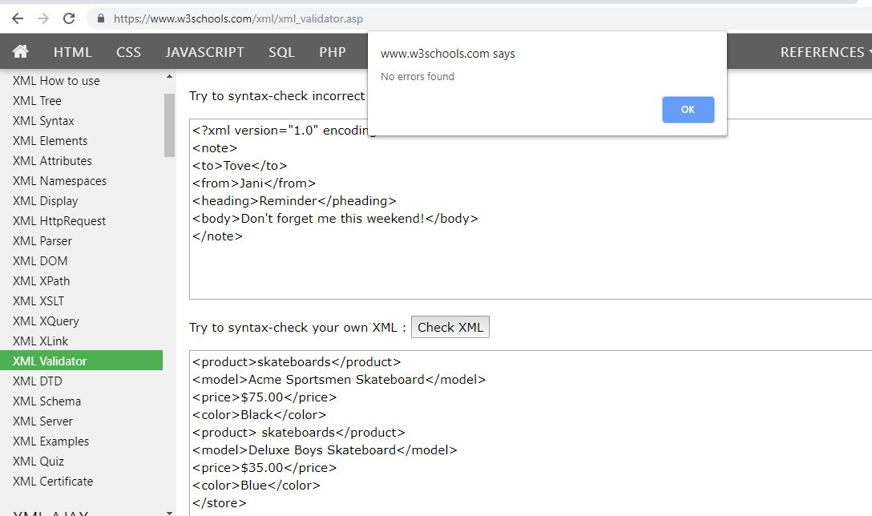

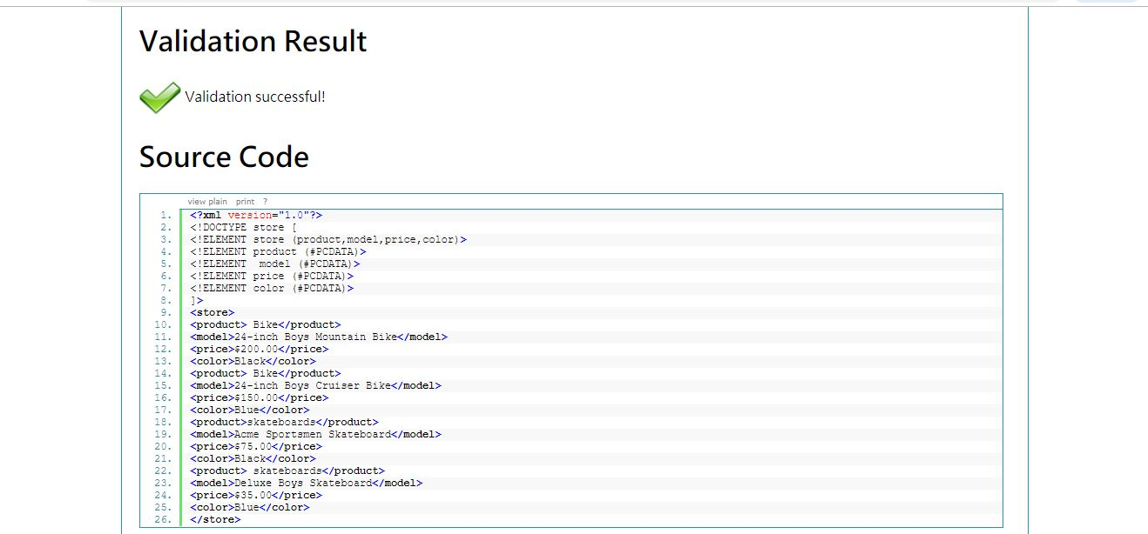

1. **Write XML Schema for the following XML document and then validate the XML document along with its schema on the following website:**

[**http://www.utilities-online.info/xsdvalidation/#.UlFx2tKmhIg**](http://www.utilities-online.info/xsdvalidation/)

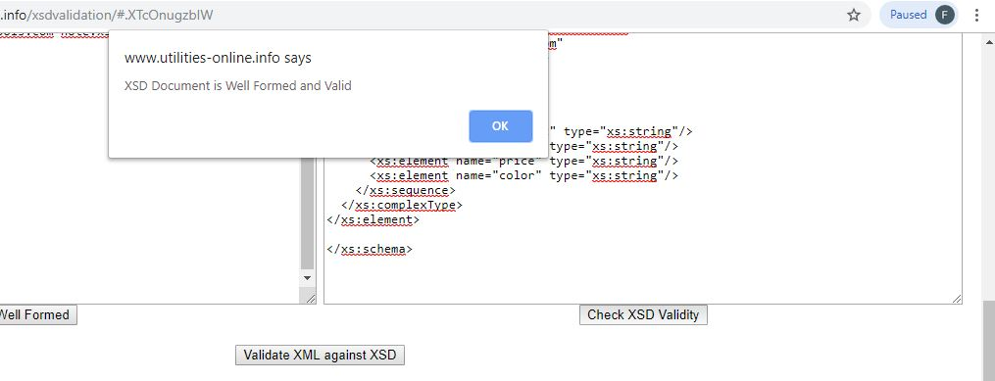

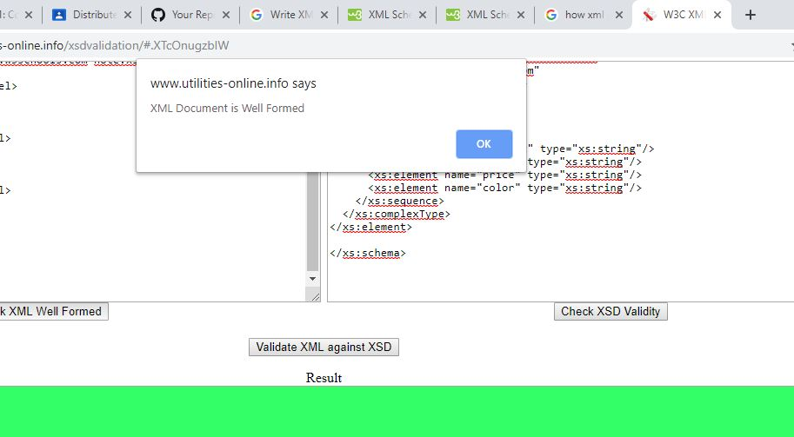

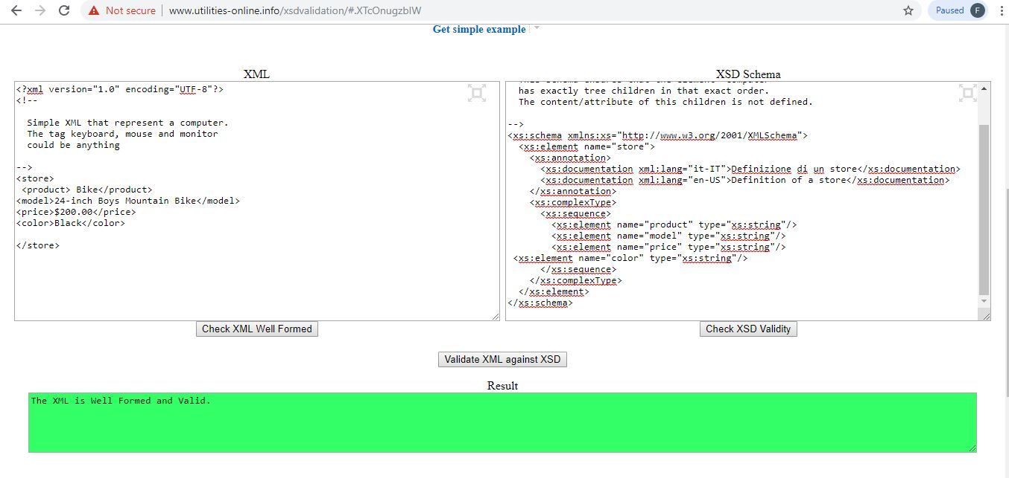

**4. Write an XML instance for following schema and then parse that document in Java using either DOM or SAX API.**

<?xml version=“1.0” ?>

<xs:schema xmlns:xs=“http://www.w3.org/2001/XMLSchema”>

<xs:element name="person“ type="persontype"/>

<xs:complexType name="persontype">  
<xs:sequence>  
 <xs:element name="firstname“ type="xs:string"/>  
<xs:element name="lastname" type="xs:string"/>  
<xs:element name=“date_of_birth” type=“date”/>

</xs:sequence>  
</xs:complexType>

<xs:complexType name=“date”>

<xs:sequence>

<xs:element name=“day” type=“xs:integer”/>

<xs:element name=“month” type=“xs:integer”/>

<xs:element name=“year” type=“xs:integer”/>

</xs:sequence>

</xs:complexType>

</xs:schema>

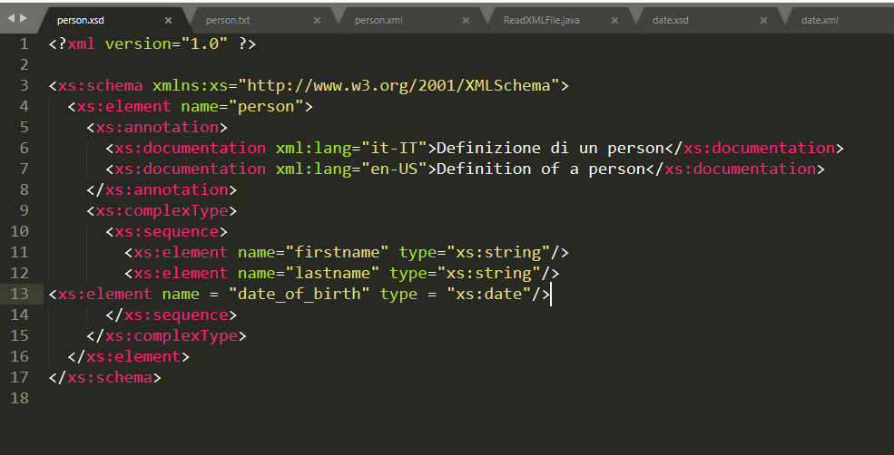

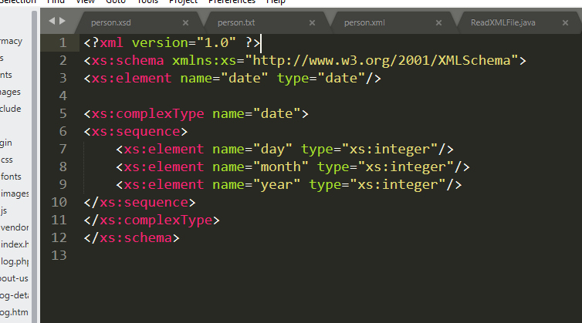

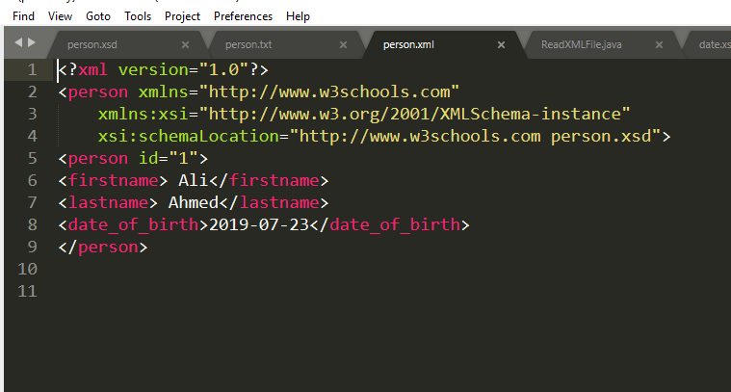

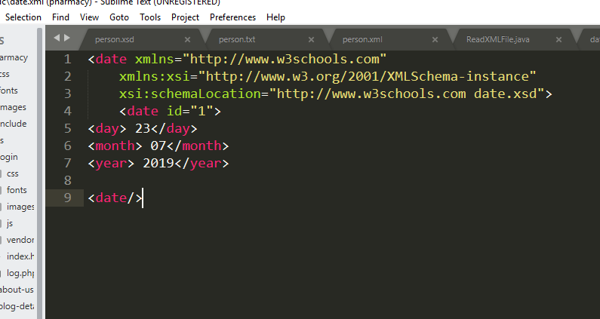

**Parse Java Code Using SAX Api:**

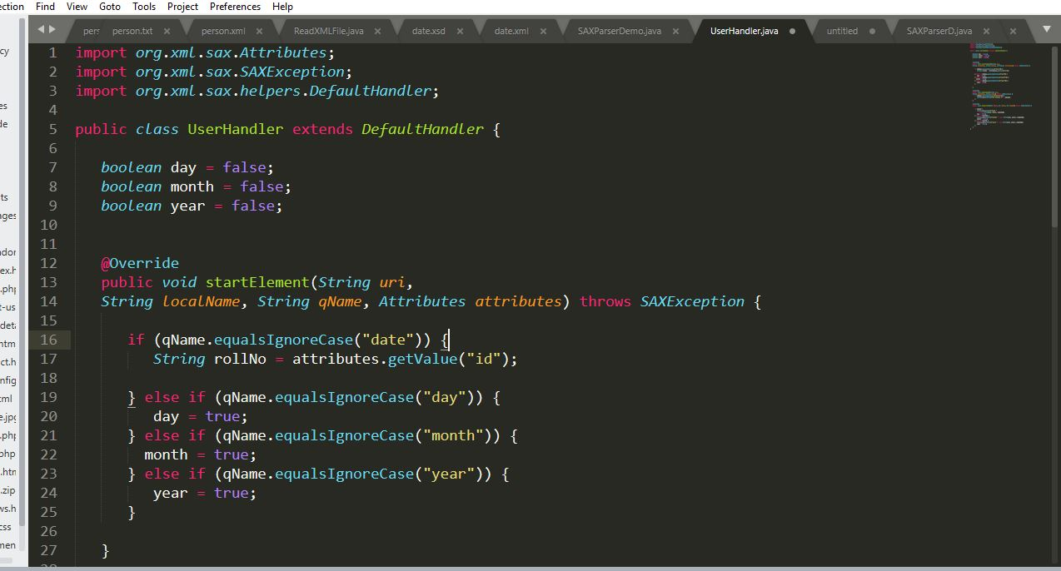

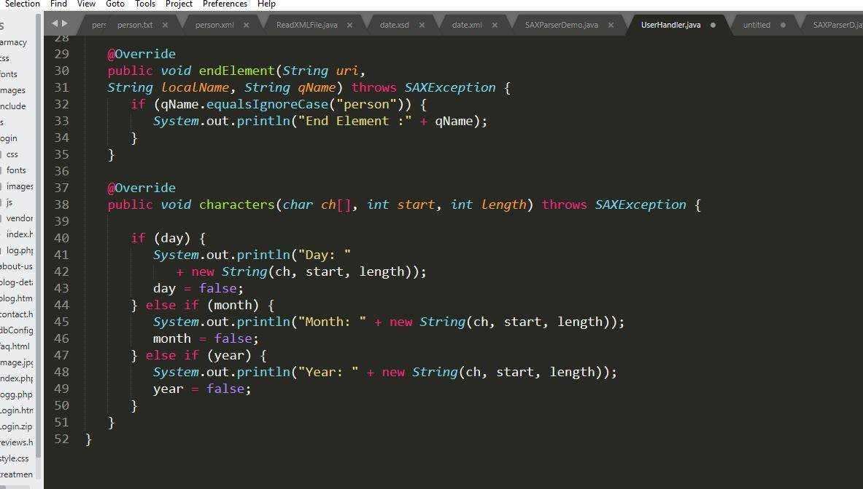

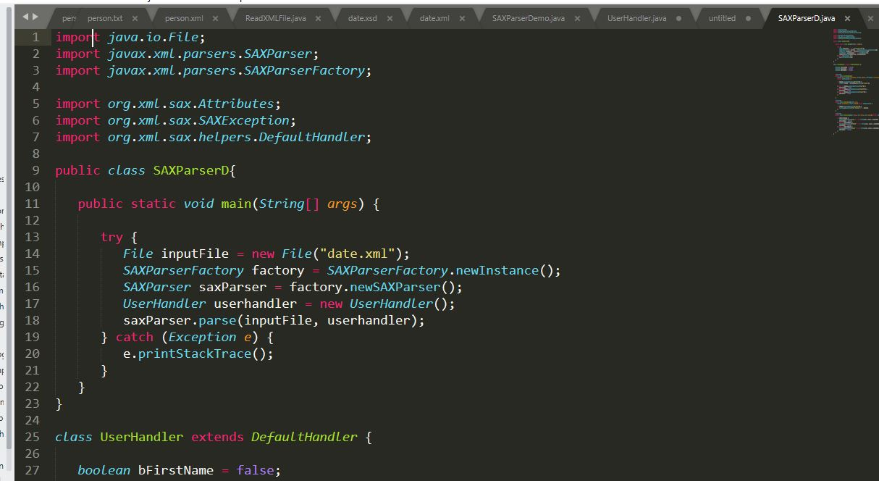

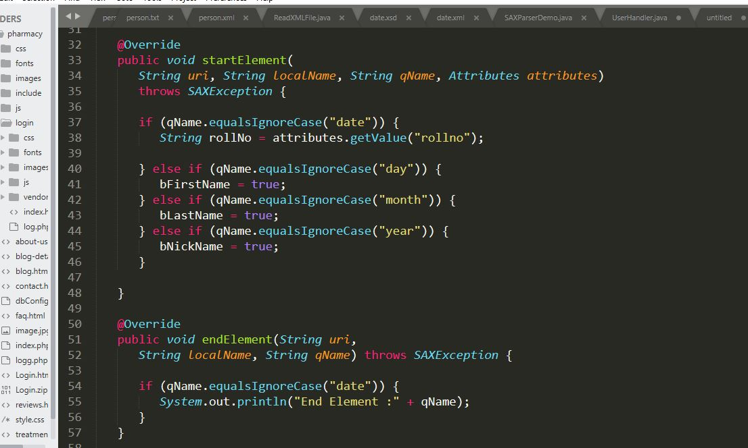

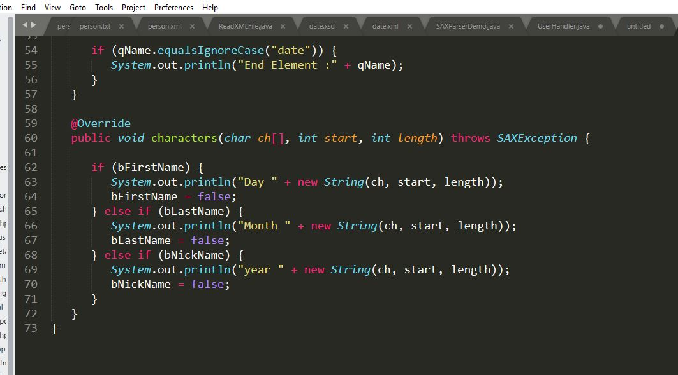

**Output:**

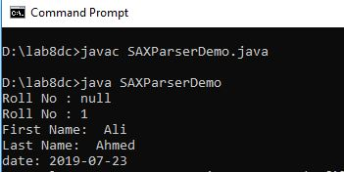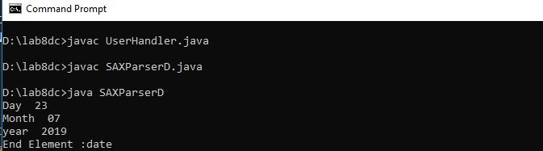

Person:

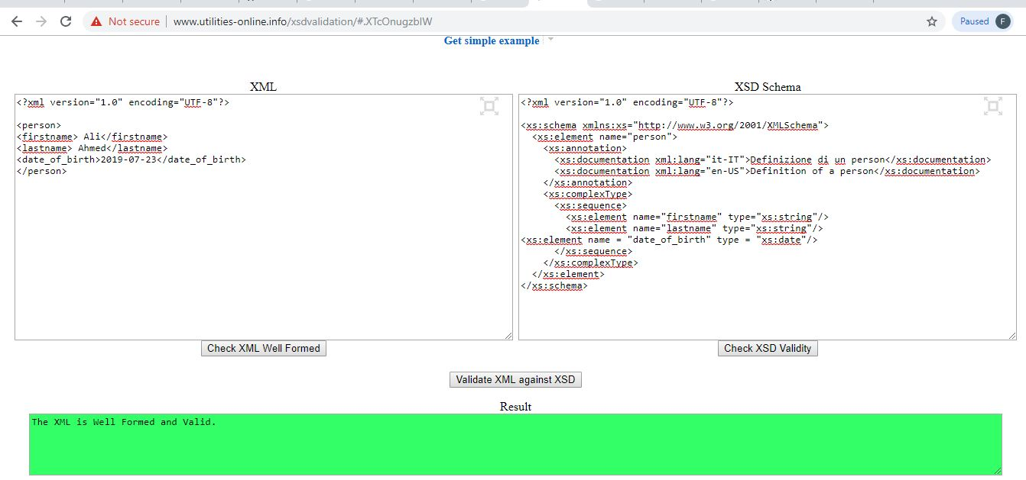

Date:

