電通二乙微處理器實驗 實驗結報

實驗名稱 | Lab 02
組別 |  | 組員 | 03053622易大閎

- 實驗目的
使用led並照順序亮滅
- 實驗步驟
詳細請看PDF
- 程式碼
Check 1 :

const byte NUM=8;
const byte led[]={17,16,15,14,11,10,9,8};
const int delaytime=1000;
int ii;
void setup()
{
for(ii=0;ii<NUM;ii++)
{
pinMode(led[ii],OUTPUT);
digitalWrite(led[ii],LOW);
}
}
void loop()
{
for(ii=0;ii<NUM;ii++) /* 從左邊第一個燈開始亮*/
{
digitalWrite(led[ii],HIGH);
delay(delaytime);
digitalWrite(led[ii],LOW); /*暗*/
}
for(ii=0;ii<NUM;ii++) /*設定全暗*/
{
pinMode(led[ii],OUTPUT);
digitalWrite(led[ii],LOW);
}
delay(delaytime);
}

Check 2 :

const byte NUM=8;
const byte led[]={17,16,15,14,10,9,8,7};
const int delaytime=200;
int ii;
void setup()
{
for(ii=0;ii<NUM;ii++)
{
pinMode(led[ii],OUTPUT);
digitalWrite(led[ii],LOW);
}
}
void loop(){
for(ii=0;ii<NUM;ii++) /* 從左邊第一個燈開始亮*/{
digitalWrite(led[ii],HIGH);
delay(delaytime);
digitalWrite(led[ii],LOW); /*暗*/
}
for(ii=0;ii<NUM;ii++) /*設定全暗*/{
digitalWrite(led[ii],LOW);
}
delay(delaytime);

for(ii=0;ii<NUM;ii++){ /* on off*/
digitalWrite(led[ii],HIGH);
}
delay(delaytime);

for(ii=0;ii<NUM;ii++) /* on off*/{
digitalWrite(led[ii],LOW);
}
delay(delaytime);

for(ii=0;ii<NUM;ii++){ /* on off*/
digitalWrite(led[ii],HIGH);
}
delay(delaytime);

for(ii=0;ii<NUM;ii++) /* on off*/{
digitalWrite(led[ii],LOW);
}
delay(delaytime);

for(ii=NUM-1;ii>=0;ii--) /*從右邊第一個開始亮*/{
digitalWrite(led[ii],HIGH);
delay(delaytime);
digitalWrite(led[ii],LOW); /*亮完暗掉*/
}
for(ii=0;ii<NUM;ii++){
digitalWrite(led[ii],LOW);
}
delay(delaytime);
for(ii=0;ii<NUM;ii++){ /* on off*/
digitalWrite(led[ii],HIGH);
}
delay(delaytime);

for(ii=0;ii<NUM;ii++) /* on off*/{
digitalWrite(led[ii],LOW);
}
delay(delaytime);for(ii=0;ii<NUM;ii++){ /* on off*/
digitalWrite(led[ii],HIGH);
}
delay(delaytime);

for(ii=0;ii<NUM;ii++) /* on off*/{
digitalWrite(led[ii],LOW);
}
delay(delaytime);
}

Check 3 :

const byte NUM=8;
const byte SW = 6;
const byte led[]={17,16,15,14,11,10,9,8};
const int delaytime=200;
int i,ii;
void setup()
{
for(ii=0;ii<NUM;ii++)
{
pinMode(led[ii],OUTPUT);
pinMode(SW,INPUT);
digitalWrite(led[ii],LOW);
}
}
void loop()
{
boolean val = digitalRead(6);
if(val){
for(ii=0;ii<NUM;ii++) /*設定全亮*/
{
pinMode(led[ii],OUTPUT);
digitalWrite(led[ii],HIGH);
}
delay(delaytime);
for(ii=0;ii<NUM;ii++) /*設定全暗*/
{
pinMode(led[ii],OUTPUT);
digitalWrite(led[ii],LOW);
}
delay(delaytime);
for(ii=0;ii<NUM;ii++) /*設定全亮*/
{
pinMode(led[ii],OUTPUT);
digitalWrite(led[ii],HIGH);
}
delay(delaytime);
for(ii=0;ii<NUM;ii++) /*設定全暗*/
{
pinMode(led[ii],OUTPUT);
digitalWrite(led[ii],LOW);
}
delay(delaytime);
for(i=1;i<=8;i++)
{
for(ii=0;ii<NUM;ii++) /* 從左邊第一個燈開始亮*/
{
digitalWrite(led[ii],HIGH);
delay(delaytime);
digitalWrite(led[ii],LOW); /*暗*/
}
for(ii=0;ii<NUM;ii++) /*設定全暗*/
{
pinMode(led[ii],OUTPUT);
digitalWrite(led[ii],LOW);
}
delay(delaytime);
for(ii=0;ii<NUM;ii++) /*設定全亮*/
{
pinMode(led[ii],OUTPUT);
digitalWrite(led[ii],HIGH);
}
delay(delaytime);
for(ii=0;ii<NUM;ii++) /*設定全暗*/
{
pinMode(led[ii],OUTPUT);
digitalWrite(led[ii],LOW);
}
delay(delaytime);
for(ii=0;ii<NUM;ii++) /*設定全亮*/
{
pinMode(led[ii],OUTPUT);
digitalWrite(led[ii],HIGH);
}
delay(delaytime);
for(ii=0;ii<NUM;ii++) /*設定全暗*/
{
pinMode(led[ii],OUTPUT);
digitalWrite(led[ii],LOW);
}
delay(delaytime);
}
for(i=1;i<=8;i++)
{
for(ii=NUM-1;ii>=0;ii--) /*從右邊第一個開始亮*/
{
digitalWrite(led[ii],HIGH);
delay(delaytime);
digitalWrite(led[ii],LOW); /*亮完暗掉*/
}
for(ii=0;ii<NUM;ii++)
{
pinMode(led[ii],OUTPUT);
digitalWrite(led[ii],LOW);
}
delay(delaytime);
}
}
else{
for(ii=0;ii<NUM;ii++) /* 從左邊第一個燈開始亮*/
{
digitalWrite(led[ii],HIGH);
delay(delaytime);
digitalWrite(led[ii],LOW); /*暗*/
}
for(ii=0;ii<NUM;ii++) /*設定全暗*/
{
pinMode(led[ii],OUTPUT);
digitalWrite(led[ii],LOW);
}
delay(delaytime);

for(ii=NUM-1;ii>=0;ii--) /*從右邊第一個開始亮*/
{
digitalWrite(led[ii],HIGH);
delay(delaytime);
digitalWrite(led[ii],LOW); /*亮完暗掉*/
}
for(ii=0;ii<NUM;ii++)
{
pinMode(led[ii],OUTPUT);
digitalWrite(led[ii],LOW);
}
delay(delaytime);
}
}

- 實驗結果及分析
實驗成功
- 心得討論
雖然實驗成功了，但過程並沒有那麼的順利。
- 修正電路圖

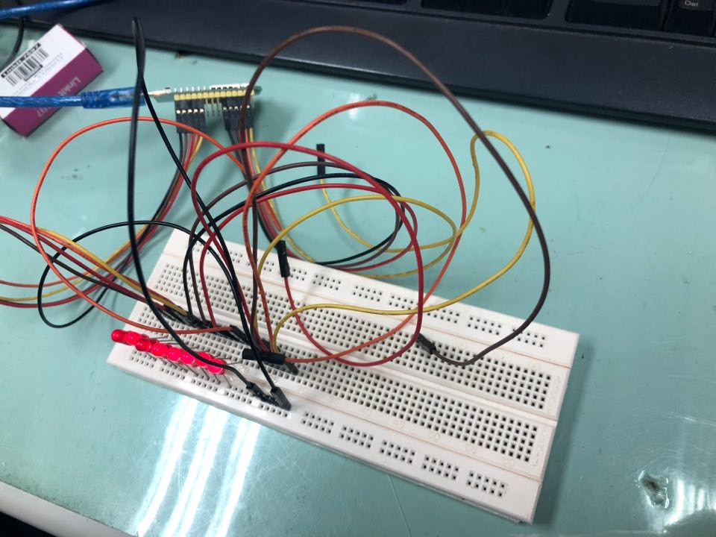
- 修正程式碼

