電通二乙微處理器實驗 實驗結報

實驗名稱 | Lab03
組別 |  | 組員 | 03053622 易大閎

- 實驗目的
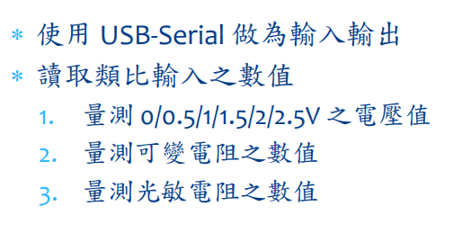
- 實驗步驟
步驟1:
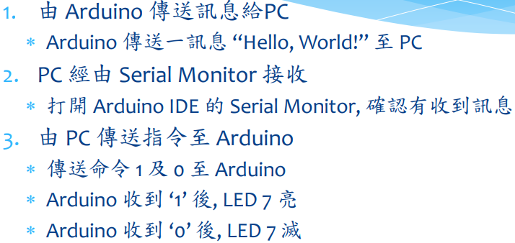
步驟2:


步驟3:
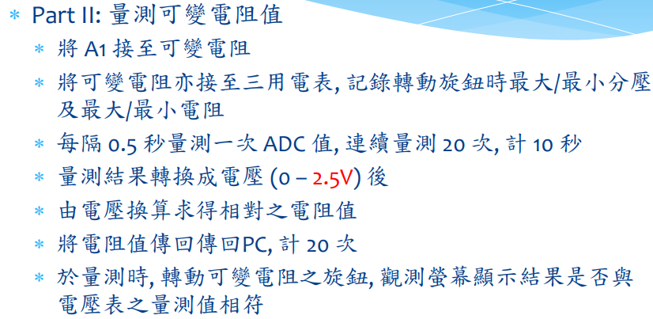
- 程式碼
Check 1 :

const byte Pin = 13;
byte val;
void setup() {
// put your setup code here, to run once:
Serial.begin(9600);
pinMode(13, OUTPUT);
}

void loop() {
// put your main code here, to run repeatedly:
if(Serial.available()){
val = Serial.read();
if(val=='1'){
digitalWrite(Pin, HIGH);
Serial.println("LED ON");
}
else if (val=='0'){
digitalWrite(Pin, LOW);
Serial.println("LED OFF");
}
}
}

Check 2 :

word Analogin;
float Vin;
void setup() {
Serial.begin(9600);
Analogin = 0;
}

void loop() {
// put your main code here, to run repeatedly:
for (int i=0;i<=5;i++){
Analogin = 0.7* Analogin + 0.3* analogRead(A0);
}
Vin = Analogin * 2.5 / 4095;
Serial.println(Vin);
delay(500);
}

Check 3 :

float sensorValue=0;
float sensorVoltage;
float Vin=2.5;
float R=500000;
float R1;
float R2;
float val;

void setup()
{
Serial.begin(9600);
pinMode(15,INPUT);
}
void loop(){
int i;
for (i=0;i<=5;i++)
sensorValue = 0.7* sensorValue + 0.3* analogRead(15);
sensorVoltage = sensorValue * 2.5 / 4095;
R1 = sensorVoltage * R / Vin;
R2=R-R1;
sensorVoltage= (Vin * R1) / R;
val=analogRead(15);

Serial.print("analogRead=");
Serial.print(val);
Serial.print("\tsensorVoltage=");
Serial.print(sensorVoltage );
Serial.print("\tR=");
Serial.print(R);
Serial.print("\tR1=");
Serial.print(R1);
Serial.print("\tR2=");
Serial.println(R2);

delay(500);
}

Check 4 :

float sensorValue=0;
float sensorVoltage;
float R=5000000;
float R1;
float val;

void setup()
{
Serial.begin(9600);
pinMode(15,OUTPUT);
}
void loop(){
int i;
for (i=0;i<=5;i++)
sensorValue = 0.7* sensorValue + 0.3* analogRead(15);
sensorVoltage = sensorValue * 2.5 / 4095;
R1 = sensorVoltage * R / 2.5;
val=analogRead(15);

Serial.print("analogRead=");
Serial.print(val);
Serial.print("\tsensorVoltage=");
Serial.print(sensorVoltage );
Serial.print("\tR1=");
Serial.println(R1);

delay(500);
}

- 實驗結果及分析
Check1 :
PC輸入 | SerialMonitor輸出 | LED狀態
0 | 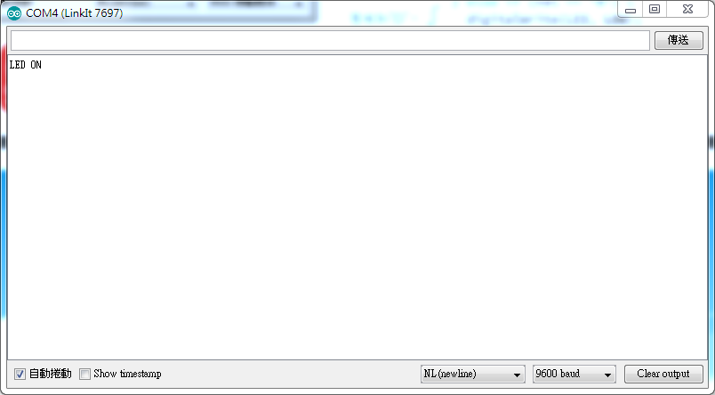 | 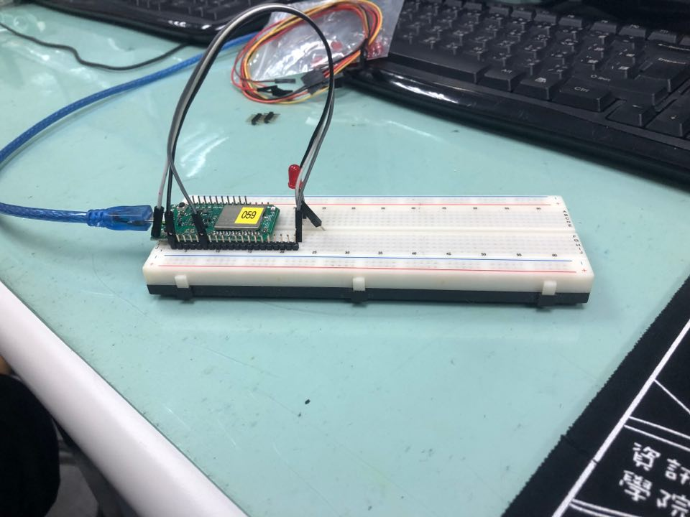
1 | 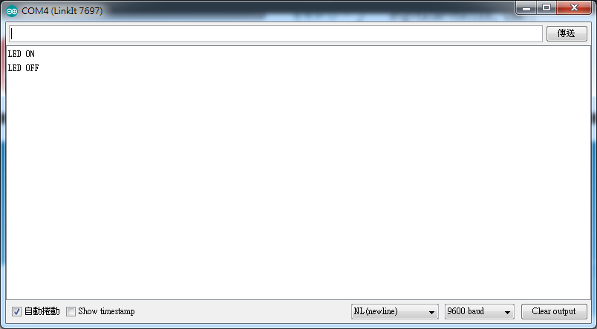 | 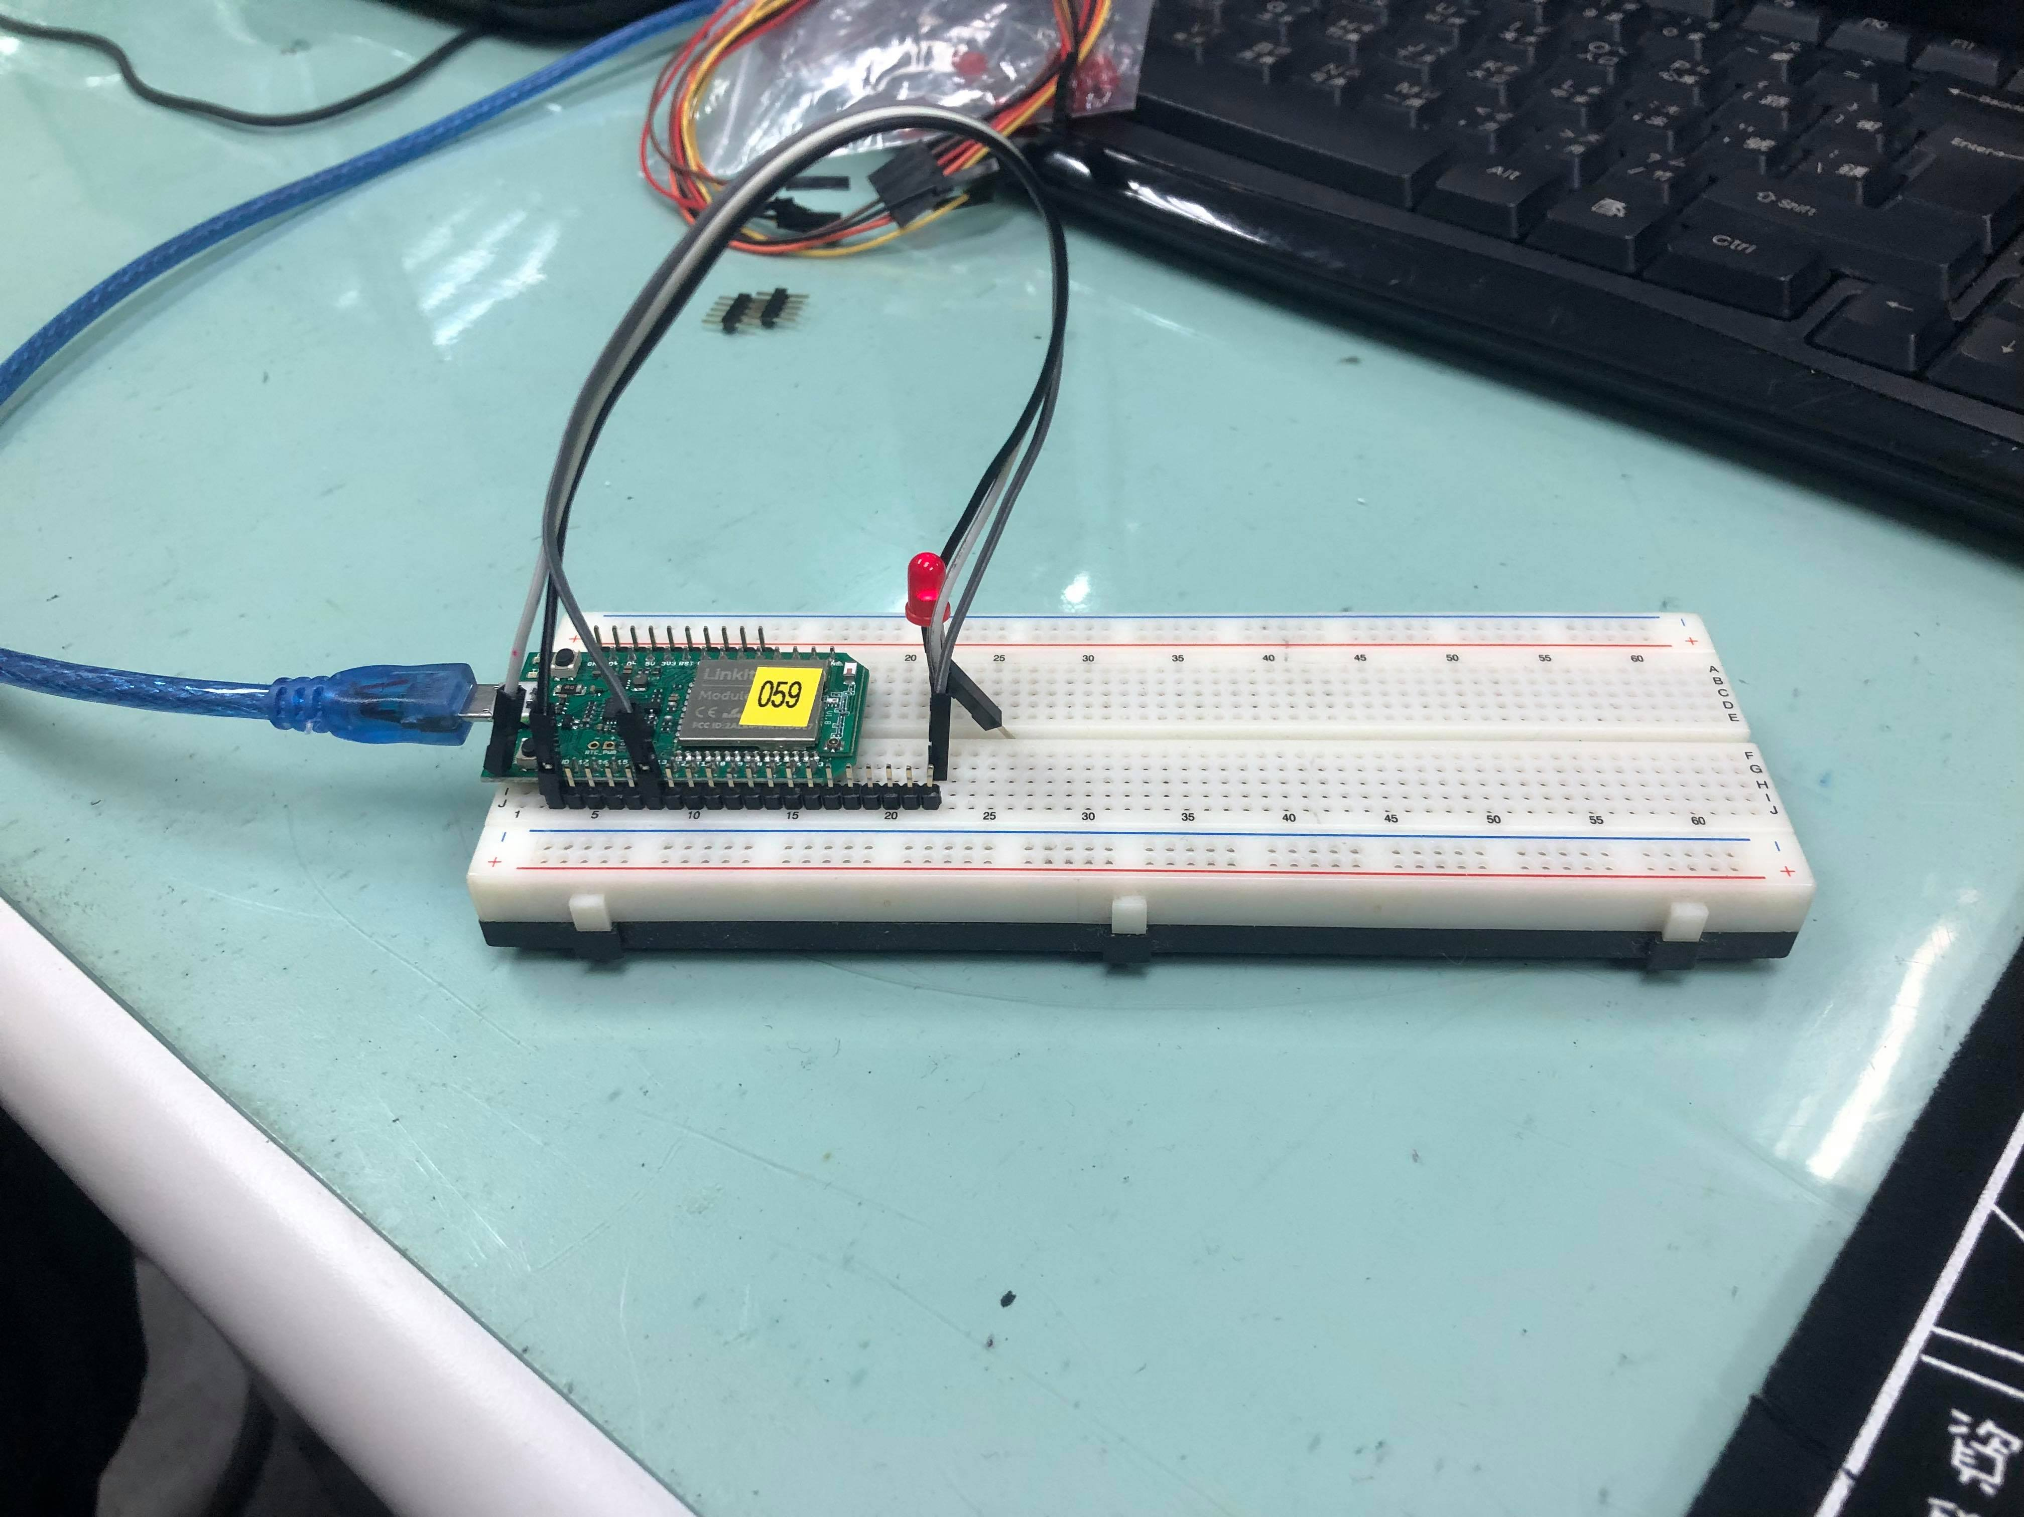

Check2 :
實際電壓(V) | AnalogRead讀值 | 推測電壓(V)
0 | 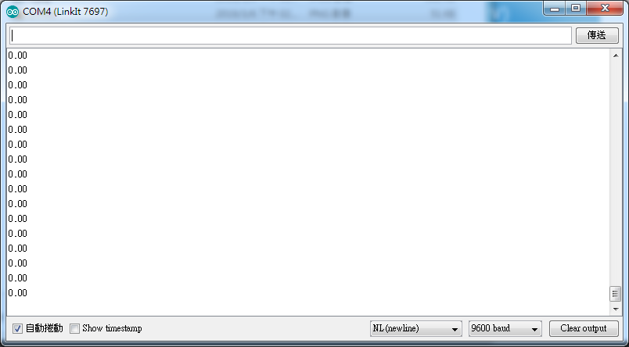 | 0
0.5 | 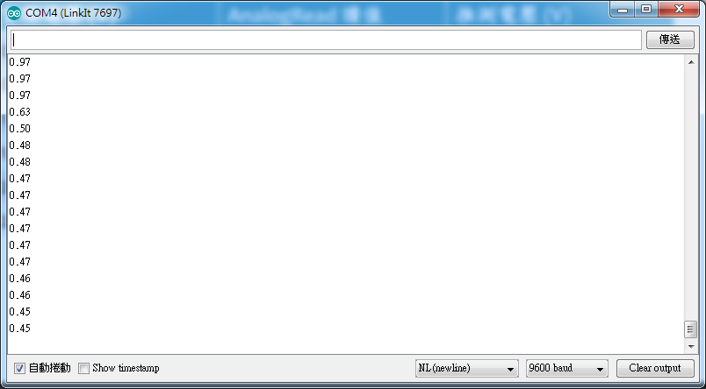 | 0.5
1 | 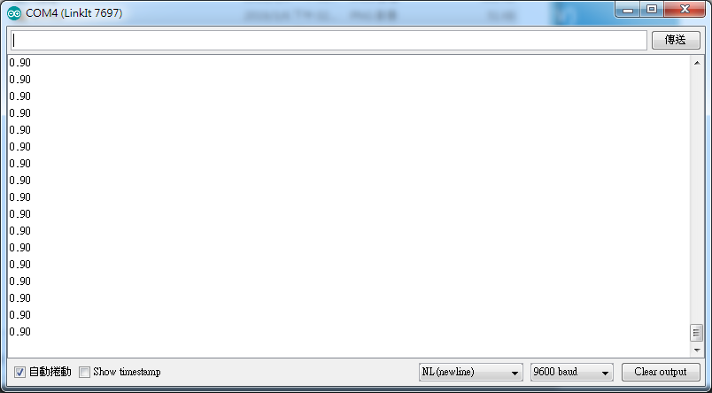 | 1
1.5 | 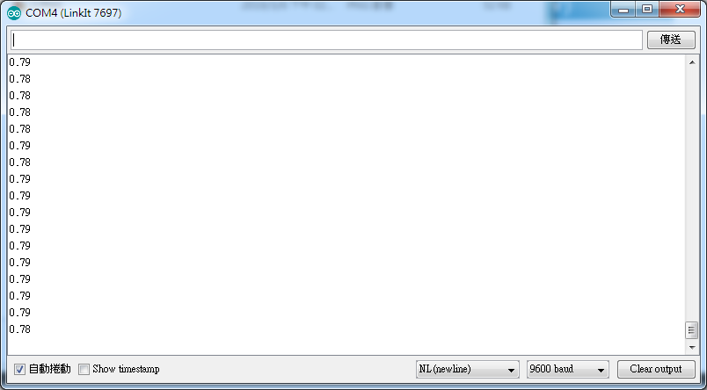 | 1.5
2 | 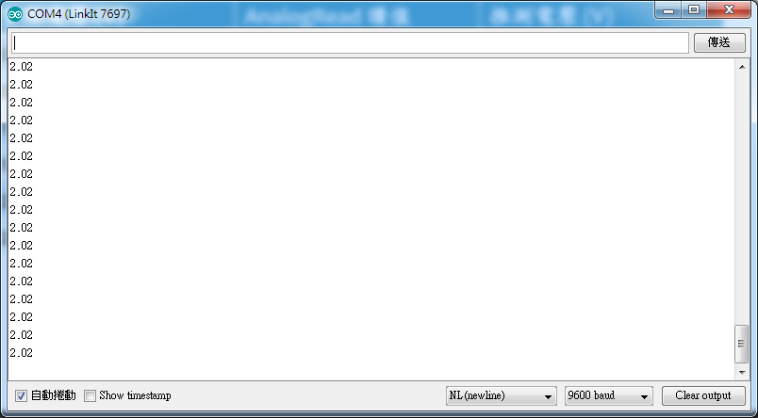 | 2
2.5 | 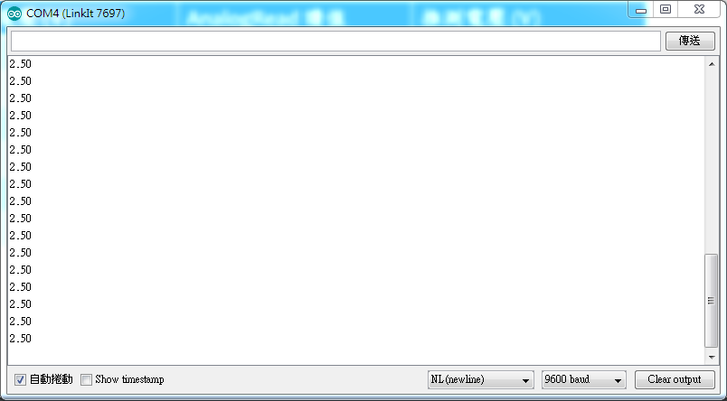 | 2.5

Check3 :
電阻實測值(KΩ) | AnalogRead | 計算電壓 | 計算電阻 | SerialMonitor
20.1 | 73 | 0.05 | 9.81 | 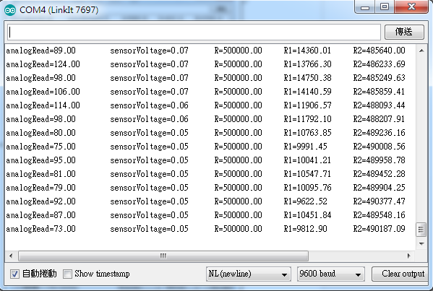
61.1 | 419 | 0.25 | 49.88 | 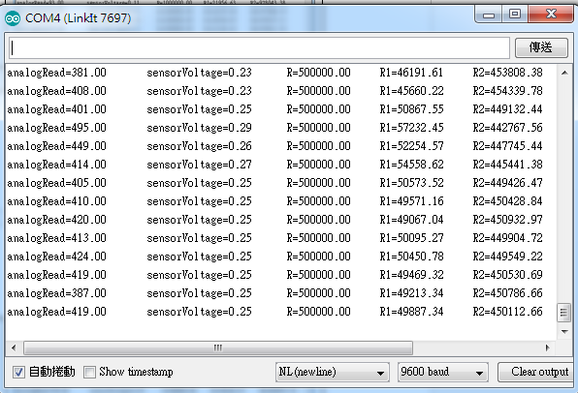
99.32 | 761 | 0.47 | 93.87 | 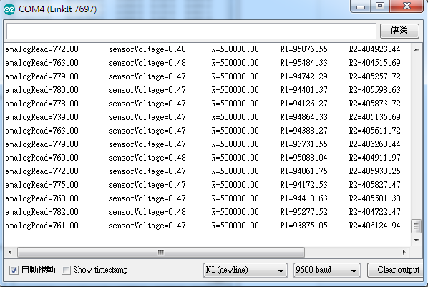
201.98 | 1569 | 0.96 | 192.1 | 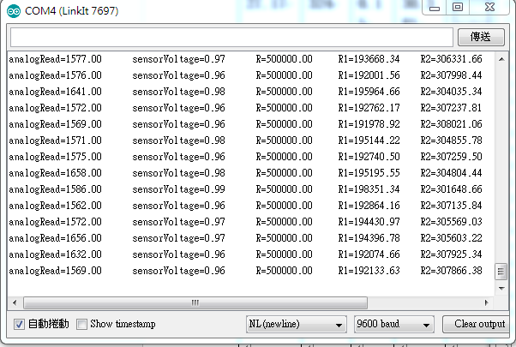
296.47 | 2443 | 1.49 | 296.7 | 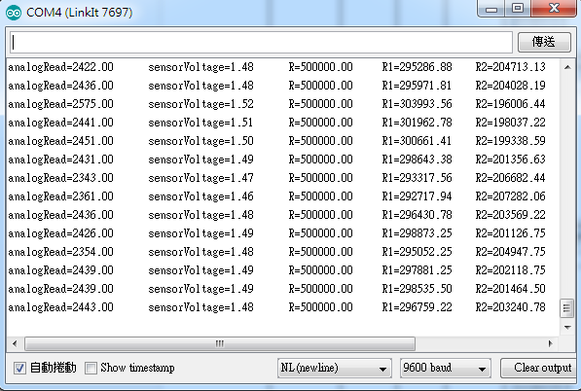
501.3 | 4021 | 2.45 | 489.5 | 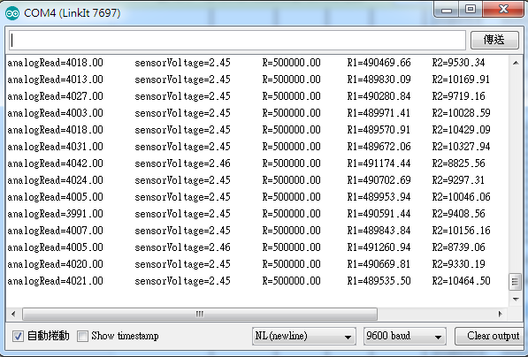

Check4 :
AnalogRead讀值 | 推測電壓 | 推測電阻值KΩ | SerialMonitor輸出
4095 | 2.5 | 500.0 | 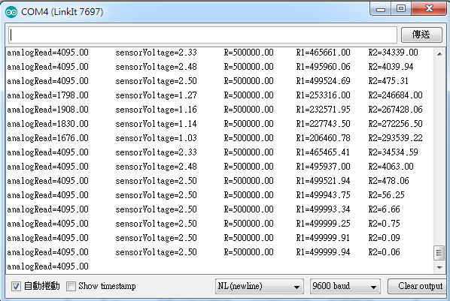
2820 | 1.69 | 337.4 | 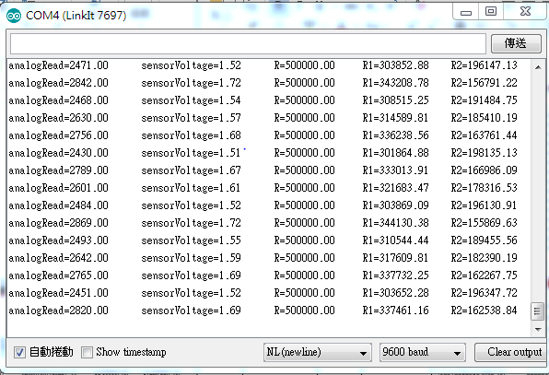
2035 | 1.21 | 242.2 | 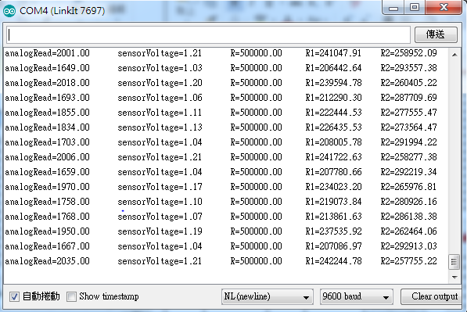
1002 | 0.61 | 121.9 | 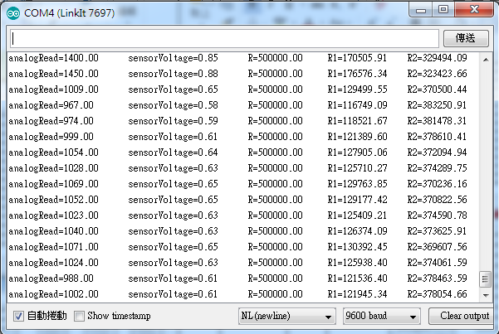
99 | 0.06 | 12.09 | 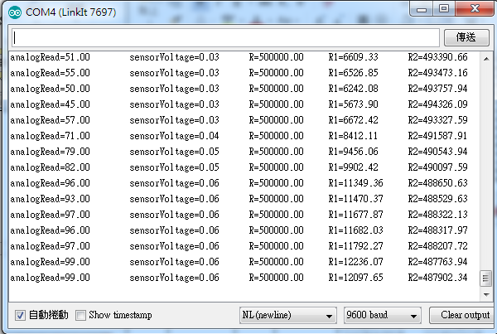

- 心得討論
前兩個挺順利的，第三個做不出來，不過幾個禮拜後倒是做出來了。
- 修正電路圖
- 修正程式碼

