Minimum depth of tree

Column Title name in Excel

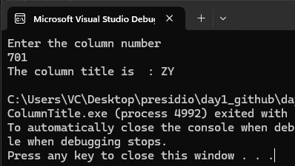

Cycle in Linked List

