

Site Readiness Guide

October 2017

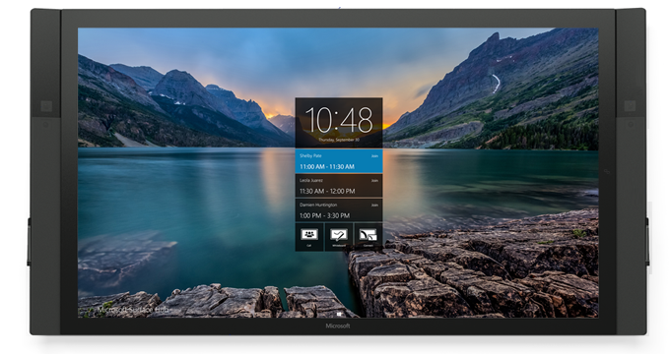

Copyright

This document is provided "as-is." Information and views expressed in this document, including URL and other Internet website references, may change without notice.

This document does not provide you with any legal rights to any intellectual property in any Microsoft product. You may copy and use this document for your internal, reference purposes.

© 2017 Microsoft. All rights reserved.

Contents

Is my site ready? 1

Steps to readiness 1

Site readiness topics 1

Site readiness planning 2

When Surface Hub arrives 2

Mounting and setup 4

Hardware considerations 5

The Connect experience 6

Technical information 9

Surface Hub burn in and image retention 10

55” Microsoft Surface Hub technical information 11

84” Microsoft Surface Hub technical information 19

|  |  |  |
| --- | --- | --- |
| Warning Icons | | |
| Attention: Caution |  | This symbol identifies safety and health messages which must be followed to avoid possible harm. |
| Warning: Hazardous voltage |  | Dangerous: Do not touch. |
| Read instructions |  | Read instruction manual for safety and health related information. |
| Do not open |  | No user-serviceable parts inside. |

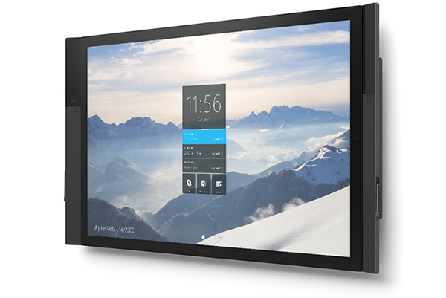

## Is my site ready?

Use this Site Readiness Guide to help plan your Surface Hub installation. In this guide, you’ll find:

* Site readiness topics
* Detailed hardware specifications on power, ports, and cables
* Recommendations for moving and storage
* Links to guidance on:
  + Unpacking
  + Mounting

## Steps to readiness

Review this list of topics to make sure you are ready for your new Surface Hub.

### Site readiness topics

1. When Surface Hub arrives at the loading dock.
2. Conference space requirements:
   1. Power requirements
   2. Data and other connections
3. Surface Hub Connect requirements:
   1. Wireless Connect
   2. Wired Connect
   3. Replacement PC
4. Fitting Surface Hub into the elevator, stairwells, hallways, doorways, etc.

## Site readiness planning

### When Surface Hub arrives

Surface Hub is large and heavy, so let Receiving know when it will arrive and what they should do to handle it safely. For details on the packing weights and other specifications, see Surface Hub burn in and image retention

Surface Hub can be used continuously for up to 18 hours a day. Nonetheless, Surface Hub is optimized for efficiency. To extend the life of the device, Surface Hub uses smart sensors to turn off the LCD when it detects that no one is near it, so there is no need to turn it off at the end of the day. If the unit is installed in a 24-hour traffic situation, the sensors can be disabled so that it can comply with the 18-hours-per day requirement. The prolonged display of a video signal may cause burned-in or image retention to occur on the LED screen.

55” Microsoft Surface Hub technical information or 84” Microsoft Surface Hub technical information. Consider the following:

* Wait to unpack Surface Hub from the shipping container until you’ve moved it to the conference area where you plan to install it.
* Make sure your loading dock can accept a shipment on a pallet and hold it securely until it can be installed.
* Check for local labor union rules that would require you to use union labor to unload or move Surface Hub.
* Do not leave Surface Hub in a hot or humid environment. As with any computer-based or display equipment, heat and humidity can damage Surface Hub. The recommended storage temperatures are 32°F to 95°F with a relative humidity of less than 70 percent.

#### Moving Surface Hub

Before you move Surface Hub, make sure that all the doorways, thresholds, hallways, and elevators are big enough to accommodate it. For information on the dimensions and weight of your Surface Hub in its shipping container, see Surface Hub burn in and image retention

Surface Hub can be used continuously for up to 18 hours a day. Nonetheless, Surface Hub is optimized for efficiency. To extend the life of the device, Surface Hub uses smart sensors to turn off the LCD when it detects that no one is near it, so there is no need to turn it off at the end of the day. If the unit is installed in a 24-hour traffic situation, the sensors can be disabled so that it can comply with the 18-hours-per day requirement. The prolonged display of a video signal may cause burned-in or image retention to occur on the LED screen.

55” Microsoft Surface Hub technical information or 84” Microsoft Surface Hub technical information.

#### Unpacking Surface Hub

For unpacking information, refer to the unpacking guide included in the shipping container. You can open the unpacking instructions before you open the shipping container. These instructions can also be found here: <http://www.microsoft.com/surface/support/surface-hub>.

 ***Important*** Retain and store all Surface Hub shipping materials—including the pallet, container, and screws—in case you need to ship Surface Hub to a new location or send it for repairs. For the 84” Surface Hub, retain the lifting handles.

#### Lifting Surface Hub

The 55” Surface Hub **requires two people** to safely lift and mount. The 84” Surface Hub **requires four people** to safely lift and mount. Those assisting must be able to lift 70 pounds to waist height.

Review the unpacking and mounting guide for details on lifting Surface Hub. You can find it at <http://www.microsoft.com/surface/support/surface-hub>.

### Mounting and setup

See the Technical information section, or your [mounting guide](http://www.microsoft.com/surface/support/surface-hub) at <http://www.microsoft.com/surface/support/surface-hub>, for detailed instructions.

There are three ways to mount your Surface Hub:

**Wall mount**: Lets you permanently hang Surface Hub on a conference space wall.

**Floor support mount**: Supports Surface Hub on the floor while it is permanently anchored to a conference space wall.

**Rolling stand**: Supports Surface Hub and lets you move it to other conference locations.

For links to guides that provide details about each mounting method, including building requirements, see <http://www.microsoft.com/surface/support/surface-hub>.

#### Considerations when choosing the location for the Surface Hub

The room needs to be large enough to provide good viewing angles, but small enough for the microphones to pick up clear signals from the people in the room. Most rooms that are about 22 feet (seven meters) long will provide a good meeting experience.

In the conference area, mount Surface Hub where:

* Everyone in the room can see it.
* People can reach all four edges of the touchscreen.
* The screen is not in direct sunlight, which could affect viewing or damage the screen.
* Ventilation openings are not blocked.
* Microphones are not affected by noise sources, such as fans or vents.

You can find more details in the Technical information section.

For cleaning, care, and safety information, see the mounting guides and user guide at <http://www.microsoft.com/surface/support/surface-hub>.

### Hardware considerations

Surface Hub arrives with:

* Two Microsoft Surface Hub pens
* A Microsoft wireless keyboard, customized for Surface Hub.
* A 9-foot NEMA 5-15P (US Standard) to C13 power cable

You’ll need to provide:

* Cat-5e or Cat-6 network cables
* Display cables (*optional*)
* Audio cable (*optional*)
* Type A to B USB cable (*optional*)

**Note**: For details about cable ports, see the Technical information section. For details about cables, see Wired Connect.

#### System hardware

Microsoft Surface Hub has an internal PC and does not require an external computer system.

#### Power requirements

For power recommendations, see Surface Hub burn in and image retention

Surface Hub can be used continuously for up to 18 hours a day. Nonetheless, Surface Hub is optimized for efficiency. To extend the life of the device, Surface Hub uses smart sensors to turn off the LCD when it detects that no one is near it, so there is no need to turn it off at the end of the day. If the unit is installed in a 24-hour traffic situation, the sensors can be disabled so that it can comply with the 18-hours-per day requirement. The prolonged display of a video signal may cause burned-in or image retention to occur on the LED screen.

55” Microsoft Surface Hub technical information or 84” Microsoft Surface Hub technical information.

For power cable safety warnings, see the mounting guides at <http://www.microsoft.com/surface/support/surface-hub>.

#### Data and other connections

To use Surface Hub, you need an active Ethernet port and a standard power outlet. In addition, you may want to:

* Equip the conference table for Wired Connect
* Expand the wall outlet configuration to include:
  + Additional AC outlets
  + Ethernet ports
  + Audio ports
  + Video ports (DisplayPort, HDMI, VGA, etc.)

### The Connect experience

Connect lets people project their laptop, tablet, or phone to the Surface Hub screen. Connect allows wireless or wired connection types:

#### Wireless Connect

Since Wireless Connect is based on Miracast, you don’t need cables or additional setup planning to use it. Your users can load Miracast on most Miracast-enabled Windows 8.1 and Windows 10 devices. Then they can project their display from their computer or phone to the Surface Hub screen.

#### Wired Connect

With Wired Connect, a cable transmits information from computers, tablets, or phones to Surface Hub. There are three video cable options, and they all use the same USB 2.0 cable. The cable bundle can include one or all of these connection options.

* **DisplayPort** (DisplayPort cable + USB 2.0 cable)
* **HDMI** (HDMI cable + USB 2.0 cable)
* **VGA** (VGA cable + 3.5mm audio cable + USB 2.0 cable)

For example, to provide audio, video, and touchback capability to all three video options, your Wired Connect cable bundle must include:

* A DisplayPort cable
* An HDMI cable
* A VGA cable
* A USB 2.0 cable
* A 3.5mm cable

When you create your Wired Connect cable bundles, check the Technical information section for specific technical and physical details and port locations for each type of Surface Hub. Make the cables long enough to reach from Surface Hub to where the presenter will sit or stand.

For details on Touchback and Inkback, see the user guide at <http://www.microsoft.com/surface/support/surface-hub>.

#### Replacement PC

To use a replacement PC, use the replacement PC ports (see the illustration Bottom view of 55” Surface Hub or Bottom view of 84” Surface Hub).

In replacement PC mode, Surface Hub’s onboard computer is disabled, and Surface Hub receives input from an external computer that’s connected to the replacement PC ports. This computer will be the replacement PC.

1. Before starting, shut down Surface Hub.
2. Connect the cables from Surface Hub’s replacement PC ports to the replacement PC.
3. Set the mode switch to **Replacement PC**. The mode switch is located next to the replacement PC ports.

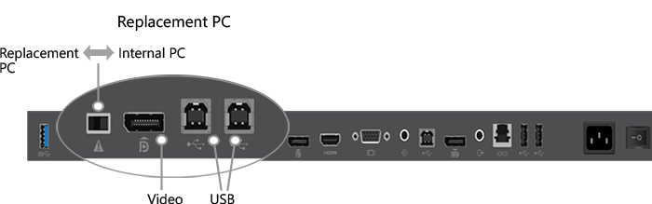

Replacement PC switch and ports on 55” Surface Hub

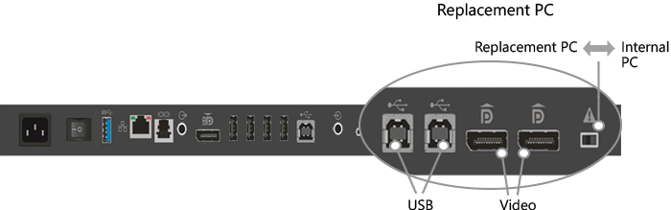

Replacement PC switch and ports on 84” Surface Hub

1. Restart Surface Hub.

You can reverse this by using the same mode switch. Slide the switch back and reboot Surface Hub. The Surface Hub will now boot from the onboard computer.

# Technical information

Detailed technical details by Surface Hub size (55” and 84”).

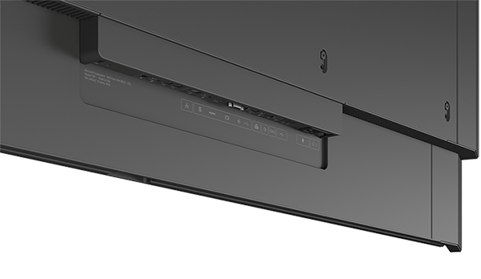

## 

## Surface Hub burn in and image retention

Surface Hub can be used continuously for up to 18 hours a day. Nonetheless, Surface Hub is optimized for efficiency. To extend the life of the device, Surface Hub uses smart sensors to turn off the LCD when it detects that no one is near it, so there is no need to turn it off at the end of the day. If the unit is installed in a 24-hour traffic situation, the sensors can be disabled so that it can comply with the 18-hours-per day requirement. The prolonged display of a video signal may cause burned-in or image retention to occur on the LED screen.

## 55” Microsoft Surface Hub technical information

Replacement PC Connections on 55” Microsoft Surface Hub

|  |  |  |
| --- | --- | --- |
| Connector, Location | Label | Description |
| Switch, Bottom I/O |  | Switches the function between using internal PC or external PC. |
| Display Port, Bottom I/O |  | Provides input for replacement PC (normally covered). |
| USB type B, Bottom I/O |  | Provides USB connection for replacement PC to internal peripherals (normally covered). |
| USB type B, Bottom I/O |  | Provides USB connection for integrated hub (normally covered). |

Wired Connect Connections on 55” Microsoft Surface Hub

|  |  |  |
| --- | --- | --- |
| Connector, Location | Label | Description |
| Display Port, Bottom I/O |  | Provides input for Wired Connect PC. |
| HDMI, Bottom I/O |  | Provides HDMI input for Wired Connect PC. |
| VGA, Bottom I/O |  | Provides VGA input for Wired Connect PC. |
| 3.5mm, Bottom I/O |  | Provides analog audio input. |
| USB type B, Bottom I/O |  | Provides USB connection for video ingest touchback. |

Additional Connections on 55” Microsoft Surface Hub

| Connector, Location | Label | Description |
| --- | --- | --- |
| USB type A, Side I/O |  | Provides 1 USB 3.0 connection for USB devices. Wake-on USB capable. |
| USB type A, Bottom I/O w/blue insulator |  | Provides USB 3.0 connection. |
| 3.5mm, Bottom I/O |  | Provides analog audio out. |
| Display Port, Bottom I/O |  | Provides mirrored video out function to another display. |
| IEC/EN60320-C13 receptacle with hard switch | http://vstfpg04:8080/tfs/Consol_04_TPC1/_api/_wit/DownloadAttachment?fileName=EN60320-C13-receptacle-24.png&attachmentId=81651&contentOnly=true&__v=5 | Provides AC input and compliance with EU power requirements. |
| RJ45. Bottom I/O |  | Connects to Ethernet. |
| RJ11, Bottom I/O |  | Connects to room control systems. |

Measurements for 55” Microsoft Surface Hub

|  |  |
| --- | --- |
| Mounting features | 4X VESA standard, 400mm x 400mm plus 1150mm x 400mm pattern, 8X M6 X 1.0 threaded mounting locations |
| Display height from floor | Recommended height of 55 inches (139.7 cm) to center of screen |
| Product weight | Approx. 105 lb. (47.6 kg) without accessories |
| Product shipping weight | Approx. 150 lb. (68 kg) |
| Product dimensions HxWxD | 31.63 x 59.62 x 3.2 inches (80.34 x 151.44 x 8.14 cm) |
| Product shipping dimensions HxWxD | 43 x 65 x 20 inches (109 x 165 x 51 cm) |
| Product thickness | Touch surface to mounting surface: ≤ 2.4 inches (6 cm) |
| Orientation | Landscape only. Display cannot be used in a portrait orientation. |
| BTU | 1706 BTU/h |
| Image resolution | 1920 x 1080 |
| Frame rate | 120Hz |
| EDID preferred timing, replacement PC | 1920 x 1080, 120Hz vertical refresh |
| EDID preferred timing, Wired Connect | 1920 x 1080, 60Hz vertical refresh |
| Input voltage (50/60Hz) | 110/230v nominal, 90-265v max |
| Input power, operating | 500W max |
| Input power, standby | 5W nominal |

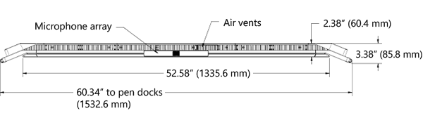

Top view of 55” Surface Hub

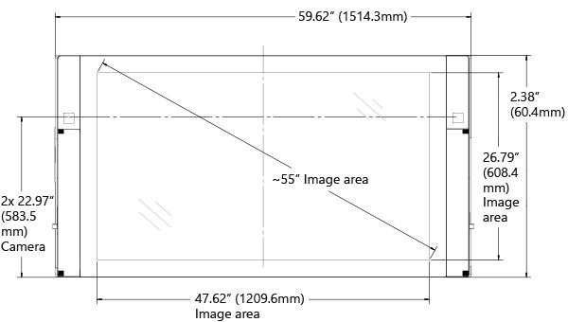

Front view of 55” Surface Hub

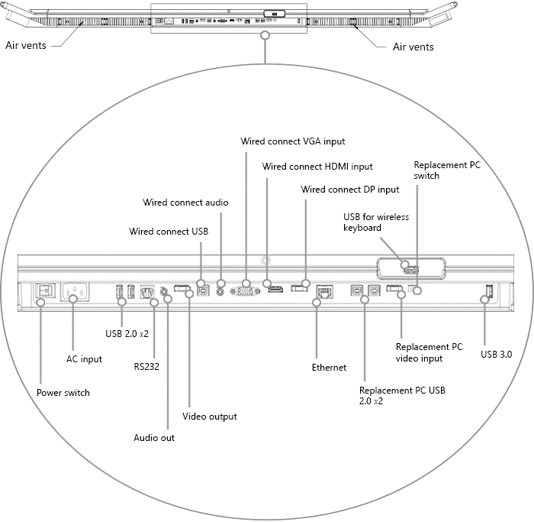

Bottom view of 55” Surface Hub



Replacement PC ports and switch on bottom of 55” Surface Hub

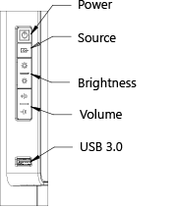

Keypad on right side of 55” Surface Hub

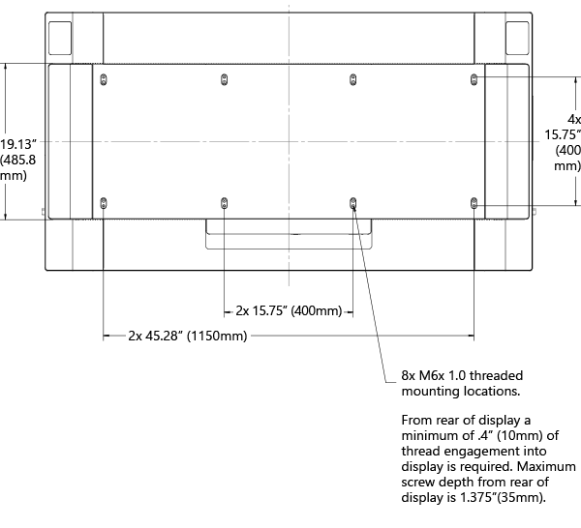

Rear view of 55” Surface Hub

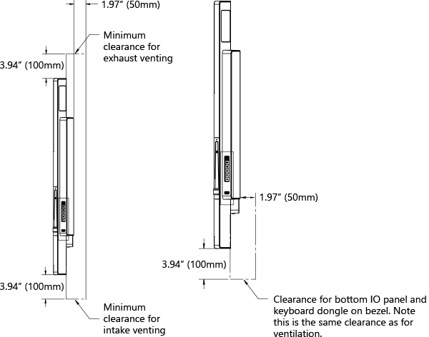

Clearances for 55” Surface Hub

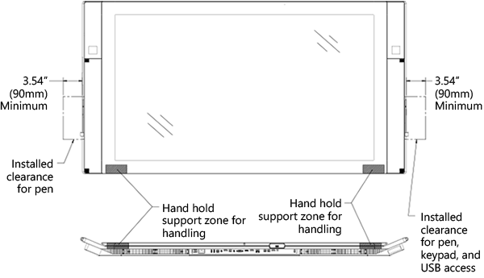

Front and bottom handholds and clearances for 55” Surface Hub

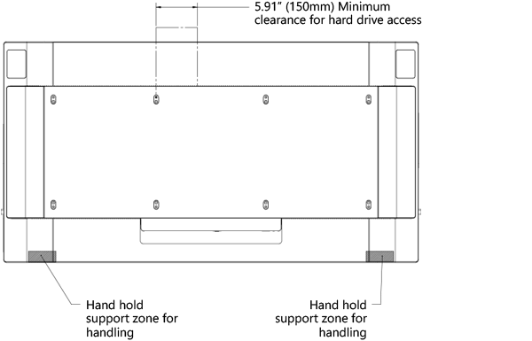

Rear handholds and clearances for 55” Surface Hub

## 84” Microsoft Surface Hub technical information

Replacement PC Connections on 84” Microsoft Surface Hub

|  |  |  |  |
| --- | --- | --- | --- |
| Connector, Location | Label | Description | |
| Switch, Bottom I/O |  | Switches the function between using internal PC or external PC. |
| Display Port, Bottom I/O |  | Provides input for replacement PC (normally covered). |
| Display Port, Bottom I/O |  | Provides 2nd input for replacement PC (normally covered). |
| USB type B, Bottom I/O |  | Provides USB connection for replacement PC to internal peripherals (normally covered). |
| USB type B, Bottom I/O |  | Provides USB connection for integrated hub (normally covered). |

Wired Connect Connections on 84” Microsoft Surface Hub

|  |  |  |  |
| --- | --- | --- | --- |
| Connector, Location | Label | Description | |
| Display Port, Bottom I/O |  | Provides input for Wired Connect PC. |
| HDMI, Bottom I/O |  | Provides HDMI input for Wired Connect PC. |
| VGA, Bottom I/O |  | Provides VGA input for Wired Connect PC. |
| 3.5mm, Bottom I/O |  | Provides analog audio input. |
| USB type B, Bottom I/O |  | Provides USB connection for video ingest touchback. |

Additional Connections on 84” Microsoft Surface Hub

|  |  |  |  |
| --- | --- | --- | --- |
| Connector, Location | Label | Description | |
| USB type A, Side I/O |  | Provides 1 USB 3.0 connection for USB devices. Wake-on USB capable. |
| USB type A, Bottom I/O w/blue insulator |  | Provides USB 3.0 connection. |
| 3.5mm, Bottom I/O |  | Provides analog audio out. |
| Display Port, Bottom I/O |  | Provides mirrored video out function to another display. |
| IEC/EN60320-C13 receptacle with hard switch | http://vstfpg04:8080/tfs/Consol_04_TPC1/_api/_wit/DownloadAttachment?fileName=EN60320-C13-receptacle-24.png&attachmentId=81651&contentOnly=true&__v=5 | Provides AC input and compliance with EU power requirements. |
| RJ45. Bottom I/O |  | Connects to Ethernet. |
| RJ11, Bottom I/O |  | Connects to room control systems. |

Measurements for 84” Microsoft Surface Hub

|  |  |
| --- | --- |
| Mounting features | 4X VESA standard, 1200mm x 600mm pattern, 8X M8 X 1.25 threaded mounting locations |
| Display height from floor | Recommended height of 54 inches (139.7 cm) to center of screen |
| Product weight | Approx. 280 lb. (127 kg.) |
| Product shipping weight | Approx. 580 lb. (263 kg.) |
| Product dimensions HxWxD | 46 x 86.9 x 4.1 inches (116.8 x 220.6 x 10.4 cm) |
| Product shipping dimensions HxWxD | 66.14 x 88.19 x 24.4 inches (168 x 224 x 62 cm) |
| Product thickness | Touch surface to mounting surface: ≤ 3.1 inches (7.8 cm) |
| Orientation | Landscape only. Display cannot be used in a portrait orientation. |
| BTU | 3070.8 BTU/h |
| Image resolution | 3840 x 2160 |
| Frame rate | 120Hz |
| EDID preferred timing, replacement PC | 3840 x 2140, 120Hz vertical refresh |
| EDID preferred timing, wired connect | 1920 x 1080, 60Hz vertical refresh |
| Input voltage (50/60Hz) | 110/230v nominal, 90-265v max |
| Input power, operating | 900W max |
| Input power, standby | 5W nominal, 1-10W max |

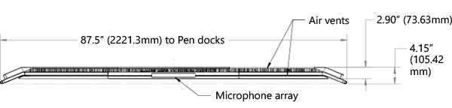

Top view of 84” Surface Hub

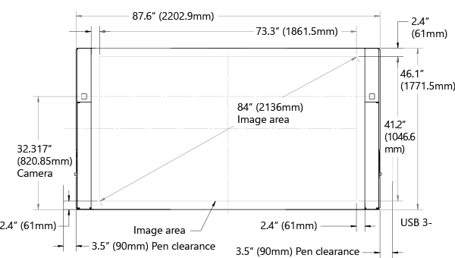

Front view of 84” Surface Hub

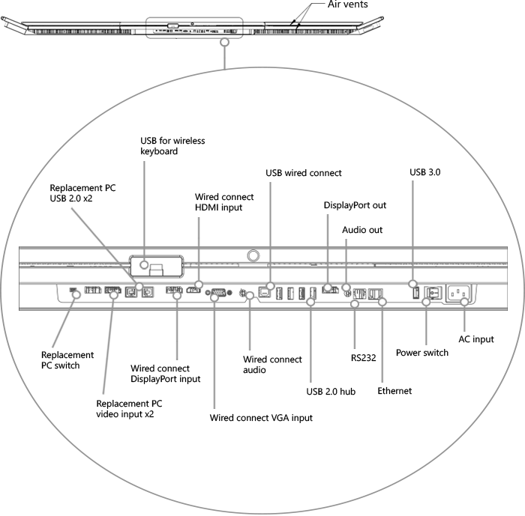

Bottom view of 84” Surface Hub



Replacement PC ports and switch on bottom of 84” Surface Hub

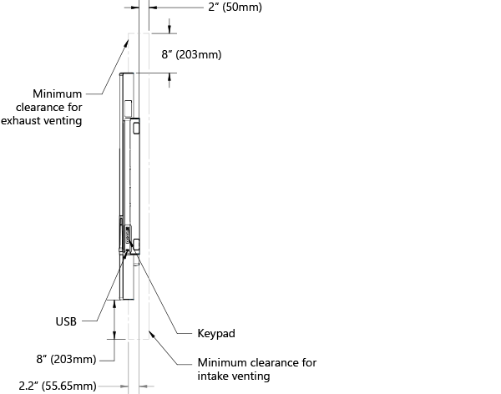

Clearances for 84” Surface Hub

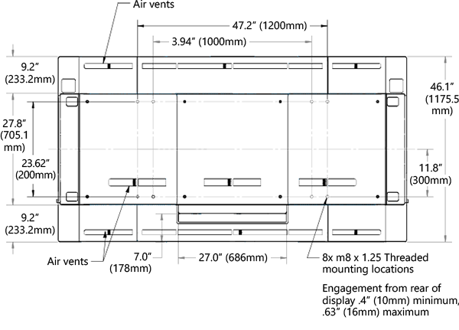

Rear view of 84” Surface Hub

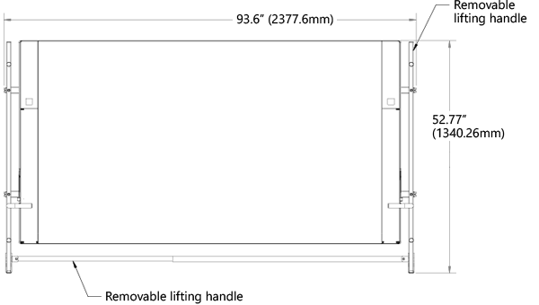

Removable lifting handles on 84” Surface Hub

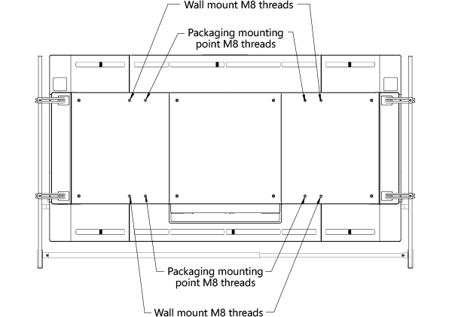

Wall mount threads on back of 84” Surface Hub

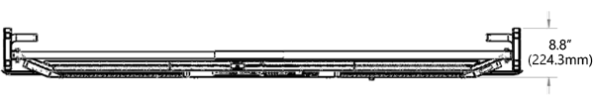

Lifting handles in top view of 84” Surface Hub

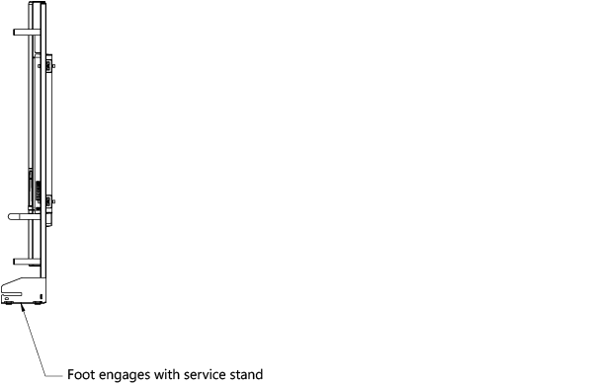

Side view of 84” Surface Hub