**Workflow Modeling and Process Management**

**SS 2014**

**Project Proposal**

Group 02

Agatic Leon (1228015)

Becirovic Sanjin (1329461)

Gusljesevic Ivan (1029600)

Seferovic Edvin (0325189)

Skakala Martin (1128233)

**Business requirements**

The team will implement a workflow application that enables an automated processing of flight aggregation from different sources, which are successively transformed into an email newsletter or posted to social networks. The requirements for the application are:

* Polling data from different sources and in different data formats
* Transformation and filtration of the data for further marketing purposes
* Enrichment of the data with additional information
* Storage of the data for future administration purposes
* Generation of the newsletter and delivery to subscribers
* Posting special offers on social networks

**Business flow description**

The BPMN diagram corresponding to this section can be found on the last page. The main goal of the application is to automatise standard workflow of scanning flight offers from various airlines. The entire workflow has been structured into three subprocesses for better understanding. At the beginning of the first phase the application polls data files from different airlines. Each of the airlines uses different interface and delivers the data files in distinct file format, hence they need to be preprocessed individually. Our application offers three interfaces, namly FTP, HTTP and Mail-Attachment that can be used to poll data from airlines. In case of FTP and Mail-Attachment we support XML and CSV data formats. The HTTP interface is, however, exclusively designed to support JSON objects only. If multiple attachments are received, the system first splits them into single files and then validates them in respect to special characters so that the the data will be displayed properly when posted or transformed into a newsletter at the end of the workflow. Finally, they are all transformed into an XML file. This files are then refactored into single messages each containing exactly one flight offer. All of these messages are put into a queue where they wait for further processing.

The second phase of our workflow starts consuming messages from the previous queue and filters only the information that are relevant for business. The business constraints for this process will be pulled from a DB. In the next step the system accesses a DB from which it downloads additional information about accommodation in the flight destination and enriches the message with it. The message are then archived in DB while pushing to next queue.

The last phase is mainly concerned with marketing and promotion of the data. It pulls the messages in certain time periods and processes them in two parallel branches. In first case the messages are aggregated by departure airport and enriched with a subscriber’s email address based on his preferences. Then the message are transformed into HTML newsletters that are send out to assigned subscribers in the final step. The second parallel branch sorts the messages according to their prices and randomly picks the two best offers of all. These are then posted on Facebook and Twitter.

**Camel workflow description**

**Offer Gathering**

*FTP route*

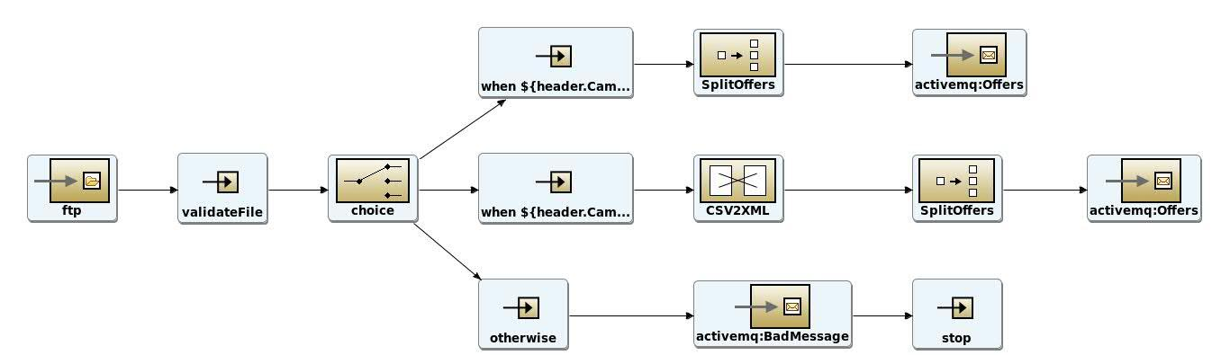

*Mail route*

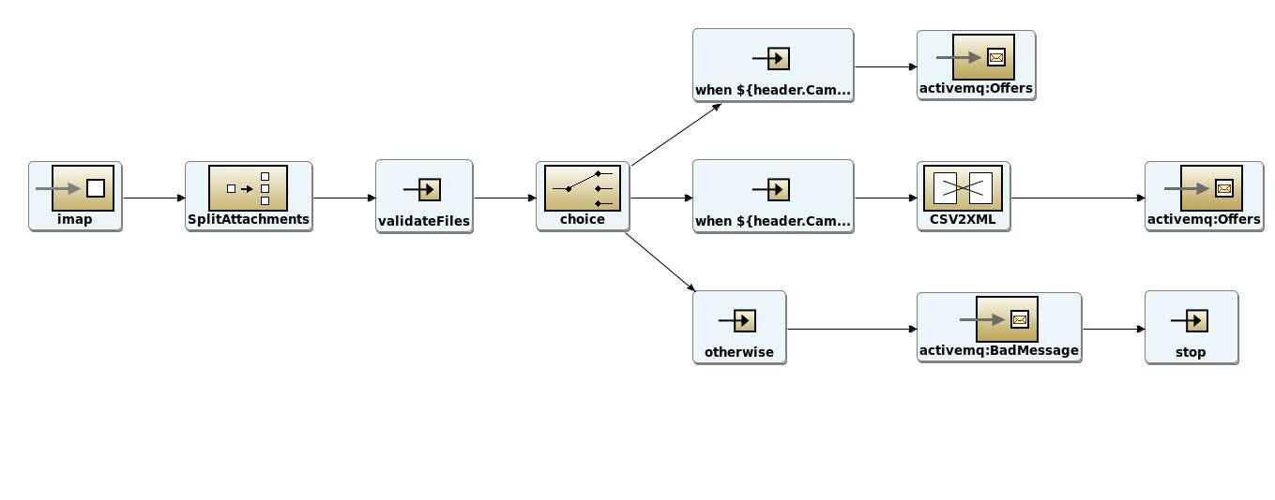

*HTTP route*

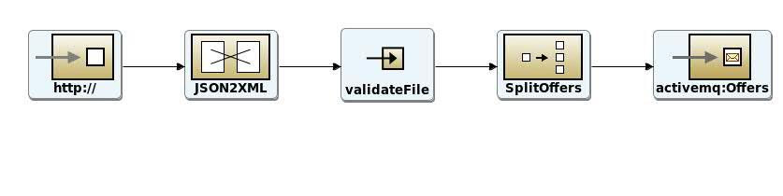

***Offer Processing***

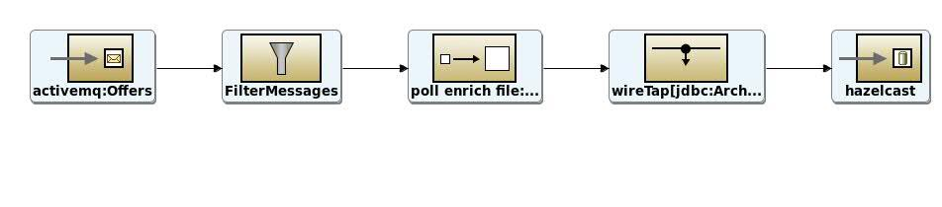

**Offer Promotion and Marketing**

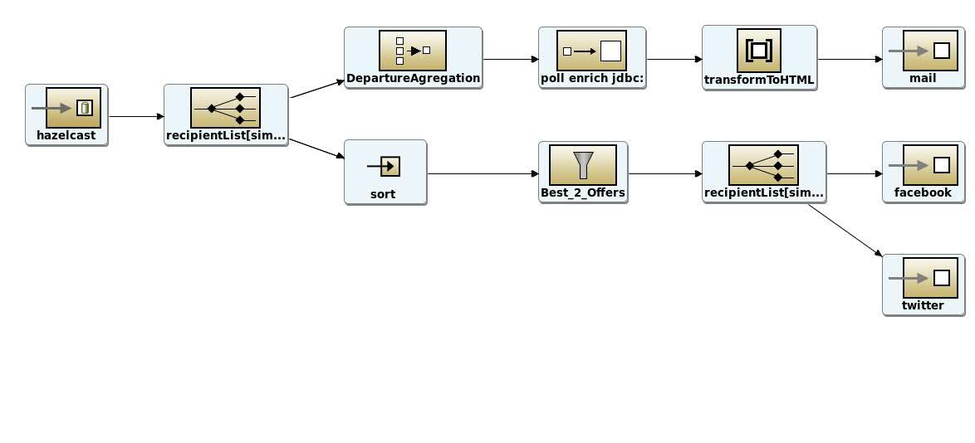

**Enterprise Integration Patterns (11)**

* *Message Routing (4)*
  + Message Filter (<http://camel.apache.org/message-filter.html>)
  + Aggregator (<http://camel.apache.org/aggregator2.html>)
  + Splitter (<http://camel.apache.org/splitter.html>)
  + Multicast (http://camel.apache.org/multicast.html)
* *System Management (1)*
  + Wire Tap (http://camel.apache.org/wire-tap.html)
* *Message Transformation (3)*
  + Content Enricher (http://camel.apache.org/content-enricher.html)
  + Content Filter (http://camel.apache.org/content-filter.html)
  + Validation (http://camel.apache.org/validate.html)
* *Other EIPs (3)*
  + Polling Consumer (http://camel.apache.org/polling-consumer.html)
  + Message Translator (http://camel.apache.org/message-translator.html)
  + Message Endpoint (http://camel.apache.org/message-endpoint.html)

**Components (9)**

|  |  |
| --- | --- |
| * Mail (<http://camel.apache.org/mail.html>)   + IMAP   + SMTP * FTP * HTTP | * Twitter / Facebook * Mock * ActiveMQ * Hazelcast * JDBC |

**Beans / Processors (8)**

* Message Translation Bean (CSV2XML, Mail, Twitter, Facebook)
* Message Filtering Bean (Content Filter)
* Message Enrichment Bean (Subscriber List, Sorting)
* Archive Bean (Wire Trap)

**Workload**

* Project Proposal (5 hours/Student)
* Meetings and Management Reviews (6 hours/Student)
  + 3x Meeting with Tutor: (3 hours/Student)
  + 3x Management Review: (3 hours/Student)
* Acquisition of Technology Knowledge (14 hours/Student)
  + Research (5 hours/Student)
  + Praxis (5 hours/Student)
  + Testing for the purpose of the project (4 hours/Student)
* Implementation: (20 hours/Student)
* Quality Management/Testing: (5 hours/Student)

