

Fakultät für Informatik

Lehrstuhl Robotic und Embedded System

**HW/SW Co-Design with a Lego Car**

**Final Project Documentation – Team Poorman’s Laser**

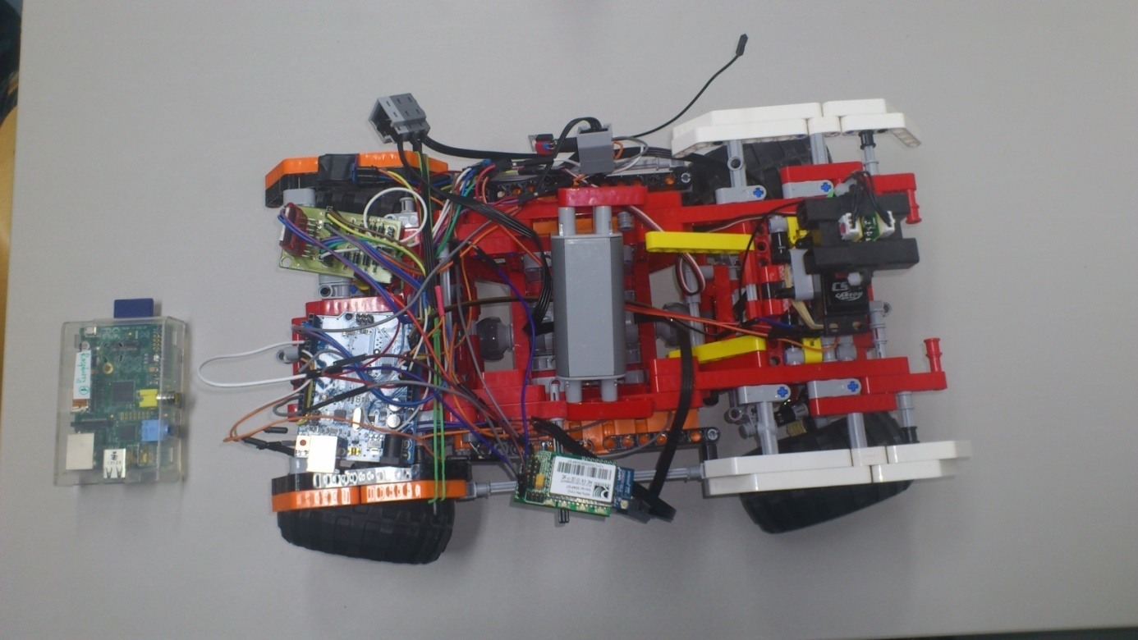

**Daniel Collazion – Juri Kuhn – Josef Stark – Thomas Sennebogen – Viet Tiep Do**

Table of Content

1. Introduction 3

1.1 Initial Situation 3

1.2 Something 3

2. Concept 5

3. Problem 5

4. Solution 5

5. Result 5

6. Experience 5

7. Conclusion 5

8. Appendix 7

# Introduction

## Initial Situation

dsafasdf

## Something

asdfasdf

# Concept

# Problem

# Solution

# Result

# Experience

# Conclusion

# Appendix

Arduino Code

Raspberry Code

Android Code

Sonst noch was?