Tên: Huỳnh Quốc Bảo

MSSS: 21107451

BÀI LÀM

Câu 1:

Câu 2:

Câu 3:

Câu 4:

Câu 5:

Câu 10:

Câu 11:

Câu 12:

Câu 13:

Câu 14:

Câu 15:

Câu 16:

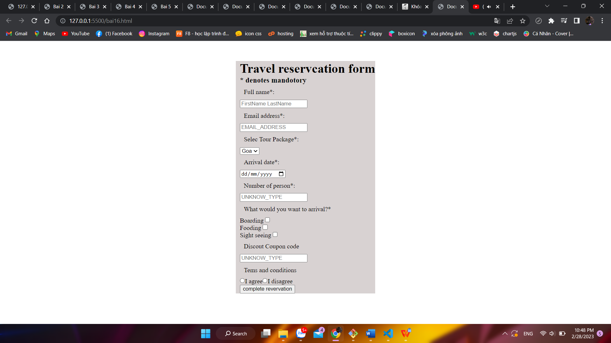

Câu 18:

