CUSTOMER CHURN PREDICTION USING DATA ANALYTICS

TEAM MEMBER

920821104006-S.APSARA JASMINE

PROJECTNAME: Customer churn prediction

INTRODUCTION

* Customer Churn prediction is a dynamic field that combines data analytics and machine learning to help businesses reduce customer attrition
* It empowers companies to take data driven actions ,ultimately fostering stronger customer relationships and sustained profitability
* Customer churn could happen for many different reasons,and churn analysis help to identify the right one ,opening up oppurtunities to implement effective retention strategies

Customer churn examples:

* Subscripton cancellation
* Suspending account
* Decreased activity for some time
* Non-renewal of a contract or service agreement
* Provider switch

Advanced machine learning techniques commonly used for customer churn prediction using data analytics

1.Ensemble learning:

* Random forest model: Random forest models combine multiple decision trees to reduce o verfitting and increase prediction accuracy
* Gradient boosting: Algorithms like XGboost,Light bgm,and catboost use gradient boosting to build powerful predictive models

2. Feature engineering

* Create new features that capture customer behavior,such as customer lifetime value,recency,frequency,and monetary value(RFM analysis)

3.Anamoly detection

* Identifying unusual customer behavior using techniques like isolation forests or one class SVMS

4.Time-series analysis:

* Analyzing historical customer data as a time series to detect temporal patterns in churn

5.Hyperparameter optimization

* Using techniques like Bayesian optimization or grid search to find the best parameters for your models

6.Transfer learning:

* Leveraging pre-trained models on related tasks,such as recommendation systems or customer segmentations,to enhance churn prediction

7.Model evaluation:

* Using advanced metrics like AUC-ROC,AUC-PR,or F1-score to assess model performance,especially when dealing with imbalanced datasets

8.Imbalanced data handling:

* Tecniques like oversampling,undersampling,or synthetic data geaneration to address class imbalance issues in churn prediction

9.Automl:

* Automated machine learning platforms can help automate the model selection and hyperparameter tuning process,making it easier to find the best model for the specific churn prediction problem

10.Recurrent neural networks(RNNs):

* RNNs are used for sequence modeling,making them suitable for churn prediction when dealing with time-series data

11.Data preprocessing:

* Data preprocessing involves cleaning and transforming data to make it suitable for analysis and this includes handling missing values,outliers,and feauture engineering

12.Feature selection:

Identifying the most relevant features is essential for accurate churn prediction and common features include customer lifetime value, usage patterns, and customer support interactions

CONTENT OF PROJECT

1.Dara source:

Churn prediction relies on data from various sources,including senior citizen,gender, techsupport, phoneservice, multiple lines, internet service and customer feedback

Dataset link : <https://www.kaggle.com/datasets/blastchar/telco-customer-churn>

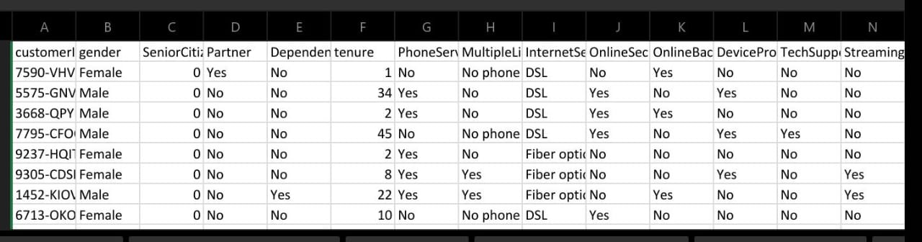

2. Data Preprocessing:

- Data preprocessing involves cleaning and transforming data to make it suitable for analysis. This includes handling missing values, outliers, and feature engineering.

3. Feature Selection:

- Identifying the most relevant features (customer attributes) is essential for accurate churn prediction. Common features include customer lifetime value, usage patterns, and customer support interactions.

4. Model Building:

- Machine learning models, such as logistic regression, decision trees, random forests, and neural networks, are used to build predictive models.

- Models are trained on historical data where the churn outcome is known.

5. Model Deployment:

- Once a reliable churn prediction model is developed, it can be integrated into operational systems for real-time predictions.

- The model might trigger actions, such as sending retention offers or alerts to customer support teams.

PROJECT CONCLUSION

* In phase 2 conclusion,the project on customer churn prediction using advanced machine learning techniques has yielded significant insights and practical outcomes
* Future work include incorporating these future work considerations will help maintain the effectiveness and relevance of your customer churn prediction system,ensuring its continued contribution to the success of your businesses