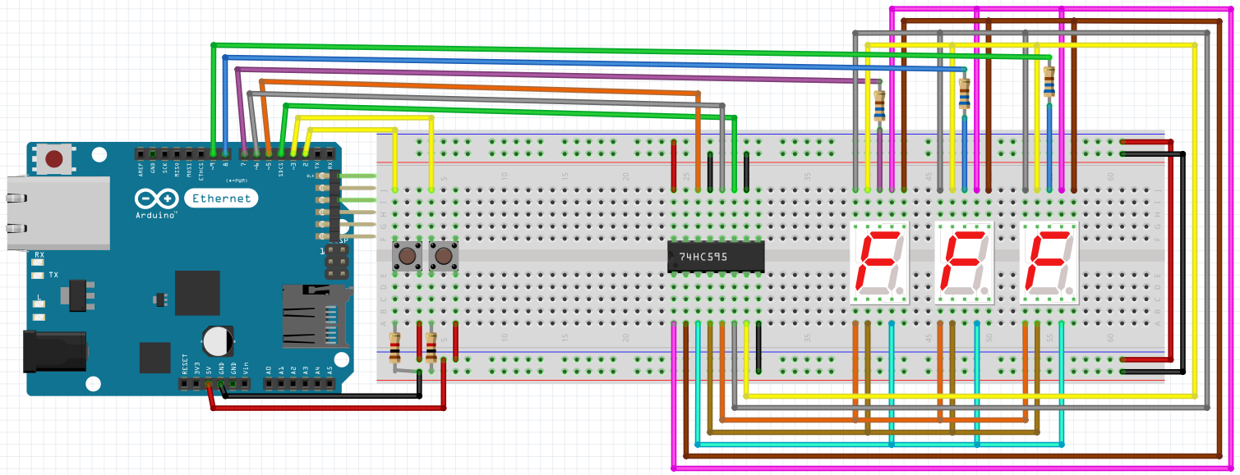

#include "Bounce2.h"
#define BTN_1 2
#define BTN_2 3
#define clock_pin 4
#define data_pin 5
#define lock_pin 6
#define DIS_1 7
#define DIS_2 8
#define DIS_3 9
Bounce btn1 = Bounce();
Bounce btn2 = Bounce();
int wait = 5; // za delay
bool count = false;
int i = 1;
int number = 0;
long unsigned int time1 = 0;
int value1 = false;
int value2;
int hundreds, tithes, singular;
int numbers[10][2] =
{
{0, 252},
{1, 96},
{2, 218},
{3, 242},
{4, 102},
{5, 182},
{6, 190},
{7, 224},
{8, 254},
{9, 246}
};

void setup() {
pinMode(BTN_1 ,INPUT_PULLUP);
btn1.attach(BTN_1);
btn1.interval(5);
pinMode(BTN_2 ,INPUT_PULLUP);
btn2.attach(BTN_2);
btn2.interval(5);

pinMode(lock_pin, OUTPUT);
pinMode(data_pin, OUTPUT);
pinMode(clock_pin, OUTPUT);
pinMode(DIS_1, OUTPUT);
pinMode(DIS_2, OUTPUT);
pinMode(DIS_3, OUTPUT);
}

void separateNumber(int number)
{
if(number < 100)
{
singular = number % 10;
tithes = (number / 10) % 10;
}
else
{
singular = number % 10;
tithes = (number / 10) % 10;
hundreds = (number / 100) % 10;
}
}

void showNumberLess10(int number)
{
digitalWrite(DIS_1, HIGH);
digitalWrite(DIS_2, HIGH);
digitalWrite(DIS_3, HIGH);
digitalWrite(lock_pin, LOW);
shiftOut(data_pin, clock_pin, MSBFIRST, numbers[0][1]);
digitalWrite(lock_pin, HIGH);
digitalWrite(DIS_1, LOW);
delay(wait);

digitalWrite(DIS_1, HIGH);
digitalWrite(DIS_2, HIGH);
digitalWrite(DIS_3, HIGH);
digitalWrite(lock_pin, LOW);
shiftOut(data_pin, clock_pin, MSBFIRST, numbers[0][1]);
digitalWrite(lock_pin, HIGH);
digitalWrite(DIS_2, LOW);
delay(wait);

digitalWrite(DIS_1, HIGH);
digitalWrite(DIS_2, HIGH);
digitalWrite(DIS_3, HIGH);
digitalWrite(lock_pin, LOW);
shiftOut(data_pin, clock_pin, MSBFIRST, numbers[number][1]);
digitalWrite(lock_pin, HIGH);
digitalWrite(DIS_3, LOW);
delay(wait);
}

void showNumber_10_to_100(int number)
{
separateNumber(number);

digitalWrite(DIS_1, HIGH);
digitalWrite(DIS_2, HIGH);
digitalWrite(DIS_3, HIGH);
digitalWrite(lock_pin, LOW);
shiftOut(data_pin, clock_pin, MSBFIRST, numbers[0][1]);
digitalWrite(lock_pin, HIGH);
digitalWrite(DIS_1, LOW);
delay(wait);

digitalWrite(DIS_1, HIGH);
digitalWrite(DIS_2, HIGH);
digitalWrite(DIS_3, HIGH);
digitalWrite(lock_pin, LOW);
shiftOut(data_pin, clock_pin, MSBFIRST, numbers[tithes][1]);
digitalWrite(lock_pin, HIGH);
digitalWrite(DIS_2, LOW);
delay(wait);

digitalWrite(DIS_1, HIGH);
digitalWrite(DIS_2, HIGH);
digitalWrite(DIS_3, HIGH);
digitalWrite(lock_pin, LOW);
shiftOut(data_pin, clock_pin, MSBFIRST, numbers[singular][1]);
digitalWrite(lock_pin, HIGH);
digitalWrite(DIS_3, LOW);
delay(wait);
}

void showNumberHigher100(int number)
{
separateNumber(number);
digitalWrite(DIS_1, HIGH);
digitalWrite(DIS_2, HIGH);
digitalWrite(DIS_3, HIGH);
digitalWrite(lock_pin, LOW);
shiftOut(data_pin, clock_pin, MSBFIRST, numbers[hundreds][1]);
digitalWrite(lock_pin, HIGH);
digitalWrite(DIS_1, LOW);
delay(wait);

digitalWrite(DIS_1, HIGH);
digitalWrite(DIS_2, HIGH);
digitalWrite(DIS_3, HIGH);
digitalWrite(lock_pin, LOW);
shiftOut(data_pin, clock_pin, MSBFIRST, numbers[tithes][1]);
digitalWrite(lock_pin, HIGH);
digitalWrite(DIS_2, LOW);
delay(wait);

digitalWrite(DIS_1, HIGH);
digitalWrite(DIS_2, HIGH);
digitalWrite(DIS_3, HIGH);
digitalWrite(lock_pin, LOW);
shiftOut(data_pin, clock_pin, MSBFIRST, numbers[singular][1]);
digitalWrite(lock_pin, HIGH);
digitalWrite(DIS_3, LOW);
delay(wait);
}

void loop() {
btn1.update();
btn2.update();

if(btn1.fell()){
value1 = !value1;
}
if(btn2.fell()){
value2 = !value2;
}
if(value1){
if(value2){
if(i == 1) i = -1;
else i = 1;
value2 = !value2;
}
else{
if(millis() - time1 > 100)
{
time1 = millis();
number += i;
if(number == 1000) number = 0;
else if(number == -1) number = 999;
}
}
}
else if(value2){
if(i == 1) i = -1;
else i = 1;
}

if(number < 10){
showNumberLess10(number);
}
else if(number < 100){
showNumber_10_to_100(number);
}
else{
showNumberHigher100(number);
}}

