## FAKE NEWS DETECTION USING NATURAL LANGUAGE PROCESSING

## Batch Member

## 510521104012 : V-GOKUL

Phase 1 submission document

**Project title:news detection using NLP:-**

1. **Abstract:-**

## In the era of information overload and digital communication, the proliferation of fake news has become a pressing concern. This research presents a comprehensive approach to Fake News Detection using Natural Language Processing (NLP) techniques. The proposed system is designed to automatically identify and classify fake news articles from legitimate ones, harnessithe power of NLP and machine learning algorithms.

## Fake News has become one of the major problem in the existing society. Fake News has high potential to change opinions, facts and can be the most dangerous weapon in influencing society.

## 

## The proposed project uses NLP techniques for detecting the 'fake news', that is, misleading news stories which come from the non-reputable sources. By building a model based on a K-Means clustering algorithm, the fake news can be detected . The data science community has responded by taking actions against the problem. It is impossible to determine a news as real or fake accurately. So the proposed project uses the datasets that are trained using count vectorizer method for the detection of fake news and its accuracy will be tested using machine learning algorithms

## Modules:-

## **Data Collection and Preprocessing**: -

## Acquiring a diverse dataset of news articles.

## Text cleaning and preprocessing to remove noise and irrelevant information

## **Feature Extraction**: -

## Utilizing NLP techniques like TF-IDF (Term Frequency-Inverse Document Frequency) and word embeddings to represent textual data.

## Extracting linguistic features such as word frequencies, n-grams, and sentiment scores.

## **Fake News Classification**: -

## Employing machine learning models like Support Vector Machines (SVM), Random Forest, and neural networks for classification.

## Training the models on labeled data to distinguish between fake and real news.

## **Textual Analysis**: -

## Conducting lexical analysis to identify suspicious patterns or language cues associated with fake news.

## Exploring linguistic and semantic aspects of the text.

## **Source and Context Analysis**:

## Assessing the credibility of news sources through domain-specific heuristics.

## Analyzing the context and corroborating information to determine the authenticity of news articles.

## **Social Media Integration**: -

## -Extending the system to analyze and detect fake news circulating on social media platforms.

## Monitoring the propagation and virality of potentially false information.

## **Evaluation and Validation**:

## Employing established evaluation metrics like accuracy, precision, recall, and F1-score to assess the model's performance.

## Conducting experiments on benchmark datasets and real-world news articles.

## **User Interface and Reporting**:

## Developing a user-friendly interface for users to verify news articles.

## Providing detailed reports on the authenticity of articles, including explanations for classification decisions.

## **Continuous Learning and Updates**:

## -Implementing mechanisms for continuous model retraining to adapt to evolving fake news tactics.

## Incorporating user feedback to improve the system's accuracy and reliability.

## **Deployment and Integration**:

## Integrating the Fake News Detection system into news websites and platforms to empower users to make informed decisions.

## Ensuring scalability and real-time processing capabilities.

# This research aims to contribute to the ongoing efforts to combat the spread of fake news and disinformation, promoting a more informed and responsible digital information landscape.

FAKE NEWS DETECTION USING NATURAL LANGUAGE PROCESSING:-

* Most text and documents contain many terms that are redundant for text classification, such as stop words, misspellings, slangs, and so on. Hence, data pre-processing has to be done before the data is sent to the classification models. After that, the dataset's dimensionality is decreased in order to save time and storage space. When the dimensions are reduced, it becomes easier to visualise. The data is then used to train classification models, which can be used to predict whether or not the presented data is fraudulent.
* Flow Chart:-

## Architecture of the proposed fake news detection system.

* RESULT:-
* To assess the effectiveness of the suggested technique on diverse datasets, we ran a number of simulations and experiments using different classifiers. The dataset was divided into training and test set.
* 80 percent of the dataset is regarded as the training data, and the remaining 20 percent is taken as the test data. The performance of several approaches was compared using the classification's accuracy as the criterion.

ANALYSIS OF CLASSIFICATION MODELS:-

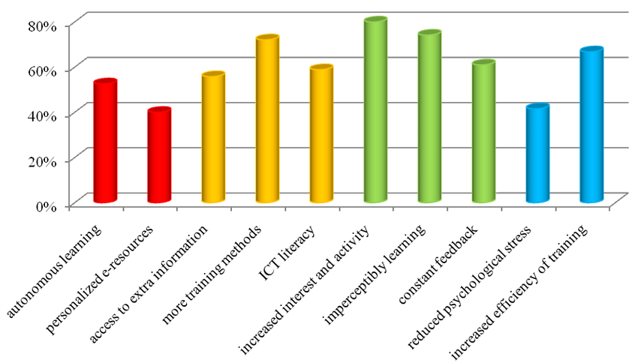

RESULT AND ANALYSIS:-

* Initially user gives the input in the text format as shown in the above figure 4. Then the tool receives it and when it is sent to the server then data preprocessing is performed on the .csv file. The dataset mainly consists of 4 columns namely news, title, text, labels(real/fake). After data preprocessing Test and Train split is done. Then tfidf vectorization takes place on the data. Tfidf is calculated by the product of tf(Term frequency) and idf(Inverse document frequency).
* Later Passive Aggressive classification takes place on the data. If the classifier results as passive then it means that the classification is correct. If the classifier results aggressive then it implies that the classification has miscalculation. In the end output is displayed on the screen saying whether the news is fake or real as follows.