PROJECT TITLE: CHATBOT DEPLOYMENT WITH IBM WATSON ASSISTANT

PHASE IV- DEVELOPMENT PART 2

STEP 1:HERE I CREATED A SLACK ACCOUNT AND DONE THE INTEGRATION PROCESS

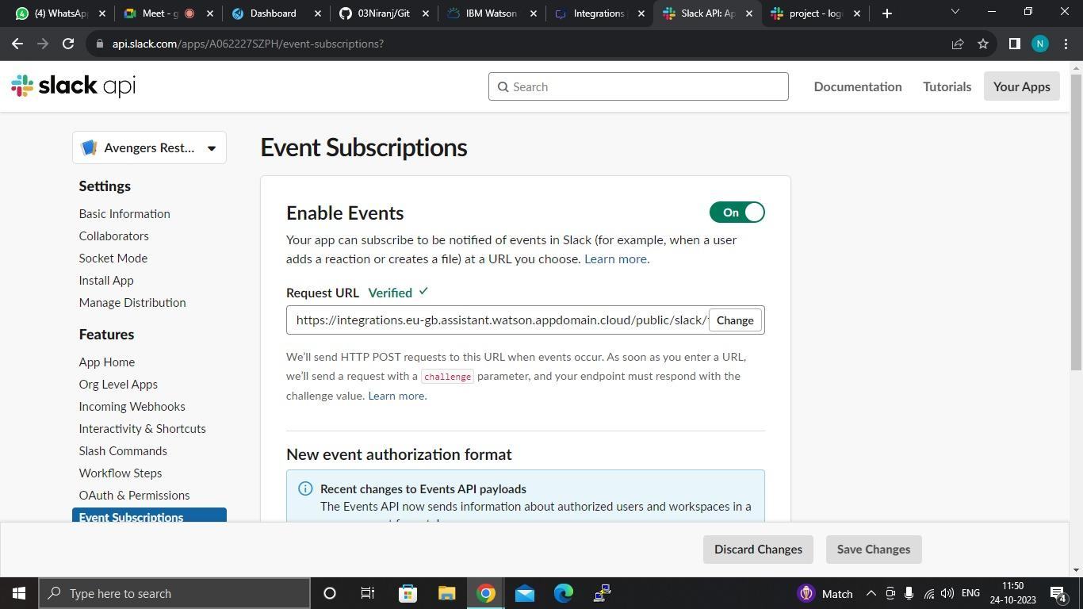

**Chatbot Slack integration** is a powerful solution that enables seamless communication and collaboration within the Slack platform.

By integrating ChatGPT, an advanced conversational AI model, with Slack, companies can enhance their messaging experience, automate repetitive tasks, and improve overall productivity.

STEP 2: AFTER ALL THE INTEGRATION PROCESS I SUCCESSFULLY PREVIEW MY WATSON

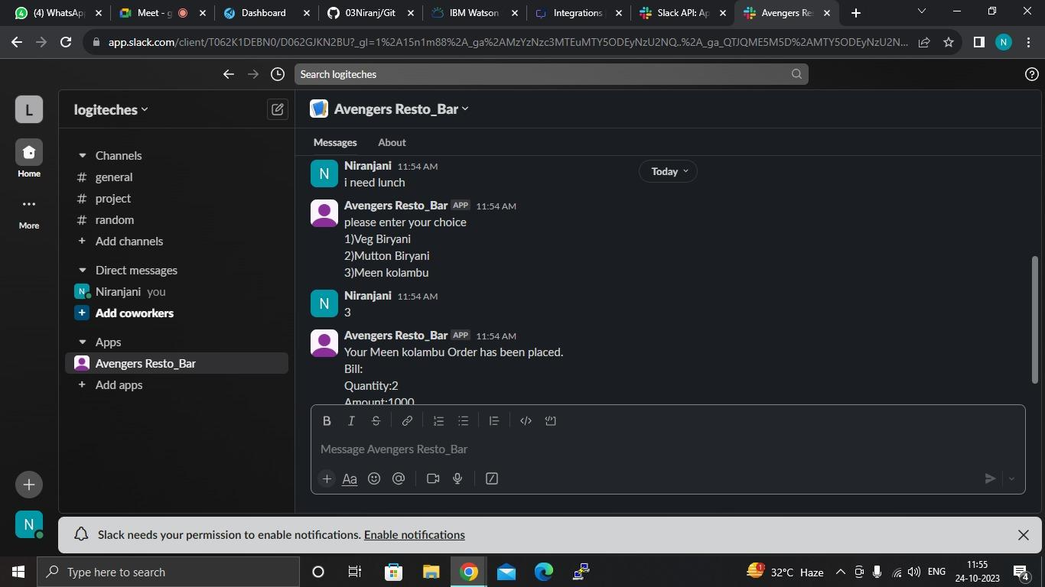

[Slack Terms refer to the rights and responsibilities when using Slack's online workplace productivity tools and platform](https://www.bing.com/ck/a?!&&p=569261f390d9d3cfJmltdHM9MTY5ODE5MjAwMCZpZ3VpZD0zNzc0MzBiOC1mMDM0LTYzOGYtMjliZC0yMjJlZjE4NjYyNjMmaW5zaWQ9NTc0Mg&ptn=3&ver=2&hsh=3&fclid=377430b8-f034-638f-29bd-222ef1866263&psq=KEY+TERMS+OF+SLACK&u=a1aHR0cHM6Ly9zbGFjay5jb20vbWFpbi1zZXJ2aWNlcy1hZ3JlZW1lbnQ&ntb=1)

STEP 3: HERE I INTEGRATE MY FACEBOOK ACCOUNT TO WATSON ASSISTANT

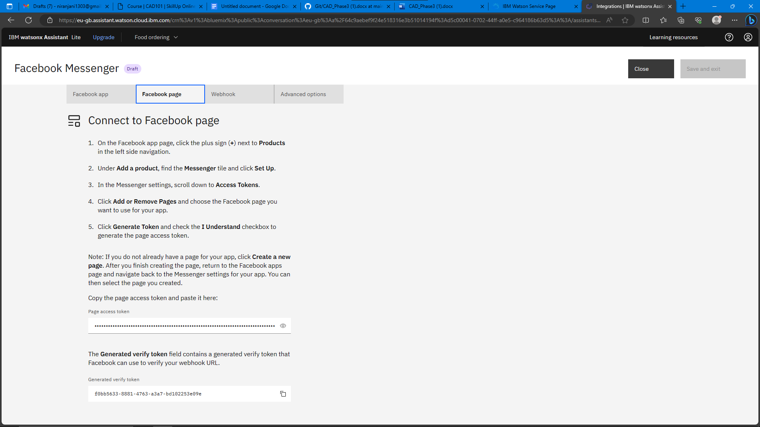

STEP 4: FINALLY WATSON ASSISTANT IS SUCESSFULLY HAS GIVEN

RESPONSE TO MY QUERIES.

